Assessment Information
- Question 4 is always worth 20 marks. This means that it’s the highest tariff question in Section A. Proportionately, it’s worth 25% of marks of the paper and 12.5% of the total GCSE qualification. In short: it’s worth taking seriously.

- Question 4 is connected to AO4, which requires students to ‘evaluate texts critically and support this with appropriate textual references.’ The key word is ‘evaluate’.

- AQA advise students to spend around 20 minutes on their response. This should be enough time for them to make a least three substantive points.

- A criticism from last year’s exam series was that student’s didn’t write enough. This could’ve been because of poor time management or as a result of limited engagement. Either way, it’s something that’s worth keeping in mind.

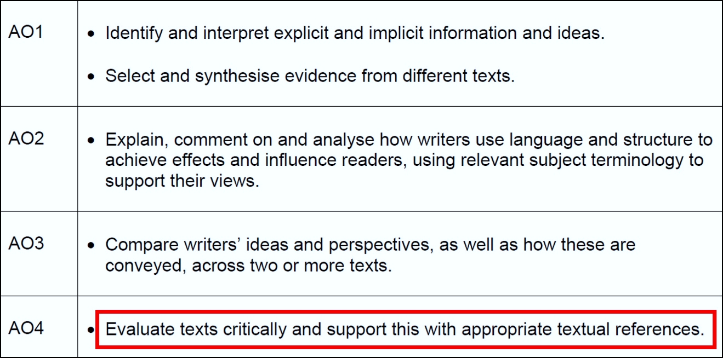

Task Information
- Students are provided with a statement about the source. The question will then guide them to a certain area of the text – usually the second part. Anything outside designated portion of the text should be ignored.

- Students will always be prompted by the words: ‘To what extent do you agree?’ They will also be provided with three bullet points to help frame their response.
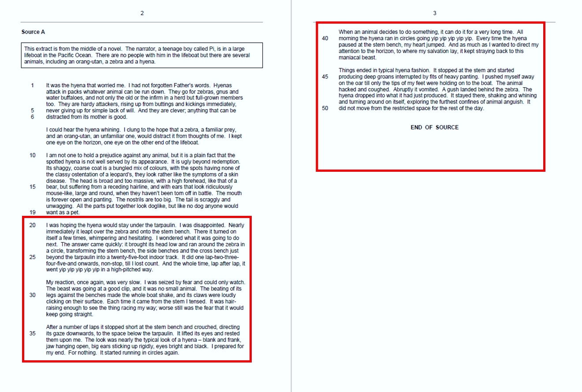
- Students will need to evaluate the statement. Any analysis that falls beyond the relevant part of the text will not be rewarded.
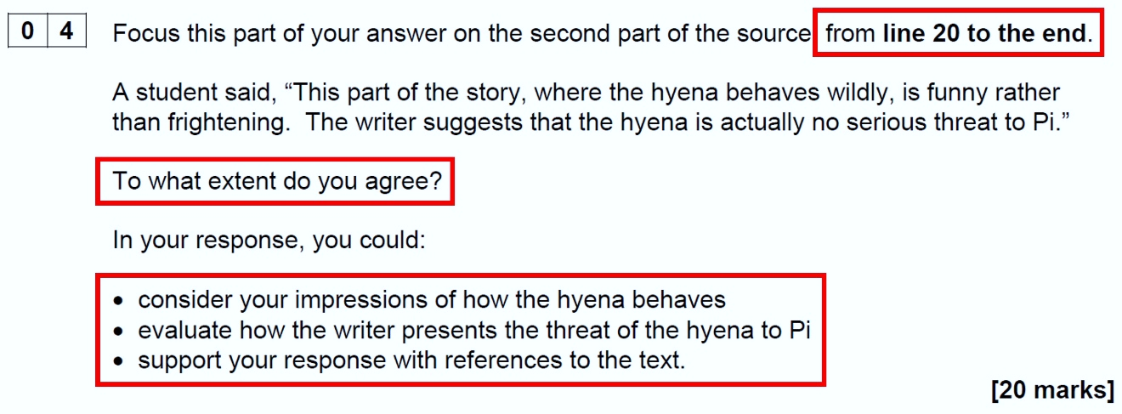

Task Requirements
- The focus of the ideas will be defined by the statement provided. Students need to fulfil three requirements.

- Students should explore the given statement. As such, it’s important that there’s a clarity on the command words.

- They should evaluate the effects of the writer’s methods. This essentially means that they should evaluate how language and structural features have been used.

- Students should support their response with textual references. It’s worth noting here that there is no explicit requirement to use quotations. Students may choose to paraphrase or make other textual references as appropriate.

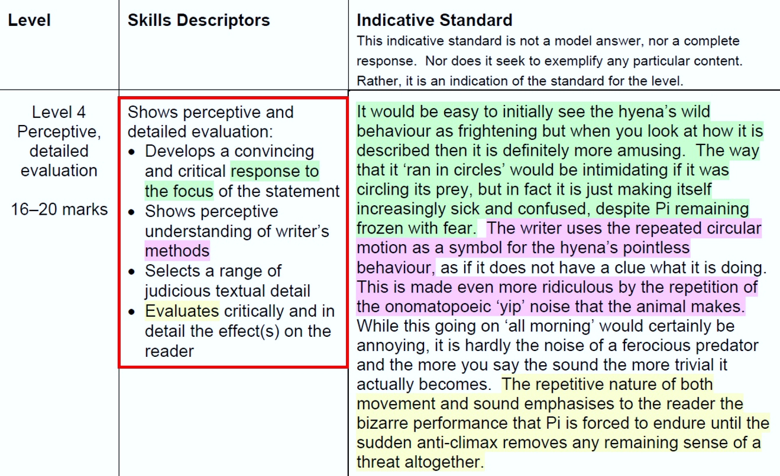

Structuring a Response
- Students need to ask themselves five questions:

- Do I agree or disagree?
- Why do I agree or disagree?
- What events or actions make me agree or disagree?
- What methods has the writer used to convey these events or actions?
- How do these methods influence my thinking?

- Students should begin their response by clearly expressing their view on the statement (i.e. through what’s now commonly called a ‘thesis statement’) and then provide a brief overview of their main points. They should then explore each point in turn.

- It might be helpful for students to follow or adapt a basic structure:

- State your view: ‘I agree because...’
- Gather evidence: ‘An important part of the text is…’
- Identify a method: ‘The writer uses the word / phrase / technique…’
- Make an inference: ‘We learn from this / This shows / This is significant…’
- Make a link with the statement: ‘This supports the student’s view because…’

- It might also be helpful for students to know some common words and phrases:

- Because / but / so
- Before / after / firstly / finally
- Although / despite
- Similarly / contrastingly
- Furthermore / additionally
- This shows…
- Not only… but also…
- Significant because…
- As revealed by…

Advice
- It’s important to balance the evaluation of ideas and methods in the question. It’s surprisingly easy to neglect the methods aspect of the task. This is something that AQA are keen to highlight.

- Students should be clear when they explain why the methods used by the writer (i.e. language and structural features) have influenced their views on the statement.

- Students should maintain a critical distance. This means that they should judge the ideas in the text in a way that is logical and detached.

- Students can entirely agree or disagree with the statement, as long as their views are appropriately supported. Partial agreement or disagreement is also fine. However, this is harder to do and success can be achieved by adopting a less complex approach.

- Brief responses are likely to inhibit students moving-up the levels in the mark scheme. This is something noted in the Report on the Exam from June 2023.

- On a connected note, students should spend roughly 20 minutes on the task. As such, they should carefully manage their time on the other tasks in Section A.
