How is the character of Macbeth presented?

Heroic | Ruthless | Ambitious | Insecure | 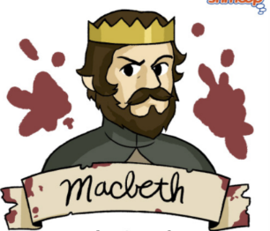
Brave | Violent | Conflicted | Erratic
Determined | Decisive | Hesitant | Cruel
Valiant | Loyal | Submissive | Tyrannical

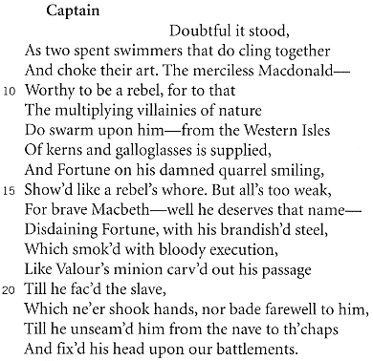
Act 1, Scene 2

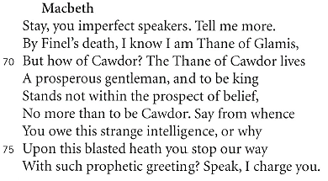
Act 1, Scene 3

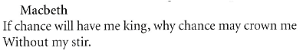
Act 1, Scene 4
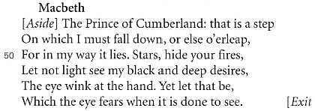
Act 1, Scene 5

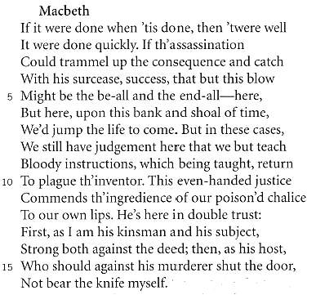
Act 2, Scene 1

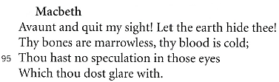
Act 3, Scene 4

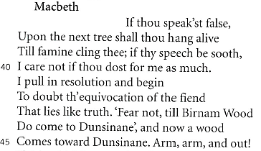
Act 5, Scene 5
How is the character of Lady Macbeth presented?

Ambitious | Resolute | Forceful | Deceitful
Persuasive | Assertive | Determined | Untrustworthy
Manipulative | Confident | Controlling | Irrational
Intelligent | Calculating | Influential | Regretful

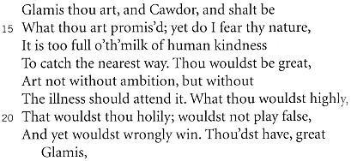
Act 1, Scene 5

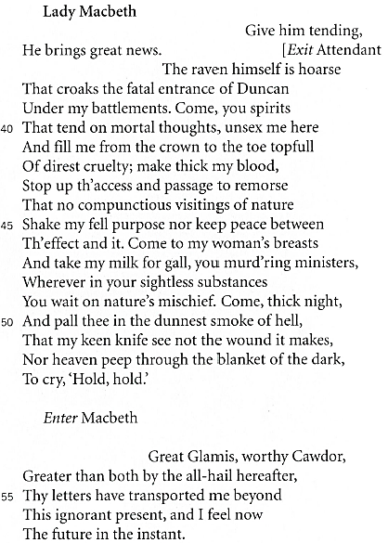
Act 1, Scene 5

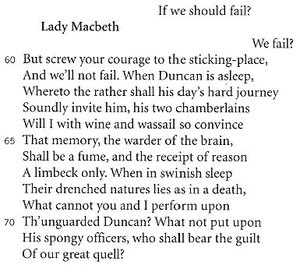
Act 1, Scene 7

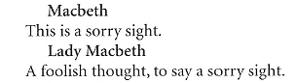
Act 2, Scene 2

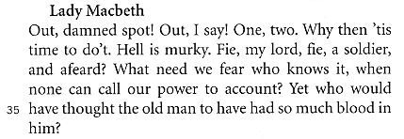
Act 5, Scene 1

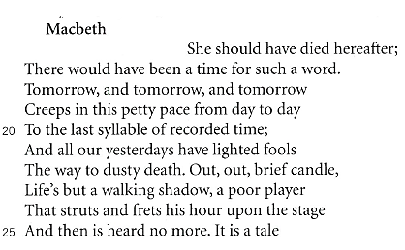
Act 5, Scene 5

