Birling
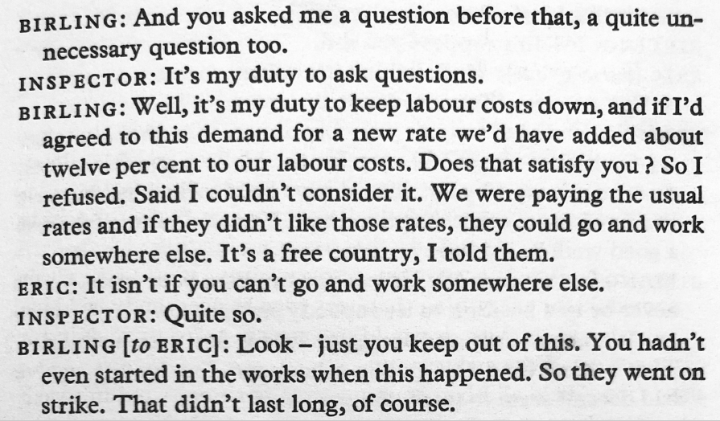 | 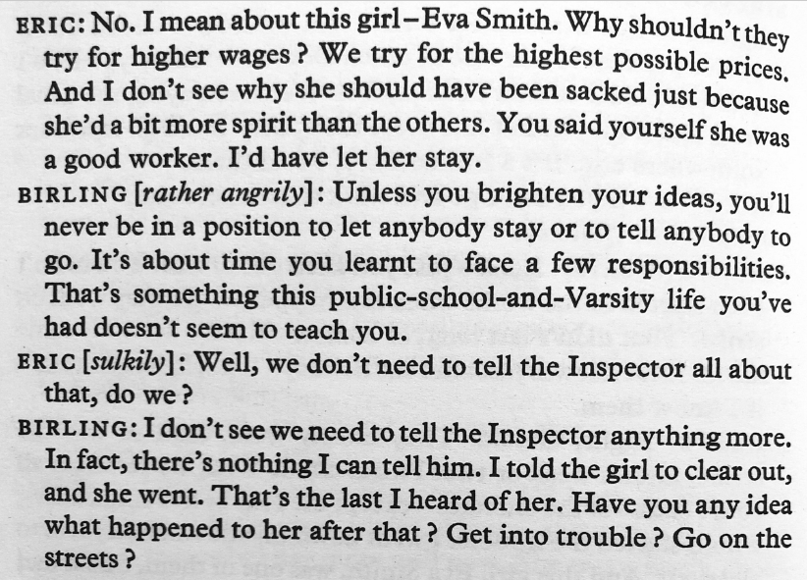
Extract 1  - Choose two words to describe Birling’s mood  - Explain why Birling refused the workers’ demands for a pay rise  - Explain why Eric doesn’t believe it’s a ‘free country’  - Describe how the relationship between Birling and Eric is presented | Extract 2  - Explain what having ‘a bit more spirit than the others’ means  - Explain why Eric would have let Eva ‘stay’ at the company  - Explain why Birling speaks ‘rather angrily’ to Eric  - Retrieve a quotation that shows Birling accepts no responsibility
Big Question

- How is the relationship between Birling and Eric presented at the start of the play?

Sheila

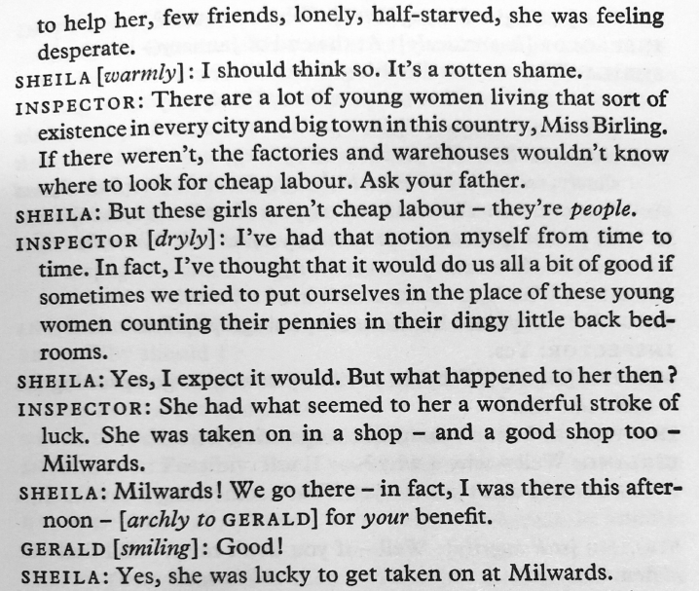 | 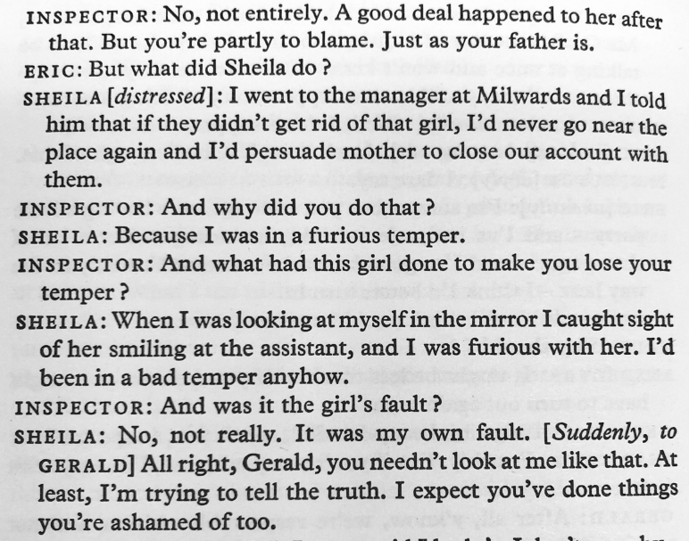
Extract 1  - Explain how Eva is similar to ‘a lot of young women’  - Explain what the phrase ‘cheap labour’ means  - Define the word ‘dingy’  - Explain why it was a ‘stroke of luck’ for Eva to get another job | Extract 2  - Explain why Sheila is ‘distressed’  - Explain why the manager does as Sheila requests  - Define the word ‘furious’  - Explain what Sheila means when she says it ‘was my own fault’
Big Question

- What are the two most important things we learn from Sheila’s reaction to the Inspector’s questions?
Gerald

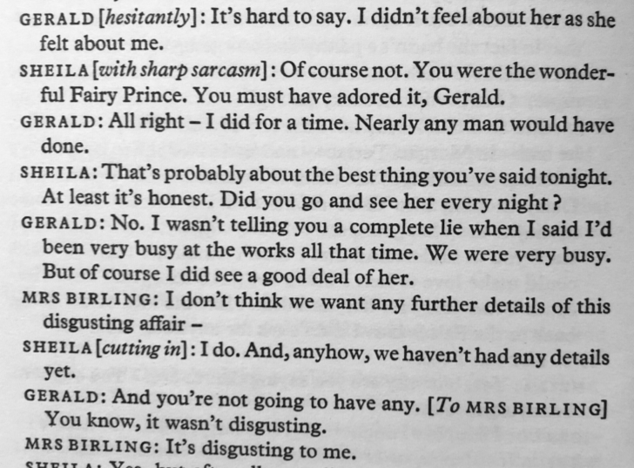 | 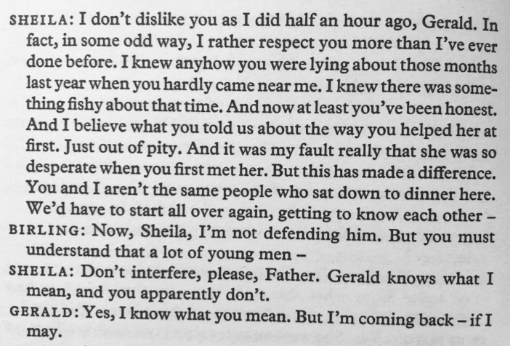
Extract 1  - Explain why Gerald speaks ‘hesitantly’  - Provide one reason why Sheila calls Gerald a ‘Fairy Prince’  - Explain what the stage direction ‘cutting in’ means  - Retrieve a quotation that shows Mrs Birling is highly judgemental | Extract 2  - Provide one reason why Sheila doesn’t ‘dislike’ Gerald as much  - Explain what Birling tries to say about Gerald’s behaviour  - Define the word ‘interfere’  - Provide one reason why Gerald leaves the stage
Big Question

- How is the relationship between Gerald and Sheila presented at this point in the play?

Mrs Birling
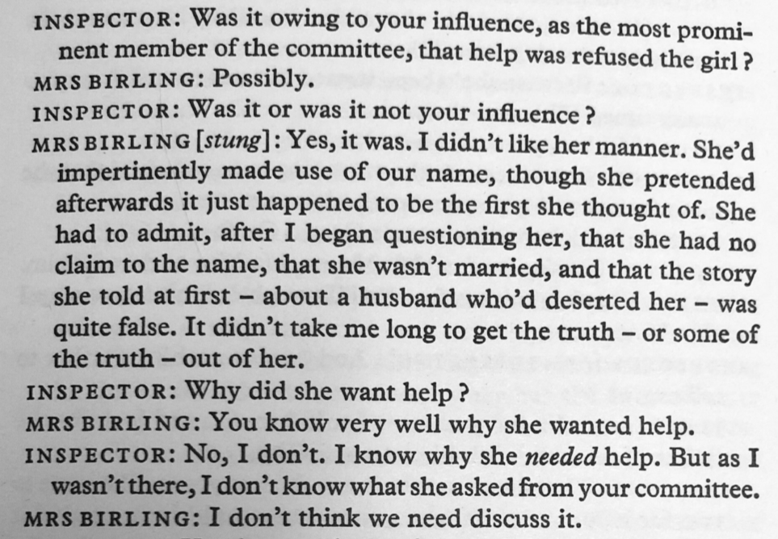 | 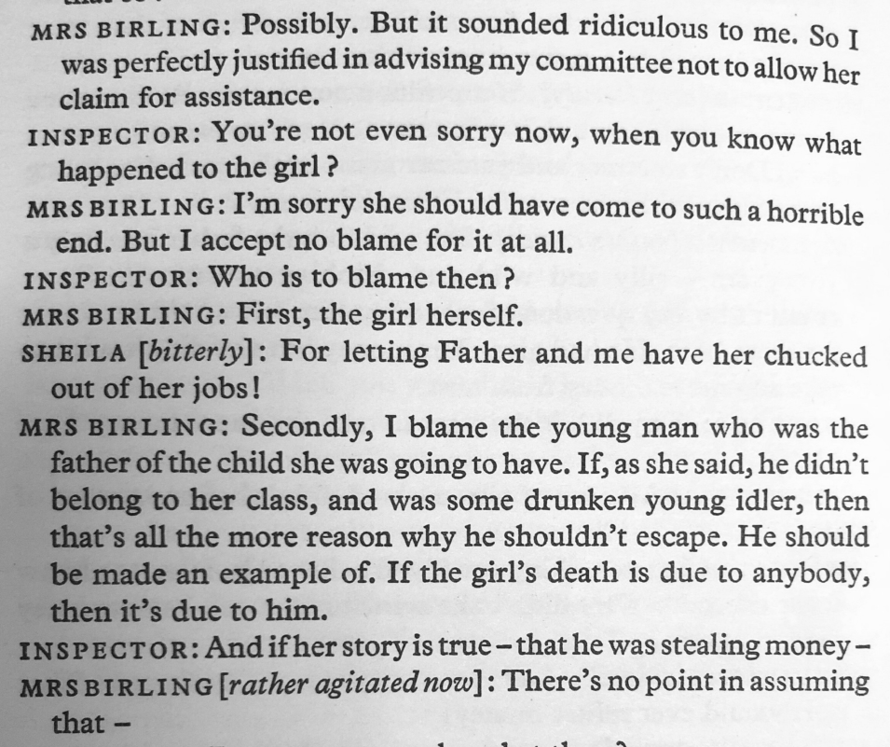
Extract 1  - Explain the purpose of the committee  - Define the word ‘impertinent’  - Explain why Mrs Birling chose not to help Eva  - Retrieve a quotation that shows Mrs Birling is unremorseful | Extract 2  - Define the phrase ‘perfectly justified’  - Explain why Mrs Birling believes Eva is to blame for the suicide  - Identify the main characteristic of an ‘idler’  - Define the word ‘agitated’
Big Question

- What are the two most important things we learn from Mrs Birling’s reaction to the Inspector’s questions?

Eric

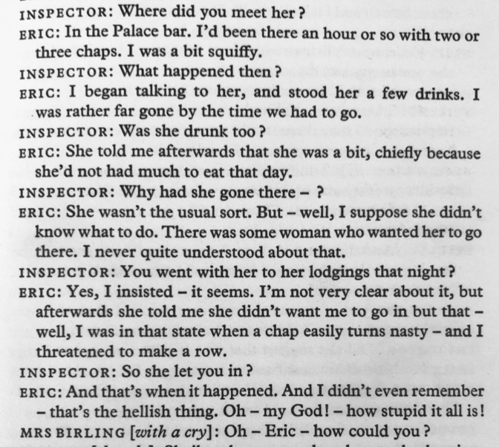 | 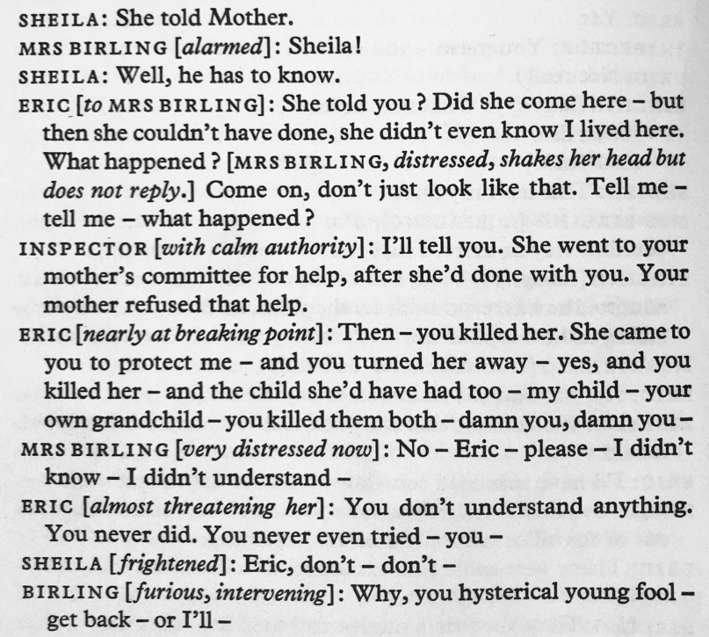
Extract 1  - Define the word ‘squiffy’  - Explain why Eric isn’t ‘very clear’ on what happened  - Retrieve a quotation that shows Eric threatened Eva  - Choose two words to describe Eric’s mood at the end of the extract | Extract 2  - Provide a reason why there are so many dashes in the dialogue  - Explain how the Inspector speaks differently from the others  - Explain why Eric is ‘nearly at breaking point’  - Explain why Sheila is ‘frightened’
Big Question

- How is the relationship between Eric and Mrs Birling presented at this point in the play?
The Beginning and the End of the Play
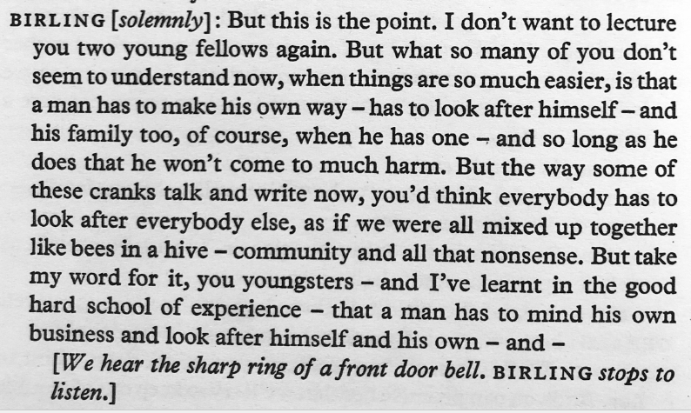 | 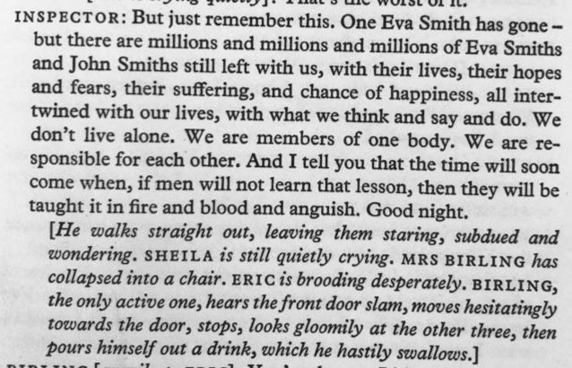
Extract 1  - Explain what Birling means by the term ‘crank’  - Provide a reason why people in a community are like ‘bees in a hive’  - Define the phrase ‘take my word for it’  - Explain Birling’s view on how a society should function | Extract 2  - Choose a word to describe the tone of the Inspector’s speech  - Define the word ‘intertwined’  - Explain the reference to ‘fire and bloody and anguish’  - Explain the Inspector’s view on how a society should function
Big Question

- How do the events on stage illustrate the Inspector’s view that human lives are intertwined?

