GCSE English Language
Paper 1
Section A

Text 1: The Children of Men, by P. D. James
Text 2: The Bone Clocks, by David Mitchell
Text 3: No Night is Too Long, by Barbara Vine (Ruth Rendell)
Text 4: A Lovely Way to Burn, by Louise Welsh
Text 5: Empire of the Sun, by J. G. Ballard

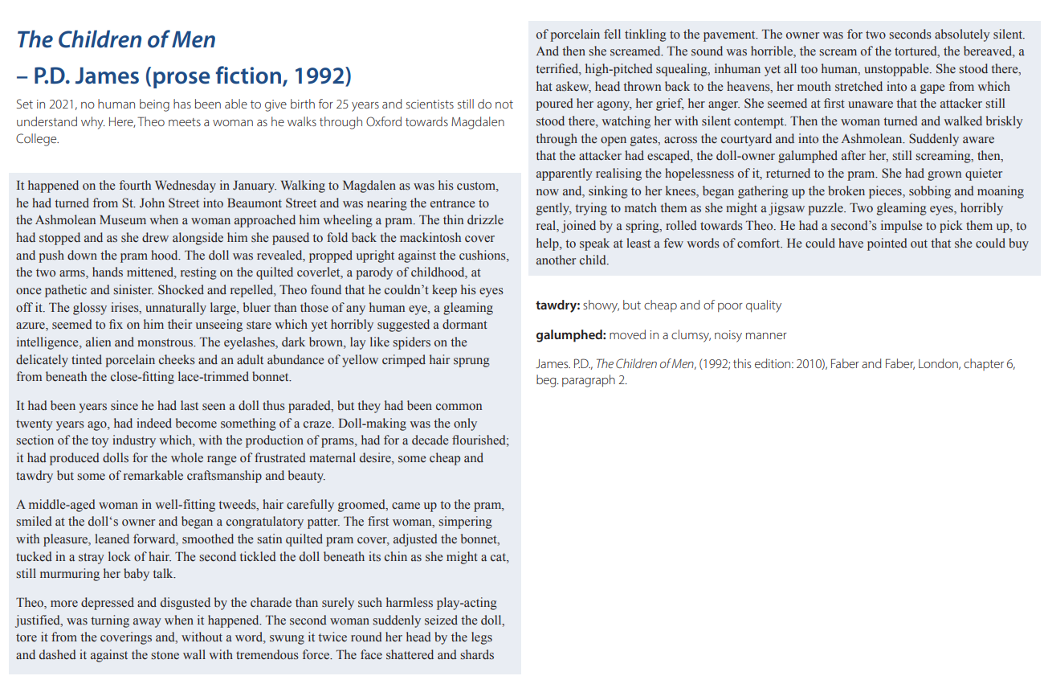

Source: https://www.ocr.org.uk/Images/373395-unseen-20th-and-21st-century-literary-texts.pdf
Q1 Read again the first part of the source, from lines 1 to 5.
List four things about Theo from this part of the source. [4 marks]

Q2 Look box in detail at this extract, from lines 5 to 12 of the source:

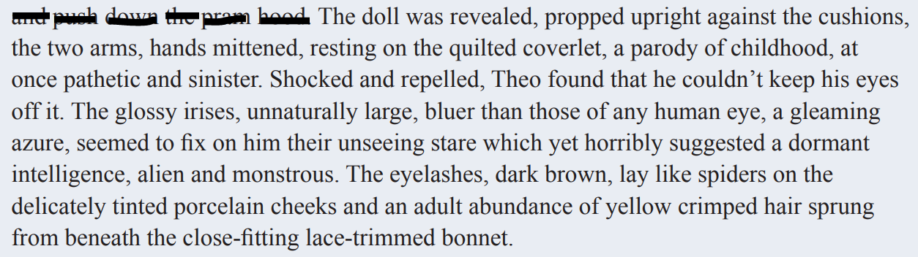

How does the writer use language here to describe the doll?

You could include the writer’s choice of:

- words and phrases
- language features and techniques
- sentence forms. [8 marks]

Q3 You now need to think about the whole of the source.

This text is from the beginning of a short story.

How has the writer structured the text to interest you as a reader?

You could write about:

- what the writer focuses your attention on at the beginning of the source
- how and why the writer changes this focus as the source develops
- any other structural features that interest you.
[8 marks]

Q4 Focus box this part of your answer on the second part of the source, from line 18 to the end.

A student said, ‘This part of the story, where the second woman attacks the doll, shows the owner is right to be shocked and angry.’

To what extent do you agree?

In your response, you could:

- consider your own impressions of the attack on the doll
- evaluate how the writer describes the attack
- support your response with references to the text.
[20 marks]
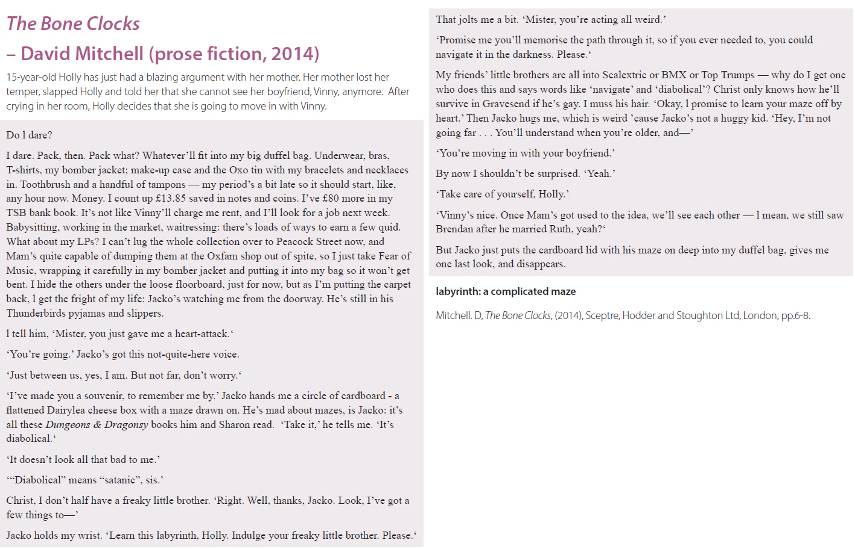

Source: https://www.ocr.org.uk/Images/373395-unseen-20th-and-21st-century-literary-texts.pdf
Q1 Read again the first part of the source, from lines 1 to 7.
List four things about the Holly from this part of the source. [4 marks]

Q2 Look box in detail at this extract, from lines 8 to 13 of the source:

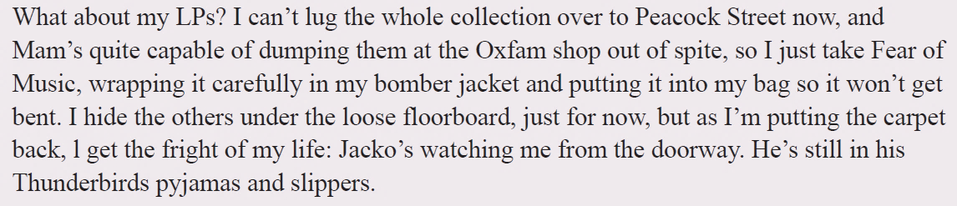

How does the writer use language here to describe how Holly is feeling?

You could include the writer’s choice of:

- words and phrases
- language features and techniques
- sentence forms. [8 marks]

Q3 You now need to think about the whole of the source.

This text is from the beginning of a short story.

How has the writer structured the text to interest you as a reader?

You could write about:

- what the writer focuses your attention on at the beginning of the source
- how and why the writer changes this focus as the source develops
- any other structural features that interest you.
[8 marks]

Q4 Focus box this part of your answer on the second part of the source, from line 15 to the end.

A student said, ‘This part of the story, where Holly speaks to Jackco, shows that she is sad to be leaving him.’

To what extent do you agree?

In your response, you could:

- consider your own impressions of Holly and Jacko’s relationship
- evaluate how the writer describes the relationship
- support your response with references to the text.
[20 marks]

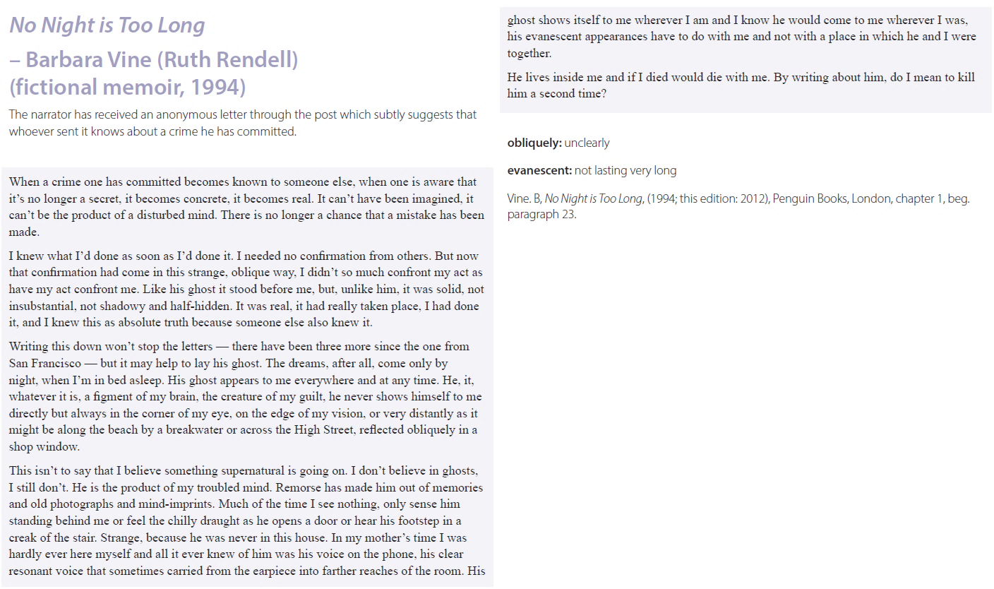

Source: https://www.ocr.org.uk/Images/373395-unseen-20th-and-21st-century-literary-texts.pdf

Q1 Read again the first part of the source, from lines 5 to 9.
List four things about the narrator from this part of the source. [4 marks]

Q2 Look box in detail at this extract, from lines 10 to 16 of the source:

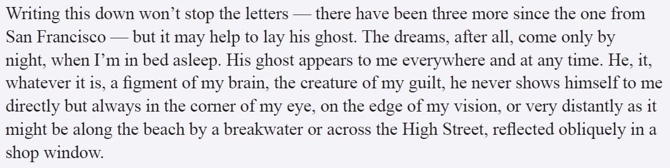

How does the writer use language here to describe how the narrator is feeling?

You could include the writer’s choice of:

- words and phrases
- language features and techniques
- sentence forms. [8 marks]

Q3 You now need to think about the whole of the source.

This text is from the beginning of a short story.

How has the writer structured the text to interest you as a reader?

You could write about:

- what the writer focuses your attention on at the beginning of the source
- how and why the writer changes this focus as the source develops
- any other structural features that interest you.
[8 marks]

Q4 Focus box this part of your answer on the second part of the source, from line 17 to the end.

A student said, ‘This part of the story, where the narrator reflects on his troubled mind, shows that he still feels very guilty about the crime he has committed.’

To what extent do you agree?

In your response, you could:

- consider your own impressions of how the narrator feels
- evaluate how the writer describes the narrator’s feelings
- support your response with references to the text.
[20 marks]
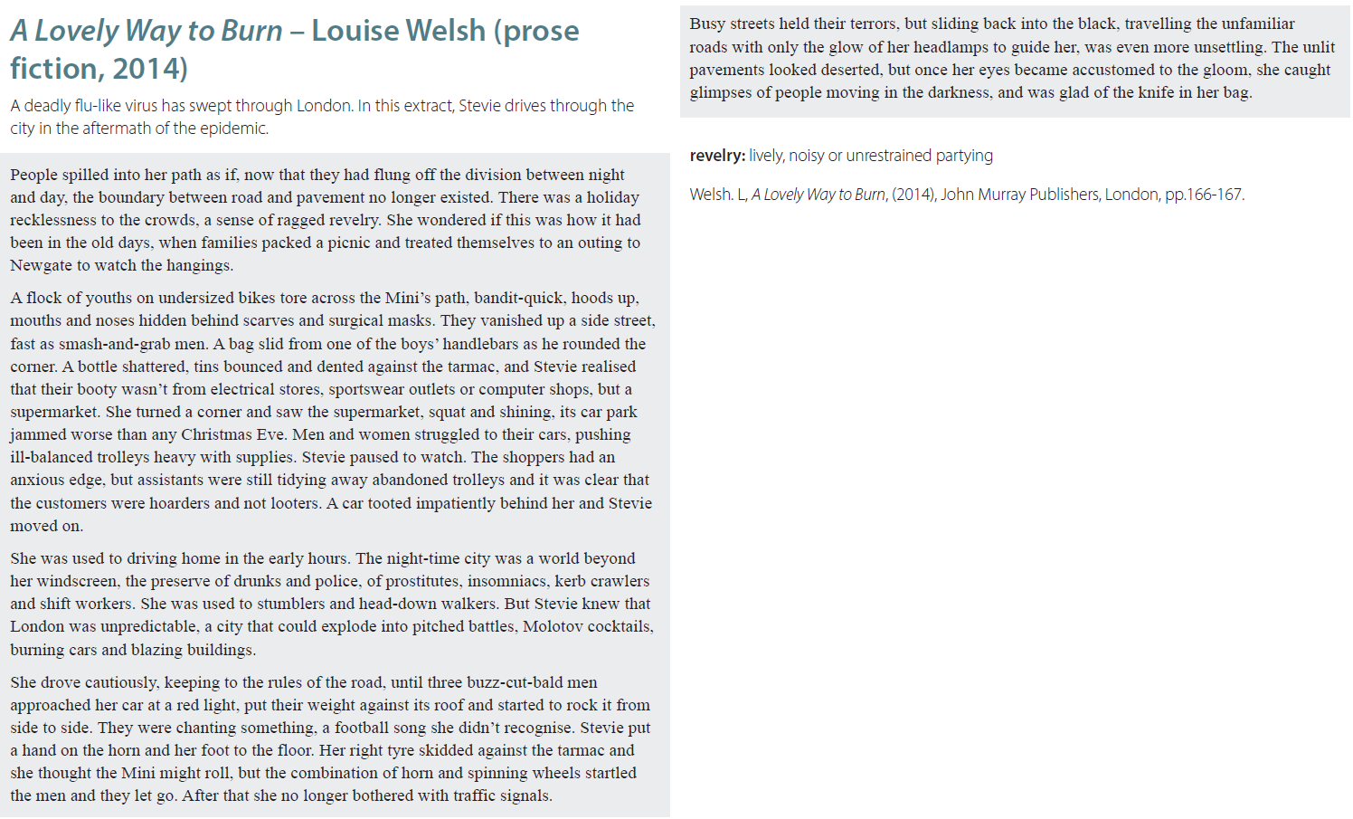

Source: https://www.ocr.org.uk/Images/373395-unseen-20th-and-21st-century-literary-texts.pdf

Q1 Read again the first part of the source, from lines 1 to 5.
List four things about the crowd of people from this part of the source. [4 marks]

Q2 Look box in detail at this extract, from lines 6 to 11 of the source:

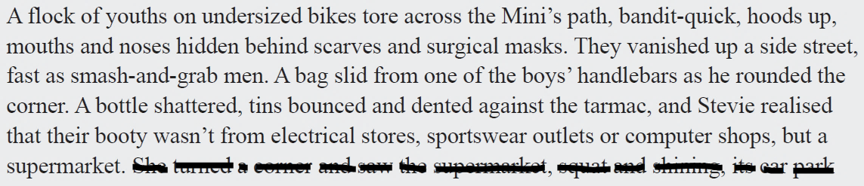

How does the writer use language here to describe the group of youths?

You could include the writer’s choice of:

- words and phrases
- language features and techniques
- sentence forms. [8 marks]

Q3 You now need to think about the whole of the source.

This text is from the beginning of a short story.

How has the writer structured the text to interest you as a reader?

You could write about:

- what the writer focuses your attention on at the beginning of the source
- how and why the writer changes this focus as the source develops
- any other structural features that interest you.
[8 marks]

Q4 Focus box this part of your answer on the second part of the source, from line 17 to the end.

A student said, ‘This part of the story, where Stevie is driving home, shows how dangerous London has become.’

To what extent do you agree?

In your response, you could:

- consider your own impressions of London
- evaluate how the writer describes London
- support your response with references to the text.
[20 marks]

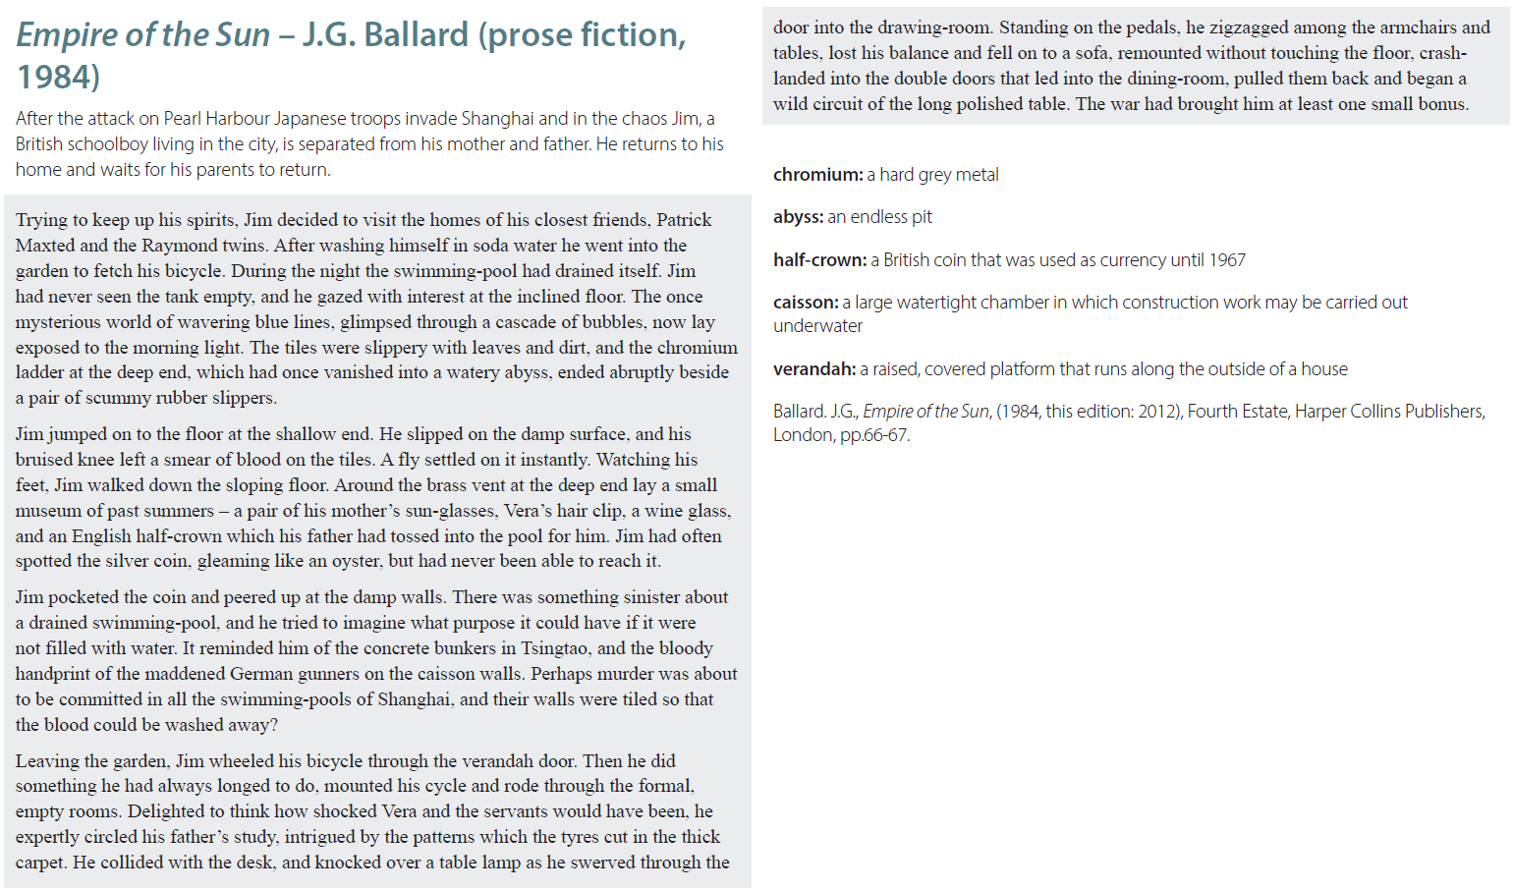

Source: https://www.ocr.org.uk/Images/373395-unseen-20th-and-21st-century-literary-texts.pdf

Q1 Read again the first part of the source, from lines 1 to 4.
List four things about Jim from this part of the source. [4 marks]

Q2 Look box in detail at this extract, from lines 4 to 8 of the source:

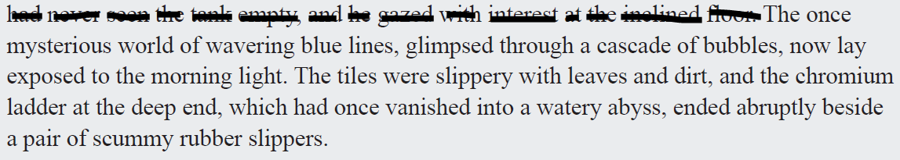

How does the writer use language here to describe the empty swimming pool?

You could include the writer’s choice of:

- words and phrases
- language features and techniques
- sentence forms. [8 marks]

Q3 You now need to think about the whole of the source.

This text is from the beginning of a short story.

How has the writer structured the text to interest you as a reader?

You could write about:

- what the writer focuses your attention on at the beginning of the source
- how and why the writer changes this focus as the source develops
- any other structural features that interest you.
[8 marks]

Q4 Focus box this part of your answer on the second part of the source, from line 15 to the end.

A student said, ‘This part of the story, where Jim is alone at home, shows that he enjoys being unsupervised.’

To what extent do you agree?

In your response, you could:

- consider your own impressions of how Jimmy uses his time at home
- evaluate how the writer describes Jimmy
- support your response with references to the text.
[20 marks]

Q2
Write: ‘A method / word / phrase that helps to convey / emphasise…’ and refer to the focus word of the question
Write: ‘This has the effect of…’ and make a point based on the method / word / phrase you zoomed-in on
Write: ‘Another effect of…’ and make another point based on the same method / word / phrase
Repeat the process at least two more times

Adjective | Metaphor | Repetition
Verb | Simile | Rhetorical question
Adverb | Personification | Onomatopoeia

Q3
Write: ‘At the beginning of the text…’ and explain what the writer focuses on
Write: ‘The writer then shifts the focus and zooms in / out on…’ and explain how and why the focus changes (e.g. we might learn more about a character or the situation they are in)
Write: ‘As the text develops…’ and explain how and why the focus changes (e.g. the mood might change or a contrast might be established)
Write: ‘Towards the end of the text, the writer focuses on / the perspective changes …’ and explain what has changed and how the end differs from the beginning (e.g. we might be surprised or tension might be built)

Beginning | Zoom-in / out | Shift
Middle | Focus | Contrast
End | Perspective | Parallel

Q4
Write: ‘I agree / disagree that…’ and provide a firm reason for why you agree / disagree (don’t just write a simple sentence: make sure you really go into detail)
Write: ‘A method / word / phrase that helps to convey / emphasise…’ and refer to the focus word of the statement
Write: ‘This has the effect of…’ and make a point based on the method / word / phrase you zoomed-in on
Write: ‘Another effect of…’ and make another point based on the same method / word / phrase
Write: ‘A further reason why I agree / disagree is…’ provide another reason why you agree / disagree (once again, don’t just write a simple sentence: make sure you really go into detail)
Write: ‘A method that helps to convey / emphasise the writer’s view is…’ and then write about the effect
Repeat the process at least two more times

Implies | Furthermore | Contrastingly
Shows | Similarly | Forcefully
Emphasises | However | Possibly

