English Language
Paper 1
June 2018

1 hour 45 minutes
80 Marks
50% of Qualification

Question | Focus | Marks | Time Allocation
1 | List Four Things | 4 | 5 mins
2 | Language | 8 | 15 mins
3 | Structure | 8 | 15 mins
4 | Agree / Disagree | 20 | 25 mins
5 | Creative Writing | 40 | 45 mins

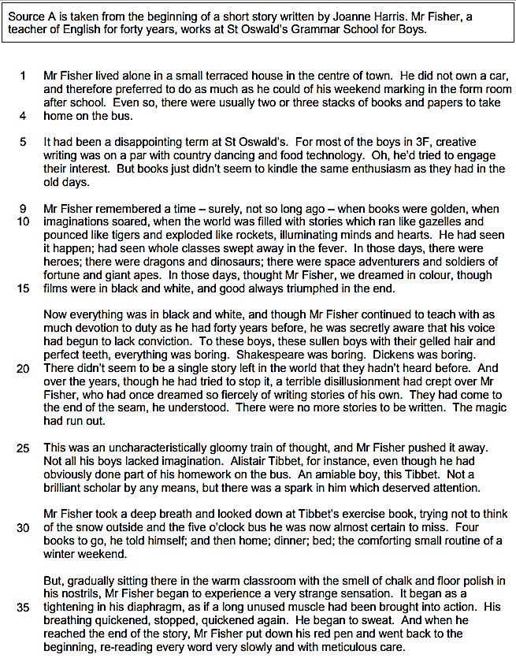
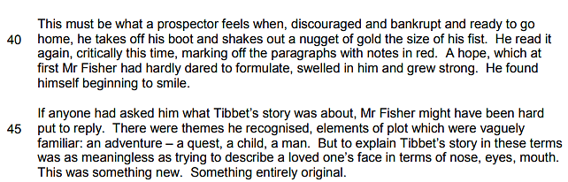

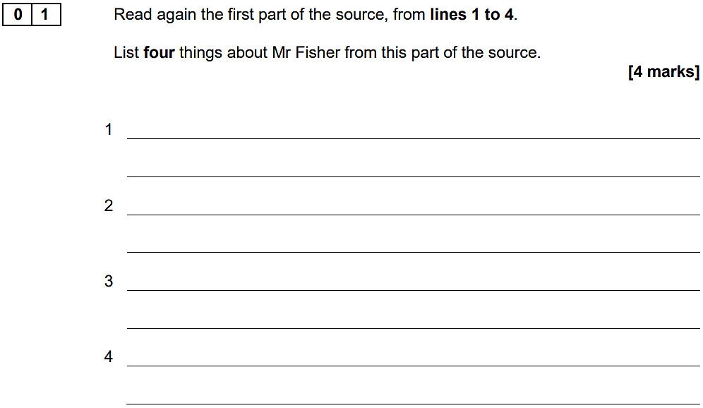

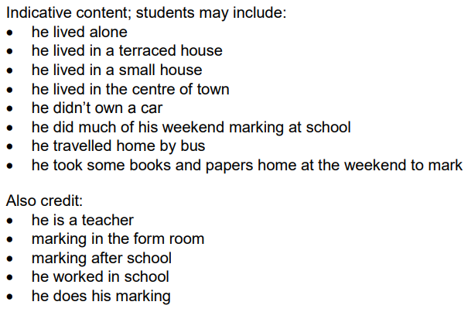
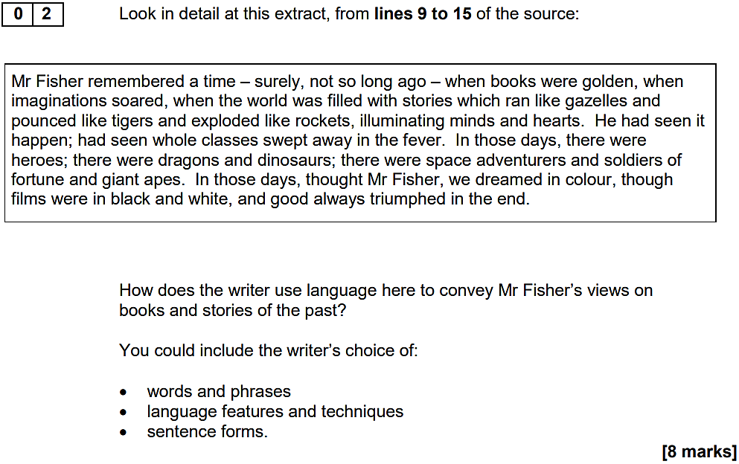

…………………………………………………………………………………………………………………………………………………………………………………………

Think of this as two separate paragraphs
- First: ‘The writer presents… / describes…’ and then gather evidence
- Identify and explore a method: ‘The writer uses the word… / phrase… / technique… This has the effect of…’
- Make an inference: ‘We learn from this… / This shows…’
- Make an additional inference: ‘Furthermore… / Additionally… / Also…’
- Repeat

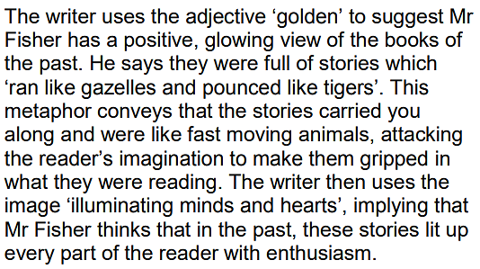
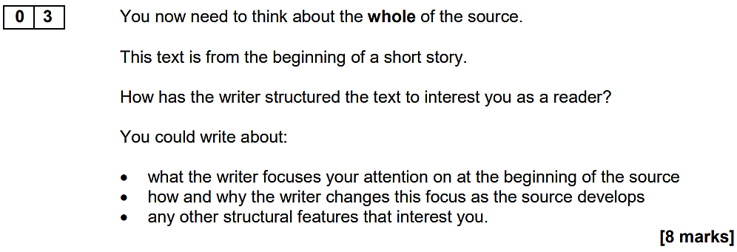

…………………………………………………………………………………………………………………………………………………………………………………………

Think of this as three separate paragraphs (beginning, middle, end)
- First: ‘At the beginning of the source, the focus is on…’
- Make an inference: ‘This has the effect of… / This interests the reader because…’
- Move through the source: ‘As the text progresses, the focus shifts to…’
- Make an inference: ‘This has the effect of… / This interests the reader because…’
- Make an additional inference: ‘Furthermore… / Additionally… / Also…’
- Repeat

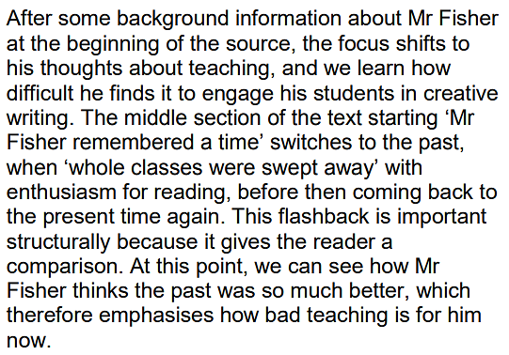
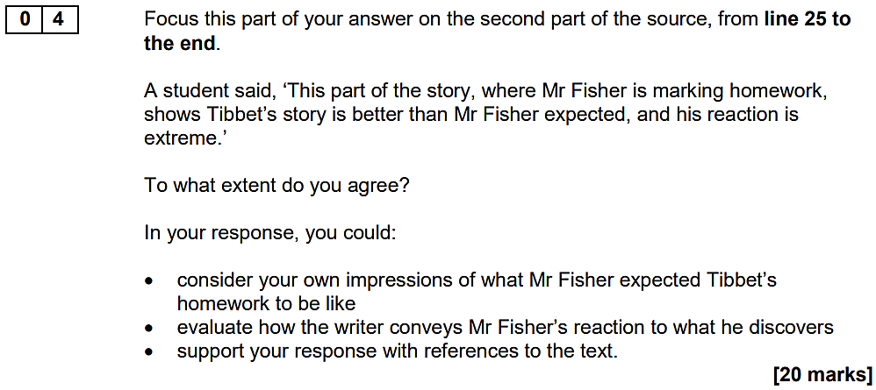

…………………………………………………………………………………………………………………………………………………………………………………………

Think of this as three separate paragraphs
- First: ‘I agree with the student because… and then gather evidence
- Identify and explore a method: ‘The writer uses the word… / phrase… / technique… This has the effect of…’
- Make an inference: ‘We learn from this… / This shows…’
- Make an additional inference: ‘Furthermore… / Additionally… / Also…’
- Make a link with the student’s viewpoint: ‘This support’s the student’s view because…’
- Repeat

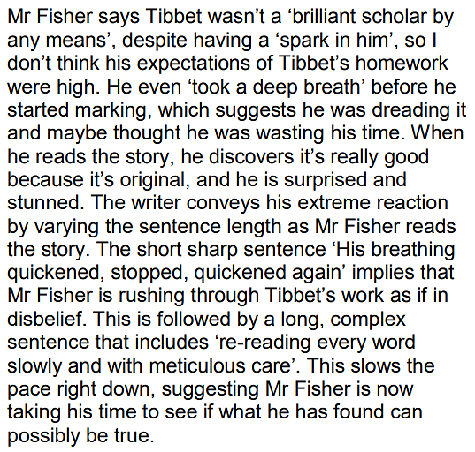
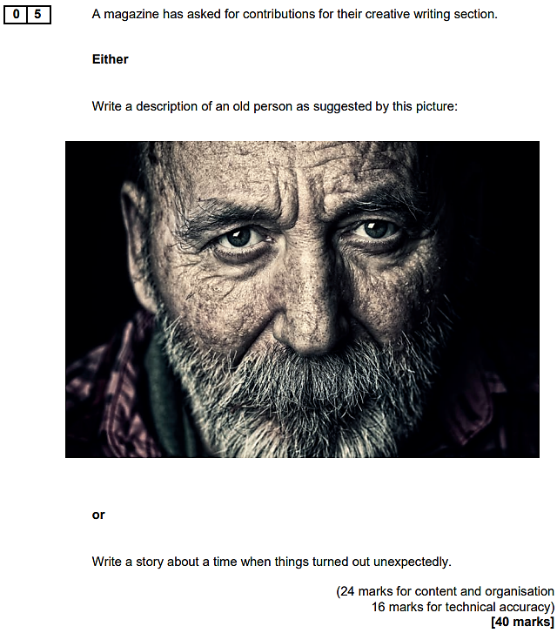

…………………………………………………………………………………………………………………………………………………………………………………………

Think of this as two (and a half) pages of writing
- First: Zoom-in on a ‘small’ bit of the image (e.g. the man’s eyes or his furrowed brow)
- Next: Consider using a ‘flashback’ that will ‘frame’ the story to come
- And then: Return to the image and go from there…

