GCSE English Language
The Final Study Booklet
Mr Wise
E1

P1 | November 2018 | 1
P2 | June 2018 | 8

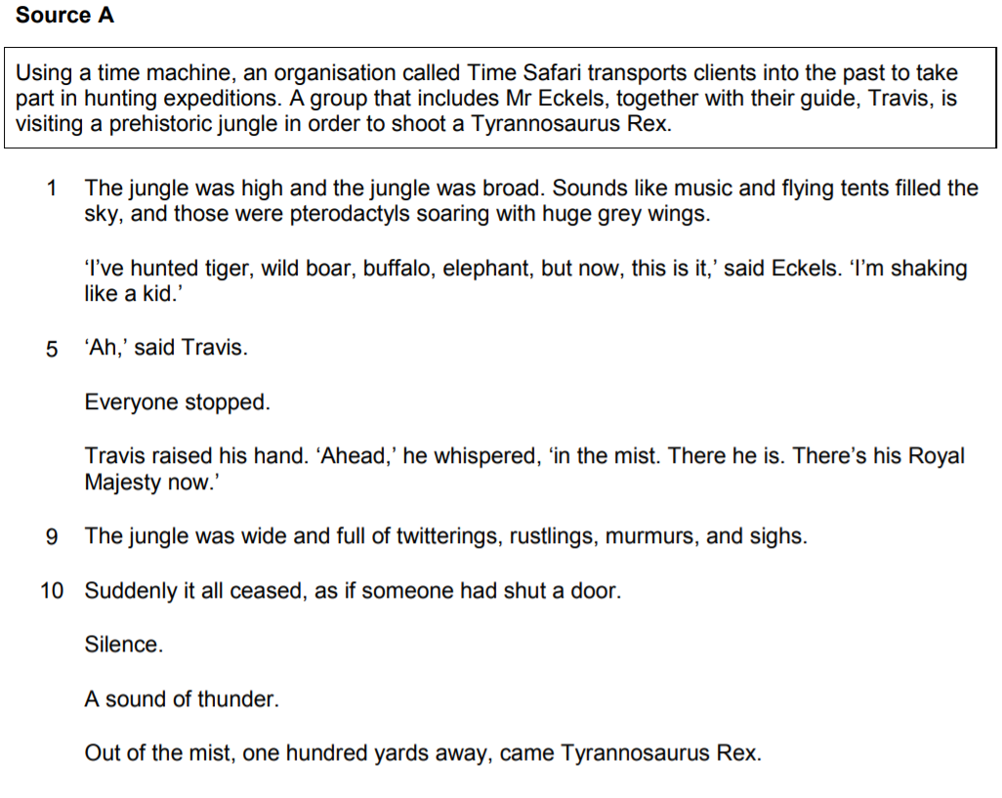
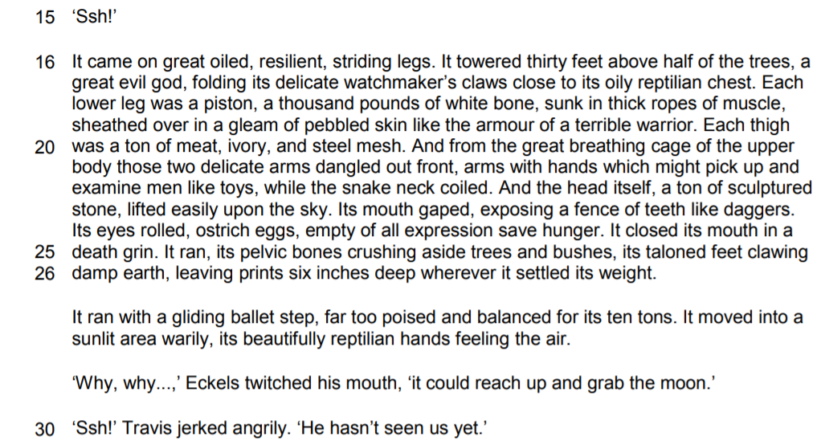

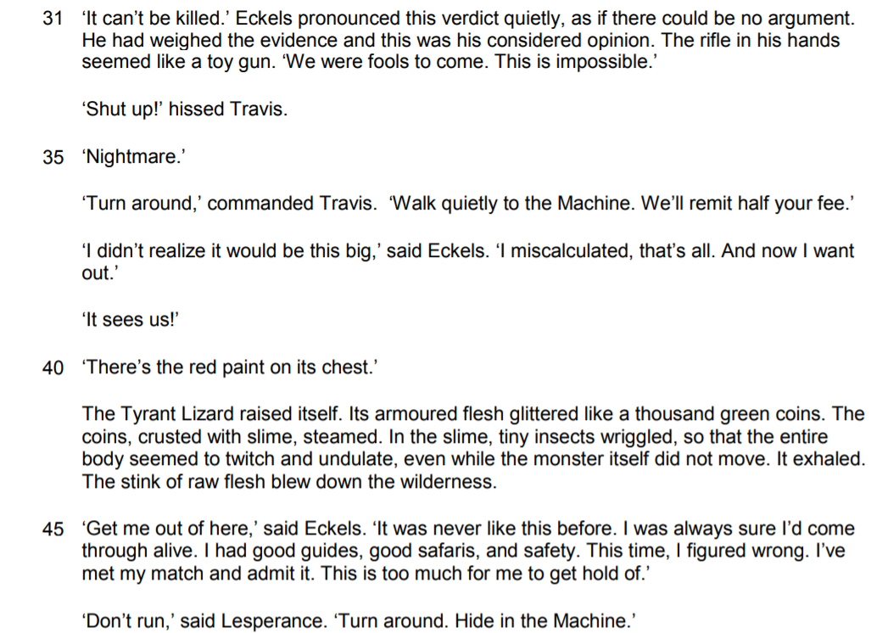
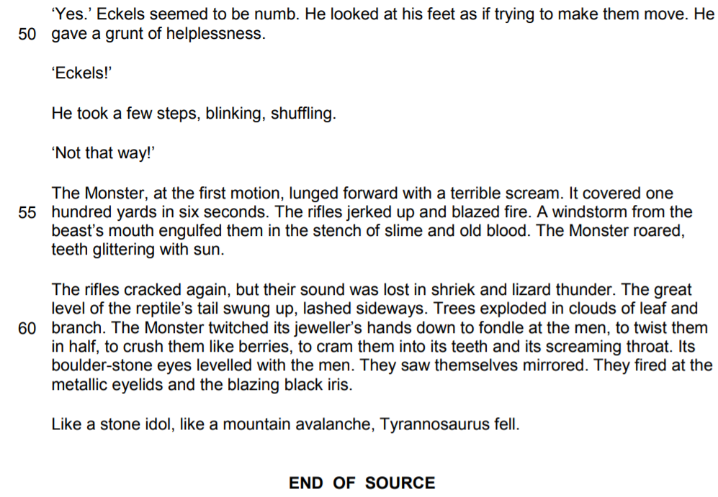
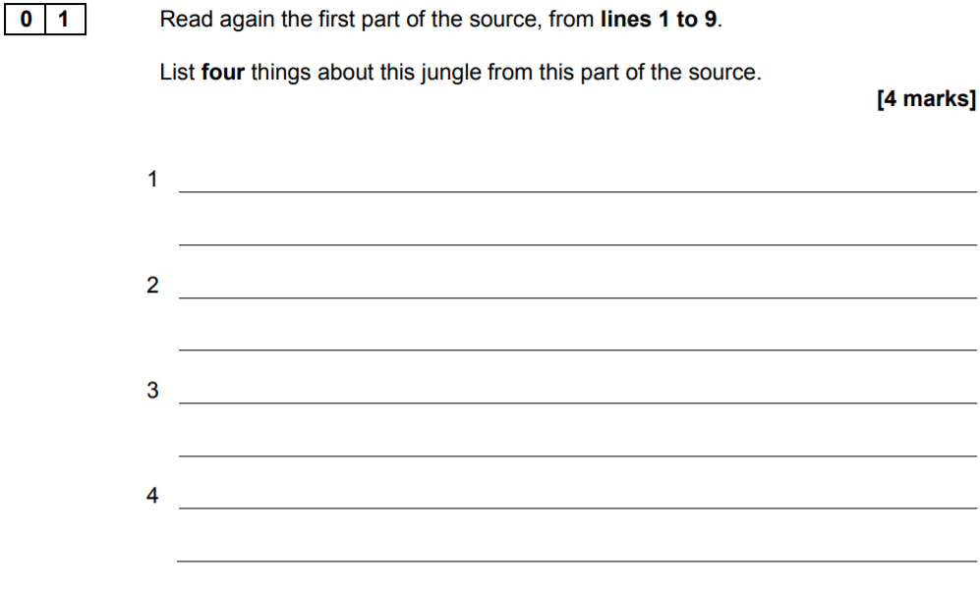

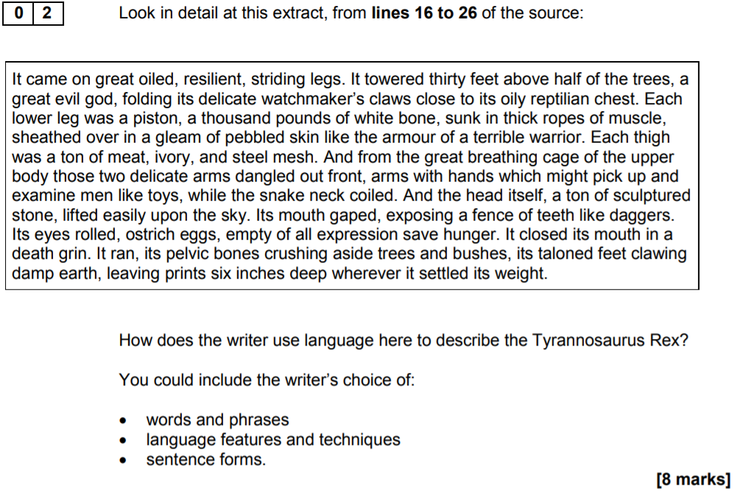

…………………………………………………………………………………………………………………………………………………………………………………………

Think of this as two separate paragraphs
- First: ‘The writer presents… / describes…’ and then gather evidence
- Identify and explore a method: ‘The writer uses the word… / phrase… / technique… This has the effect of…’
- Make an inference: ‘We learn from this… / This shows…’
- Make an additional inference: ‘Furthermore… / Additionally… / Also…’
- Repeat

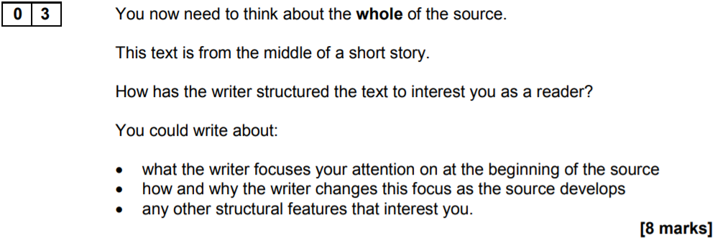

…………………………………………………………………………………………………………………………………………………………………………………………

Think of this as three separate paragraphs (beginning, middle, end)
- First: ‘At the beginning of the source, the focus is on…’
- Make an inference: ‘This has the effect of… / This interests the reader because…’
- Move through the source: ‘As the text progresses, the focus shifts to…’
- Make an inference: ‘This has the effect of… / This interests the reader because…’
- Make an additional inference: ‘Furthermore… / Additionally… / Also…’
- Repeat

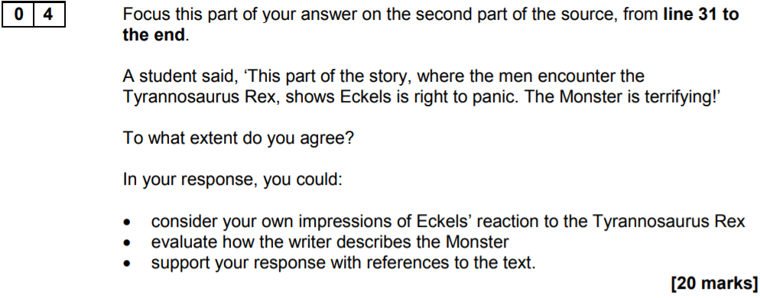

Think of this as three (or four) separate paragraphs
- First: ‘I agree with the student because… and then gather evidence
- Identify and explore a method: ‘The writer uses the word… / phrase… / technique… This has the effect of…’
- Make an inference: ‘We learn from this… / This shows…’
- Make an additional inference: ‘Furthermore… / Additionally… / Also…’
- Make a link with the student’s viewpoint: ‘This support’s the student’s view because…’
- Repeat

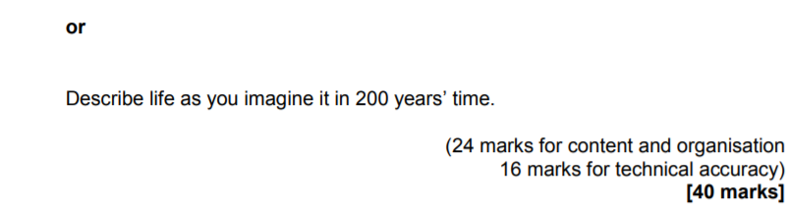
Think of this as two (and a half) pages of writing
- First: Zoom-in on a ‘small’ bit of the image (e.g. one of the people)
- Next: Consider using a ‘flashback’ that will ‘frame’ the story to come
- And then: Return to the image and go from there…

Checklist
- Adverb start: ‘Apprehensively, I turned around…’
- A short sentence: ‘The noise around me suddenly stopped. Heavy silence. I looked above and saw…’
- Brackets: ‘I watched her smile (I knew exactly what she was thinking) and stepped back from the crowd…’
- Same word starter: ‘Whoever did it was in this room… Whoever did it was keeping very quiet…’
- Rhetorical question: What was I supposed to do?
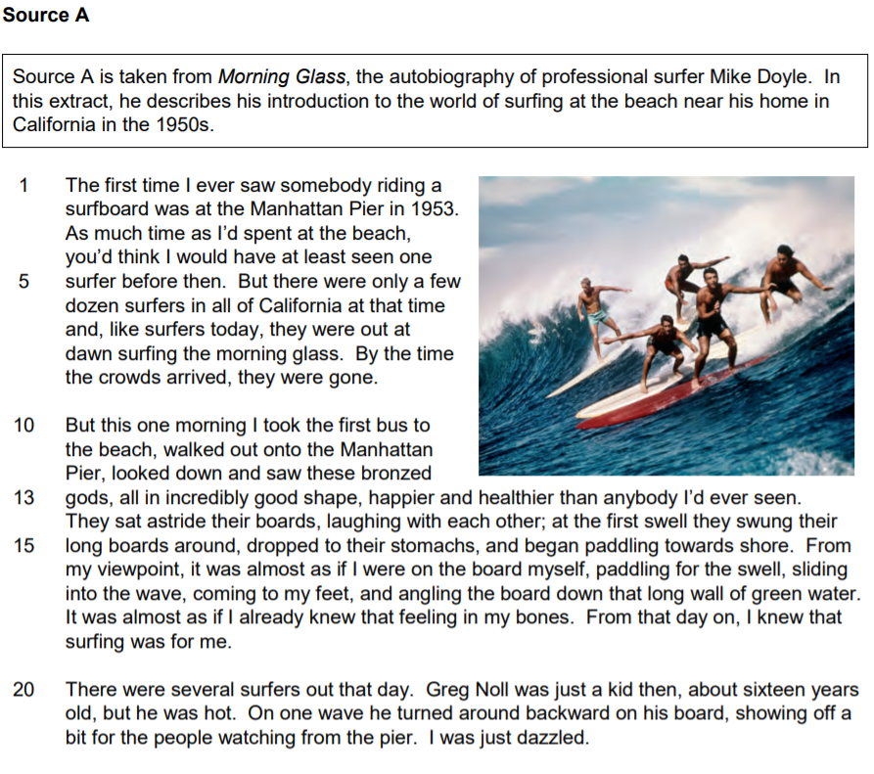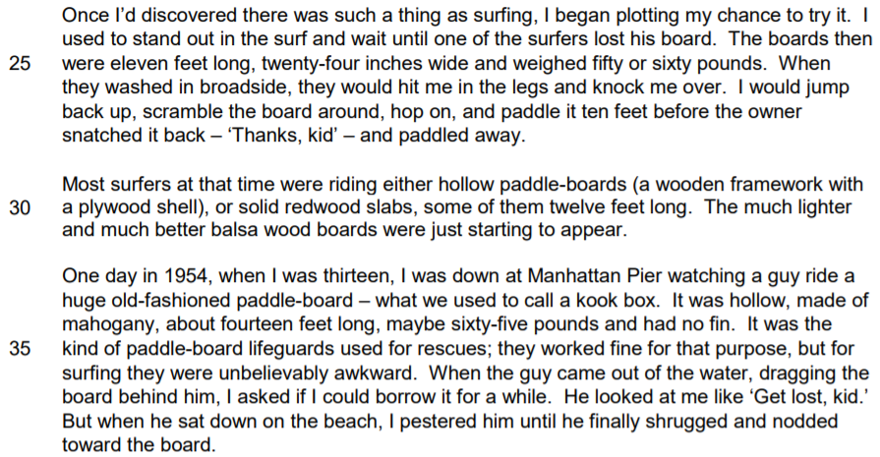

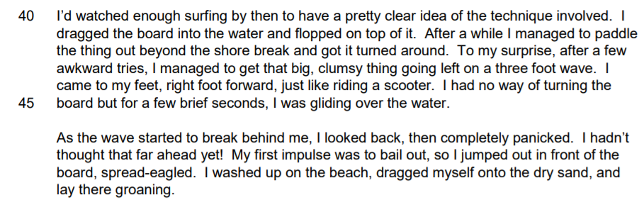

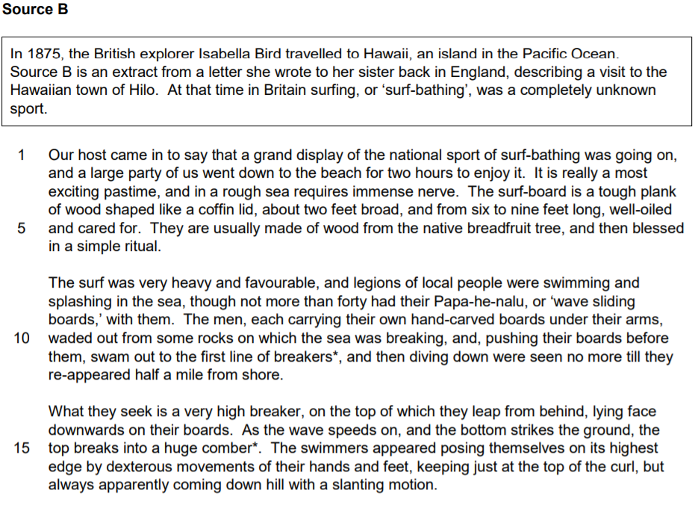
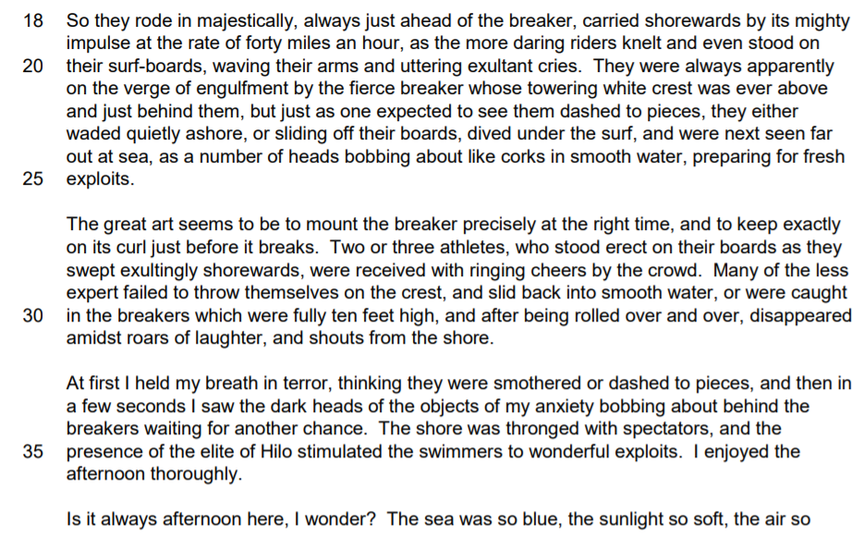
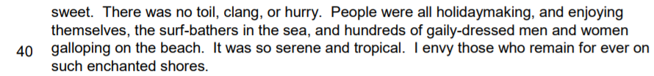
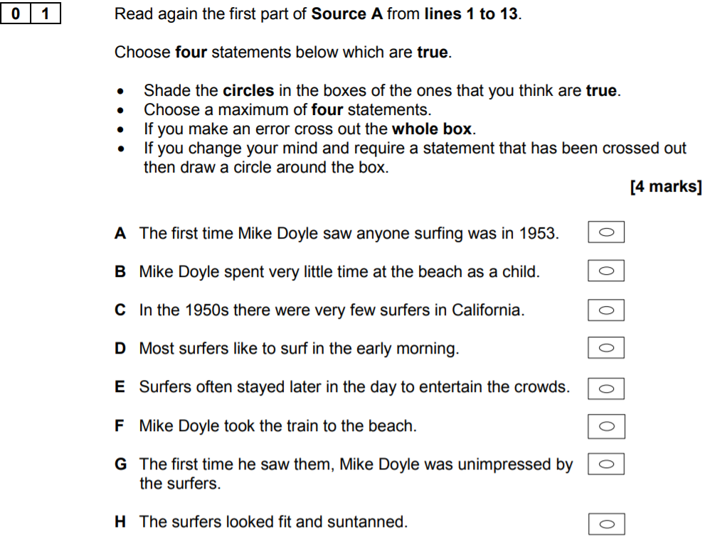

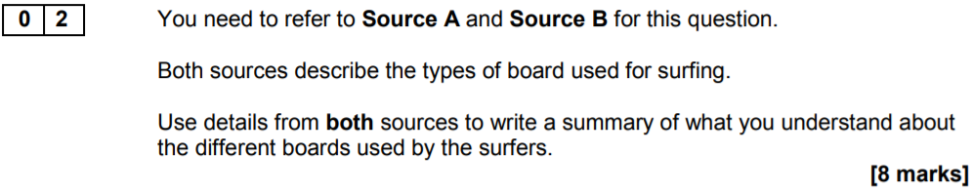

…………………………………………………………………………………………………………………………………………………………………………………………

Think of this as two separate paragraphs
- First: ‘One difference between Source A and Source B is…’ and then gather evidence for Source A
- Make an inference: ‘We learn from this… / This shows…’
- Make a link: ‘In contrast to Source A…’ and then gather evidence from Source B
- Make an inference: ‘We learn from this… / This shows…’
- Repeat

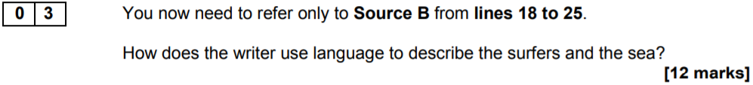

…………………………………………………………………………………………………………………………………………………………………………………………

Think of this as three separate paragraphs
- First: ‘The writer presents… / describes…’ and then gather evidence
- Identify and explore a method: ‘The writer uses the word… / phrase… / technique… This has the effect of…’
- Make an inference: ‘We learn from this… / This shows…’
- Make an additional inference: ‘Furthermore… / Additionally… / Also…’
- Repeat

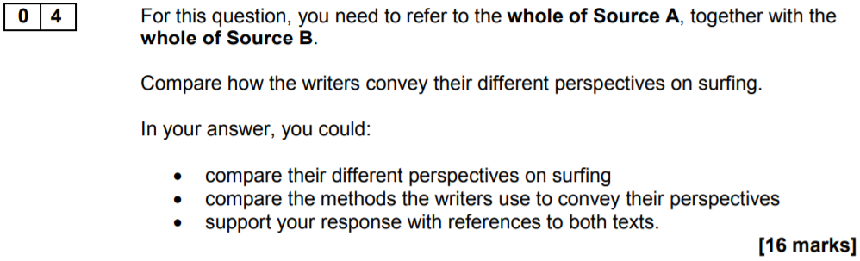

…………………………………………………………………………………………………………………………………………………………………………………………

Think of this as three separate paragraphs
- First: ‘The writer presents… / describes… / conveys… ’ and then gather evidence from Source A
- Identify and explore a method: ‘The writer uses the word… / phrase… / technique… This has the effect of…’
- Make an inference: ‘We learn from this… / This shows…’
- Make an additional inference: ‘Furthermore… / Additionally… / Also…’
- Make a link: ‘In contrast to Source B…’ and then gather evidence from Source B
- Identify and explore a method: ‘The writer uses the word… / phrase… / technique… This has the effect of…’
- Make an inference: ‘We learn from this… / This shows…’
- Make an additional inference: ‘Furthermore… / Additionally… / Also…’
- Repeat

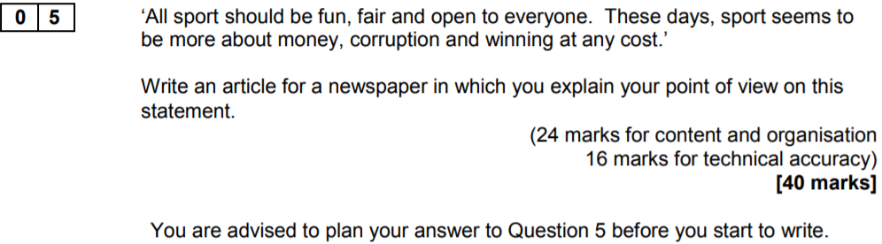

…………………………………………………………………………………………………………………………………………………………………………………………

Think of this as two (and a half) pages of writing
- First: Highlight the purpose of your writing
- Next: Provide some wider contextual details and interesting facts
- And then: Go from there and try to include a counter-argument at some point

Checklist
- Adverb start: ‘Pleasingly, there is a solution to this problem…’
- A short sentence: ‘Those who lazily criticise footballers will usually focus on one issue. Money. However, this is…’
- Brackets: ‘I enjoy watching my local team play (even when it’s freezing cold) and I’ve become a loyal supporter…’
- Same word starter: ‘Sport bring friends and families together each week… Sport is central to community life…’
- Rhetorical question: Who wants to watch players that don’t want to win?

