English Language, Paper 2
Study Booklet
Mr Wise
E1

1 | Specimen Paper 3
8 | Specimen Paper 4
15 | Writing Checklist

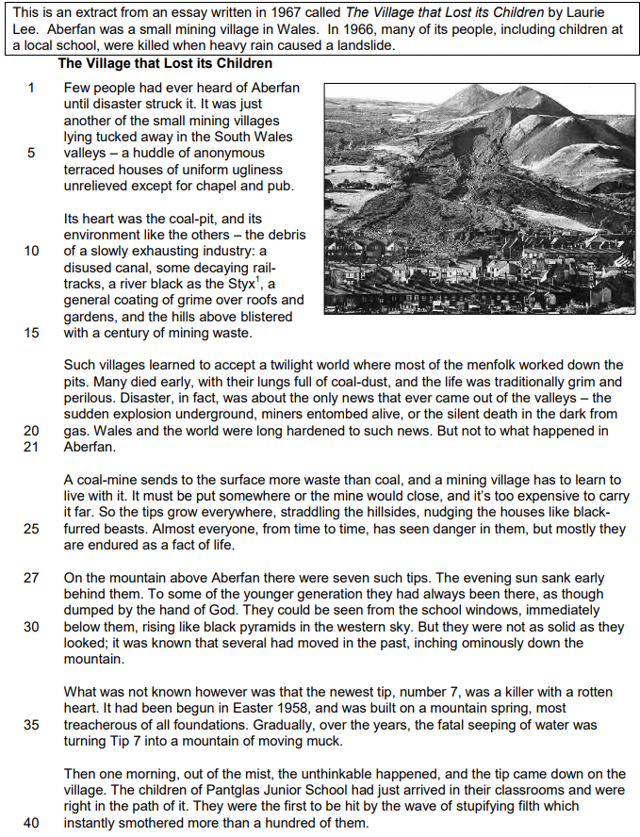

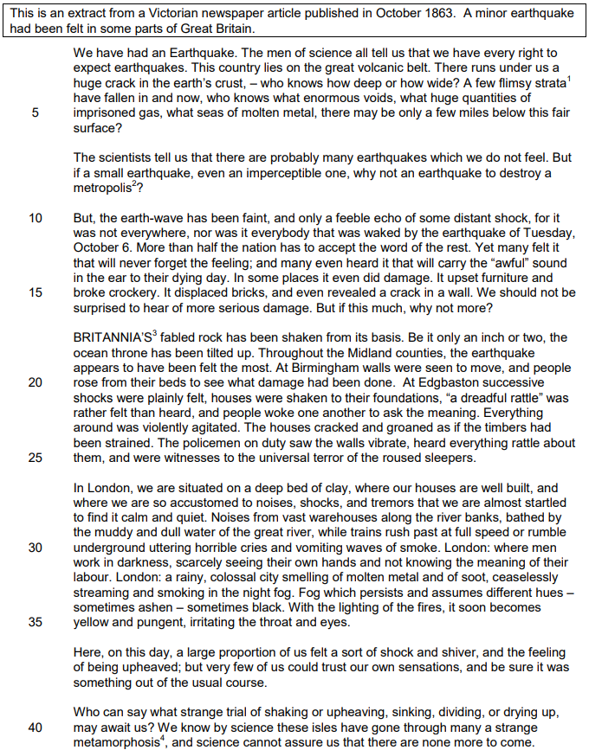

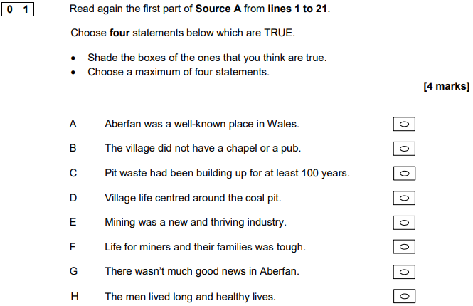

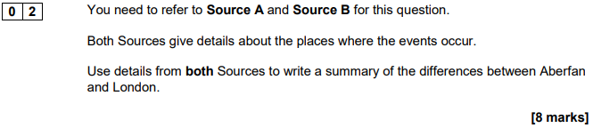

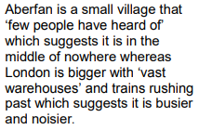
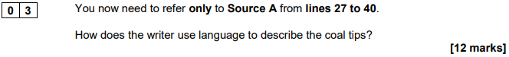

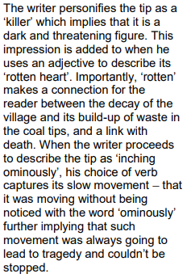
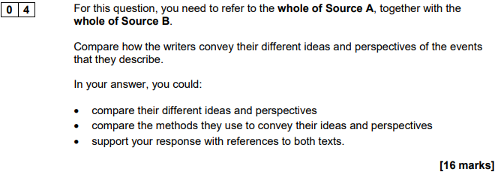

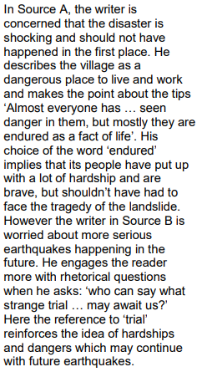
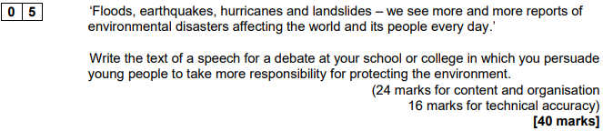

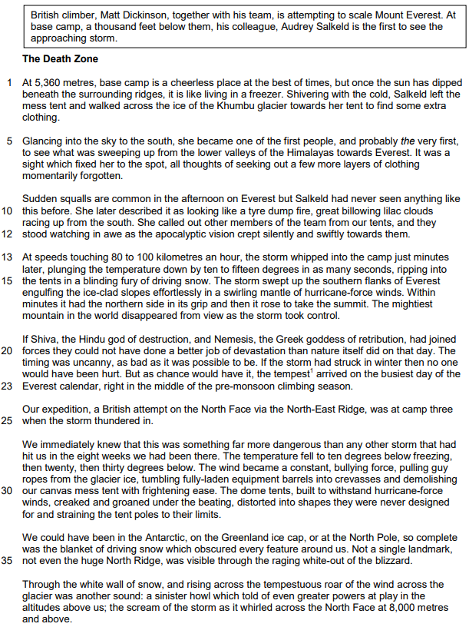
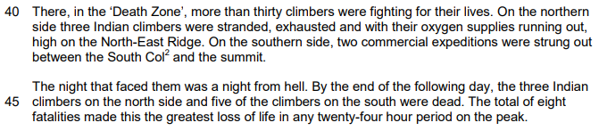
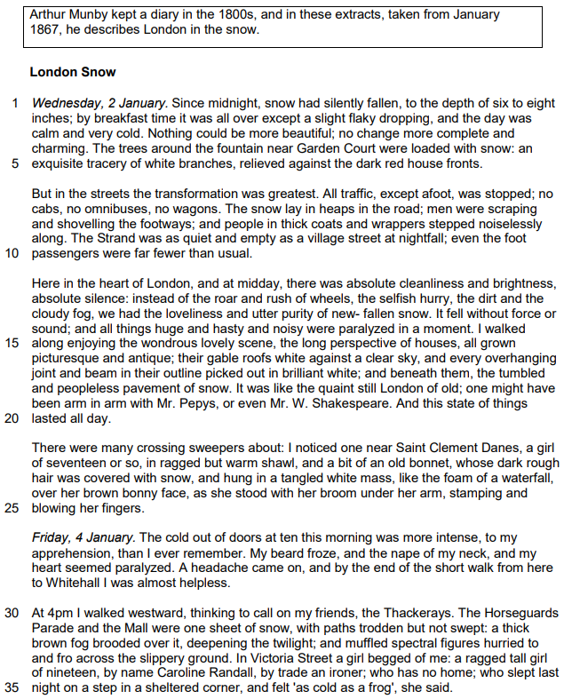

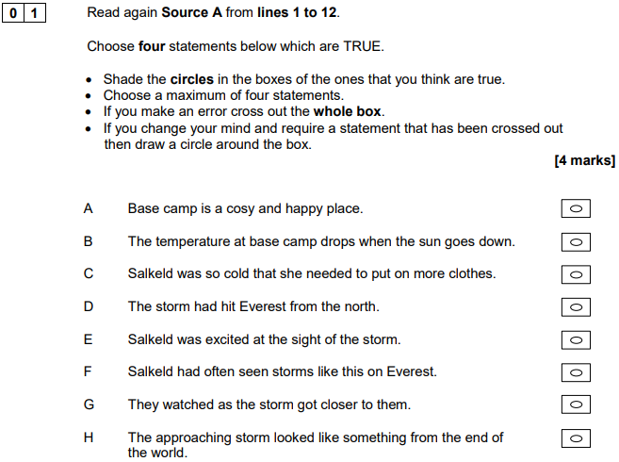

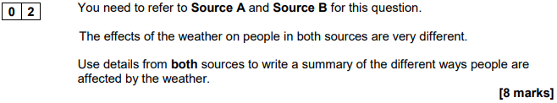

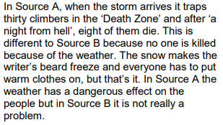
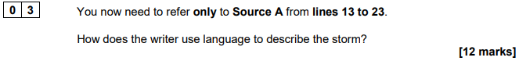

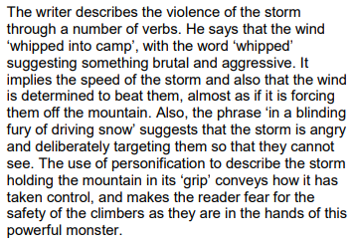
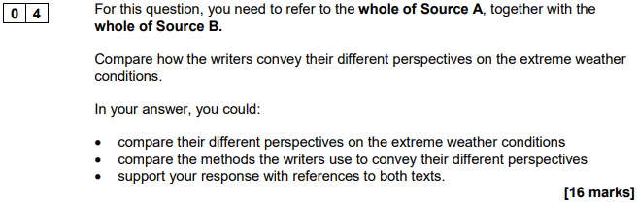

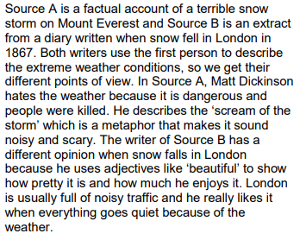
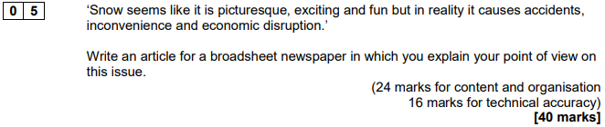

Writing Checklist
Question 1
Read the statements more carefully: it’s surprisingly easy to choose an incorrect statement from the list
Double-check your answers before moving on

Question 2
Highlight at least two differences (e.g. Source A clearly shows…)
Embed short quotations as evidence
Use linking words (e.g. however, contrastingly)
Remember that you need to make an inference about each ‘difference’ (e.g. We learn from this…)
Don’t simply ‘retell’ what happens in each source
Remember that you don’t need to analyse how the writer use language

Question 3
Zoom-in on a specific word, phrase or method for each ‘point’ you make
Embed short quotations as evidence
Fully explain the effect of each word, phrase or method (e.g. This has the effect…)
Try to identify an additional effect for each word, phrase or method (e.g. Another effect of…)
Use linking words (e.g. similarly, furthermore, however, contrastingly)
Aim to make at least three separate points

Question 4
Remember that you need to make an inference about each ‘difference’ (e.g. We learn from this…)
Embed short quotations as evidence
Zoom-in on a specific word, phrase or method that the writer uses to convey their perspective or feeling
Fully explain the effect of each word, phrase or method (e.g. This has the effect of…)
Don’t simply ‘retell’ what happens in each source
Use linking words (e.g. similarly, furthermore, however, contrastingly)
Aim to make at least three separate points

Question 5
Start by highlighting the purpose of your writing
Provide some wider context about the issue, but make sure it’s relevant
Construct a counter-argument (although / despite) and then break it down
Use the same word in three sentences (Now is the time. Now we must act. Now is not…)
Craft the way you start your sentences (e.g. triple-noun-colon) and vary the structure of them
Proof-read your work and make the necessary corrections

