English Language, Paper 1
Study Booklet
Mr Wise
E1

1 | Specimen Paper 2
7 | November 2017
13 | Writing Checklist

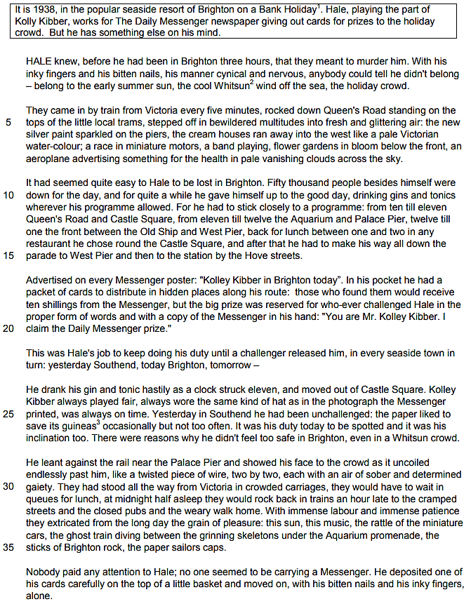

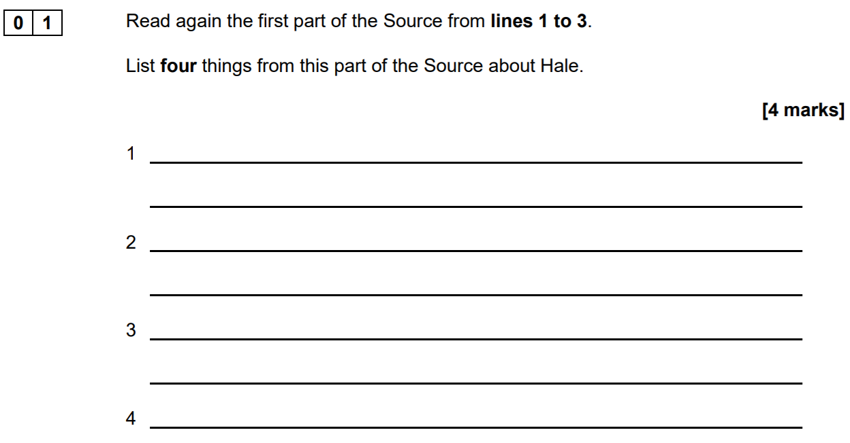

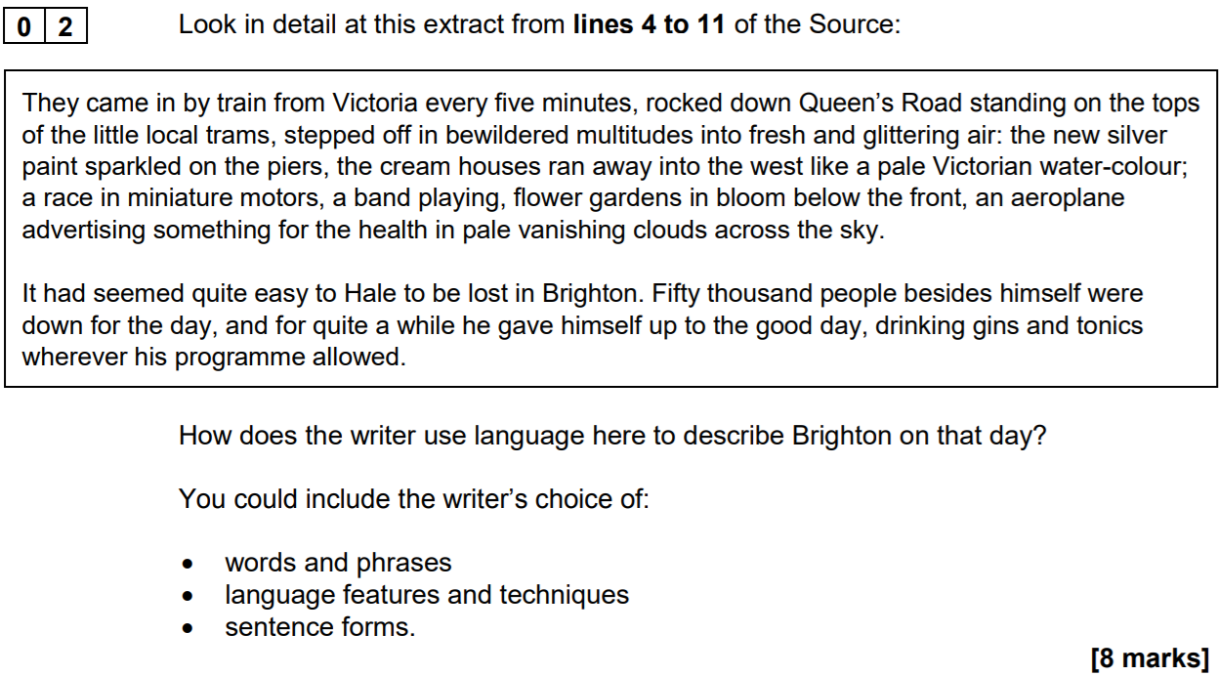

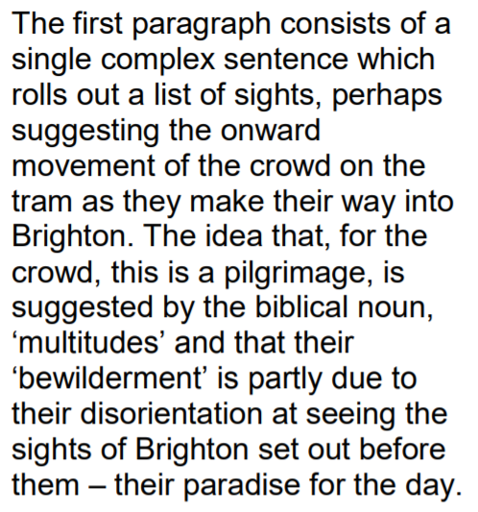
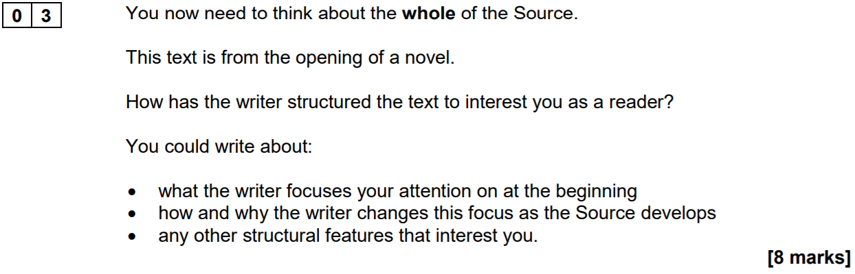

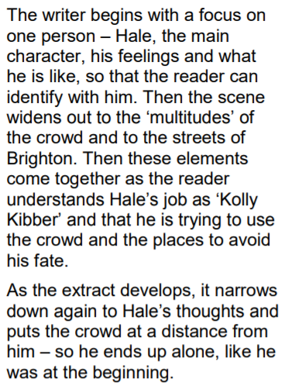
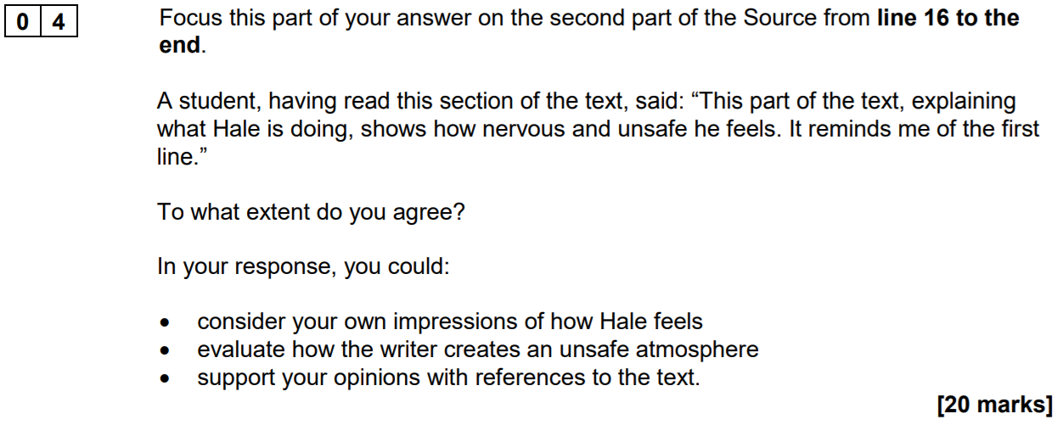

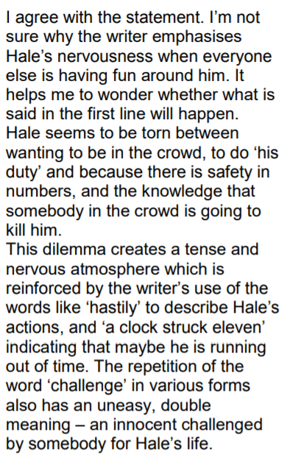
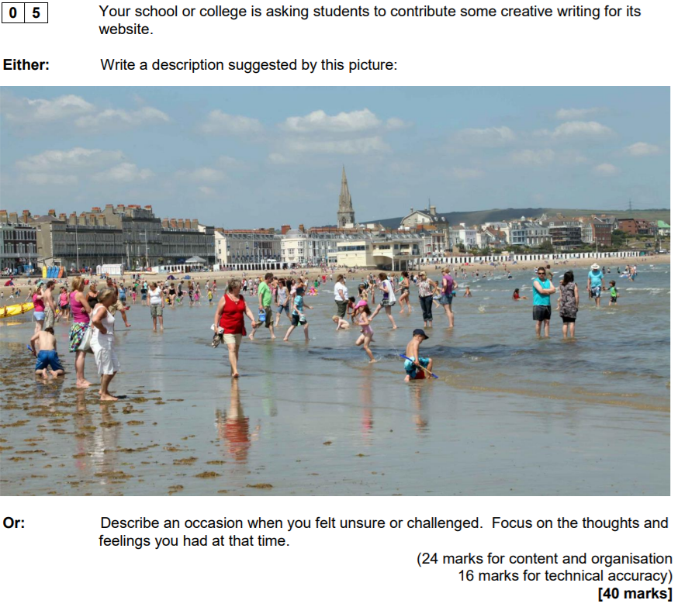

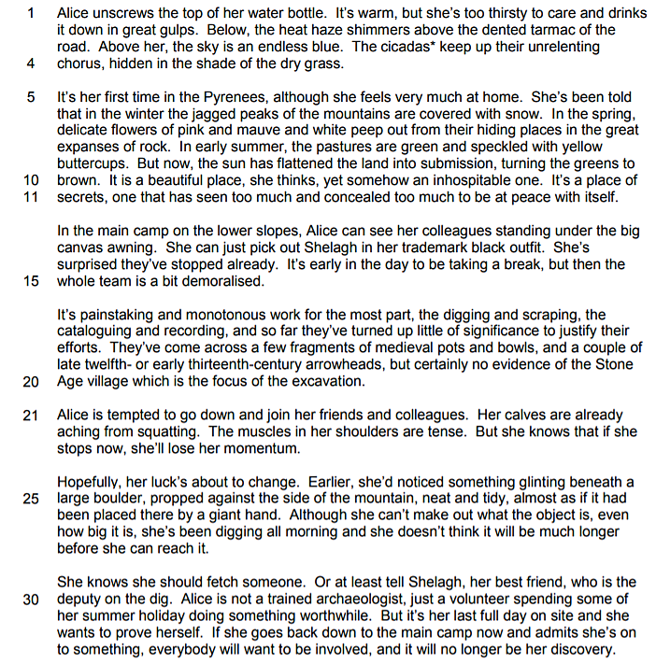
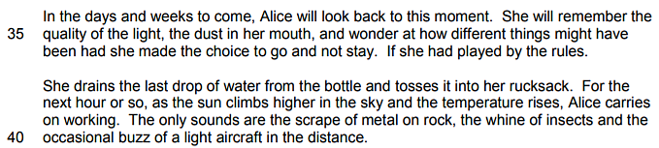

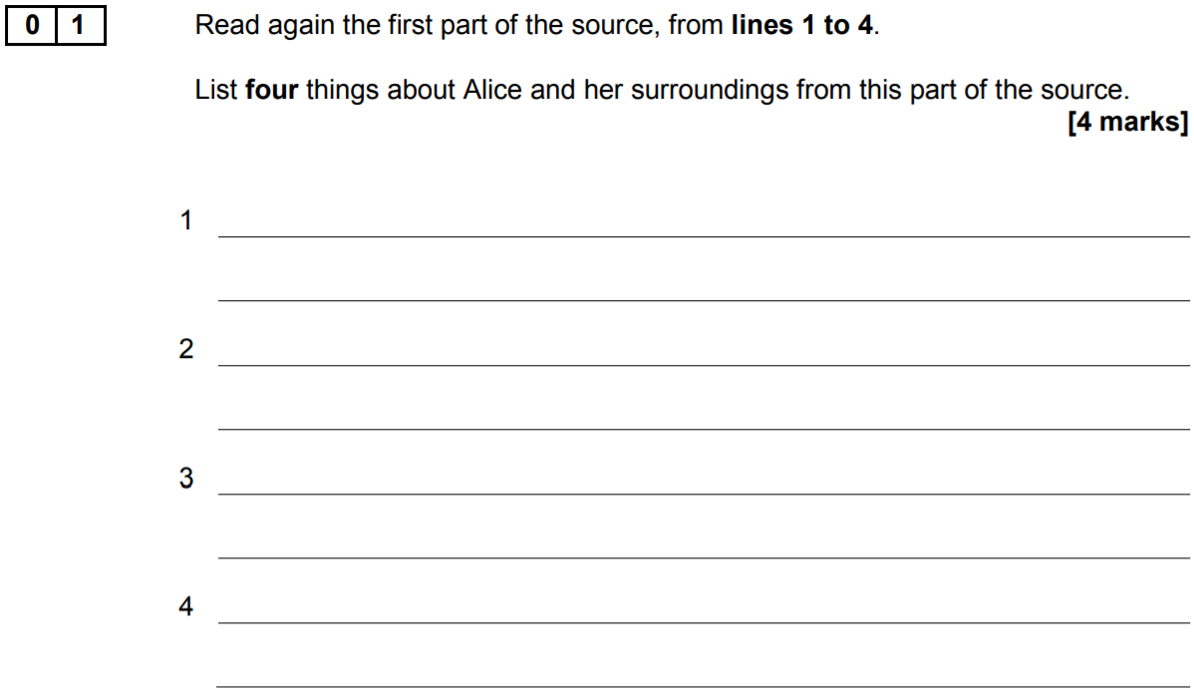

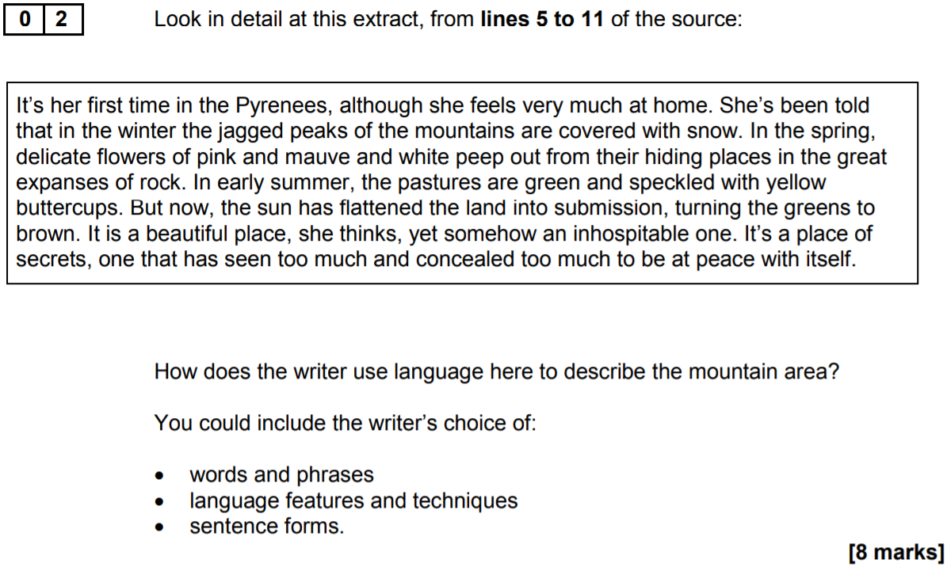

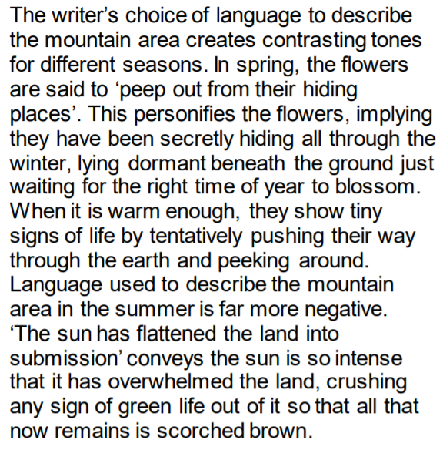
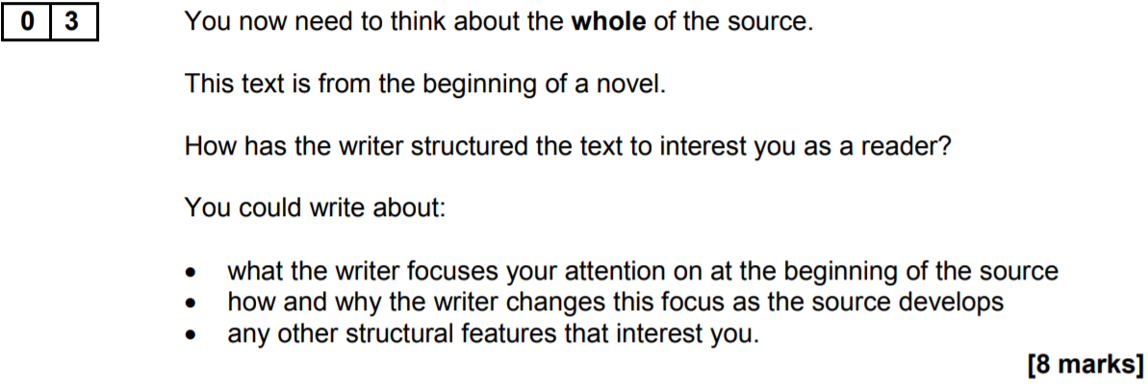

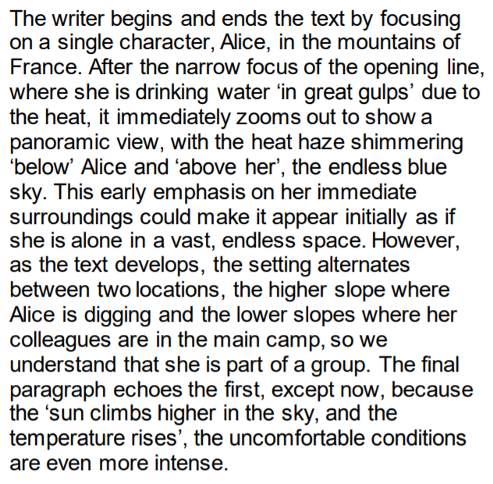
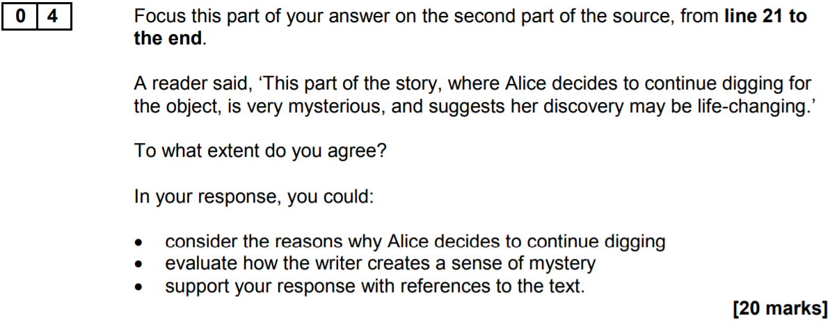

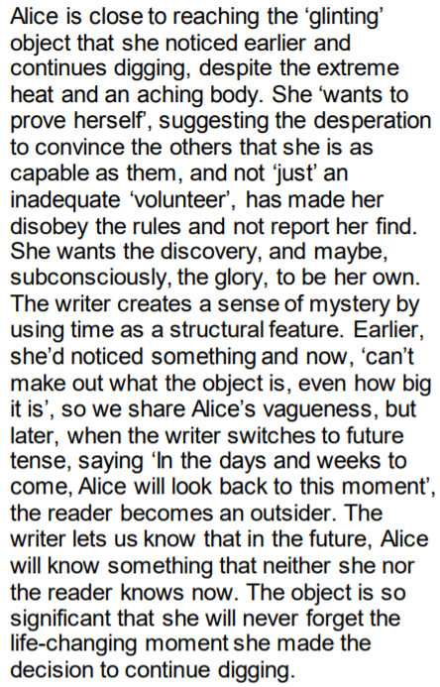
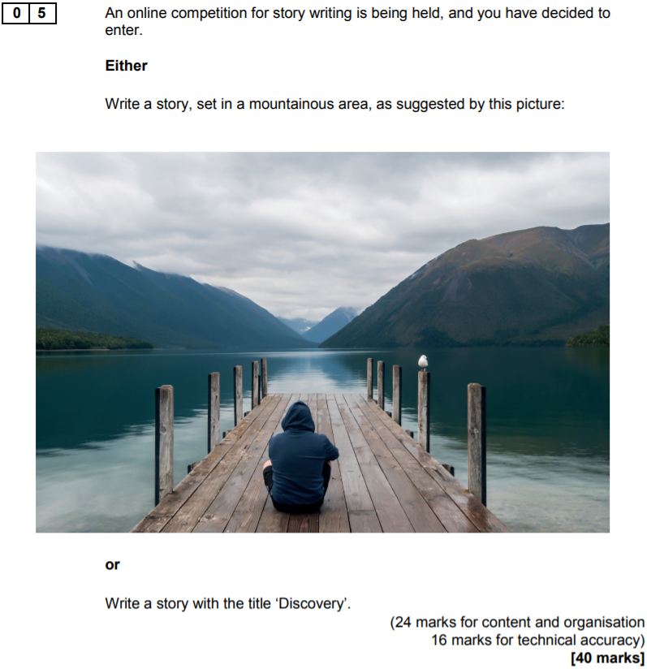

Writing Checklist
Question 1
Avoid writing lengthy answers
Select short, relevant quotations

Question 2
Zoom-in on a specific word, phrase or method for each ‘point’ you make
Embed short quotations as evidence
Fully explain the effect of each word, phrase or method (e.g. This has the effect…)
Try to identify an additional effect for each word, phrase or method (e.g. Another effect of…)
Use linking words (e.g. similarly, furthermore, however, contrastingly)
Aim to make at least two separate points

Question 3
Remember the use the key words: beginning, middle, end; zoom-in/out, focus, perspective; shift, contrast, parallel
Avoid simply retelling the sequence of events and remember not to analyse language
Fully explain the effect of each structural device (e.g. This has the effect…)
Try to identify an additional effect for each structural device (e.g. Another effect of…)
Use linking words (e.g. similarly, furthermore, however, contrastingly)
Aim to make at least three separate points

Question 4
Form a firm view on the statement
Remember not to extend your response beyond the demarcated lines
Explicitly refer to the statement when you make a point to help keep your response focused
Zoom-in on a specific word, phrase or method that the writer uses to convey their perspective or feeling
Fully explain the effect of each word, phrase or method (e.g. This has the effect of…)
Use linking words (e.g. similarly, furthermore, however, contrastingly)
Aim to make at least three separate points

Question 5
Go beyond the picture; use it as a stimulus; don’t be constrained by it
Start with a wide focus and then zoom-in on specific details
Flashback and then jump forward if it fits your narrative to do so
Craft the way you start your sentences (e.g. triple-noun-colon) and vary the structure of them
Proof-read your work; always be meticulous
Try to finish your narrative by refocusing on the image

