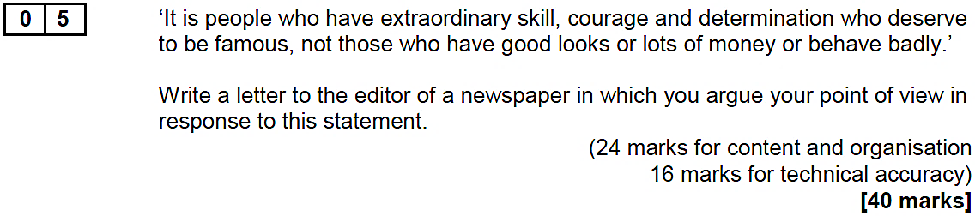

A | Spend more time planning so that you are clear on the focus of each paragraph  e.g. Through a spider-diagram or a list of bullet-points
B | Begin your first paragraph by clearly and firmly stating your viewpoint  e.g. I strongly believe that fame is something that should be earned rather than…
C | End your writing by constructing a brief conclusion  e.g. In conclusion, I hope I have made it clear that…
D | Provide evidence to support your arguments (e.g. personal stories, facts, examples)  e.g. Interestingly, results from a recent survey conducted by the BBC showed that…
E | Make sure the transitions between your paragraphs are clearly signposted  e.g. Another issue to be considered… Some may respond to the point I made by… A further point is…
F | Construct a counter-argument and then expose the flaws in it  e.g. Although it might be the case that celebrities… However, this is not a credible argument because…
G | Vary the type of your sentences to a greater extent  e.g. Include a rhetorical question, use a one-word sentence, construct an appositive sentence
H | Vary the structure of your sentences to a greater extent  e.g. Not only do I disagree, I also… Now’s the time to act, now’s the time… Happily, I found…
I | Choose your words with a bit more care (aim for formality and precision)  e.g. ‘delighted’ rather than ‘happy’, ‘disappointed’ rather than ‘unhappy’, ‘harmful’ rather than ‘bad’…
J | Try to include a slightly wider range of punctuation marks  e.g. Use round brackets to create a ‘whispering’ effect or use a colon to emphasise a point
K | Be meticulous when you proof-read your work at the end  e.g. In particular, look for capitalisation, spelling and apostrophe errors
L | Read through your work at the end and ensure that it all makes sense  e.g. It shouldn’t sound ‘jarring’ or be hard to understand

