**GCSE English Language**

Paper 2 | June 2019

**Source A**

**Source B**

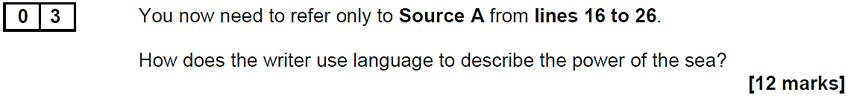

**GCSE English Language**

Paper 2 | June 2020

**Source A**

**Source B**



