Study Booklet

Cosmic

Pages 3-9

Big Question

‘I’m not exactly in the Lake District’ – What do we learn about Liam Digby (and why isn’t he in the Lake District)?

Vocabulary

Novel | Prologue | Tone
Narrative | Character | Structure
Genre | Fiction | Setting

Statements

- Liam Digby is different from other children his age because…

- At school, his teachers seem to believe that…

- Liam is not in the Lake District because…

- Liam believes he might be ‘completely doomed’ because…

- Liam is unable to use his phone to make a call because…

Quotations

- ‘To be fair, everyone lies about their age’ (4)

- ‘Talking makes me feel less lonely’ (5)

- ‘Even if you’re Completely Doomed, you’ve got to be impressed’ (8)

Key Image
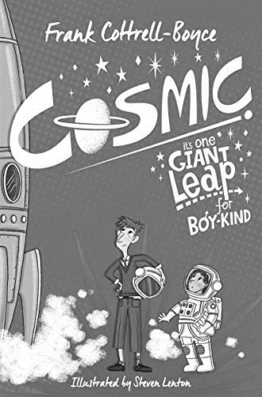
Writing Assessment
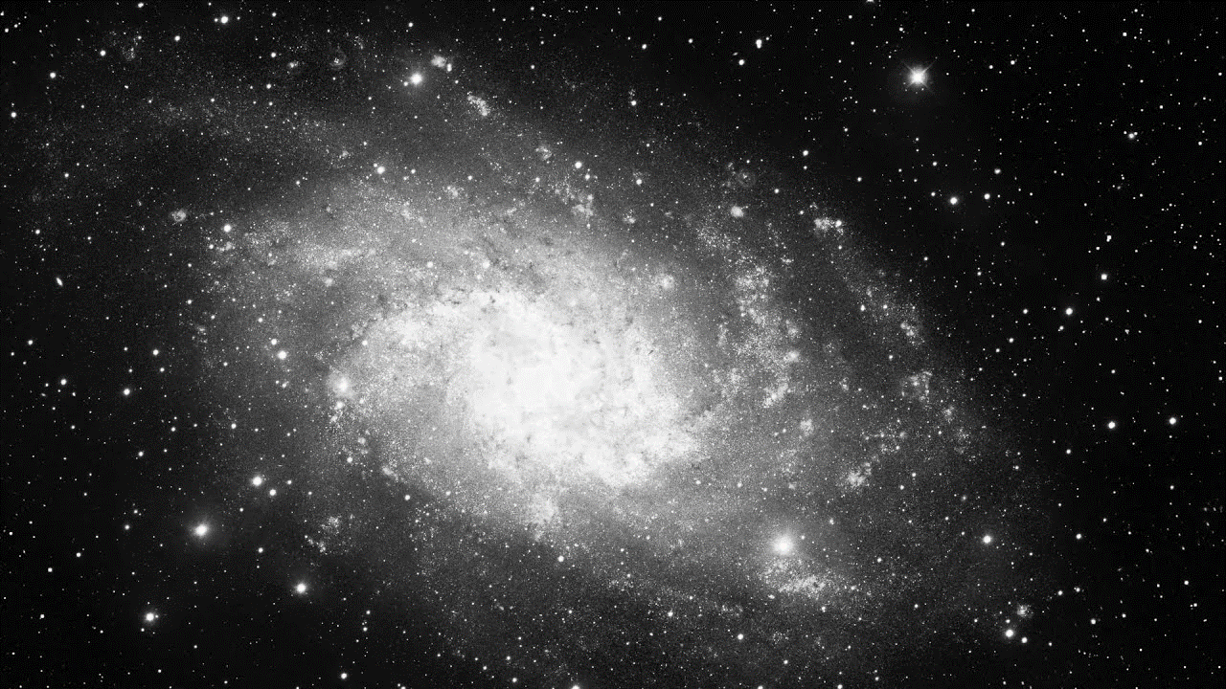

Imagine you are in an amazing place. It could be in space or it could be in your favourite place on Earth.

Write a letter home to explain and describe where you are…

Plan

Pages 10-20

Recap

What do we know about Liam so far? List at least five things.

Big Question

‘He thought I was a grown-up!’ – What more do we learn about Liam from his actions at the theme park?

Vocabulary

Sensitive | Adventurous | Curious
Excitable | Optimistic | Kind

Retrieval

- Liam and the rest of the students discover that the Cosmic has a height requirement

- Liam discovers that he meets the height requirement

- Liam’s dad agrees to ride the Cosmic with him

- Liam’s dad and Wayne Ogunsiji engage in a deep conversation about Liverpool’s defence

- Liam is mistakenly directed to the main exit as is separated from his friends

- Liam returns to the Cosmic

- Liam rides the Cosmic again

- Liam is eventually reunited with his father

Quotations

- ‘When we got off I was tingling all over and everything around me looked sort of more in focus than usual’ (14)

- ‘And the rest of me thought, I’ve got to do that again’ (15)

- ‘He thought I was a grown-up!’ (15)

- ‘So I did have two options, but somehow, in my head, they dwindled down to one’ (16)

- ‘I said, ‘I’m sorry’’ (19)

Key Image

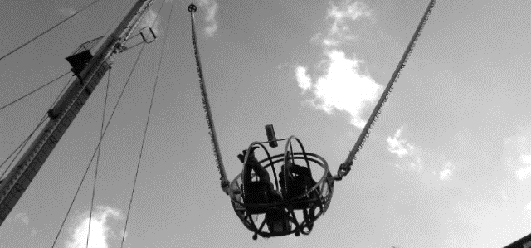
Pages 21-34

Recap

- How old is Liam?

- What school does he go to?

- What is the name of the technology company that makes phones and software?

- What is the name of the theme park that Liam visits?

- What does Liam’s dad do for a job?

Big Question

‘Wolverine!’ – How does Cottrell-Boyce use language to create a vivid impression of Liam’s appearance and experiences?

Vocabulary

Verb | Metaphor | Simile
Exaggeration | Humour | Adjective

Quotations

- ‘I slashed at the brown candyfloss with Dad’s razor’ (21)

- ‘Sheets of blood fell out of my face’ (21)

- ‘Twelve hundred hands shot up and waggled in the air like a salute’ (30)

- ‘Then she looked at me and she hissed, ‘Who are you?’’ (33)

- ‘There were about ten million meetings and letters home about my ‘peculiar and disruptive behaviour’ (34)

Reading Assessment

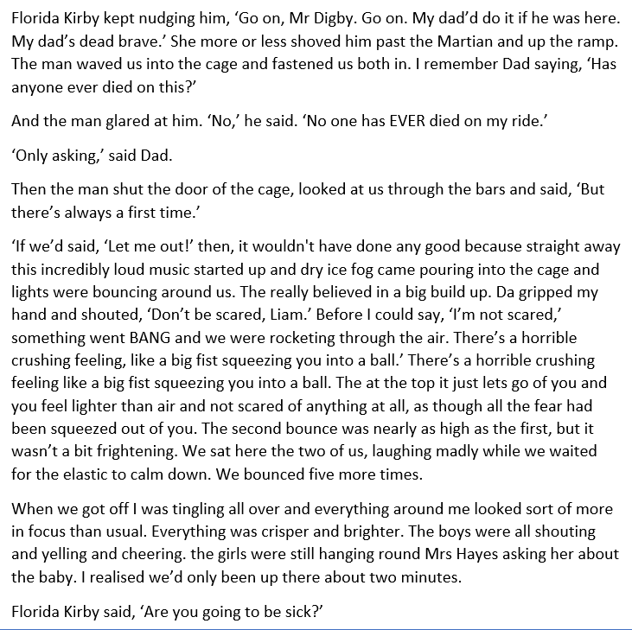

- What four things do we learn about the Cosmic ride from this extract?

A

B

C

D

- How does Frank Cottrell-Boyce use language to make the Cosmic ride feel exciting? Write about:

- The language he uses

- How the language he uses affects the reader

Pages 34-48

Recap

- What is the name of Liam’s new school?

- What is the name of the Headteacher?

- Who is Liam mistaken for?

- Finish the line: ‘DraxWorld gives you directions to anywhere, so it’s __________’ (27)

- Finish the line: ‘Sometimes, it’s better not to __________’ (33)

Big Question

‘Florida always has to be a celebrity’ – How do we know that Florida Kirby is not just a superficial character?

Vocabulary

Assertive | Confident | Intelligent
Rebellious | Excitable | Playful

Previous Chapters

- Florida strongly encourages Liam’s dad to go on the Cosmic with Liam (12)

- Florida teasingly asks Liam if he’s going to be sick after he’s ridden on the Cosmic (14)

- Liam recognises Florida in the assembly hall at his new school (29)

Quotations

- ‘When Lisa made us do a role play in which we had to act like we’d seen a ghost, Florida saw the ghost of Britney Spears’ (36)

- ‘She even tried to get me to buy her cigarettes’ (37)

- ‘How much did Florida love that when I told her’ (38)

- ‘Florida asked for more sandwiches’ (40)

- ‘That’s when Florida said, ‘Can we sit in it then?’’ (43)

- ‘We both got in. She whispered, ‘You should’ve told me to say please’’ (43)

Pages 49-65

Recap

- Which online game does Liam play?

- What is the name of the drama group that Liam and Florida are part of?

- What type of car did Liam nearly take for a test drive?

- Finish the line: ‘The thing about Level Two of course is that __________’ (45)

Big Question

‘But it’s good on here because people just accept you for what you are’ – Why is online gaming so important to Liam?

Vocabulary

Entertainment | Competition | Challenge
Escapism | Friendship | Identity

Retrieval

- Liam’s dad announces that he wants to play Monopoly

- Liam says he doesn’t want to play

- Liam’s logs into the World of Warcraft server

- Liam’s dad finally shows an interest in World of Warcraft

- Liam attempts to explain what it is to his father

Key Image

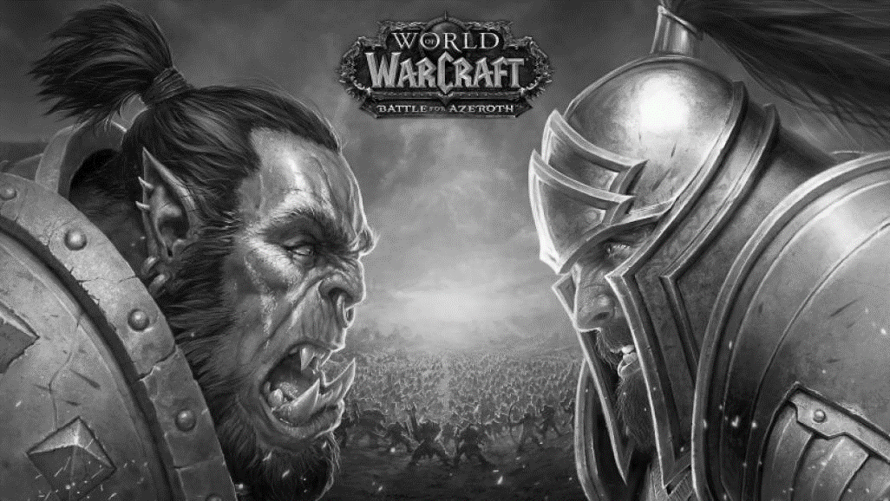
Pages 66-82

Recap

Write down five things you know about Liam and five things you know about his father.

Big Question

‘I was being put through!’ – What do we learn about the other children and how is Liam different to them?

Vocabulary

Ambitious | Intelligent | Focused
Wealthy | Compliant | Disciplined

Children

- Anna from Hamburg (Germany)

- Samson Two from Sierra Leone (West Africa)

- Max Martinet from Lille (France)

- Hassan Xanadu from Bosnia (Southern Europe)

Statements

- The other children who have been selected are similar because…

- In contrast, Liam is…

- However, Liam might have been selected because…

Pages 82-94

Recap

- What is the name of Liam’s maths teacher?

- Who was announced as the second winner of the competition?

- In which continent is Sierra Leone?

- Who was announced as the third winner of the competition?

- What is the name of Liam’s media studies teacher?

- What is the first name of Dr Drax?

- Is Dr Drax male or female?

- Finish the line: ‘If Liverpool city centre was Level Two, a secret location in __________’ (78)

- Finish the line: ‘I felt I’d mastered __________’ (82)

Big Question

‘I’ve been getting dad skills’ – What signs are we given that Florida is actually more responsible than Liam?

Vocabulary

Responsible | Mature | Superficial

Evidence

- Liam plays the role of a ‘famous film director dad’ (85)

- Florida makes things awkward for Liam during the role play (85-8)

- Lisa says the role play is ‘very real and also very moving’ (88)

- Florida says that she has to pick-up her younger brother (90)

- Florida says that Liam doesn’t ‘ACT like a dad’ (91)

- Florida says that dads ‘don’t steal fast cars’ (91)

- Liam argues that he’s been studying what listen to and what they typically say (91)

Pages 95-102

Recap

How does Liam trick his parents into allowing him to go away and what does this reveal about him?

Big Question

‘Let’s go’ – How have Liam and Florida ended-up on an adventure to Infinity Park?

Vocabulary

Narrative | Complication | Opportunity

Main Events

- Liam rides on the cosmic with his dad (13)

- Liam is mistaken for a teacher at his new school (27)

- Liam is sent to the Little Stars drama group (35)

- Liam and Florida almost test drive a Porsche (40)

- Liam receives a call from Drax Communications about his pattern of use (56)

- Liam receives a text message from Drax Communications announcing that he has been selected for a competition (58)

- Liam calls Drax Communications and is put on hold (66)

- Liam is announced as the third winner (76)

- Liam persuades Florida to pretend she’s his daughter (93)

- Liam and Florida are picked-up by a limo (97)

Key Image

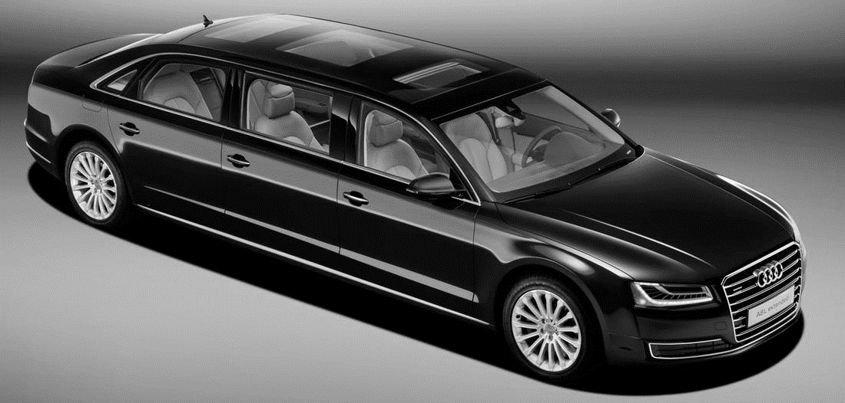
Pages 102-114

Recap

- What type of limo collects Liam and Florida?

- What is the name of chauffer?

- Finish the line: ‘If ‘limo’ had a magical effect on Florida, you should __________’ (98)

- What is the name of the ‘girly Game Boy’ made by Draxcom?

- What type of jet are Liam and Florida due to fly in?

Big Question

‘I’m Florida’s father’ – How does Liam cope with being in ‘Florida’s father’ on the plane?

Vocabulary

Competitive | Ambitious | Boastful
Arrogant | Successful | Confident

Interview

- How do you feel about the other dads? (I think the other dads are…)

- How do you feel about the other children? (I think the other children are…)

- How do you feel about Florida panicking? (I think Florida is…)

- What are you expecting to happen in the next few days? (I’m expecting to…)

Key Image

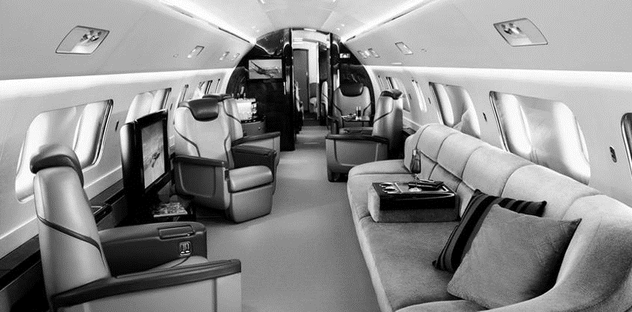
Pages 115-133

Recap

Which adjectives accurately describe Florida? Superficial | vain | intelligent | talented | irritable | brave | loyal | adventurous

Big Question

‘If my dad could see it now, he’d be really worried’ – What experiences does Liam have and should his father be worried?

Vocabulary

Technology | Future | Experiment
Space | Planet | Generations

Inferences

- ‘When I was being a grown-up in Liverpool, I got free yoghurt. In China, I got my own house!’ (116)

- ‘I threw her a bottle just to make it fair and we had this excellent water fight all over the house’ (120)

- ‘I pointed the phone at it and the headlights blinked and all the doors popped open’ (123)

- ‘It was really big. And red. Like a huge unopened present’ (126)

- ‘I AM NOT GOING TO SPACE’ (133)

Key Image

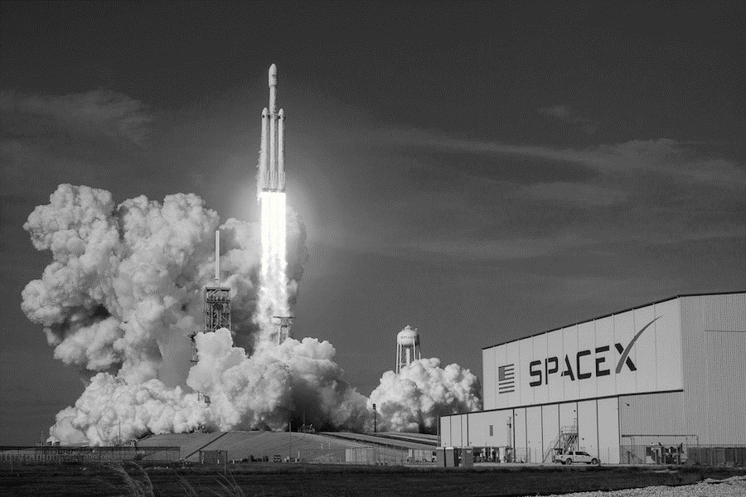
Pages 134-146

Recap

- ‘I called the rocket a present, but it’s more a kind of apology’ (130) – who said it?

- ‘Does that mean we’re going to be famous’ – (131) – who said it?

- ‘Could we call it Ballistic Blue’ (131) – who said it?

- ‘Very nice’ (132) – who said it?

- ‘Completely safe. Almost’ (132) – who said it?

- ‘But we can see around the rocket too, can’t we?’ (133) – who said it?

Big Question

‘After the paperwork, it got worse’ – What struggles does Liam encounter and how does he overcome them?

Vocabulary

Competitive | Dismissive | Arrogant
Impolite | Irritable | Condescending

Struggles

- Vaccinations (135)

- Playing golf (136)

- Monsieur Martinet’s dismissal of computer games (138)

- The rules of golf (140)

- Space training (143)

Pages 147-170

Recap

Which statements are true?

- The Gobi Desert is in West Africa

- The word ‘gobi’ is derived from the Mongolian word for ‘waterless place’

- Snow falls in the Gobi Desert in winter

- There are no sand dunes in the Gobi Desert

- The Gobi Desert is home to a diverse range of animals including gazelles and lizards

Big Question

‘If my dad could see it now, he’d be really worried’ – What experiences does Liam have and should his father be worried?

Vocabulary

Image | Metaphor | Simile

Extract

My first day of taikonaut training, we had to be at the launch site before dawn. I was really excited. Florida was really sleepy. It was so dark we couldn’t tell who else was there. There was just a bunch of yawning, stretching shadows. Even the Possibility Building didn’t look that solid, until the Sun rolled up and peeled a strip of shadow off its back, as though is was a huge red banana. And then it tore up all the other shadows like tissue paper and there was everyone unwrapped on the tarmac like surprises.

Statements

- The darkness of the early morning is vividly shown by…

- The power of the Sun is initially conveyed by…

- It is then emphasised by…

- Liam’s excitement is conveyed by…

Key Image

Pages 171-186

Recap

- What object does Dr Drax ask the group to find? (148)

- What is the item that looks like a ‘massive firework’? (149)

- Which character wanted to get his ‘protective clothing’? (150)

- Which character shouts, ‘Can’t we just go NOW?!’? (150)

- Which character shouts, ‘And why is it so SANDY?!’? (152)

- Who is the only character to have sunglasses? (153)

- Which character wants the sunglasses? (154)

- Which character says his child is a ‘natural leader’? (155)

- How high is the sand dune? (156)

- How does the dune remind Liam of? (157)

- Finish the line: ‘Gobi Desert sand is even softer than _________’ (158)

- Do the group go up the dune or around it? (159)

- Finish the line: ‘Bombs of sand exploded around us as we _________’ (160)

- Finish the line: ‘Unfortunately, the other thing we couldn’t see was _________’ (161)

- In which direction does the sun rise? (163)

- What type of sweets does Florida have ‘a surprising amount of’? (165)

- Which character has a Thermos flask? (166)

- Which character growls, ‘We ALL want some’? (167)

- Which character secures all the votes? (169)

- Why doesn’t Florida vote for Liam? (170)

Big Question

‘Florida smiled’ – Why does Florida get upset and how does Liam make her feel better?

Vocabulary

Spacesuit | Knowledge | Vote

Key Images

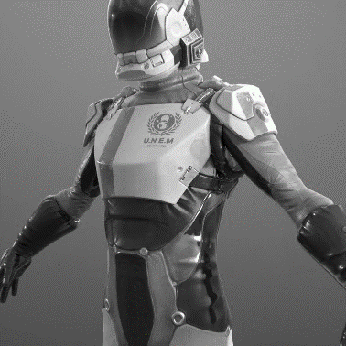
Pages 187-200

Recap

Which statements are true?

- Liam did not get drunk

- Florida has blonde hair

- Samson One currently has the most points

- Liam currently has one point

- Florida voted for Liam

Big Question

‘Sick bags are under the seats’ – Who do each of the group react to the flight and what does this reveal about them?

Vocabulary

Anxious | Scared | Terrified
Nauseous | Excited | Pragmatic
Elated | Ecstatic | Brave

References

- Max: 191

- Hasan: 191

- Monsieur Martinet: 192-4

- Liam: 193

- Florida: 195

Key Image

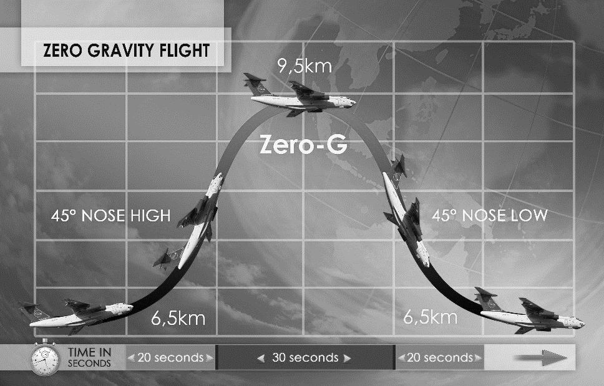
Pages 201-220

Recap

Turn back to page 16. What does riding the Cosmic involve and how much gravitational force does it exert?

Big Question

‘Florida Digby’ – Dr Drax smiled – ‘you certainly seem to have the Right Stuff to be a taikonaut’ – What is the ‘Right Stuff’?

Vocabulary

Stoical | Determined | Triumphant

Quotations

- ‘Florida didn’t react. She knew they were going to laugh at her and she still asked the question’ (205)

- ‘Max wouldn’t budge’ (206)

- ‘Hassan wasn’t moving either’ (206)

- ‘Samson One tried to explain to Samson Two that gravity was just a natural force and nothing to be afraid of’ (206)

- ‘She liked the sound of that’ (207)

- Florida said, ‘I’m really, really scared now’’ (208)

Key Image

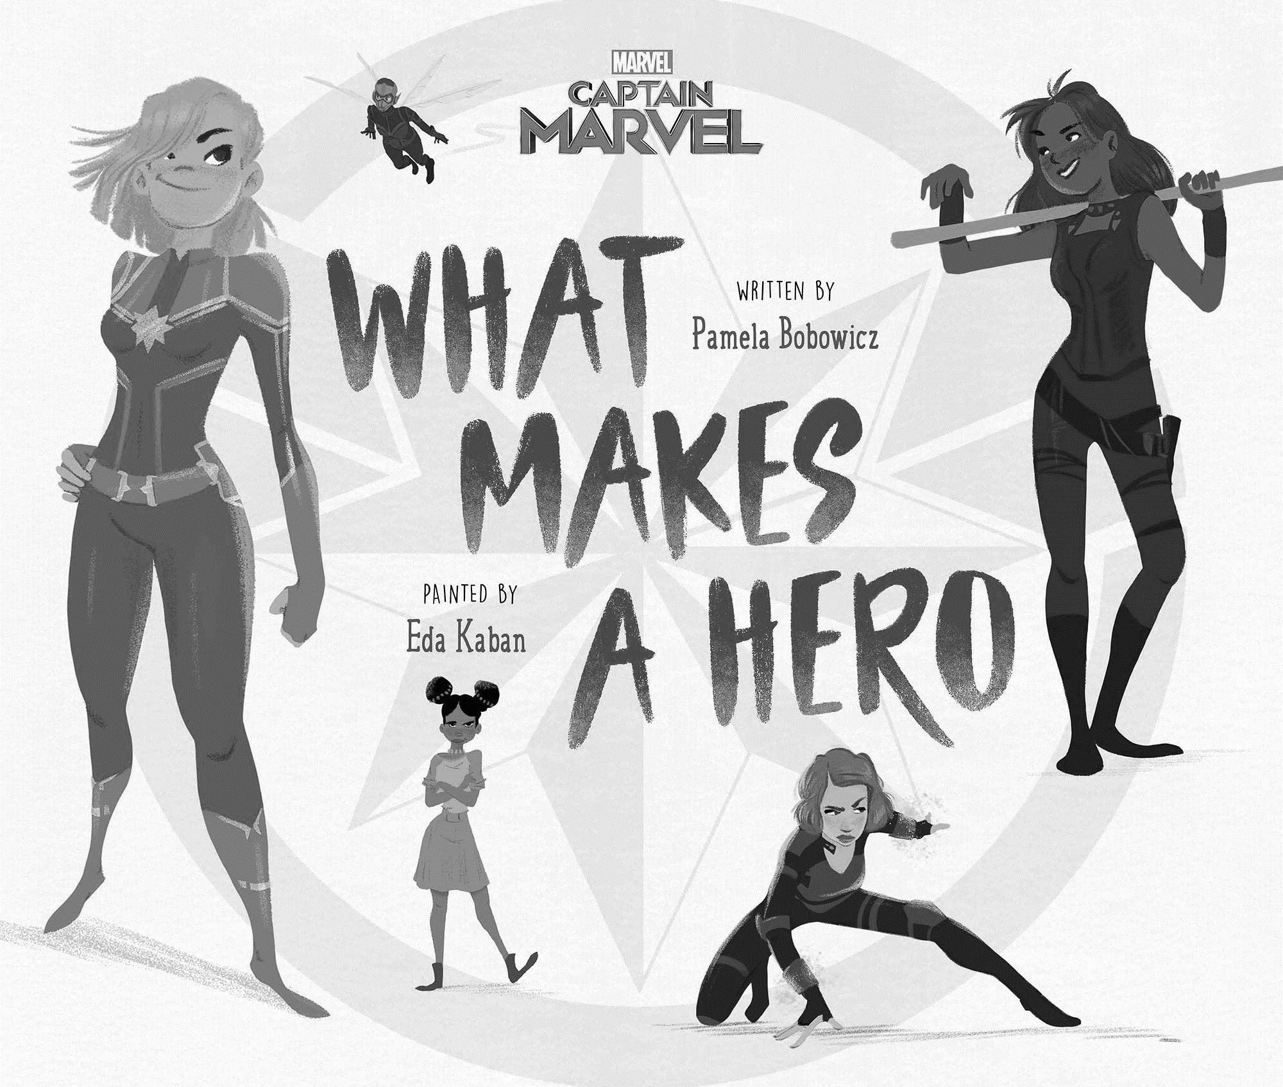
Pages 221-230

Recap

Turn back to page 73. What do we learn about Eddie Xanadu?

Big Question

‘Eddie got ten points all together. I got six’ – Why does Eddie win and why is his victory so unfair?

Vocabulary

Greedy | Egotistical | Manipulative
Boastful | Cynical | Sarcastic

Character Focus

Eddie Xanadu: 108, 167, 218

Pages 231-236

Recap

- Why was the Penultima given its name? (221)

- Finish the line: ‘And the golden glow flew away like wrapping paper, leaving the blue Earth…’ (225_

- Which game that Liam plays is just like the Penultima? (225)

- What type of car does Monsieur Martinet drive? (225)

- What type of car does Liam say that he drives? (226)

- Finish the line: ‘Samson Two smiled, nodded his head and then went off and…’ (229)

- How many points did Liam achieve altogether? (230)

- How many points did Eddie achieve altogether? (230)

Big Question

‘I was worried about Florida Kirby’ – How have Liam’s feelings for Florida developed since the beginning of the novel?

Vocabulary

Distant | Humorous | Challenging
Friendly | Playful | Relaxed

Relationship Focus

Liam and Florida: 14, 29, 36, 40

Pages 137-249

Recap

Proof-read the passage below and correct the errors.

i felt realy lonley that night. I think it must be the only time Ive bean in a house on my own at knight. And now look – I felt bad on

my own in a house. Now Im on my own in The universe.

Big Question

‘We all make mistakes’ – What mistake does Eddie make and what does it mean for Liam?

Vocabulary

Mistake | Opportunity | Justice

Key Images

 | 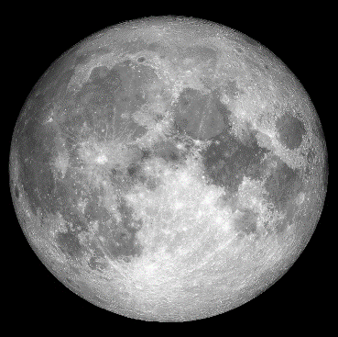 | 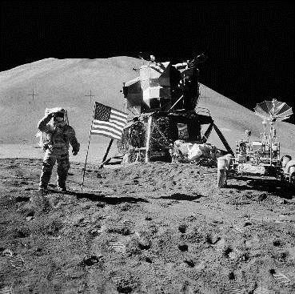

Interview

- How do you feel about the opportunity you’ve been given? (I feel…)

- What are you most looking forward to doing? (I’m most looking forward to…)

- How do you feel about what Eddie did? (I feel that Eddie…)

- What is the first thing you’ll say to Florida when you see her? (I’ll say…)

Pages 250-260

Recap

Turn back to pages and 37 and 38. What does Florida say about her dad?

Big Question

‘I was worried about Florida Kirby’ – How have Liam’s feelings for Florida developed since the beginning of the novel?

Vocabulary

Convention | Expectation | Taboo

Retrieval

- Florida teasingly asks Liam for her birthday present (250)

- Liam asks Florida why she didn’t tell him it’s her birthday (251)

- Liam urgently tells Florida they are in danger (252)

- Florida admits that she is no longer in touch with her father (253)

- Florida reveals that her father left the family after an argument (254)

- Liam presents Florida with a crown in an attempt to make her feel better (255)

- The group play a range of party games and Florida becomes much happier (256)

Key Image

Pages 261-271

Recap

Turn back to page 258. Why was the Dandelion given its name?

Big Question

‘It was a test of Dadness’ – What indications are we given that the group really are just children?

Vocabulary

Fear | Anxiety | Curiosity
Authority | Hierarchy | Bravery

Quotations

- ‘Hasan said, ‘It is bears?’’ (262)

- ‘I was thinking, That is so much scarier than bears’ (263)

- ‘If I couldn’t control them here in the living room, what would it be like in orbit?’ (265)

- ‘I wished he’d turn up now’ (266)

- ‘At launch minus six I was still insanely hoping that Dad would actually turn up’ (267)

Key Image

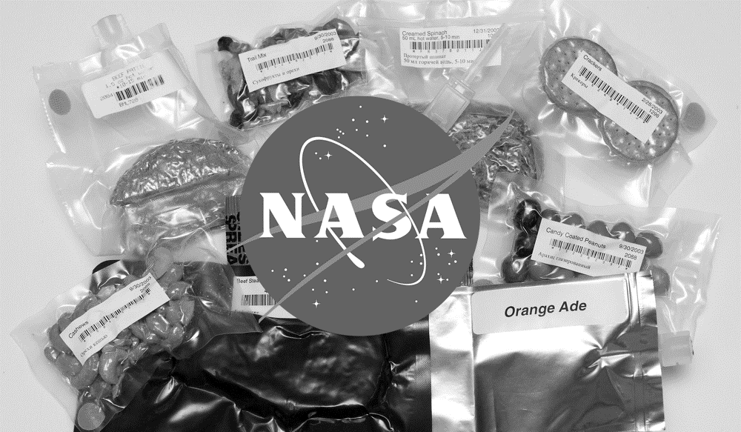
Pages 272-286

Recap

Turn back to page 257. Write a definition of each type of quest: grey | yellow | orange | red.

Big Question

‘Like I would know what to do’ – What sort of quest is Liam on (grey, yellow, orange or red) and how do you know?

Vocabulary

Easy | Harder | Fatal

Extracts

- The Dandelion’s protective cover had blown off and its silvery sails had popped out. But it had not separated from the command module… (281)

- Instead of gliding off nicely towards the Moon’s orbit, the Dandelion had gone spinning over and pulled us off course… (282)

Statements

- Liam is on a…

- I believe this because…

- Evidence to support my view is…

- Furthermore, it is also significant that…

Pages 287-304

Recap

Turn back to page 276. What does Liam say that take-off feels like?

Big Question

‘When you look at the Moon from Earth, it looks a bit smudgy’ – How does the Moon look from Liam’s perspective?

Vocabulary

Adjective | Metaphor | Simile

Key Images

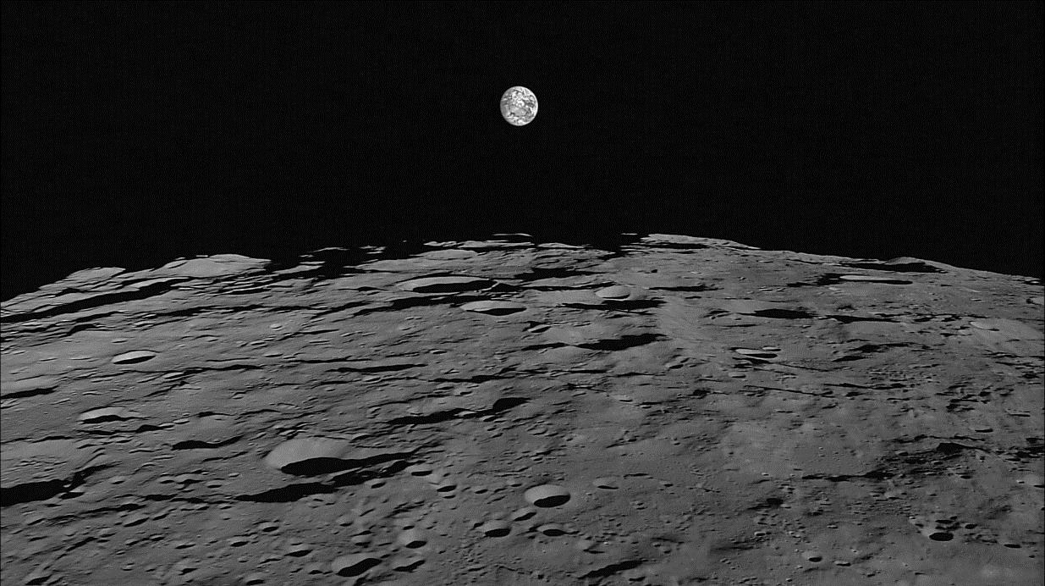

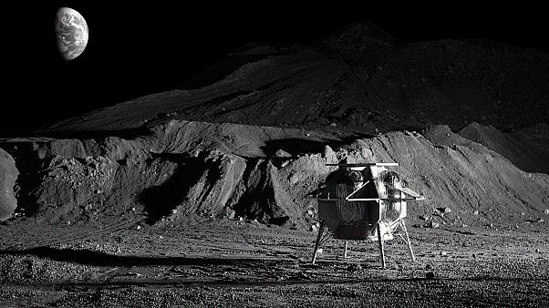
Pages 304-315

Recap

- What is the name of the parenting book that Liam occasionally refers to? (294)

- Finish the line: ‘Low-gravity Monopoly is better than __________’ (295)

- Apart from Liam, who is the only other child to have played Rock-Paper-Scissors? (296)

- Which character goes ‘very red’ and starts ‘yelling’? (297)

- Who does Florida say is a ‘rubbish driver’? (299)

- Finish the line: ‘They could be dishing out nine different kinds of _________’ (300)

- Which character goes missing? (301)

- After searching the rockets, is this character found? (302)

Big Question

‘So I won?’ – Who emerges as the real winner at the end of the chapter and why?

Vocabulary

Brave | Daring | Heroic
Stoical | Responsible | Mature

Key Quotations

- ‘Unfortunately I’d missed the part of training where we did that because of Eddie Xanadu’s electric Ribena’ (304)

- ‘And I was out there in the black nothingness’ (305)

- ‘My own hands shuffling painfully slowly along the sail towards the module’ (306)

- ‘I had no choice. I had to risk it’ (308)

- ‘I pushed on one panel and tugged on the other, and there was Hasan, snoring’ (311)

Key Image

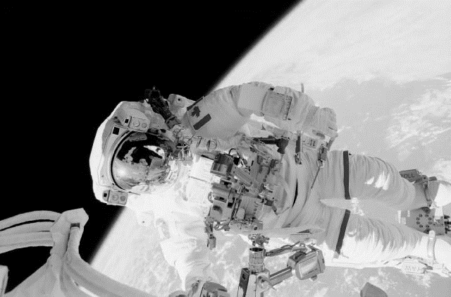
Pages 316-325

Recap

Turn back to page 232. Who or what is Laika and why is she so famous?

Big Question

‘I’m feeling really proud of us all’ – What have the group achieved and why is Liam proud?

Vocabulary

Cooperative | Engaged | Mature

Retrieval

- Samson Two suggests that they orbit the Moon again (320)

- Samson Two says that he is never wrong about maths (322)

- Liam suggests running a parallel simulation to work out the best course of action (323)

- Max allows Hassan to press the green button (324)

Pages 326-336

Recap

- Why does Liam’s dad ‘glare’? (19)

- What does Liam’s dad tell Liam to pick up? (46)

- What does Liam’s dad say Liam has ‘TOO MANY social skills? (49)

- What does Liam’s dad attempt to argue is a better investment than a holiday? (53)

- What does Liam’s dad offer Flora whilst she and Liam are waiting for the limo? (96)

Big Question

‘It was my dad’ – Who is the relationship between Liam and his dad presented?

Vocabulary

Concern | Absence | Connection

Discussion Points

- Liam’s dad’s expressions of concern (333)

- His attempt to discuss the football match (333)

- Liam’s decision not to tell his dad that he’s in space (333)

Key Image

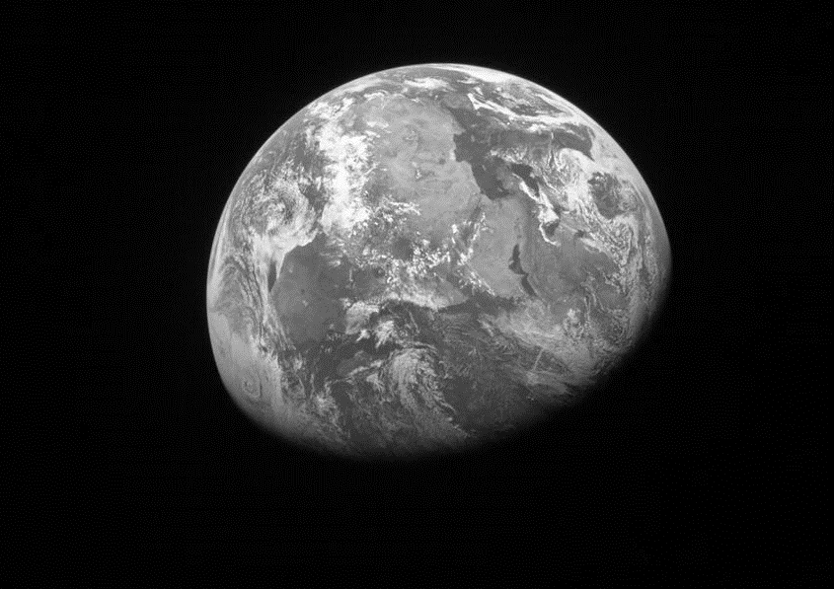
Pages 337-353

Recap

Turn back to page 249. What does Dr Drax make Liam sign?

Big Question

‘Hello, Dad!’ – To what extent does the story end happily?

Vocabulary

Gravity | Universe | Metaphor

Retrieval

- Liam feels the hot breath of an animal (344)

- Liam sees his dad’s St Christopher in pieces on the floor (345)

- Liam realises he has no credit on his phone (345)

- Liam’s dad calls him (346)

- The group argue over who pressed the button (347)

- Dr Drax arrives in her plane (348)

Key Quotations

- ‘It’s Dad. He’s walking towards me like there’s some special gravity pulling him towards me’ (350)

- ‘The universe goes on forever, but that doesn’t make you small’ (351)

- ‘Florida rang to make sure I was watching’ (353)

- ‘I was grinning all over my face’ (353)

