Key Contextual Information

Society in 1912 was divided: there was a large gap between the rich and the poor. Roughly 10% of the population controlled 90% of the wealth. Gerald and Mrs Birling are part of the aristocracy, which is to say that they are both from families that have been wealthy for many generations. Mr Birling is slightly different; he is part of the emerging upper-middle class because he has made his money more recently. Think back to his conversation with Gerald about Crofts Limited being both ‘older and bigger than Birling and Company’. Birling has ‘new’ money, whilst his wife and Gerald have ‘old’ money.

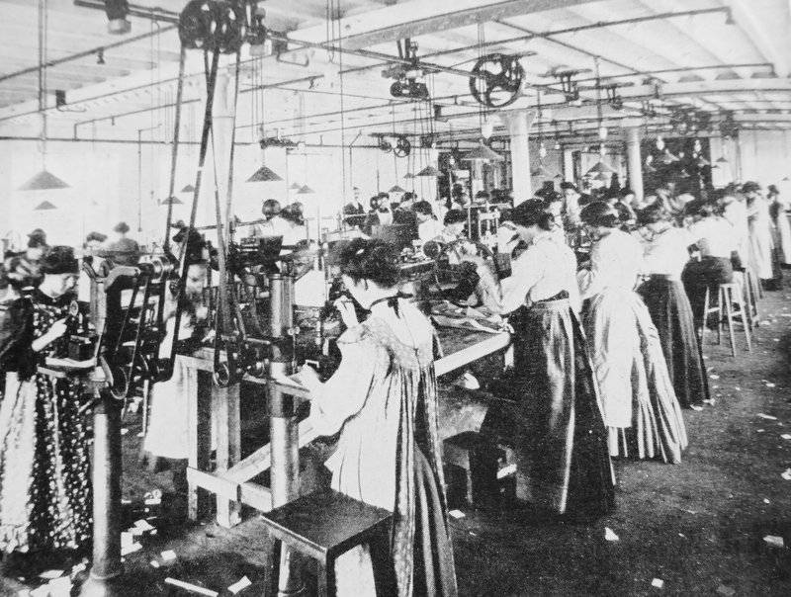 | 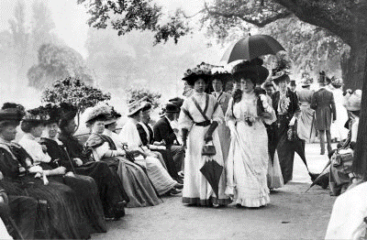

Society in 1946 was different. World War I and II resulted in significant financial losses for families like the Birlings. In addition to this, the wars had required people from different backgrounds to mix and this helped to change what were once firmly established conventions. Society was becoming more equal and there was widespread desire for further change.

1912 | 1914 | 1917 | 1939 | 1945
The Titanic Sinks | World War I Begins | The Russian Revolution | World War II Begins | Labour Party Elected

As a socialist – someone who believed in social equality – Priestley wanted to remind his audience about how bad things were in 1912 as a way of encouraging them to continue pushing for changes that would result in greater freedom and fairness. Always remember as you’re reading the play that Priestley uses dramatic irony: the audience will always know more than the characters on stage. We know when they make mistakes and we know when they behave badly.

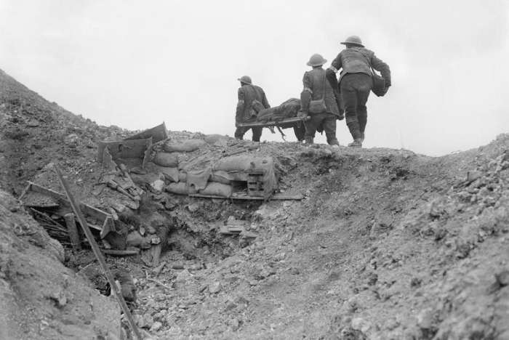 | 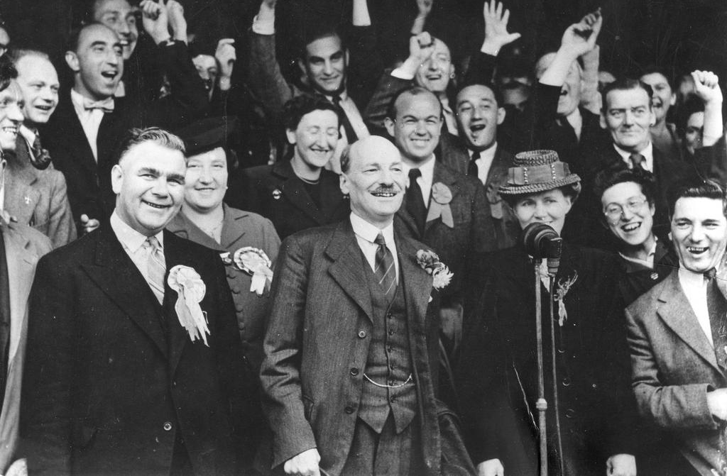

Aristocracy | Capitalism | Socialism
Wealth | Poverty | Equality

