Context Handbook
Macbeth

- King James’s Witch Hunts
- Concepts of Tragedy
- The Divine Right of Kings
- Good and Evil in Macbeth
- Going to the Theatre in Shakespeare’s Time
- The Gunpowder Plot
- Soliloquies
- The Form and Structure of Shakespeare’s Language
- Regicide
- Hospitality, Food and Feasting

King James’s Witch Hunts
Source: https://www.historyextra.com/period/stuart/shakespeares-macbeth-and-king-jamess-witch-hunts/

‘The witch hunts that swept across Europe between 1450 and 1750 are one of the most controversial and terrifying phenomena in history, resulting in the trial of around 100,000 people (most of them women), a little under half of whom were put to death.’

‘One of the most active centres of witch-hunting was Scotland, where up to 4,000 people were put to the flames. This was striking for such a small country, and was more than double the execution rate in England. The ferocity of the Scottish persecutions can be attributed to royal witch-hunter James I. James’s obsession with witchcraft can be traced back to his childhood.’

‘In 1589, James was betrothed to Anne of Denmark, but she almost lost her life in a violent tempest when she set sail across the North Sea to meet her new husband. In an uncharacteristic show of chivalry, James resolved to sail across to Denmark and collect her in person. But on their return voyage, the royal fleet was battered by more storms and one of the ships was lost. James immediately placed the blame on witches, claiming that they must have cast evil spells upon his fleet.’

‘As soon as he reached Scottish shores, James ordered a witch-hunt on a scale never seen before. No fewer than 70 suspects were rounded up in the coastal Scottish town of North Berwick on suspicion of raising a storm to destroy James and his new bride. Most of the suspects soon confessed – under torture – to concocting a host of bizarre and gruesome spells and rituals in order to whip up the storm. They were swiftly convicted and put to death.’

‘In James’s view, the English law was by no means strict enough in prosecuting the crime. Barely a year after his accession, James therefore ordered that the Elizabethan statute on witchcraft be replaced by a much harsher version. Until [then], those who practised witchcraft were severely punished only if they were found to have committed murder or other injuries through their devilish arts. However, James wanted the practice of any form of magic to be severely punished, regardless of whether it had caused harm to others.’

‘The Witchcraft Act of 1604 made hanging mandatory for a first offence of witchcraft, even if the accused had not committed murder. And if the suspected witch was found to have the devil’s mark on their body, this was enough to condemn them to death.’

Concepts of Tragedy
Source: https://www.englishandmedia.co.uk/assets/uploads/preview_files/Tragedy.pdf

‘Tragedy has been important in Western art for two and a half thousand years. Theories about its nature have inevitably changed and developed over that time. There are, however, certain concepts which have remained more or less central to what we understand the term to mean.’

‘The drama is usually centred upon one or more main character who acts in a way which proves disastrous.’

‘There is a calamitous outcome which causes an emotional response in its audience.’

‘The protagonist is a character with whom the audience can identify, someone who makes a wrong decision for good reasons or with the best of intentions. Aristotle called the protagonist’s error of judgement hamartia. It is often the result of a condition called hubris, the excessive pride which brings down divine punishment upon the head of the protagonist.’

‘A.C. Bradley’s Shakespearean Tragedy (1904) proposed the idea of the tragic flaw in the psychological make-up of the protagonist. This [should not] be confused with the notion of hamartia, which is a matter of action, not character.’

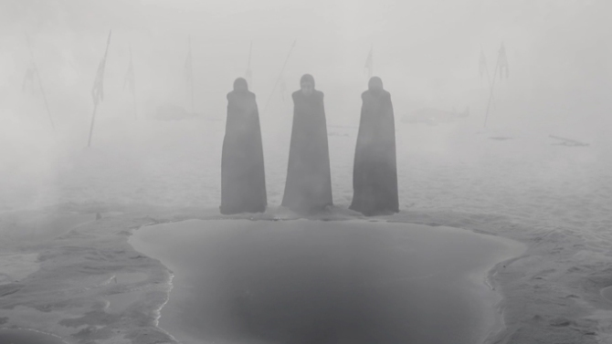

The Divine Right of Kings
Source: https://www.britannica.com/topic/divine-right-of-kings

‘The Divine Right of Kings […] asserted that kings derived their authority from God and could not therefore be held accountable for their actions by any earthly authority such as a parliament.’

James delivered a speech to Parliament in 1609, in which he conveyed his views:

‘Kings are justly called gods, for that they exercise a manner or resemblance of divine power upon earth: for if you will consider the attributes to God, you shall see how they agree in the person of a king. God hath power to create or destroy make or unmake at his pleasure, to give life or send death, to judge all and to be judged nor accountable to none; to raise low things and to make high things low at his pleasure, and to God are both souls and body due. And the like power have kings: they make and unmake their subjects, they have power of raising and casting down, of life and of death, judges over all their subjects and in all causes and yet accountable to none but God only.’

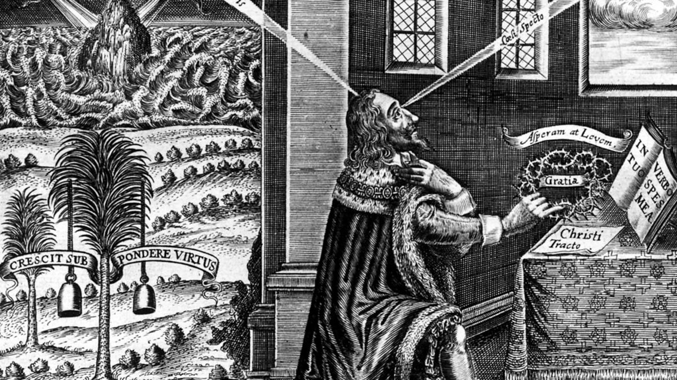

Good and Evil in Macbeth
Source: https://www.englishandmedia.co.uk/e-magazine/articles/15197

‘Good and evil are a potent source of conflict within Macbeth. Not only do we have the overtly evil presence of the witches and the domineering Lady Macbeth, but we also have the deeply divided character of Macbeth himself, where this conflict works itself out in depth. The first act of the play offers an increasing insight into the complex interaction of good and evil in Macbeth’s mind. The noble, valiant and loyal soldier of the early scenes is tempted by the visions of future personal glory conjured by the witches and comes increasingly under their influence. The battle between these conflicting elements of Macbeth’s character becomes evident immediately after the first of the witches' prophecies has come true, when he observes…’

‘this supernatural soliciting
Cannot be ill, cannot be good’
A1-S3 (129-30)

‘Closely allied to good and evil are innocence and guilt. Macbeth is at first tortured by guilt at the thought of murdering Duncan and the need – if the witches’ prophecies are to be made true – to overcome his natural loyalty and honour.’

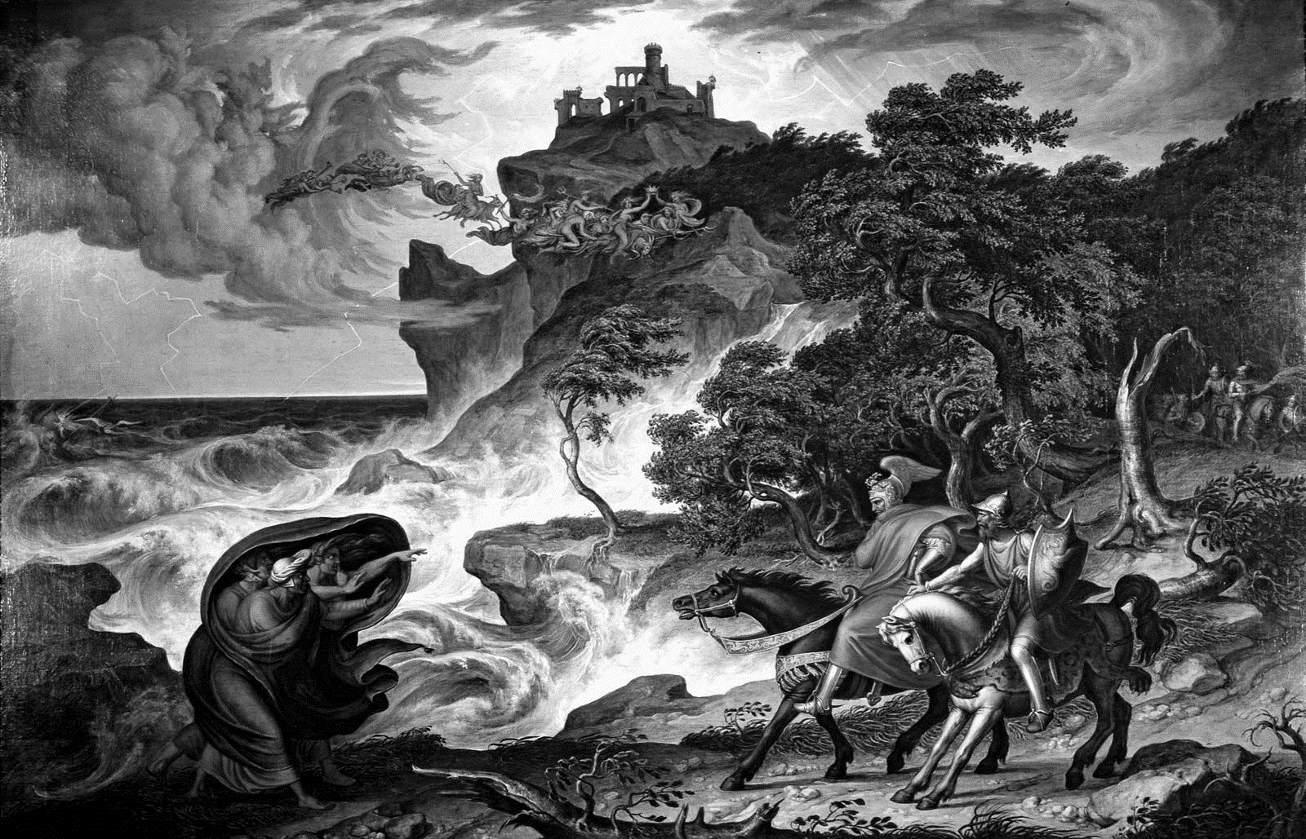

Going to the Theatre in Shakespeare’s Time
Source: https://tinyurl.com/mrxnvs9j

‘The theatre’s doughnut-like shape will be familiar to anyone who has stood inside a replica such as the reconstructed Globe in London: a circular yard open to the sky and surrounded on all sides by tiers of seats, with a broad-thrust stage jutting out into the centre. Above the stage was a canopy, colloquially known as the ‘heavens’, richly painted and supported by two huge pillars.’

‘Audiences paid at the box office, named for the pottery boxes in which the takings were kept, fragments of which have been recovered by archaeologists. For a penny you could be a ‘groundling’ and hustle on foot in the yard; tickets for so-called Lord’s Rooms upstairs were considerably more expensive. As many as 3,000 people crammed in for shows at the outdoor amphitheatres, coming from all social classes, with apprentices and servants rubbing shoulders – at least on the way in – with middle-class citizens and gentry.’

Jacobeans talked of going to ‘hear’ rather than see a play: the theatre was a noisy environment onstage as well as off. Cannonballs were rolled around a drum to create thunder effects; guns or firecrackers announced a battle. Bursts of music – blaring trumpets to herald an entrance, or soft string music for a mystical transformation – helped punctuate the action. Scenery was essentially non-existent, and props such as candles, letters and books were minimal and generic. Though stage directions in Shakespeare are famously minimal, clues as to how things might have been done are scattered liberally through the texts. In Macbeth, Banquo comments that ‘their candles are all out,’ indicating a late-evening setting, after which Macbeth enters, accompanied by a servant carrying a torch (probably made of rush).

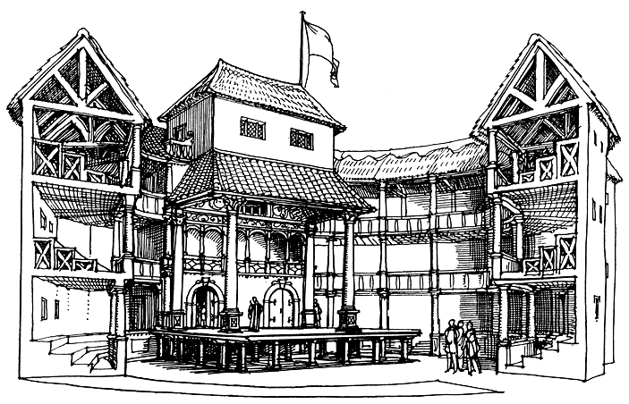
The Gunpowder Plot
Source: https://tinyurl.com/2p8a9xft

‘Jacobeans believed that the whole universe had an order to it which was decided by God. Anything unnatural was against this divine order.’

‘Shakespeare’s ‘Scottish Play’ was probably written in 1606, just three years after King James I was crowned as Elizabeth I’s successor, and so undoubtedly seems to be paying homage to the succession of the Scottish King to the English throne. But within that time, in November 1605, the Gunpowder Plot had been discovered: the plan to blow up the Houses of Parliament, kill James, and replace him with a Catholic monarch failed, and the plotters were tortured and horribly executed. The impact of the event was so dramatic, we still remember it today on Bonfire Night, so we can only imagine the enormity of the event for Shakespeare and his contemporaries.’

‘Many of Macbeth’s themes resonate with the attempted revolt: it’s a play about treason, the overthrow of a King, and the downfall of his murderers.’

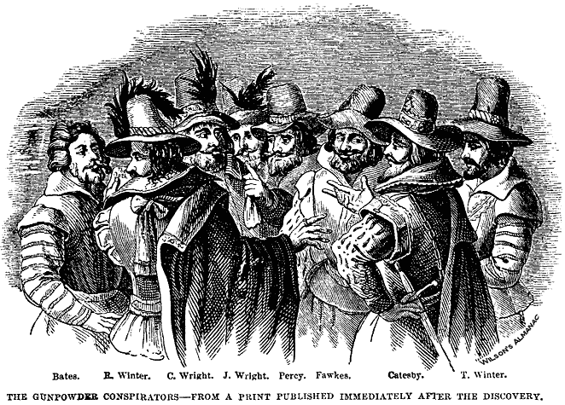

Soliloquies
Source: https://tinyurl.com/sxtdpy3s

‘Soliloquies and monologues are both spoken by a single person. The difference between these two literary and theatrical devices, however, is not who is speaking, but rather, who is listening. In a soliloquy, the speaker is talking to him or herself. In a monologue, the speaker is talking to the audience.

‘The soliloquy, a speech that reveals the innermost thoughts of a character in a play, is not so much an expression of what the character knows, as a discovery of what he or she thinks. In the course of speaking, the character – usually alone on stage – arrives at a revelation about him or herself that wasn’t previously clear.’

‘In a soliloquy, the speech is kept private from the other characters in the play, and, although the audience is privy to the character’s thoughts, the character is talking to him or herself alone. Soliloquies can create dramatic irony, because the audience is made aware of thoughts and events that the other characters in the play are not.’

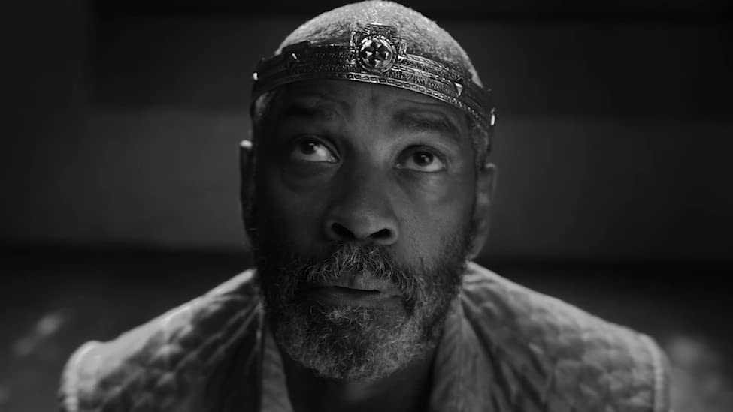

The Form and Structure of Shakespeare’s Language
Source: https://www.englishandmedia.co.uk/e-magazine/articles/14539

‘Shakespeare was a great experimenter. He continued to experiment throughout his career with the forms which he inherited and continued to explore ways in which he could influence the audience’s responses. At the beginning of his career, he used the regular iambic pentameter line: a line of ten syllables divided into five feet of two syllables each with the second syllable stressed. It’s a line that goes like this: di dum / di dum / di dum/ di dum / di dum.’

‘The audience will also sit up and take notice if there is a stretch of lines which don’t rhyme (blank verse) and then some which do rhyme. Shakespeare inherited a convention of ending scenes with rhyming couplets.’

‘Something else he does is to chart the relationships between characters, particularly the power relationships, by splitting a line between characters. You need to think about whether the second character is filling in a gap or a pause when the first one has finished or whether the second character is interrupting.’

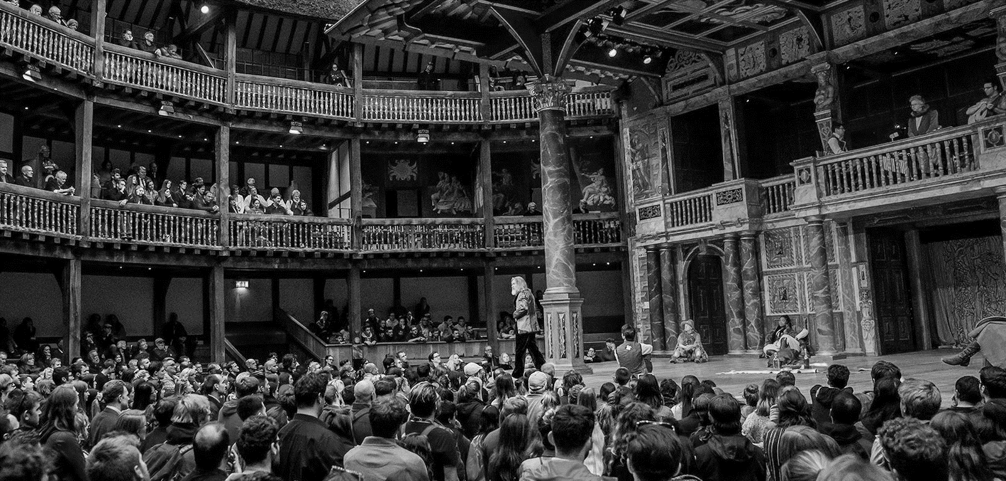

Regicide
Source: https://www.englishandmedia.co.uk/e-magazine/articles/15641

In Macbeth, as in any play of the period, the ultimate taboo is regicide: to kill the king is a heinous act, violating feudal loyalties and offending against God. Macbeth always knows that Duncan’s murder is ‘deep damnation’.

‘In his first soliloquy, he reveals the early stirrings of ‘horrible imaginings’, thoughts that terrify him and deprive him of all sense of reality […] Similarly, when Macduff discovers Duncan’s body, his imagery is religious, not simply political…’

‘Confusion now hath made his masterpiece!
Most sacrilegious Murder hath broke ope
The Lord’s anointed Temple’
A2-S3 (65-7)

‘In Macbeth’s world, regicide is the taboo which makes ‘my seated heart knock at my ribs’. In this respect, the play resembles […] a world where the brakes are off and the unthinkable is enacted.’

‘Macbeth’s own intense mental, emotional and spiritual suffering is evident from his anguish before (and, of course, after) Duncan’s murder up to his final soliloquy where he finds only ‘Nothing’ at the heart of life. The isolation of his suffering is part of the horror of the play.’

‘Macbeth’s solitude is inherent to his tragedy; equally, Lady Macbeth is tormented by nightmare, horror and isolation. These two have embraced a world of blood and it haunts them.’

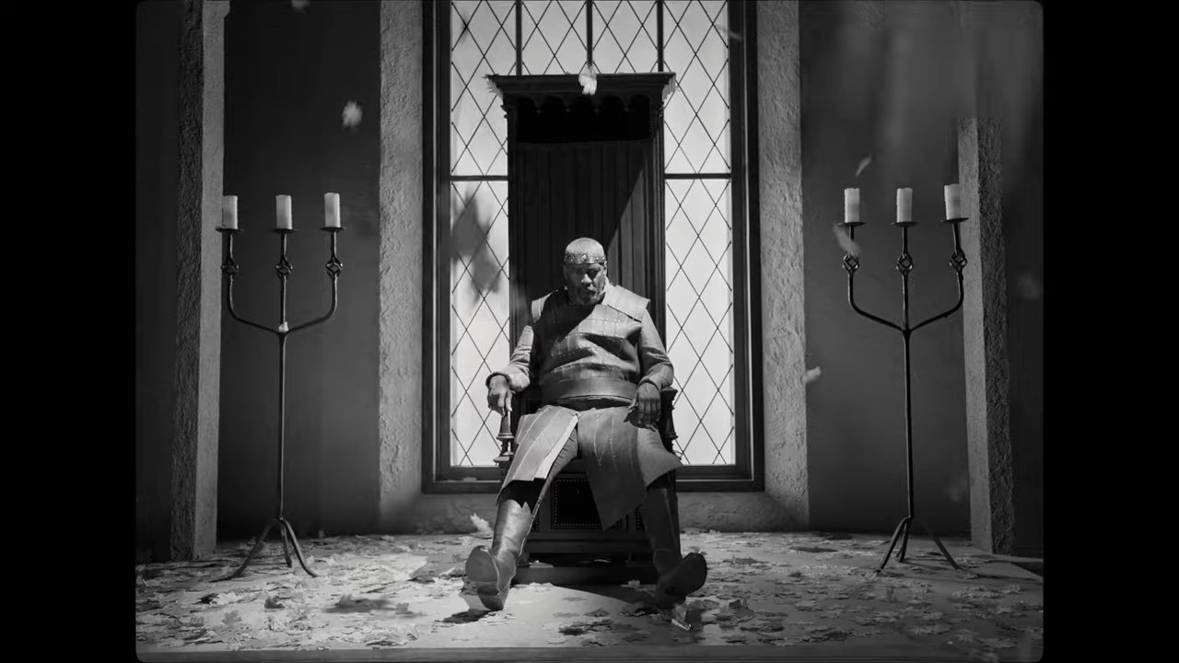
Hospitality, Food and Feasting
Source: https://tinyurl.com/2s4rxnum

‘Hospitality expressed through food is central to Macbeth, with the hero first hosting a feast to celebrate Duncan’s victory over the rebels and later attempting to cement his own kingship through the banquet at which Banquo’s ghost makes its unwelcome appearance.’

‘It is significant, then, that Macbeth’s attempt to consolidate and cement his position as king is dramatised in the pivotal banquet scene of A3-S4, rather than through his coronation, which is not staged. The coronation marks the symbolic transference of power onto the new king, but it is the hosting of the feast – proving his ability to provide abundance of food for himself and his followers, demonstrating that he […] is in a position to be bountiful – that will mark him as a truly powerful leader.’

‘Sufficient sustenance and the ability to eat in peace seem to be the figurative benchmarks by which Macbeth measures his success, security, comfort, and happiness.’

‘Macbeth and this Lords have utterly opposite hopes and ambitions, yet they articulate these conflicting hopes in the same terms: feasting and sleeping. Food unites these opposed characters, becoming universal shorthand for security, comfort, order and peacefulness.’

‘Food becomes in Macbeth a symbol of unifying significance.’

