An Inspector Calls
Wider Reading Booklet

The Life of J. B. Priestley
An Inspector Calls and J B Priestley’s political journey
Programme note by J B Priestley about An Inspector Calls
An Overview and Key Productions
Extracts from meeting notes about the set and staging of An Inspector Calls (1992)
An introduction to An Inspector Calls (Parts 1, 2 and 3)

All extracts takes from the British Library website
https://www.bl.uk/works/an-inspector-calls

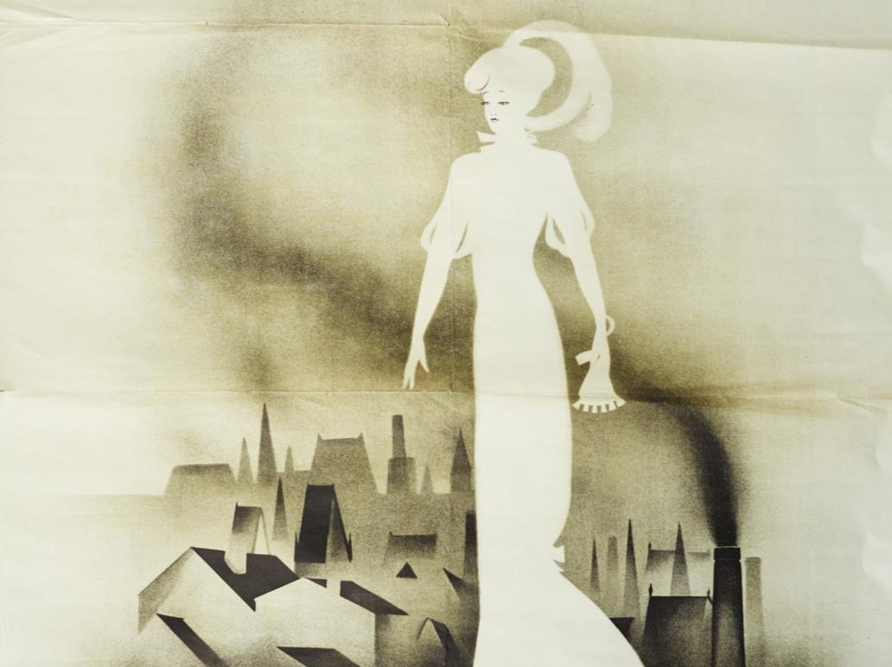
Extracts from The Life of J. B. Priestley
Source: https://www.bl.uk/people/j-b-priestley

The novelist, playwright and broadcaster, John Boynton ‘J B’ Priestley, was born in Yorkshire in 1894. At the age of 16 he took a job as a junior clerk at a local wool firm and started writing at night. During the First World War, Priestley was posted to France and was badly wounded. After the war he rarely spoke of these experiences. When he returned to Britain, he attended Cambridge University and started to write again, mainly short pieces for local periodicals, before embarking on a career as a freelance writer in London. By the age of 30 he was well established as an essayist, critic and a novelist. His biggest success as a novelist was 1929’s The Good Companions.

During the Second World War Priestley was a regular and influential broadcaster on the BBC. His Postscripts began in June 1940 in the aftermath of the Dunkirk evacuation, and continued throughout that year. They were popular with the public, but Priestley’s strong socialist beliefs did not go down well with some politicians and commentators. The broadcasts were eventually cancelled.

An Inspector Calls, his best-known and most-performed play, was written at the end of the Second World War. As there was no theatre available in London at that time, it premiered in Russia before opening in London in 1946. Ralph Richardson played Inspector Goole, the stranger who visits the affluent Birling family and confronts them with their complicity in the suicide of a young woman. It has been revived a number of times, most famously by Stephen Daldry in a 1992 production for the National Theatre. Following Daldry’s revival, there was something of a reassessment of Priestley’s legacy as a dramatist, and revivals of less well-known plays followed.

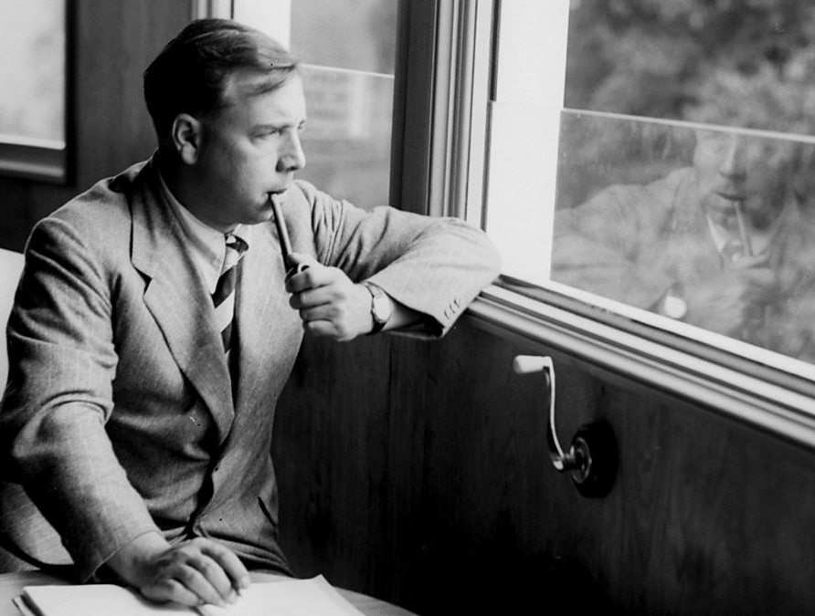
Extracts from An Inspector Calls and J B Priestley’s political journey
Source: https://www.bl.uk/20th-century-literature/articles/an-inspector-calls-and-j-b-priestleys-political-journey

An Inspector Calls poses troubling questions: how can people live together? To what extent are individuals responsible for others? Gareth Lloyd Evans described the play as ‘perhaps the clearest expression made by Priestley of his belief that ‘no man is an island’ – the theme is guilt and social responsibility’.

An Inspector Calls was born out of this tumultuous wartime debate about society, though Priestley had first thought of using a mysterious inspector years before. He had then mentioned the idea to a theatrical director, Michael MacOwen, who reminded him about it during the autumn of 1944. Priestley was enthused by the idea, found it in his ‘little black notebook’, and quickly wrote a playscript based around it. No suitable theatre was available in London, so in May 1945 Priestley sent the script to his Russian translator to see if there was any interest (his work was already popular in the Soviet Union). An Inspector Calls was thus first seen in productions by the Kamerny Theatre and the Leningrad Theatre in Moscow, followed by a European tour ending at the Old Vic in London.

Priestley and his wife Jane later travelled to the USSR, as guests of the Society for Cultural Relations with Foreign Countries; he wrote about his experiences for the Sunday Express, his articles being reprinted in the pamphlet ‘Russian Journey’. Priestley found the Russian people highly congenial and wrote sympathetically about a country that had recently been Britain’s wartime ally. Later, he was to realise more about the nature of the regime.

The play embodies Priestley’s reasons for calling for the ‘new and vital democracy’ by showing the personal consequences of a selfish society, and the future that would result if lessons were not learned about being ‘responsible for each other’: ‘If men will not learn that lesson, then they will be taught it in blood and fire and anguish’. This future might be the Great War which Priestley’s 1945 audiences knew was just two years ahead for his 1912 protagonists, or it might be a terrible revolution yet to come: his Russian audiences had seen just that when the frustrations of an unequal society had led to violent revolution and terrible suffering. Such ambiguities Priestley leaves in the play, along with its origins in his own past and his deepest beliefs, allowing it to work for audiences worldwide ever since, despite its historical origins in a complacent 1912 and his bleak yet hopeful 1945.

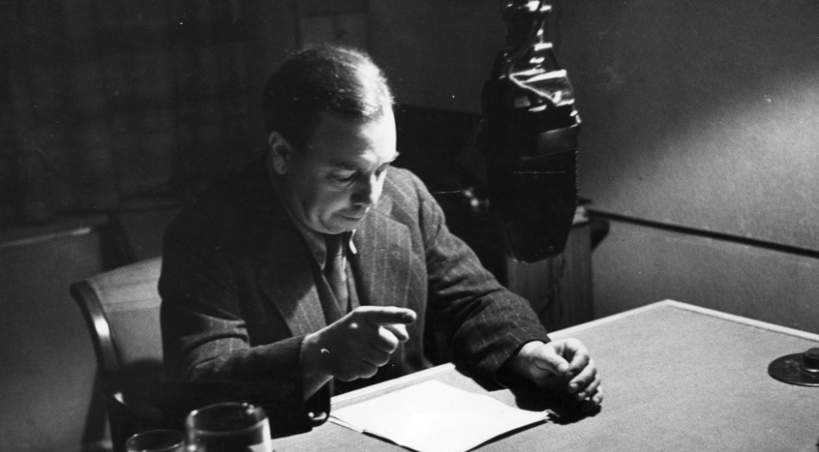
Extracts from Programme note by J B Priestley about An Inspector Calls
Source: https://www.bl.uk/collection-items/programme-note-by-j-b-priestley-about-an-inspector-calls

This note provides an insight into J B Priestley’s thoughts on An Inspector Calls, and the play’s impact since its premiere in 1945/46. It was written by Priestley for the programme to accompany the 1972 Mermaid Theatre production. Priestley highlights the play’s popularity around the world, noting that audiences’ reactions were ‘almost always exactly the same’. The play’s success is due largely to its finely balanced combination of social comment on the one hand, and mystery and suspense on the other. Priestley received ‘innumerable letters’ from students demanding to know ‘who or what the Inspector was’. In this note, Priestley writes: ‘the particular year in which the action is supposed to be happening was not chosen at random: it is significant and is indeed another key to the play’. Set in 1912, shortly before the First World War, An Inspector Calls was a powerful warning to a 1945/46 audience still reeling from the horrors of the Second World War. Just as the Birlings come face-to-face with their future at the end of the play, the present-day audience are faced with the mistakes of their past and can also choose to act differently to create a fairer, safer world. This message is brought home by the Inspector’s words, which warn of violence and destruction: ‘If men will not learn that lesson, then they will be taught it in fire and blood and anguish’.

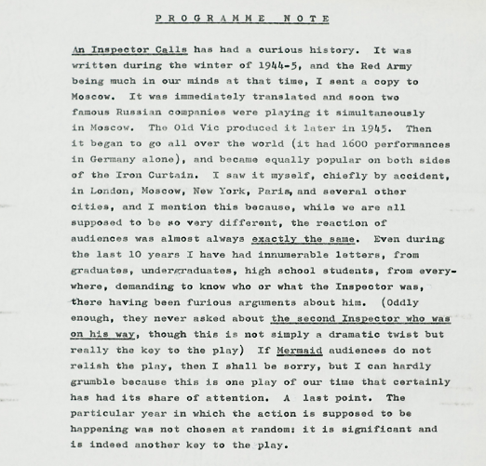
Extracts from An Overview and Key Productions
Source: https://www.bl.uk/works/an-inspector-calls

An Inspector Calls is J B Priestley’s most performed play. It’s set in the household of a prosperous northern manufacturer, Arthur Birling. It’s 1912 and the Birling family are celebrating the engagement of daughter Sheila, when a stranger, who introduces himself as Inspector Goole, shows up at their door. He’s there to question them about the death of a young working-class woman, Eva Smith, who killed herself by drinking disinfectant. As Goole interrogates the family – Birling, his wife Sybil, his son Eric, Sheila and her fiancé Gerald – it comes to light that they have all, to some extent, been responsible for the young woman’s decline in circumstances. They may not have killed her, but through action – and inaction – they all played a role in the events that led to her death. Arthur dismissed her from her job at his mill, Sheila contrived to have her fired from her new post in a department store, both Gerald and Eric slept with her and Sybil denied her charity when she came to her in desperation.

After Goole departs, Birling becomes suspicious and calls the chief constable. He discovers that there is no Inspector Goole and there have been no recent suicides. Birling and his wife see this as cause for celebration, but their children are more chastened by the night’s events. The ending twists things further, concluding with a phone call to the Birlings telling them that the police are on their way to talk to them about the death of a young woman in a suspected case of suicide.

An Inspector Calls is scathing in its criticism of middle-class hypocrisy. The play gives voice to Priestley’s strong socialist principles, and carries a clear moral message, stressing the importance of social responsibility: ‘We don’t live alone. We are members of one body. We are responsible for each other’.

The play was first performed in Leningrad in 1945, before being produced in the UK in 1946. The role of Inspector Goole was written for Ralph Richardson, who starred in the original London production.

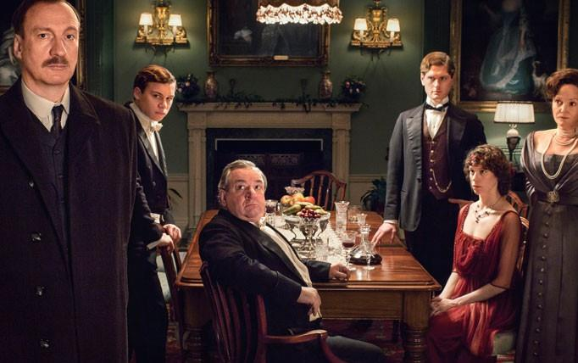
Extracts from meeting notes about the set and staging of An Inspector Calls (1992)
Source: https://www.bl.uk/collection-items/meeting-notes-about-the-set-and-staging-of-an-inspector-calls-at-the-national-theatre-1992

The Birlings’ house is described in the notes as ‘a dolls house..not full size’, so that the characters have to ‘stoop to get through doors’, and the furniture is ‘specially made and scaled down .. also made to break specifically’. The effect created when the house tipped forward and collapsed was made all the more dramatic by the sound of falling crockery which, according to the notes, ‘must smash’. The spectacular nature of the staging was further intensified with the use of heavy rain, a complex special effect which posed its own challenges.

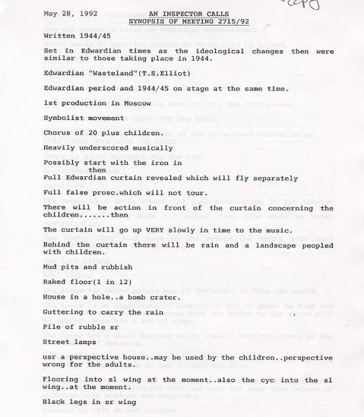
Extracts from An introduction to An Inspector Calls – Part 1
Source: https://www.bl.uk/20th-century-literature/articles/an-introduction-to-an-inspector-calls

Priestley’s play revolves around a central mystery, the death of a young woman, but whereas a traditional detective story involves the narrowing down of suspects from several to one, An Inspector Calls inverts this process as, one by one, nearly all the characters in the play are found to be guilty. In this way, Priestley makes his larger point that society is guilty of neglecting and abusing its most vulnerable members. A just society, he states through his mysterious Inspector, is one that respects and exercises social responsibility.

Social responsibility is the idea that a society’s poorer members should be helped by those who have more than them. Priestley was a socialist, and his political beliefs are woven through his work. There are many different types and degrees of socialism, but a general definition is as follows: an ideal socialist society is one that is egalitarian – in other words, its citizens have equal rights and the same opportunities are available to everybody; resources are shared out fairly, and the means of production (the facilities and resources for producing goods) are communally owned. Therefore, socialism stands in opposition to a capitalist society, such as ours, where trade and industry is mostly controlled by private owners, and these individuals or companies keep the profits made by their businesses, rather than distributing them evenly between the workers whose labour produced them.

An Inspector Calls is a three-act play with one setting: the dining room of ‘a fairly large suburban house belonging to a fairly prosperous manufacturer’. The year is 1912, and we are in the home of the Birling family in the fictional industrial city of Brumley in the North Midlands. In the dining room five people are finishing their dinner: four members of the Birling family and one guest. Arthur Birling is a factory owner; his wife Sibyl is on the committee of a charity, and is usually scolding someone for a social mistake. Their adult children are Sheila and Eric, and their guest is Gerald Croft, Sheila’s fiancé, who is from a wealthier manufacturing family than the Birlings. One other person is present: Edna the maid, who is going back and forth to the sideboard with dirty plates and glasses.

Priestley’s description of the set at the beginning of the play script stresses the solidity of the Birlings’ dining room: ‘It is a solidly built room, with good solid furniture of the period’. But a later section of this scene-setting – on the walls are ‘imposing but tasteless pictures and engravings’, and the ‘general effect is substantial and comfortable and old-fashioned but not cosy and homelike’ – suggests that although the Birling’s have wealth and social standing, they are not loving to one another or compassionate to others. The setting of the play in a single room also suggests their self-absorption, and disconnectedness from the wider world.

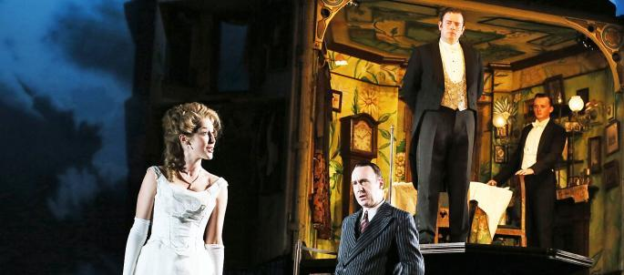
Extracts from An introduction to An Inspector Calls – Part 2
Source: https://www.bl.uk/20th-century-literature/articles/an-introduction-to-an-inspector-calls

Priestley has some fun using this opening section to show how wrong Arthur Birling’s opinions are, thus positioning the play as anti-capitalist. He does this through the use of dramatic irony, having Arthur state opinions that the audience, with the advantage of hindsight, knows to be incorrect. He goes on to describe an ocean liner that is clearly meant to be the Titanic (which sank in April 1912) as ‘unsinkable, absolutely unsinkable’, and suggests that in time, ‘let’s say, in the forties’, ‘all these Capital versus Labour agitations and all these silly little war scares’ will be long forgotten. In fact, as audiences in 1945 would have been keenly aware, the period between 1912 and 1945 saw a huge number of strikes, including the monumental General Strike of 1926, and not one but two global conflicts, the second of which had only recently ended. Dramatic irony is rarely a subtle technique, but Priestley’s use of it is exceptionally blunt. This could be considered clumsy, but it underlines the fact that An Inspector Calls is a play with a point to make, and a character whose sole job is to make it.

When Inspector Goole arrives everything changes. He tells the Birlings and Gerald that a young woman, Eva Smith, has committed suicide by drinking disinfectant, and he has questions about the case. Over the course of the next two acts he will lay responsibility for Eva Smith’s death at the feet of each of the Birlings and Gerald Croft, showing how their indifference to social responsibility has contributed to the death of this young woman. Or is it young women? He shows each person an identifying photograph of the dead woman one by one, leading Gerald to later suspect they were all shown photographs of different women.

But who is the Inspector? In the play’s penultimate twist, he is revealed not to be a police inspector at all, yet, as Eric states, ‘He was our Police Inspector, all right’. Details about him are scant. He says he is newly posted to Brumley, and he is impervious to Arthur Birling’s threats about his close relationship with the chief constable ‘I don’t play golf’, he tells Birling. ‘I didn’t suppose you did’, the industrialist replies: a brief exchange that makes a clear point about class, and the battle between egalitarianism and privilege. Beyond these sparse biographical details, the Inspector seems less like a person and more like a moral force, one which mercilessly pursues the wrongs committed by the Birlings and Gerald, demanding that they face up to the consequences of their actions. His investigation culminates in a speech that is a direct expression of Priestley’s own view of how a just society should operate, and is the exact antithesis of the speech Arthur Birling made in Act 1.

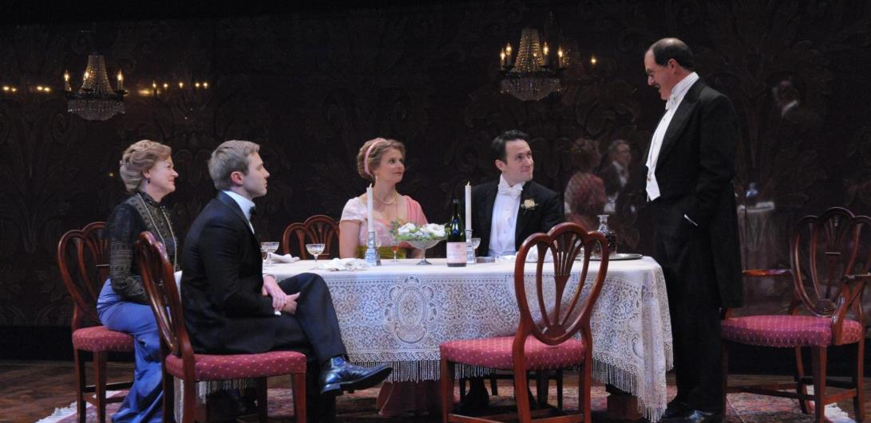
Extracts from An introduction to An Inspector Calls – Part 3
Source: https://www.bl.uk/20th-century-literature/articles/an-introduction-to-an-inspector-calls

Throughout the course of the Inspector’s investigation, and the testimony of Gerald and each of the Birlings, the supposedly respectable city of Brumley is revealed to be a place of deep class divisions and hypocrisy. As Arthur Birling’s behaviour towards Eva makes clear, it is a place where factory owners exploit their workers as a matter of course – part of his ‘a man has to look after himself’ philosophy. Eric accuses his father of hypocrisy for sacking the dead girl after she asked for higher wages, because the Birling firm always seeks to sell their products at the highest possible prices.

This exploitation is not limited to the factories. In the testimony of Gerald, and later Eric, the Palace Theatre emerges as a place where prostitutes gather, and where the supposedly great and good of the town go to meet them. When Gerald first met Eva, as he describes it, she was trapped in a corner by ‘Old Joe Meggarty, half-drunk and goggle-eyed’. Sibyl Birling, scandalised, asks ‘surely you don’t mean Alderman Meggarty?’ An unsurprised Sheila tells her mother ‘horrible old Meggarty’ has a reputation for groping young women: the younger characters are either more knowledgeable or frank about the dark secrets of the city, whereas the older Birlings live in a dream world of respectability, or hypocritically turn a blind eye to any disreputable behaviour by supposedly respectable people.

The play begins with the characters’ corrupt, unpleasant natures safely hidden away (a respectable group in a respectable home, enjoying that most respectable event, an engagement party); it ends with naked displays of hypocrisy. When it is confirmed that Goole is not really a policeman, Arthur, Sibyl and Gerald immediately regain an unjustified sense of outrage. ‘Then look at the way he talked to me’, Arthur Birling complains. ‘He must have known I was an ex-Lord Mayor and a magistrate and so forth’. Once it is confirmed, in the play’s penultimate twist, that there is no suicide lying on a mortuary slab, they forget the immoral, uncharitable behaviour they were recently accused of – things, remember, that they undoubtedly did – and begin talking about getting away with things. Only Sheila and Eric recognise and resist this hypocritical behaviour. ‘I suppose we’re all nice people now!’ Sheila remarks sarcastically. Earlier she broke off her engagement to Gerald, telling him ‘You and I aren’t the same people who sat down to dinner here’. Likewise, Eric angrily accuses his father of ‘beginning to pretend now that nothing’s really happened at all’. Priestley’s vision is cautiously optimistic insofar as the youngest characters are changed by the Inspector’s visit, while the older Birlings and Gerald appear to be too set in their beliefs to change them.

He play leaves open the question of whether Eva Smith is a real woman (who sometimes uses different names, including Daisy Renton), or multiple people the Inspector pretends are one. There is no right answer here, and in terms of Priestley’s message it is beside the point: because his socialist principles demand that everyone should be treated the same, in his opinion abusing one working-class woman is equivalent to abusing all working-class women. Eva Smith is, therefore, not an individual victim, but a universal one. This helps explain the effectiveness of the play’s final twist. Having discovered that Inspector Goole is not a real policeman, and that there is no dead woman called Eva Smith at the Brumley morgue, a phone call announces that a woman has killed herself, and an inspector is on his way to question the Birlings. The invented story Inspector Goole related has now come true. This seems a bizarre coincidence with which to end the play, but if we consider An Inspector Calls as a moral fable, and not as naturalistic theatre, it begins to seem much more like a logical, even inevitable, conclusion. The characters have been confronted with the error of their ways; some have repented, some have not. Now is the time for judgement, and for the watching audience to ask themselves, according to Priestley’s design, are any of these people like me?

