AQA Power and Conflict Poetry

Key Biblical Allusions

London, by William Blake

- ‘And blights with plagues the marriage hearse’ (line 16)

Menacingly evocative of the traditional vows: ‘in sickness and in health, to love and to cherish, till death us do part’.

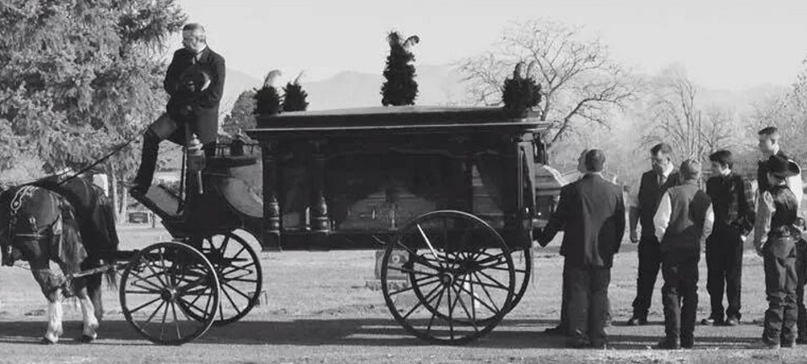

…………………………………………………………………………………………………………………………………………………………………………………………

Charge of the Light Brigade, by Alfred Tennyson

- ‘Into the valley of Death / Rode the six hundred’ (lines 7-8)

A reference from Psalm 23 that conveys the inevitability of death and the spiritual significance of the sacrifice.

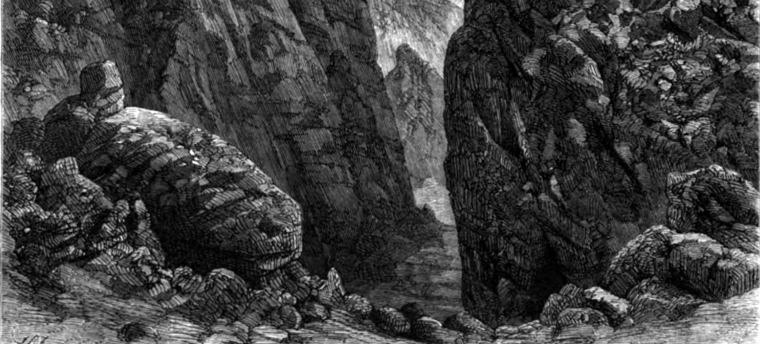
Charge of the Light Brigade, by Alfred Tennyson

- ‘Into the jaws of Death / Into the mouth of Hell’ (lines 24-25)

The entrance to Hell has typically been portrayed as the mouth (or jaws) of a terrifying and monstrous creature.

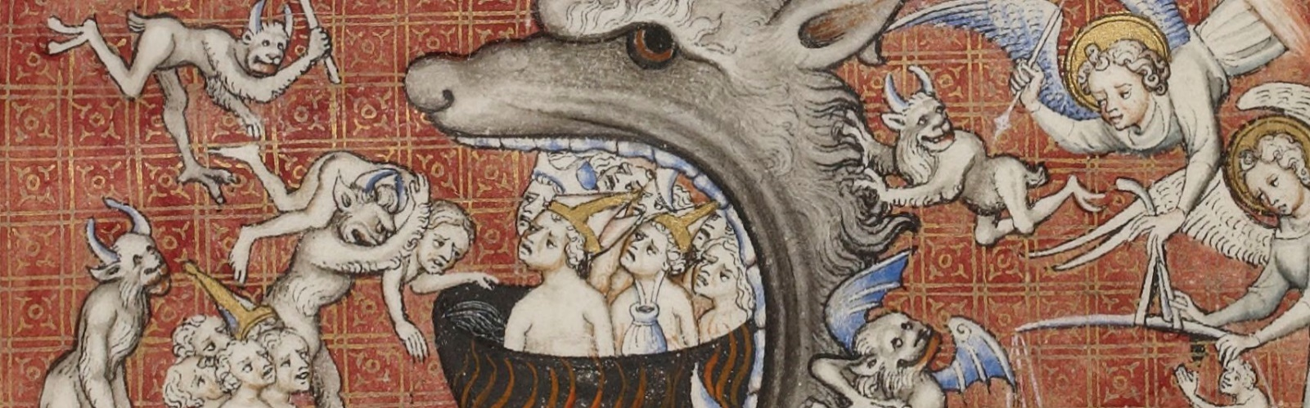

…………………………………………………………………………………………………………………………………………………………………………………………

Exposure, by Wilfred Owen

- ‘For love of God seems dying’ (line 35)

An expression that indicates Owen’s loss of religious faith and (or) his feeling of spiritual abandonment.

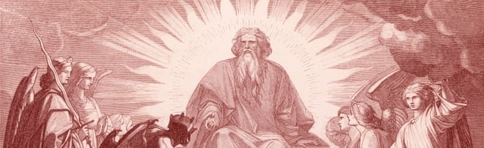

…………………………………………………………………………………………………………………………………………………………………………………………

Poppies, by Jane Weir

- ‘I resisted the impulse / to run my fingers through the gelled / blackthorns of your hair’ (lines 14-16)

An allusion to the crown of thorns that Jesus wore during his crucifixion: an evocative image of sacrifice

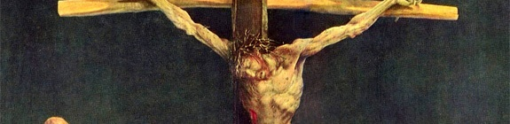
War Photographer, by Carol Ann Duffy

- ‘as though this were a church and he / a priest preparing to intone a Mass’ (lines 4-5)

Mass is a Catholic act of worship that serves as a memorial to the redeeming work of Jesus and the sacrifice he made.

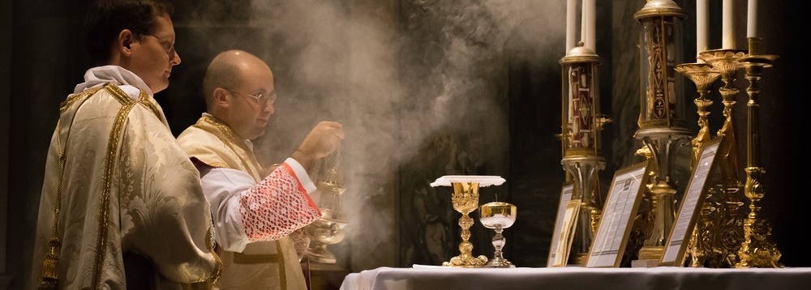

- ‘All flesh is grass’ (line 6)

A reference from the Old Testament Book of Isaiah that emphasises the fragile and transient nature of human life.

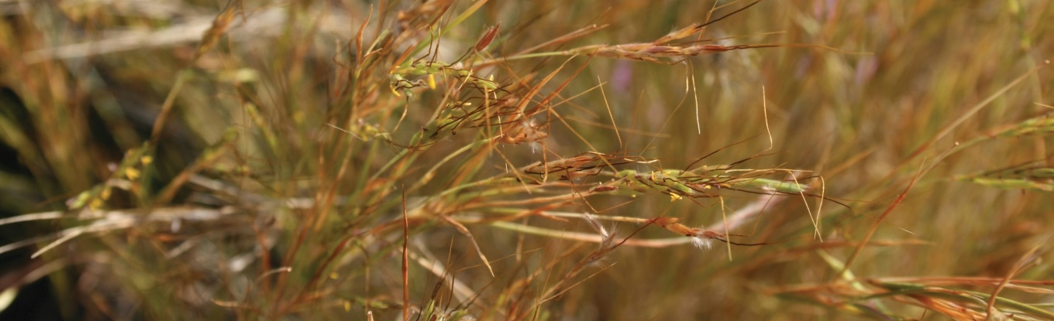

…………………………………………………………………………………………………………………………………………………………………………………………

Tissue, by Imtiaz Dharker

- ‘the kind you find in well-used books, the back of the Koran’ (lines 5-6)

The Koran (Qur’an) is the holy book of Islam; Muslims attribute the words of the Koran to the Angel Gabriel.

