The Landlady
Roald Dahl

The Landlady
Comprehension Questions

- Neat handwriting
- Accurate spelling
- Correct use of apostrophes
- Answer in full sentences
- Use the language of the questions in the answers

- How did Billy Weaver travel to Bath?
- Who are the ‘big shots’?
- What sort of animal can he see by looking through the window?
- What does Billy initially compare the Landlady to after she opens the door?
- Do any other guests appear to be staying at the house?
- Who is a ‘bit choosy’ – Billy or the Landlady?
- What does the Landlady mistakenly call Billy?
- Billy believes the Landlady is ‘slightly off her rocker’ – what does he mean?
- What do Billy and the Landlady drink whilst sitting on the sofa?
- What final words does the Landlady say to Billy?

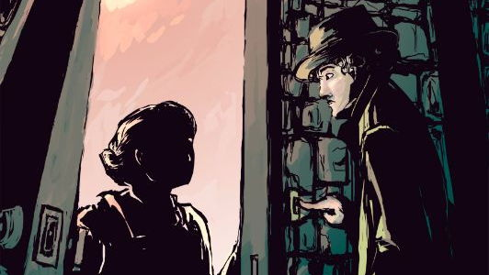

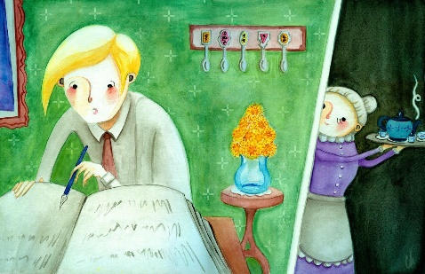
The Landlady
Review Tasks

- Neat handwriting
- Accurate spelling

- Write down two adjectives to describe Billy Weaver and then find a supporting quotation for each one

- ‘Bily Weaver had traveled down from Lundon on the slow afternoon trane’ – correct the spelling errors

- ‘She gave him a warm, welcoming smile’ – write down what this quotation reveals about the Landlady

- Write down the adjective that does not accurately describe the Landlady: hostile | polite | friendly

- ‘Billy answered brightly’ – Write down a definition of the adverb ‘brightly’

- ‘His landlady appeared to be slightly off her rocker’ – write down two reasons to explain Billy’s viewpoint

- ‘He found the geust-book lieyng open on the pianno’ – correct the three spelling errors

- Write down the adjective that accurately describes the Landlady at the end of the story: pleasant | sinister

- Write down an adjective to describe the mood at the end of the story and find a supporting quotation

- Write a full sentence to explain why the Landlady gives ‘a gentle little smile’ at the end of the story

