Superman and Paula Brown’s New Snowsuit
Sylvia Plath

Paragraph 1
- What do you learn about Paula?
- What does the ‘kaleidoscope’ metaphor suggest about the narrator’s outlook on life?
Paragraph 2
- What are the ‘moving beacons’ on the runway?
- How is the act of kneeling by the west window connected to the metaphor about the airport being Mecca?
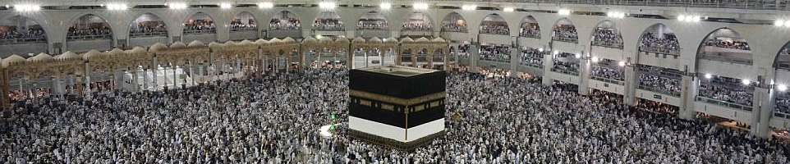
Paragraph 3
- What does the ‘technicolour dreams’ metaphor suggest about narrator’s childhood?
- Why does the narrator compare herself to Icarus?
Paragraph 4
- What does the verb ‘invading’ suggest about the presence of Superman in the narrator’s dreams?
- What does the verb ‘roaring’ suggest about the way in which Superman moves?
Review Task
- List five adjectives to describe the narrator and find supporting evidence.
Paragraph 6
- Which words and phrases make the narrator’s school seem particularly dull?
- How does the description of the school contrast to the imaginary world of the narrator’s dreams?
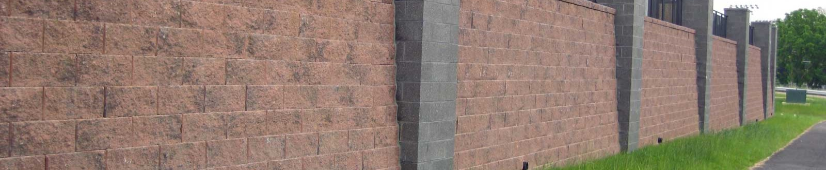
Paragraph 7
- Which words and phrases make the narrator’s and her two friends seem like outsiders?
- What does the phrase ‘sallow mamma’s boy’ suggest about Sheldon Fein?
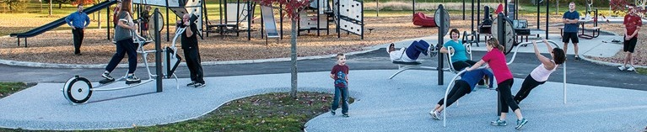
Paragraph 11
- What does the verb ‘seeping’ suggest about the perceived threat of war?
- Why does Mrs Fein grow ‘thin’ and ‘pale’?
Paragraph 12
- Why does nobody appear to like Paula Brown?
- How is the tone in this paragraph different to the tone of the opening paragraph?
Review Task
- List five adjectives to describe the mood of the story and find supporting evidence.
Paragraph 14
- Which details indicate that Paula Brown’s snowsuit is expensive?
- How do we know that Pauls is proud of it?
Paragraph 17
- What is suggested by the laughs of the Japanese soldiers?
- What details show the narrator is shocked at what she has seen?
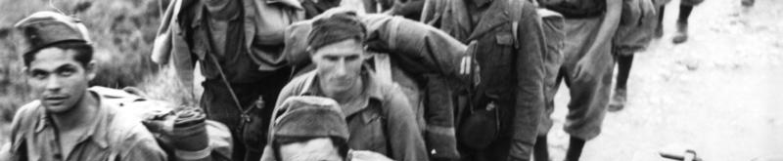
Paragraph 18
- What does the verb ‘sprang’ suggest about the narrator’s troubled memories about the film?
- Why is the narrator’s inability to imagine Superman saving the day particularly significant?
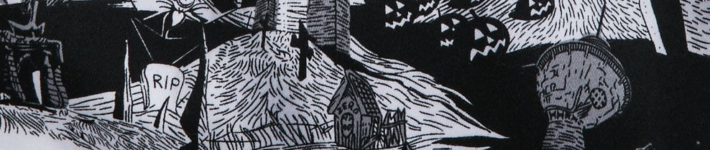
Paragraph 19
- How is the relationship between the narrator and Paula presented?
- How does Plath give prominence to the presence of the oil slick on the road?
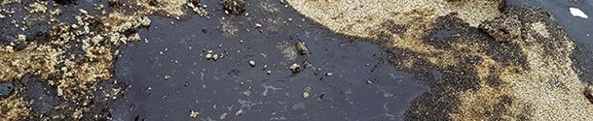
Review Task
- Make list of the contrasts you can spot between the first half and the second half of the story so far.
Paragraph 22
- What mood is conveyed by the silence of the children as they watch Paula fall into the oil slick?
- What does the ‘dull, green light of later afternoon’ reflect?
Paragraph 23
- What is emphasised by the ‘black cat’s fur’ simile?
- What is Paula ‘searching for’ in the aftermath of the fall?
Paragraph 27
- What is suggested by the narrator’s emphatic denial?
- How is the narrator’s confusion highlighted?
Paragraph 42
- How do the colours used in the final paragraph contrast to the colours used in the first?
- What does the narrator mean when she talks about ‘the real world’?
Review Task
- Make a list of adjectives that describe the narrator’s mood at the end of the story.

