Lamb to the Slaughter
Roald Dahl

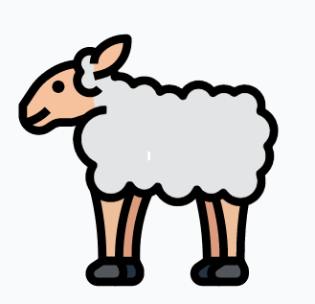

Lamb to the Slaughter
Comprehension Questions: First Half

- Neat handwriting
- Accurate spelling
- Correct use of apostrophes
- Answer in full sentences
- Use the language of the questions in the answers

- Is the room warm or cold?
- How many table lamps are lit?
- What time does Patrick arrive home?
- Finish the quote: ‘She took his coat and…’
- Finish the quote: ‘For her, this was always…’
- How does Patrick reply when asked if he is tired?
- What does Mary initially offer Patrick to eat?
- What object does Mary remove from the freezer?
- What does Mary do with the object?
- What time does Mary visit the grocer?

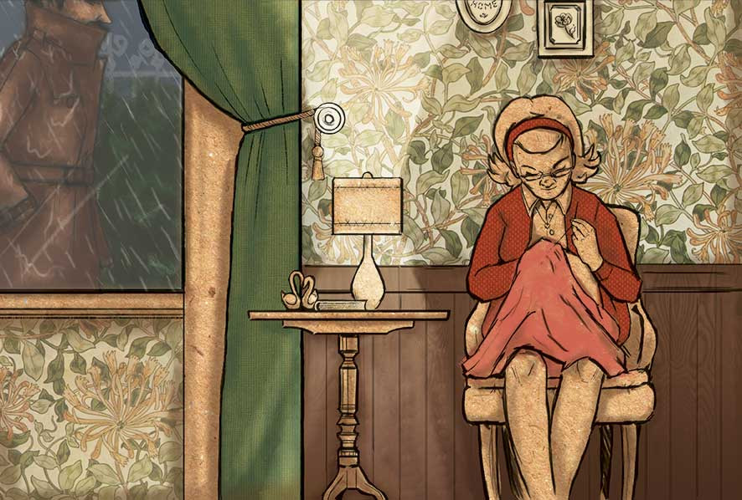
Lamb to the Slaughter
Comprehension Questions: Second Half

- Neat handwriting
- Accurate spelling
- Correct use of apostrophes
- Answer in full sentences
- Use the language of the questions in the answers

- What two items does Mary initially order from the grocer’s shop?
- What does Mary say she has in the freezer?
- What time does Patrick arrive home?
- What does the grocer suggest Mary buys for desert?
- Finish the quote: ‘She was just going home with…’
- What was ‘no acting’ necessary for?
- What does Sergeant Noonan wrongly believe the murder weapon is?
- What is Sergeant Noonan’s first name?
- What does Mary offer the policemen to eat?
- At the end of the story, what does Mary do?

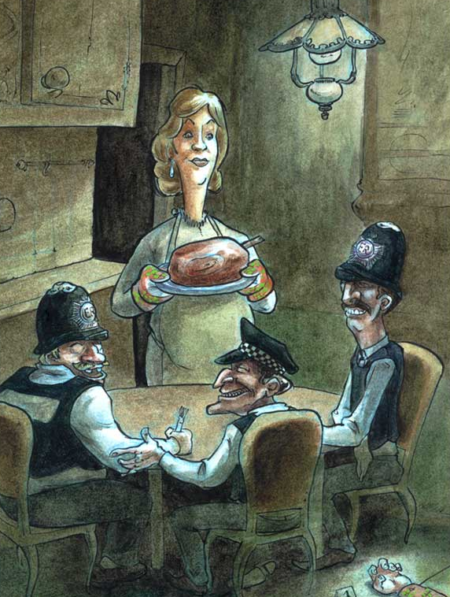
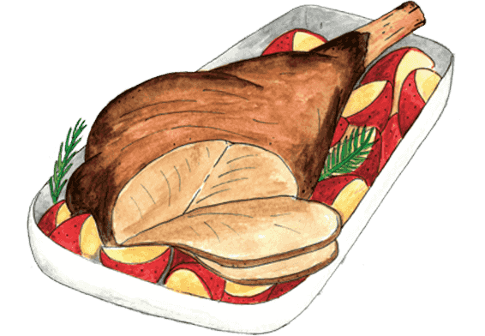
Lamb to the Slaughter
Review Tasks

- Neat handwriting
- Accurate spelling

- Write down two adjectives to describe Mary Maloney and then find a supporting quotation for each one

- ‘The room was warm, the curtains were clossed, to table lamps were lit’ – correct the two spelling errors

- ‘She took his coat and hung it up’ – write down what this quotation reveals about Mary

- Write down the adjective that does not accurately describe Patrick: tense | awkward | friendly | secretive

- Write down a definition of the adverb ‘punctually’

- ‘As the wife of a detecktive, she new what the punishment wud be’ – correct the three spelling errors

- ‘The two detectives were exceptionally nice to her’ – write down two reasons to explain their behaviour

- Write down the adjective that accurately describes Mary at the end of the story: distraught | relieved

- Write down an adjective to describe Jack Noonan and then find a supporting quotation

- Write a full sentence to explain why Mary begins to laugh at the end of the story

