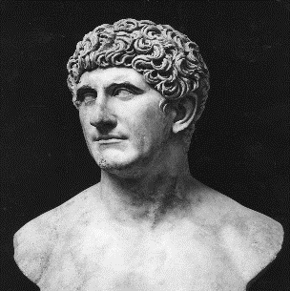 | 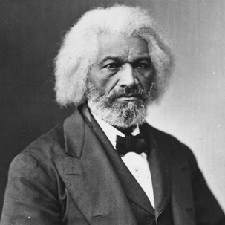 | 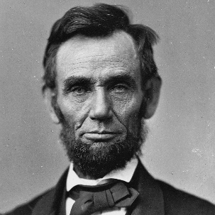 | 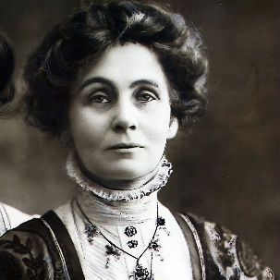
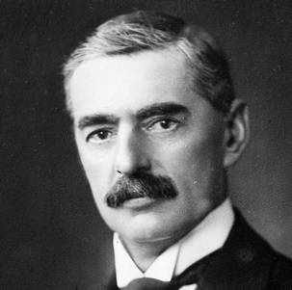 | 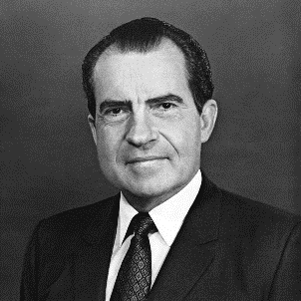 | 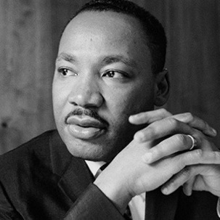 | 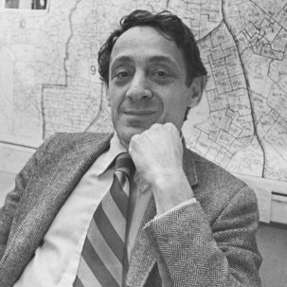
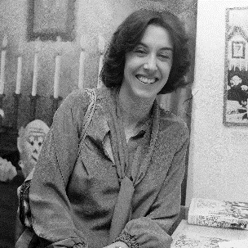 | 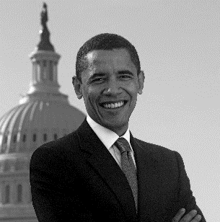 | 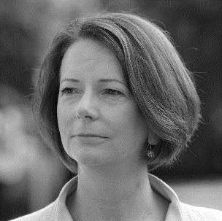 | 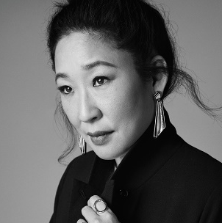

- Ethos Establish your authority with your audience

- Pathos Affect the emotions of the audience

- Logos Present a plausible argument to the audience

An Introduction to Rhetoric

Mr Wise

Year 9

The opening words of Mark Anthony’s funeral oration in Julius Caesar, by William Shakespeare

At the point in the play, Julius Ceasar has recently been murdered by a group of conspirators who were fearful that he was becoming too powerful. A senator named Brutus landed the final blow. Against the advice of those closest to him, Brutus has allowed Mark Anthony – a former ally of Ceasar – to speak at the funeral. However, it is he who speaks first. When his turn comes,

Mark Antony begins his speech with an attempt to align himself with the mourners who have gathered in the crowd. He knows that Brutus is popular, so he doesn’t want to make it too obvious that he feels Brutus was wrong to commit the murder. However, he also wants to subtly convey his enduring loyalty to Caesar. A difficult balancing act!

BRUTUS Romans, countrymen, and lovers! Hear me for my
Cause, and be silent, that you may hear: believe me
For mine honour, and have respect to mine honour, that
You may believe: censure me in your wisdom, and
Awake your senses, that you may the better judge.
If there be any in this assembly, any dear friend of
Caesar’s, to him I say, that Brutus’ love to Caesar
Was no less than his. If then that friend demand
Why Brutus rose against Caesar, this is my answer:
Not that I loved Caesar less, but that I loved
Rome more.

…

ANTHONY Friends, Romans, countrymen, lend me your ears;
I come to bury Caesar, not to praise him.
The evil that men do lives after them;
The good is oft interred with their bones;
So let it be with Caesar. The noble Brutus
Hath told you Caesar was ambitious:
If it were so, it was a grievous fault,
And grievously hath Caesar answer’d it.
Here, under leave of Brutus and the rest –
For Brutus is an honourable man;
So are they all, all honourable men –
Come I to speak in Caesar’s funeral.
Part of Frederick Douglass’s Fourth of July speech at an Independence Day celebration in New York

Frederick Douglass was born into slavery in 1818, but managed to escape his plantation by posing as a ‘free’ sailor and travelling to New York. Just three years later, Douglass began to give lectures on behalf of the Massachusetts Anti-Slavery Society and he published a memoir of his life in 1845. From that point onwards, he became one of the most influential and respected members of the abolitionist movement.

In his 1852, Douglass was invited to address a crowd who had gathered to celebrate Independence Day. He used the opportunity to interrogate the concept of independence for enslaved African Americans and, as such, the relevance to them of the Declaration of Independence at a time when there was widespread inequality and injustice.

DOUGLASS At a time like this, scorching irony, not convincing argument, is needed. O! had I the ability, and could reach the nation’s ear, I would, today, pour out a fiery stream of biting ridicule, blasting reproach, withering sarcasm, and stern rebuke. For it is not light that is needed, but fire; it is not the gentle shower, but thunder. We need the storm, the whirlwind, and the earthquake. The feeling of the nation must be quickened; the conscience of the nation must be roused; the propriety of the nation must be startled; the hypocrisy of the nation must be exposed; and its crimes against God and man must be proclaimed and denounced.

…

What, to the American slave, is your 4th of July? I answer; a day that reveals to him, more than all other days in the year, the gross injustice and cruelty to which he is the constant victim. To him, your celebration is a sham; your boasted liberty, an unholy license; your national greatness, swelling vanity; your sounds of rejoicing are empty and heartless; your denunciation of tyrants, brass fronted impudence; your shouts of liberty and equality, hollow mockery; your prayers and hymns, your sermons and thanksgivings, with all your religious parade and solemnity, are, to Him, mere bombast, fraud, deception, impiety, and hypocrisy – a thin veil to cover up crimes which would disgrace a nation of savages. There is not a nation on the earth guilty of practices more shocking and bloody than are the people of the United States, at this very hour. Go where you may, search where you will, roam through all the monarchies and despotisms of the Old World, travel through South America, search out every abuse, and when you have found the last, lay your facts by the side of the everyday practices of this nation, and you will say with me, that, for revolting barbarity and shameless hypocrisy, America reigns without a rival.

Abraham Lincoln’s Gettysburg address delivered at the Gettysburg National Cemetery

Gettysburg was the site of a particularly bloody battle between Union and Confederacy troops during the American Civil War in 1863. It is estimated that over 50,000 men were killed or seriously wounded over a period of three days. Afterwards, many of the dead soldiers were hurriedly buried and a local lawyer called David Wills campaigned to turn the site into national cemetery.

Wills asked Abraham Lincoln, the sixteenth President of the United State of American, to speak at cemetery dedication just a few months later. And he agreed, delivering a speech that lasted for only two minutes. However, despite its brevity, Lincoln’s ‘Gettysburg Address’ swiftly became one of the most memorable and influential speeches in American history.

LINCOLN Four score and seven years ago, our fathers brought forth on this continent a new nation, conceived in liberty, and dedicated to the proposition that all men are created equal. Now we are engaged in a great civil war, testing whether that nation, or any nation so conceived and so dedicated, can long endure. We are met on a great battlefield of that war. We have come to dedicate a portion of that field as a final resting place for those who here gave their lives that that nation might live. It is altogether fitting and proper that we should do this. But in a larger sense we cannot dedicate, we cannot consecrate, we cannot hallow this ground. The brave men, living and dead, who struggled here have consecrated it, far above our poor power to add or detract. The world will little note, nor long remember, what we say here, but it can never forget what they did here. It is for us the living, rather, to be dedicated here to the unfinished work which they who fought here have thus far so nobly advanced. It is rather for us to be here dedicated to the great task remaining before us, that from these honoured dead we take increased devotion to that cause for which they gave the last full measure of devotion, that we here highly resolve that these dead shall not have died in vain, that this nation, under God, shall have a new birth of freedom, and that government of the people, by the people, for the people, shall not perish from the earth.

Part of Emmeline Pankhurst’s Freedom or Death speech delivered in Connecticut

Through her tireless campaigning, and despite the very real risks and sacrifices involved, Emmeline Pankhurst played a vital role in helping women win the right to vote. Indeed, she delivered her speech just five months after Emily Davidson, a fellow Suffragette, stepped-out in front of King George V’s horse at the Epsom Derby and was trampled to death.

In her speech, given to a crowd gathered on the steps of the Parsons Theater in 1913, Pankhurst defiantly justifies the militant approach adopted by the British Suffragettes and argues that a show of force is necessary to achieve lasting and meaningful political change.

PANKHURST It is about eight years since the word militant was first used to describe what we were doing. It was not militant at all, except that it provoked militancy on the part of those who were opposed to it. When women asked questions in political meetings and failed to get answers, they were not doing anything militant. In Great Britain, it is a custom, a time-honoured one, to ask questions of candidates for parliament and ask questions of members of the government. No man was ever put out of a public meeting for asking a question. The first people who were put out of a political meeting for asking questions, were women; they were brutally ill-used; they found themselves in jail before 24 hours had expired.

We were called militant, and we were quite willing to accept the name. We were determined to press this question of the enfranchisement of women to the point where we were no longer to be ignored by the politicians.

You have two babies very hungry and wanting to be fed. One baby is a patient baby and waits indefinitely until its mother is ready to feed it. The other baby is an impatient baby and cries lustily, screams and kicks and makes everybody unpleasant until it is fed. Well, we know perfectly well which baby is attended to first. That is the whole history of politics. You have to make more noise than anybody else, you have to make yourself more obtrusive than anybody else, you have to fill all the papers more than anybody else, in fact you have to be there all the time and see that they do not snow you under.

Part of Neville Chamberlain’s speech to the House of Commons following the German invasion of Poland

Neville Chamberlain, Prime Minister at the time, addressed the House of Commons in 1939 to convey news of the recent invasion of Poland by the Germany army. A formal declaration of war between Britain and Germany would soon follow.

Chamberlain carefully sticks to important factual information and avoids making embellishments. However, his words convey strong moral judgements and his feelings about the German Chancellor, Adolf Hitler, are made very clear.

CHAMBERLAIN No man can say that the Government could have done more to try to keep open the way for an honourable and equitable settlement of the dispute between Germany and Poland. Nor have we neglected any means of making it crystal clear to the German Government that if they insisted on using force again in the manner in which they had used it in the past we were resolved to oppose them by force. Now that all the relevant documents are being made public we shall stand at the bar of history knowing that the responsibility for this terrible catastrophe lies on the shoulders of one man – the German Chancellor, who has not hesitated to plunge the world into misery in order to serve his own senseless ambitions.

…

Only last night the Polish Ambassador did see the German Foreign Secretary, Herr von Ribbentrop. Once again he expressed to him what, indeed, the Polish Government had already said publicly, that they were willing to negotiate with Germany about their disputes on an equal basis. What was the reply of the German Government? The reply was that, without another word, the German troops crossed the Polish frontier this morning at dawn and are since reported to be bombing open towns.

Part of Richard Nixon’s ‘Checkers’ speech delivered at the El Capitan Theatre in Los Angeles

Richard Nixon, a senator from California, won the nomination from the Republican Party to become the vice-presential candidate in 1952 for the forthcoming election. However, he swiftly became embroiled in a widely publicised scandal that centred on accusations of corruption. One of the charges made against him was the misappropriation of $18,000.

In response, Nixon defended himself in a speech delivered live to the nation. He made a particular effort to emphasise his credentials as an honest outsider (rather than a shifty member of the political establishment).

NIXON Now, the usual political thing to do when charges are made against you is to either ignore them or to deny them without giving details. I believe we’ve had enough of that in the United States, particularly with the present Administration in Washington.

…

I’m sure that you have read the charge, and you’ve heard it, that I, Senator Nixon, took $18,000 from a group of my supporters. Now, was that wrong? And let me say that it was wrong. I’m saying, incidentally, that it was wrong, not just illegal, because it isn’t a question of whether it was legal or illegal, that isn’t enough. The question is, was it morally wrong? I say that it was morally wrong if any of that $18,000 went to Senator Nixon, for my personal use. I say that it was morally wrong if it was secretly given and secretly handled. And I say that it was morally wrong if any of the contributors got special favours for the contributions that they made.

…

One other thing I probably should tell you, because if I don’t they’ll probably be saying this about me, too. We did get something, a gift, after the election. A man down in Texas heard Pat on the radio mention the fact that our two youngsters would like to have a dog. And believe it or not, the day before we left on this campaign trip we got a message from Union Station in Baltimore, saying they had a package for us. We went down to get it. You know what it was? It was a little cocker spaniel dog in a crate that he’d sent all the way from Texas, black and white, spotted. And our little girl Tricia, the six-year-old, named it ‘Checkers’. And you know, the kids, like all kids, love the dog, and I just want to say this, right now, that regardless of what they say about it, we’re gonna keep it.

Part of Martin Luther King’s address delivered at the March for Jobs and Freedom in Washington

Although slavery had been abolished in 1865, widespread segregation, discrimination and racially motivated violence against Black Americans and other people of colour persisted. However, through the Civil Rights Movement, which began during the 1950s, many Americans mobilised to fight for equality.

Martin Luther King delivered his speech in 1963 on the steps of the Lincoln Memorial to a crowd of over 250,000 people who had gathered to draw attention to the continuing injustices faced by Black Americans a century after Abraham Lincoln issued the Emancipation Proclamation.

KING I have a dream that one day on the red hills of Georgia, the sons of former slaves and the sons of former slave owners will be able to sit down together at the table of brotherhood.

I have a dream that one day even the state of Mississippi, a state sweltering with the heat of injustice, sweltering with the heat of oppression will be transformed into an oasis of freedom and justice.

I have a dream that my four little children will one day live in a nation where they will not be judged by the colour of their skin but by the content of their character. I have a dream today.

I have a dream that one day down in Alabama with its vicious racists, with its governor having his lips dripping with the words of interposition and nullification, one day right down in Alabama little Black boys and Black girls will be able to join hands with little white boys and white girls as sisters and brothers. I have a dream today.

I have a dream that one day every valley shall be exalted, every hill and mountain shall be made low, the rough places will be made plain, and the crooked places will be made straight, and the glory of the Lord shall be revealed, and all flesh shall see it together.

This is our hope. This is the faith that I go back to the South with. With this faith, we will be able to hew out of the mountain of despair a stone of hope. With this faith we will be able to transform the jangling discords of our nation into a beautiful symphony of brotherhood. With this faith we will be able to work together, to pray together, to struggle together, to go to jail together, to stand up for freedom together, knowing that we will be free one day.

Part of Harvey Milk’s speech delivered at the Gay Freedom Day Parade in San Francisco

Harvey Milk moved to San Francisco during the early 1970s and established himself as a prominent activist for the gay community. Widespread discrimination was pervasive at the time and continued to be long after the decade passed. Of course, homosexuality was illegal in all 50 American states until 1962 and it wasn’t until 2003 that all remaining same-sex laws were invalidated.

Milk delivered his speech to a large crowd on the steps of San Francisco Hall in June 1978. At the time, he had recently been elected to The Board of Supervisors – an important and influential legislative body. He was assassinated just a few months later.

MILK I know we are pressed for time so I'm going to cover just one more little point. That is to understand why it is important that gay people run for office and that gay people get elected. I know there are many people in this room who are running for central committee who are gay. I encourage you. There's a major reason why. If my non-gay friends and supporters in this room understand it, they'll probably understand why I've run so often before I finally made it. You see there is a major difference – and it remains a vital difference – between a friend and a gay person, a friend in office and a gay person in office. Gay people have been slandered nationwide. We've been tarred and we've been brushed with the picture of pornography. In Dade County, we were accused of child molestation. It's not enough anymore just to have friends represent us. No matter how good that friend may be..

…

The first gay people we elect must be strong. They must not be content to sit in the back of the bus. They must not be content to accept pabulum. They must be above wheeling and dealing. They must be – for the good of all of us – independent, unbought. The anger and the frustrations that some of us feel is because we are misunderstood, and friends can't feel the anger and frustration. They can sense it in us, but they can't feel it. Because a friend has never gone through what is known as coming out. I will never forget what it was like coming out and having nobody to look up toward. I remember the lack of hope - and our friends can't fulfil it.

…

So if there is a message I have to give, it is that I've found one overriding thing about my personal election, it's the fact that if a gay person can be elected, it's a green light. And you and you and you, you have to give people hope.
Part of Nora Ephron’s commencement address to students at Wellesley College

Nora Ephron, a successful writer and filmmaker, graduated from the prestigious Wellesley College in 1962 and was invited back to deliver a commencement address in 1996.

In her speech, Ephron highlights the progress made in America towards equal opportunities for women. However, she is also careful to convey words of caution and makes it clear that there is still much to be done if women are to access the same benefits and privileges enjoyed by men.

EPHRON Don't underestimate how much antagonism there is toward women and how many people wish we could turn the clock back. One of the things people always say to you if you get upset is, don't take it personally, but listen hard to what's going on and, please, I beg you, take it personally. Understand: Every attack on Hillary Clinton for not knowing her place is an attack on you. Underneath almost all those attacks are the words: Get back, get back to where you once belonged. When Elizabeth Dole pretends that she isn't serious about her career, that is an attack on you. The acquittal of O. J. Simpson is an attack on you. Any move to limit abortion rights is an attack on you – whether or not you believe in abortion. The fact that Clarence Thomas is sitting on the Supreme Court today is an attack on you.

Above all, be the heroine of your life, not the victim. Because you don't have the alibi my class had – this is one of the great achievements and mixed blessings you inherit: unlike us, you can't say nobody told you there were other options. Your education is a dress rehearsal for a life that is yours to lead. Twenty-five years from now, you won't have as easy a time making excuses as my class did. You won't be able to blame the deans, or the culture, or anyone else: you will have no one to blame but yourselves.

…

Whatever you choose, however many roads you travel, I hope that you choose not to be a lady. I hope you will find some way to break the rules and make a little trouble out there. And I also hope that you will choose to make some of that trouble on behalf of women. Thank you. Good luck. The first act of your life is over. Welcome to the best years of your lives.

Part of Barak Obama’s election night speech delivered in Chicago

Barak Obama became was elected as the forty fourth President of the United States in November 2008. He started the campaign as an outsider, but quickly gained widespread support in what was then – and still remains – a highly conservative country. Obama would go on to gain a second term in 2012.

In his election speech, which was delivered from behind bullet-proof glass, Obama emphasised that change had come to America and that further change would shortly follow.

OBAMA If there is anyone out there who still doubts that America is a place where all things are possible; who still wonders if the dream of our founders is alive in our time; who still questions the power of our democracy, tonight is your answer. It’s the answer told by lines that stretched around schools and churches in numbers this nation has never seen; by people who waited three hours and four hours, many for the very first time in their lives, because they believed that this time must be different; that their voice could be that difference. It’s the answer spoken by young and old, rich and poor, Democrat and Republican, black, white, Latino, Asian, Native American, gay, straight, disabled and not disabled – Americans who sent a message to the world that we have never been a collection of red states and blue states; we are, and always will be, the United States of America. It’s the answer that led those who have been told for so long by so many to be cynical, and fearful, and doubtful of what we can achieve to put their hands on the arc of history and bend it once more toward the hope of a better day. It’s been a long time coming, but tonight, because of what we did on this day, in this election, at this defining moment, change has come to America.

…

I was never the likeliest candidate for this office. We didn’t start with much money or many endorsements. Our campaign was not hatched in the halls of Washington – it began in the backyards of Des Moines and the living rooms of Concord and the front porches of Charleston. It was built by working men and women who dug into what little savings they had to give $5 and $10 and $20 to this cause. It grew strength from the young people who rejected the myth of their generation’s apathy; who left their homes and their families for jobs that offered little pay and less sleep; from the not-so- young people who braved the bitter cold and scorching heat to knock on the doors of perfect strangers; from the millions of Americans who volunteered and organised, and proved that more than two centuries later, a government of the people, by the people and for the people has not perished from this earth. This is your victory.
Part of Julia Gillard’s speech delivered in response to accusations of sexism by Tony Abbott

Julia Gillard was elected as Australia’s Prime Minister in 2010. She was the first woman to hold the role and, to date, remains the only woman to hold it.

In 2012, in response to cynical accusations of sexism by Tony Abbott, the Leader of the Opposition, Gillard delivered a speech to parliament in which she criticised the misogynistic treatment of female politicians and leaders. Gillard herself had long endured outrageous insults and comments based on her gender, both from other politicians and media commentators.

GILLARD The Leader of the Opposition says that people who hold sexist views and who are misogynists are not appropriate for high office. Well I hope the Leader of the Opposition has got a piece of paper and he is writing out his resignation. Because if he wants to know what misogyny looks like in modern Australia, he doesn't need a motion in the House of Representatives, he needs a mirror. That's what he needs.

…

He has said, and I quote, in a discussion about women being under-represented in institutions of power in Australia, the interviewer was a man called Stavros. The Leader of the Opposition says ‘If it's true, Stavros, that men have more power generally speaking than women, is that a bad thing?’ And then a discussion ensues, and another person says, ‘I want my daughter to have as much opportunity as my son.’ To which the Leader of the Opposition says, ‘Yeah, I completely agree, but what if men are by physiology or temperament, more adapted to exercise authority or to issue command?’ Then ensues another discussion about women's role in modern society, and the other person participating in the discussion says, ‘I think it's very hard to deny that there is an underrepresentation of women,’ to which the Leader of the Opposition says, ‘But now, there's an assumption that this is a bad thing.’

…

Good sense, common sense, proper process is what should rule this Parliament. That's what I believe is the path forward for this Parliament, not the kind of double standards and political game-playing imposed by the Leader of the Opposition now looking at his watch because apparently a woman's spoken too long.

Sandra Oh’s speech delivered during a surprise appearance at the Stop Asian Hate protest in Pittsburgh

Sandra Oh is an actor perhaps best known for her roles in Grey’s Anatomy and Killing Eve. She was born in Canada to Korean parents, both of whom moved to the country during the 1960s. In 2019, in recognition of her success, Oh was named as one of the most influential people in the world by Time Magazine.

In her speech, delivered in 2021 at the Stop Asian Hate protest, Oh emphasised urged the crowd to support members of the Asian-American community in the wake of recent shootings that claimed the lives of eight people – six of whom were Asian women.

OH For many of us in our community, this is the first time we were even able to voice our fear and our anger. And I really am so grateful for everyone willing to listen. I’m going to be very, very brief, but one thing that I know many of us in our community are very scared and I understand that. And one way to go through and get through our fear is reach out to our community, reach out everyone here.

I will offer a challenge everyone here, if you see something, will you help me? If you see one of our sisters and brothers in need, would you help us? So, we must understand, as Asian Americans, we need to reach out our hand to our sisters or brothers and say, ‘Help me.’ And I’m here. And just for one thing, I am proud to be Asian. I want to hear you. I am proud to be Asian. I belong here. I am proud to be Asian. I belong here. Many of us don’t have that chance to be able to say that, so I just wanted to give us an opportunity to be able to shout that. Thank you so much.

