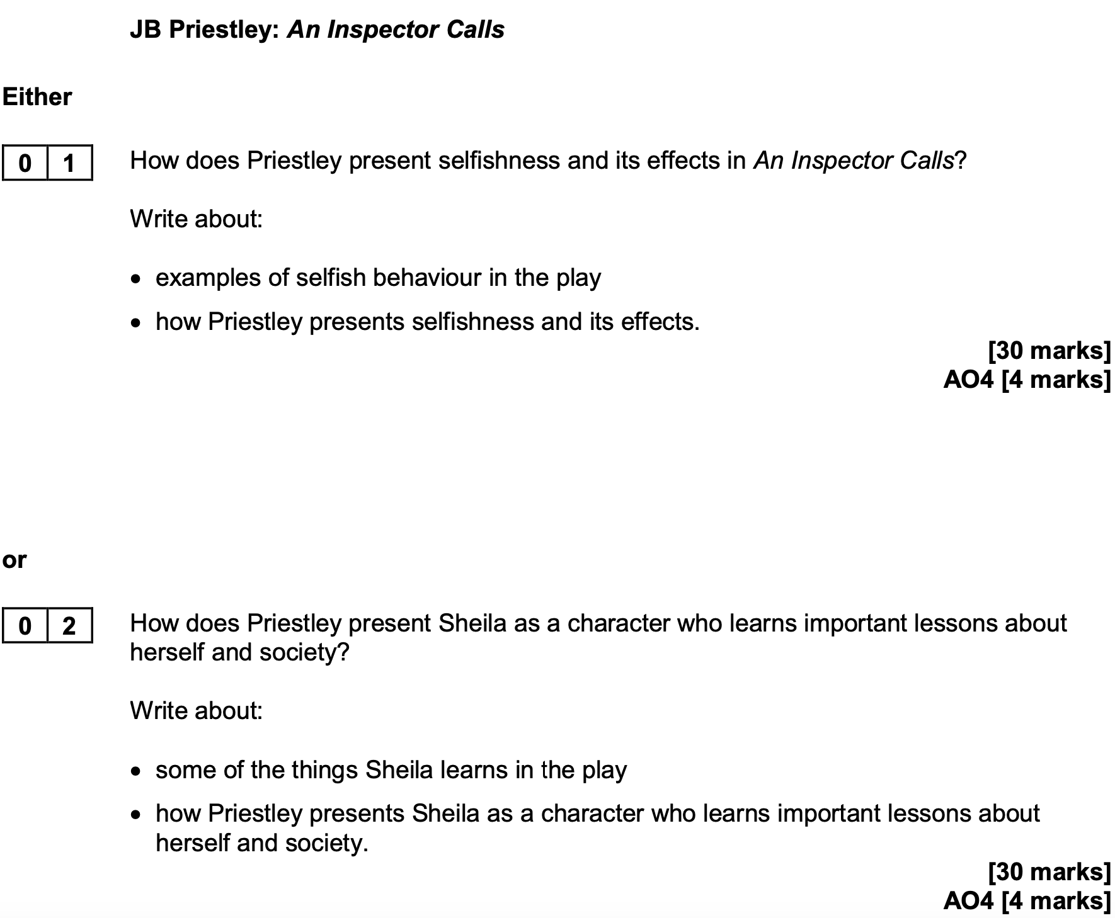

How does Priestley present selfishness
and its effects in An Inspector Calls?

In An Inspector Calls, Priestley shows that selfishness can have serious effects on other people’s lives. He uses the characters in the play to show different types of selfish behaviour and how it leads to bad consequences.  One character who is selfish is Mr Birling. He only cares about his business and profits. He says that ‘a man has to mind his own business and look after himself’, which shows he doesn’t care about others. As a result of his attitude, he sacks Eva Smith from his factory just for asking for higher wages. This leads to her getting into more trouble later.  Another selfish character is Mrs Birling. She refuses to help Eva when she comes to her charity. She says that Eva is lying and says, ‘I used my influence to have her case refused.’ This shows she is more concerned about her reputation than helping someone in need. Because of her selfishness, Eva had nowhere else to turn.  Sheila is a character who is selfish at the beginning of the play. She uses her position to get Eva sacked from the shop. However, she soon realises her mistake. Sheila says she feels ‘really responsible,’ which shows she is learning. This shows that people can change and learn to be less selfish.  Priestley uses the Inspector to show how selfishness causes suffering. The Inspector says, ‘We are members of one body,’ meaning we should all care about each other. Priestley wanted the audience to think about how their actions affect others, especially after the two World Wars.  In conclusion, Priestley presents selfishness as something that harms others. Through the different characters, he shows that selfish actions have bad effects, but also that people can change and become more caring. |  | Add a bit about how selfishness particularly affects the most vulnerable and choose a more precise word to replace ‘bad’  Explain why Birling in particular has an obligation to care about others and  Explain how Eric challenges Birling’s decision to sack Eva Smith  Compare Mrs Birling’s behaviour with Mr Birling’s behaviour in Act One  Explain who Mrs Birling blames and what this shows about her  Explain why Sheila makes a complaint about Eva Smith  Provide further details about Sheila’s reaction and make a comparison with Mrs Birling  Explain what the metaphor of ‘one body’ shows about society  Add a point about the ‘millions and millions’ of other Eva Smiths  Add a further point about why the ending of the play arguably very optimistic

