GCSE English Language
Paper 1
50%

- The Company of Wolves, by Angela Carter 2

- The Metamorphosis, by Franz Kafka 3

- The Road, by Cormac McCarthy 4

- The Handmaid’s Tale, by Margaret Attwood 5

- Small Island, by Andrea Levy 6

- Circe, by Madeline Miller 7

- Jude the Obscure, by Thomas Hardy 8

- The Old Man and the Sea, by Ernest Hemingway 9

- The Bell Jar, by Sylvia Plath 10

- The Life of Pi, by Yann Martel 11

The Company of Wolves, by Angela Carter

One beast and only one howls in the woods by night.

The wolf is carnivore incarnate and he’s as cunning as he is ferocious; once he’s had a taste of flesh then nothing else will do.

At night, the eyes of wolves shine like candle flames, yellowish, reddish, but that is because the pupils of their eyes fatten on darkness and catch the light from your lantern to flash it back to you – red for danger; if a wolf’s eyes reflect only moonlight, then they gleam a cold and unnatural green, a mineral, a piercing colour. If the benighted traveller spies those luminous, terrible sequins stitched suddenly on the black thickets, then he knows he must run, if fear has not struck him stock-still.

But those eyes are all you will be able to glimpse of the forest assassins as they cluster invisibly round your smell of meat as you go through the wood unwisely late. They will be like shadows, they will be like wraiths, grey members of a congregation of nightmare; hark! his long, wavering howl… an aria of fear made audible.

The wolfsong is the sound of the rending you will suffer, in itself a murdering.

It is winter and cold weather. In this region of mountain and forest, there is now nothing for the wolves to eat. Goats and sheep are locked up in the byre, the deer departed for the remaining pasturage on the southern slopes – wolves grow lean and famished. There is so little flesh on them that you could count the starveling ribs through their pelts, if they gave you time before they pounced. Those slavering jaws; the lolling tongue; the rime of saliva on the grizzled chops – of all the teeming perils of the night and the forest, ghosts, hobgoblins, ogres that grill babies upon gridirons, witches that fatten their captives in cages for cannibal tables, the wolf is worst for he cannot listen to reason.

Q1 List four things about the wolves.

Q2 Look at paragraphs three and four. How does the writer use language to show that the wolves are dangerous creatures?

Q3 How has the writer structured the text to interest you as a reader?

Q4 A student said, ‘This part of the story creates a threatening mood’. To what extent do you agree?
The Metamorphosis, by Franz Kafka

One morning, as Gregor Samsa was waking up from anxious dreams, he discovered that in bed he had been changed into a monstrous verminous bug. He lay on his armour-hard back and saw, as he lifted his head up a little, his brown, arched abdomen divided up into rigid bow-like sections. From this height the blanket, just about ready to slide off completely, could hardly stay in place. His numerous legs, pitifully thin in comparison to the rest of his circumference, flickered helplessly before his eyes.

‘What’s happened to me?’ he thought. It was no dream. His room, a proper room for a human being, only somewhat too small, lay quietly between the four well-known walls. Above the table, on which an unpacked collection of sample cloth goods was spread out (Samsa was a traveling salesman) hung the picture which he had cut out of an illustrated magazine a little while ago and set in a pretty gilt frame. It was a picture of a woman with a fur hat and a fur boa. She sat erect there, lifting up in the direction of the viewer a solid fur muff into which her entire forearm disappeared.

Gregor’s glance then turned to the window. The dreary weather (the raindrops were falling audibly down on the metal window ledge) made him quite melancholy. ‘Why don’t I keep sleeping for a little while longer and forget all this foolishness,’ he thought. But this was entirely impractical, for he was used to sleeping on his right side, and in his present state he couldn’t get himself into this position. No matter how hard he threw himself onto his right side, he always rolled again onto his back. He must have tried it a hundred times, closing his eyes, so that he would not have to see the wriggling legs, and gave up only when he began to feel a light, dull pain in his side which he had never felt before.

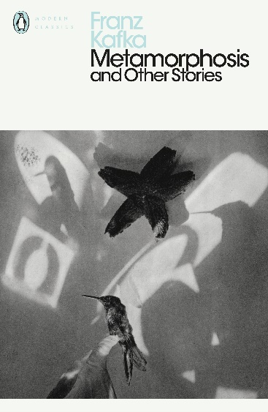

Q1 List four things about Gregor.

Q2 Look at paragraph one. How has writer used language to show that Gregor has completely transformed?

Q3 How has the writer structured the text to interest you as a reader?

Q4 A student said, ‘Gregor’s does not seem to be fully aware of that he has transformed into a beetle’. To what extent do you agree?
The Road, by Cormac McCarthy

With the first gray light he rose and left the boy sleeping and walked out to the road and squatted and studied the country to the south. Barren, silent, godless. He thought the month was October but he wasnt sure. He hadnt kept a calendar for years. They were moving south. There’d be no surviving another winter here.

When it was light enough to use the binoculars he glassed the valley below. Everything paling away into the murk. The soft ash blowing in loose swirls over the blacktop. He studied what he could see. The segments of road down there among the dead trees. Looking for anything of color. Any movement. Any trace of standing smoke. He lowered the glasses and pulled down the cotton mask from his face and wiped his nose on the back of his wrist and then glassed the country again. Then he just sat there holding the binoculars and watching the ashen daylight congeal over the land. He knew only that the child was his warrant. He said: If he is not the word of God, God never spoke.

When he got back the boy was still asleep. He pulled the blue plastic tarp off of him and folded it and carried it out to the grocery cart and packed it and came back with their plates and some cornmeal cakes in a plastic bag and a plastic bottle of syrup. He spread the small tarp they used for a table on the ground and laid everything out and he took the pistol from his belt and laid it on the cloth and then he just sat watching the boy sleep. He’d pulled away his mask in the night and it was buried somewhere in the blankets. He watched the boy and he looked out through the trees toward the road. This was not a safe place. They could be seen from the road now it was day. The boy turned in the blankets. Then he opened his eyes. Hi, Papa, he said.

I’m right here.

I know.

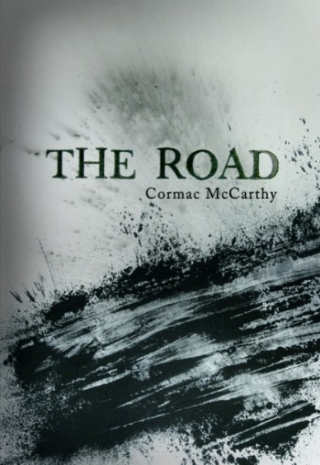

Q1 List four things about the landscape.

Q2 Look at paragraphs one and two. How has the writer used language to show that the landscape is desolate?

Q3 How has the writer structured the text to interest you as a reader?

Q4 A student said, ‘The father clearly cares for his son’. To what extent do you agree?
The Handmaid’s Tale, by Margaret Attwood

A chair, a table, a lamp. Above, on the white ceiling, a relief ornament in the shape of a wreath, and in the centre of it a blank space, plastered over, like the place in a face where the eye has been taken out. There must have been a chandelier, once. They’ve removed anything you could tie a rope to.

A window, two white curtains. Under the window, a window seat with a little cushion. When the window is partly open – it only opens partly – the air can come in and make the curtains move. I can sit in the chair, or on the window seat, hands folded, and watch this. Sunlight comes in through the window too, and falls on the floor, which is made of wood, in narrow strips, highly polished. I can smell the polish. There’s a rug on the floor, oval, of braided rags. This is the kind of touch they like: folk art, archaic, made by women, in their spare time, from things that have no further use. A return to traditional values. Waste not want not. I am not being wasted. Why do I want?

On the wall above the chair, a picture, framed but with no glass: a print of flowers, blue irises, water-colour. Flowers are still allowed. Does each of us have the same print, the same chair, the same white curtains, I wonder? Government issue?

Think of it as being in the army, said Aunt Lydia.

A bed. Single, mattress medium-hard, covered with a flocked white spread. Nothing takes place in the bed but sleep; or no sleep. I try not to think too much. Like other things now, thought must be rationed. There’s a lot that doesn’t bear thinking about. Thinking can hurt your chances, and I intend to last. I know why there is no glass, in front of the watercolour picture of blue irises, and why the window only opens partly and why the glass in it is shatterproof. It isn’t running away they’re afraid of. We wouldn’t get far. It’s those other escapes, the ones you can open in yourself, given a cutting edge.

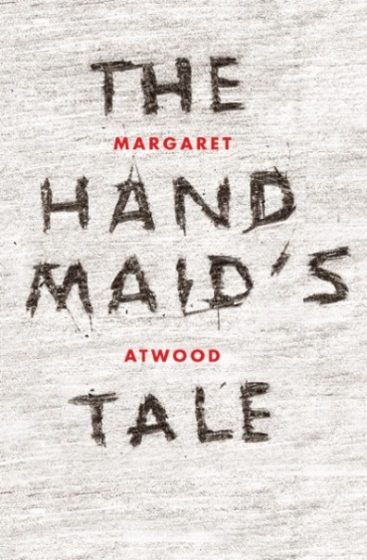

Q1 List four things about the room.

Q2 Look at the whole text. How has the writer used language to show that the speaker feels trapped?

Q3 How has the writer structured the text to interest you as a reader?

Q4 A student said, ‘The speaker clearly wants to escape from the room’. To what extent do you agree?
Small Island, by Andrea Levy

It brought it all back to me. Celia Langley. Celia Langley standing in front of me, her hands on her hips and her head in a cloud. And she is saying: ‘Oh, Hortense, when I am older’ (all her dreaming began with ‘when I am older’). ‘When I am older, Hortense, I will be leaving Jamaica and I will be going to live in England.’ This is when her voice became high-class and her nose pointed into the air – well, as far as her round flat nose could – and she swayed as she brought the picture to her mind’s eye. ‘Hortense, in England I will have a big house with a bell at the front door and I will ring the bell.’ And she made the sound, ding-a-ling, ding-a-ling. ‘I will ring the bell in this house when I am in England. That is what will happen to me when I am older.’

I said nothing at the time. I just nodded and said, ‘You surely will, Celia Langley, you surely will!’ I did not dare to dream that it would one day be I that would go to England. It would one day be I that would sail on a ship as big as a world and feel the sun’s heat on my face gradually change from roasting to caressing. But there was I! Standing at the door of a house in London and ringing the bell. Pushing my finger to hear the ding-a-ling, ding-a-ling. Oh, Celia Langley, where were you then with your big ideas and your nose in the air? Could you see me? Could you see me there in London? Hortense Roberts married with a gold ring and a wedding dress in a trunk. Mrs Joseph. Mrs Gilbert Joseph. What you think of that, Celia Langley? There was I in England ringing the doorbell on one of the tallest houses I had ever seen.

But when I pressed this doorbell I did not hear a ring. No ding-a-ling, ding-a-ling. I pressed once more in case the doorbell was not operational. The house, I could see, was shabby.

Q1 List four things about Celia Langley.

Q2 Look at paragraph two. How has the writer used language to show that Hortense feels excited?

Q3 How has the writer structured the text to interest you as a reader?

Q4 A student said, ‘Hortense seems to view Celia as a big rival’. To what extent do you agree?
Circe, by Madeline Miller

When I was born, the name for what I was did not exist. They called me nymph, assuming I would be like my mother and aunts and thousand cousins. Least of the lesser goddesses, our powers were so modest they could scarcely ensure our eternities. We spoke to fish and nurtured flowers, coaxed drops from the clouds or salt from the waves. That word, nymph, paced out the length and breadth of our futures. In our language, it means not just goddess, but bride.

My mother was one of them, a naiad, guardian of fountains and streams. She caught my father’s eye when he came to visit the halls of her own father, Oceanos. Helios and Oceanos were often at each other’s tables in those days. They were cousins, and equal in age, though they did not look it. My father glowed bright as just-forged bronze, while Oceanos had been born with rheumy eyes and a white beard to his lap. Yet they were both Titans, and preferred each other’s company to those new-squeaking gods upon Olympus who had not seen the making of the world.

Oceanos’ palace was a great wonder, set deep in the earth’s rock. Its high-arched halls were gilded, the stone floors smoothed by centuries of divine feet. Through every room ran the faint sound of Oceanos’ river, source of the world’s fresh waters, so dark you could not tell where it ended and the rock-bed began. On its banks grew grass and soft gray flowers, and also the unnumbered children of Oceanos, naiads and nymphs and river-gods. Otter-sleek, laughing, their faces bright against the dusky air, they passed golden goblets among themselves and wrestled, playing games of love. In their midst, outshining all that lily beauty, sat my mother.

Her hair was a warm brown, each strand so lustrous it seemed lit from within. She would have felt my father’s gaze, hot as gusts from a bonfire. I see her arrange her dress so it drapes just so over her shoulders. I see her dab her fingers, glinting, in the water. I have seen her do a thousand such tricks a thousand times. My father always fell for them. He believed the world’s natural order was to please him.

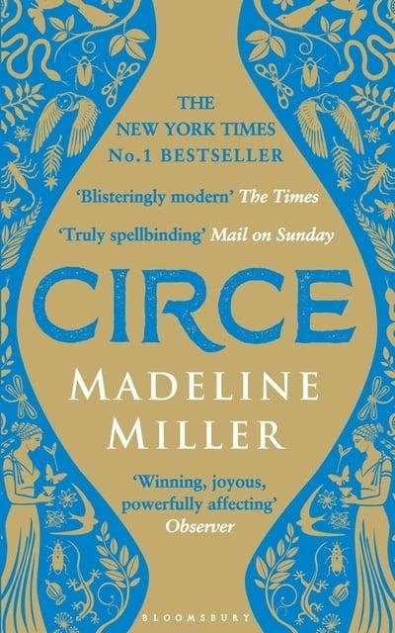

Q1 List four things about Circe.

Q2 Look at paragraph two. How has the writer used language to show that Helios is a powerful figure?

Q3 How has the writer structured the text to interest you as a reader?

Q4 A student said, ‘Circe’s mother seems to be just as powerful as Helios’. To what extent do you agree?
Jude the Obscure, by Thomas Hardy

He ascended the ladder to have one more look at the point the men had designated, and perched himself on the highest rung, overlying the tiles. He might not be able to come so far as this for many days. Perhaps if he prayed, the wish to see Christminster might be forwarded. People said that, if you prayed, things sometimes came to you, even though they sometimes did not. He had read in a tract that a man who had begun to build a church, and had no money to finish it, knelt down and prayed, and the money came in by the next post. Another man tried the same experiment, and the money did not come; but he found afterwards that the breeches he knelt in were made by a wicked person. This was not discouraging, and turning on the ladder Jude knelt on the third rung, where, resting against those above it, he prayed that the mist might rise.

He then seated himself again, and waited. In the course of ten or fifteen minutes the thinning mist dissolved altogether from the northern horizon, as it had already done elsewhere, and about a quarter of an hour before the time of sunset the westward clouds parted, the sun’s position being partially uncovered, and the beams streaming out in visible lines between two bars of slaty cloud. The boy immediately looked back in the old direction.

Some way within the limits of the stretch of landscape, points of light like the topaz gleamed. The air increased in transparency with the lapse of minutes, till the topaz points showed themselves to be the vanes, windows, wet roof slates, and other shining spots upon the spires, domes, freestone-work, and varied outlines that were faintly revealed. It was Christminster, unquestionably; either directly seen, or miraged in the peculiar atmosphere. The spectator gazed on and on until the windows and vanes lost their shine, going out almost suddenly like extinguished candles. The vague city became veiled in mist. Turning to the west, he saw that the sun had disappeared. The foreground of the scene had grown funereally dark, and near objects put on the hues and shapes of chimaeras.

Q1 List four things about Jude.

Q2 Look at paragraph three. How has the writer used language to show that Christminister is a beautiful place?

Q3 How has the writer structured the text to interest you as a reader?

Q4 A student said, ‘I doubt Jude will ever be able to study in Christminister.’ To what extent do you agree?
The Old Man and the Sea, by Ernest Hemingway

He was an old man who fished alone in a skiff in the Gulf Stream and he had gone eighty-four days now without taking a fish. In the first forty days a boy had been with him. But after forty days without a fish the boy’s parents had told him that the old man was now definitely and finally salao, which is the worst form of unlucky, and the boy had gone at their orders in another boat which caught three good fish the first week. It made the boy sad to see the old man come in each day with his skiff empty and he always went down to help him carry either the coiled lines or the gaff and harpoon and the sail that was furled around the mast. The sail was patched with flour sacks and, furled, it looked like the flag of permanent defeat.

The old man was thin and gaunt with deep wrinkles in the back of his neck. The brown blotches of the benevolent skin cancer the sun brings from its reflection on the tropic sea were on his cheeks. The blotches ran well down the sides of his face and his hands had the deep-creased scars from handling heavy fish on the cords. But none of these scars were fresh. They were as old as erosions in a fishless desert.

Everything about him was old except his eyes and they were the same color as the sea and were cheerful and undefeated.

‘Santiago,’ the boy said to him as they climbed the bank from where the skiff was hauled up. ‘I could go with you again. We’ve made some money.’

The old man had taught the boy to fish and the boy loved him.

‘No,’ the old man said. ‘You’re with a lucky boat. Stay with them.’

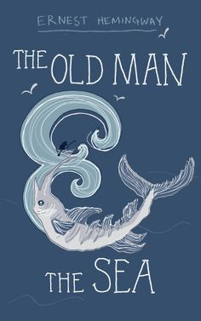

Q1 List four things about the boy.

Q2 Look at paragraph two. How has the writer used language to show that the man is old?

Q3 How has the writer structured the text to interest you as a reader?

Q4 A student said, ‘The old man doesn’t seem to possess much luck’. To what extent do you agree?
The Bell Jar, by Sylvia Plath

I was supposed to be having the time of my life.

I was supposed to be the envy of thousands of other college girls just like me all over America who wanted nothing more than to be tripping about in those same size-seven patent leather shoes I’d bought in Bloomingdale’s one lunch hour with a black patent leather belt and black patent leather pocketbook to match. And when my picture came out in the magazine the twelve of us were working on – drinking martinis in a skimpy, imitation silver-lamé bodice stuck on to a big, fat cloud of white tulle, on some Starlight Roof, in the company of several anonymous young men with all-American bone structures hired or loaned for the occasion – everybody would think I must be having a real whirl.

Look what can happen in this country, they’d say. A girl lives in some out-of-the-way town for nineteen years, so poor she can’t afford a magazine, and then she gets a scholarship to college and wins a prize here and a prize there and ends up steering New York like her own private car.

Only I wasn’t steering anything, not even myself. I just bumped from my hotel to work and to parties and from parties to my hotel and back to work like a numb trolleybus. I guess I should have been excited the way most of the other girls were, but I couldn’t get myself to react. (I felt very still and very empty, the way the eye of a tornado must feel, moving dully along in the middle of the surrounding hullabaloo.)

There were twelve of us at the hotel.

We had all won a fashion magazine contest, by writing essays and stories and poems and fashion blurbs, and as prizes they gave us jobs in New York for a month, expenses paid, and piles and piles of free bonuses, like ballet tickets and passes to fashion shows and hair stylings at a famous expensive salon and chances to meet successful people in the field of our desire and advice about what to do with our particular complexions.

Q1 List four things about the speaker.

Q2 Look at paragraph four. How has the writer used language to show that the speaker is dissatisfied?

Q3 How has the writer structured the text to interest you as a reader?

Q4 A student said, ‘The speaker should be having the time of her life’. To what extent do you agree?
The Life of Pi, by Yann Martel

I was alone and orphaned, in the middle of the Pacific, hanging on to an oar, an adult tiger in front of me, sharks beneath me, a storm raging about me. Had I considered my prospects in the light of reason, I surely would have given up and let go of the oar, hoping that I might drown before being eaten. But I don’t recall that I had a single thought during those first minutes of relative safety. I didn’t even notice daybreak. I held on to the oar, I just held on, God only knows why.

The elements allowed me to go on living. The lifeboat did not sink. Richard Parker kept out of sight. The sharks prowled but did not lunge. The waves splashed me but did not pull me off.

I watched the ship as it disappeared with much burbling and belching. Lights flickered and went out. I looked about for my family, for survivors, for another lifeboat, for anything that might bring me hope. There was nothing. Only rain, marauding waves of black ocean and the flotsam of tragedy.

The darkness melted away from the sky. The rain stopped.

I could not stay in the position I was in forever. I was cold. My neck was sore from holding up my head and from all the craning I had been doing. My back hurt from leaning against the lifebuoy. And I needed to be higher up if I were to see other lifeboats.

In the morning I could not move. I was pinned by weakness to the tarpaulin. Even thinking was exhausting. I applied myself to thinking straight. At length, as slowly as a caravan of camels crossing a desert, some thoughts came together.

I thought of sustenance for the first time. I had not had a drop to drink or a bite to eat or a minute of sleep in three days. Finding this obvious explanation for my weakness brought me a little strength.

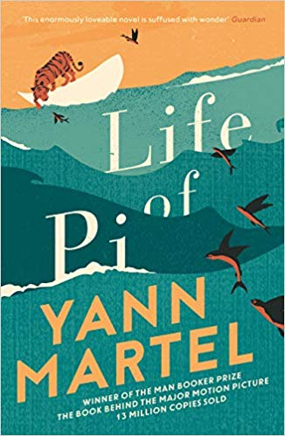

Q1 List four things about the speaker.

Q2 Look at paragraphs six and seven. How has the writer used language to show that the speaker is frail?

Q3 How has the writer structured the text to interest you as a reader?

Q4 A student said, ‘The speaker is lucky to be alive’. To what extent do you agree?
Section B: Writing
You are advised to spend about 45 minutes on this section.
Write in full sentences.
You are reminded of the need to plan your answer.
You should leave enough time to check your work at the end.

A magazine has asked for contributions for their creative writing section.

Either

Write a story set in the city of a foreign country as suggested by this picture:

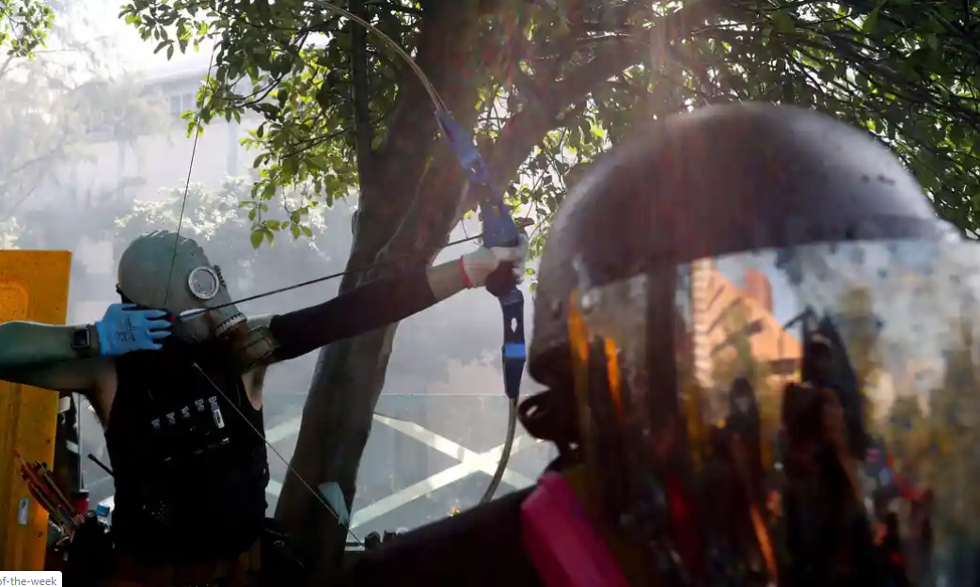

or

Write a story that begins with the sentence: ‘I knew immediately that I would have to make a choice.’

(24 marks for content and organisation
16 marks for technical accuracy)

Section B: Writing
You are advised to spend about 45 minutes on this section.
Write in full sentences.
You are reminded of the need to plan your answer.
You should leave enough time to check your work at the end.

Your local newspaper is running a creative writing competition and the best entries will be published.

Either

Write a story about a festival or carnival as suggested by this picture:

or

Write a story about a situation that involved a big surprise.

(24 marks for content and organisation
16 marks for technical accuracy)

Section B: Writing
You are advised to spend about 45 minutes on this section.
Write in full sentences.
You are reminded of the need to plan your answer.
You should leave enough time to check your work at the end.

An online competition for story writing is being held and you have decided to enter.

Either

Describe an adventure as suggested by this picture:

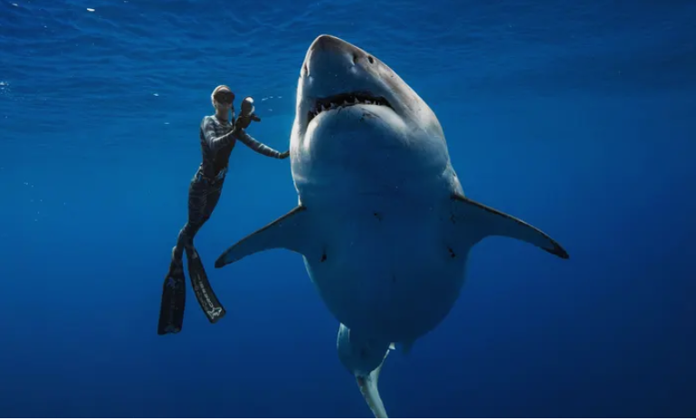

or

Write a story with the title ‘Escape’.

(24 marks for content and organisation
16 marks for technical accuracy)

Section B: Writing
You are advised to spend about 45 minutes on this section.
Write in full sentences.
You are reminded of the need to plan your answer.
You should leave enough time to check your work at the end.

You have decided to enter a creative writing competition.

Either

Describe two friends as suggested by this picture:

or

Write a story about people on a protest march.

(24 marks for content and organisation
16 marks for technical accuracy)

