Power and Conflict Poetry Pack
- Ozymandias, by Percy Bysshe Shelley
- London, by William Blake
- Extract from The Prelude, by William Wordsworth
- My Last Duchess, by Robert Browning

 | 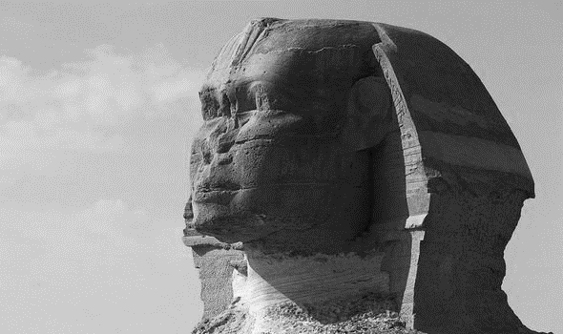 | 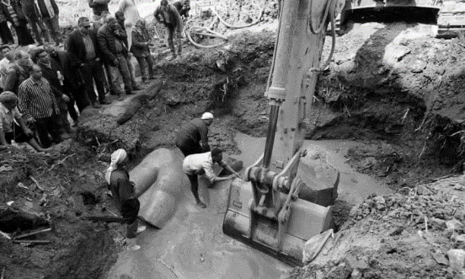
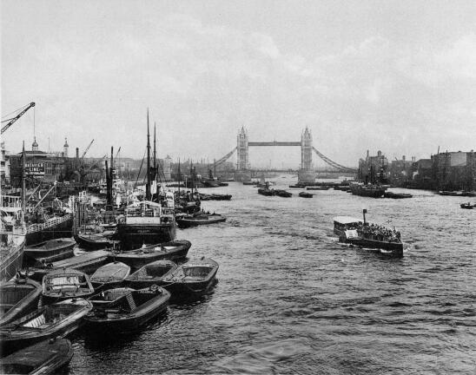 | 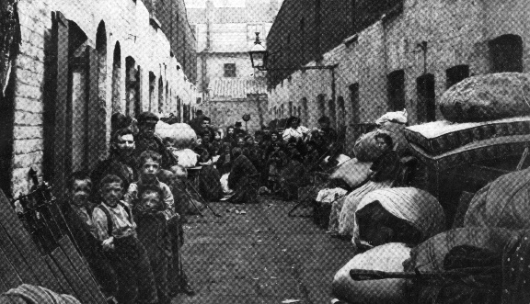 | 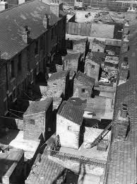
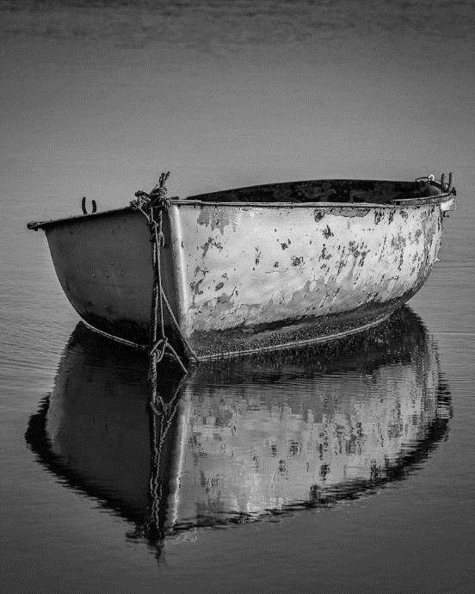 | 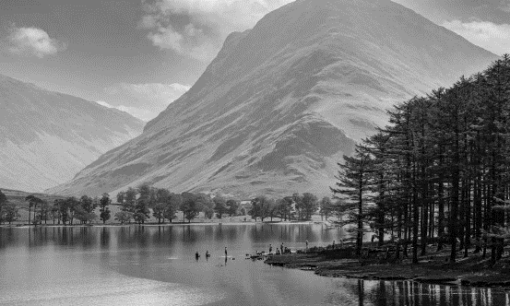 | 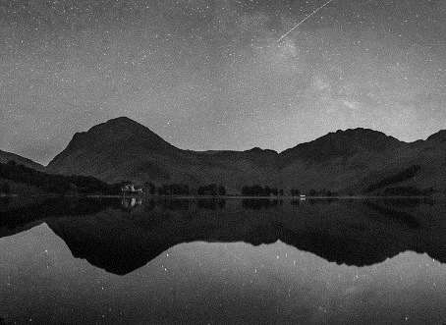
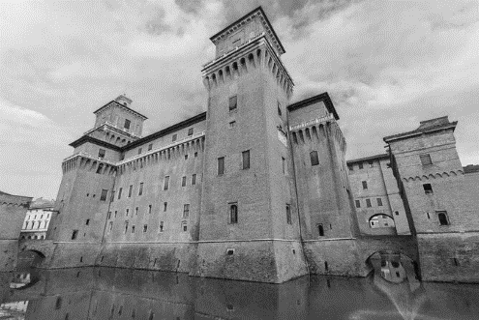 | 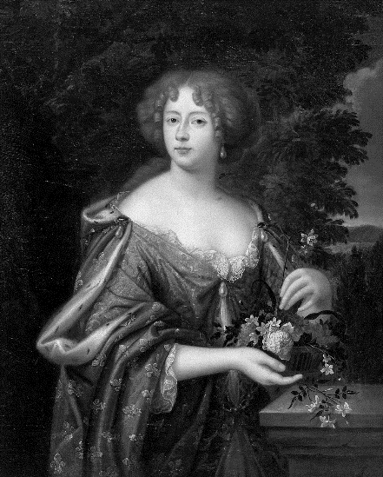 | 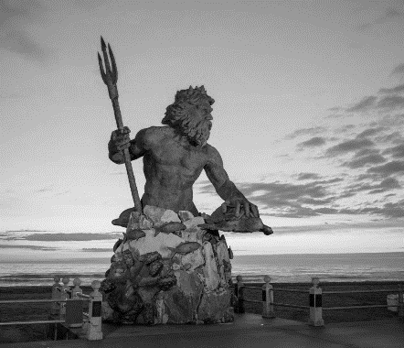
Ozymandias

- Define the word ‘antique’

- Identify the word that shows the ruined statue was once very large

- Identify the details that suggest Ozymandias was a ruthless, cruel leader

- Define the word ‘pedestal’

- Write down two things the inscription shows about Ozymandias

- Explain the difference between Ozymandias’s kingdom as it once was and what now remains of it

- What images stand out?

- What does the poem reveal about power?
I met a traveller from an antique land,
Who said: Two vast and trunkless legs of stone
Stand in the desert. Near them, on the sand,
Half sunk a shattered visage lies, whose frown
5 And wrinkled lip, and sneer of cold command
Tell that its sculptor well those passions read
Which yet survive, stamped on these lifeless things,
The hand that mocked them, and the heart that fed;
And on the pedestal, these words appear:
10 ‘My name is Ozymandias, King of Kings;
Look on my Works, ye Mighty, and despair!’
Nothing beside remains. Round the decay
Of that colossal wreck, boundless and bare,
The lone and level sands stretch far away.

Percy Bysshe Shelley

London

- Define the word ‘wander’

- Explain how the citizens of London seem to feel

- Identify two emotions suggested by the word ‘cry’

- Define the word ‘manacles’

- Identify the reference to child labour

- Identify an emotion suggested by the word ‘sigh’

- Identify an image connected to violence

- Identify an image that convey a sense of misery

- What sights and sounds are associated with London?

- What emotions are associated with London?

- What does the poem show about the effects of power?

I wander thro’ each charter’d street,
Near where the charter’d Thames does flow,
And mark in every face I meet
Marks of weakness, marks of woe.

5 In every cry of every man,
In every Infants cry of fear,
In every voice: in every ban,
The mind-forg’d manacles I hear:

How the chimney-sweeper’s cry
10 Every black’ning Church appalls,
And the hapless soldier’s sigh
Runs in blood down palace walls.

But most through midnight streets I hear
How the youthful harlot’s curse
15 Blasts the new-born infant’s tear
And blights with plagues the marriage hearse.

William Blake

Extract from The Prelude
One summer evening (led by her) I found
A little boat tied to a willow tree
Within a rocky cove, its usual home.
Straight I unloosed her chain, and stepping in

- Define the word ‘stealth’

- Provide one reason why stealing the boat might result in the mixed emotion of ‘troubled pleasure’

- Choose an image that conveys a sense of tranquillity

- Explain why the light on the water is ‘sparkling’

- Retrieve a short quotation that shows the speaker is in control

- Explain how the movement of the boat is similar to the movement of a swan

- Explain what ‘struck and struck’ shows about the speaker’s movement

- Identify what ‘towers up’ as the speaker looks at the horizon
5 Pushed from the shore. It was an act of stealth
And troubled pleasure, nor without the voice
Of mountain-echoes did my boat move on;
Leaving behind her still, on either side,
Small circles glittering idly in the moon,
10 Until they melted all into one track
Of sparkling light. But now, like one who rows,
Proud of his skill, to reach a chosen point
With an unswerving line, I fixed my view
Upon the summit of a craggy ridge,
15 The horizon’s utmost boundary; far above
Was nothing but the stars and the grey sky.
She was an elfin pinnace; lustily
I dipped my oars into the silent lake,
And, as I rose upon the stroke, my boat
20 Went heaving through the water like a swan;
When, from behind that craggy steep till then
The horizon’s bound, a huge peak, black and huge,
As if with voluntary power instinct,
Upreared its head. I struck and struck again,
25 And growing still in stature the grim shape
Towered up between me and the stars, and still,
For so it seemed, with purpose of its own
And measured motion like a living thing,
Strode after me. With trembling oars I turned,

- Identify the word that shows that speaker is fearful

- Explain where the speaker returns to at this stage of the poem

- Choose a word to describe the speaker’s emotions

- Look back at the other page and identify another reference to darkness

- Explain what ‘troubles’ the speaker’s dreams

- What images stand out?

- What contrasting emotions does the speaker experience?

- What examples of power are there in the poem?

30 And through the silent water stole my way
Back to the covert of the willow tree;
There in her mooring-place I left my bark,
And through the meadows homeward went, in grave
And serious mood; but after I had seen
35 That spectacle, for many days, my brain
Worked with a dim and undetermined sense
Of unknown modes of being; o’er my thoughts
There hung a darkness, call it solitude
Or blank desertion. No familiar shapes
40 Remained, no pleasant images of trees,
Of sea or sky, no colours of green fields;
But huge and mighty forms, that do not live
Like living men, moved slowly through the mind
By day, and were a trouble to my dreams.

William Wordsworth

My Last Duchess
Ferrara

- Who is the painting of that is displayed on the wall?

- What is the name of the artist?

- What does the Duke invite his guest to do?

- Define the word ‘countenance’

- What is it that only the Duke is allowed to do?

- What do those who look at the painting ask the Duke?

- What emotion is painted onto the face of the Duchess?

- Explain how Frà Pandolf might have been ‘courteous’ to the Duchess

- Identify the line that suggests the Duchess was easy to please

- Identify the line that suggests the Duchess was eager to attract attention

That’s my last Duchess painted on the wall,
Looking as if she were alive. I call
That piece a wonder, now; Frà Pandolf’s hands
Worked busily a day, and there she stands.
5 Will’t please you sit and look at her? I said
‘Fra Pandolf’ by design, for never read
Strangers like you that pictured countenance,
The depth and passion of its earnest glance,
But to myself they turned (since none puts by
10 The curtain I have drawn for you, but I)
And seemed as they would ask me, if they durst,
How such a glance came there; so, not the first
Are you to turn and ask thus. Sir, ‘twas not
Her husband’s presence only, called that spot
15 Of joy into the Duchess’ cheek: perhaps
Frà Pandolf chanced to say, ‘Her mantle laps
Over my lady’s wrist too much,’ or ‘Paint
Must never hope to reproduce the faint
Half-flush that dies along her throat’: such stuff
20 Was courtesy, she thought, and cause enough
For calling up that spot of joy. She had
A heart – how shall I say? – too soon made glad,
Too easily impressed; she liked whate’er
She looked on, and her looks went everywhere.
25 Sir, ‘twas all one! My favour at her breast,
The dropping of the daylight in the West,
The bough of cherries some officious fool
Broke in the orchard for her, the white mule
She rode with round the terrace – all and each

- Look at this part of the poem and the final lines on the previous page and identify two things that made the Duchess happy

- Identify the reference to the Duke’s status as an aristocrat

- Explain what the Duke means when he says he does have ‘skill in speech’

- Retrieve a short quotation that shows the Duke was jealous

- Choose a word to describe the tone of this part of the poem

- Explain what the Duke is attempting to arrange

- Identify who Neptune might represent

- How is power used in the poem?

30 Would draw from her alike the approving speech,
Or blush, at least. She thanked men – good! but thanked
Somehow – I know not how – as if she ranked
My gift of a nine-hundred-years-old name
With anybody’s gift. Who’d stoop to blame
35 This sort of trifling? Even had you skill
In speech – which I have not – to make your will
Quite clear to such an one, and say, ‘Just this
Or that in you disgusts me; here you miss,
Or there exceed the mark’ – and if she let
40 Herself be lessoned so, nor plainly set
Her wits to yours, forsooth, and made excuse –
E’en then would be some stooping; and I choose
Never to stoop. Oh, sir, she smiled, no doubt,
Whene’er I passed her; but who passed without
45 Much the same smile? This grew; I gave commands;
Then all smiles stopped together. There she stands
As if alive. Will’t please you rise? We’ll meet
The company below, then. I repeat,
The Count your master’s known munificence
50 Is ample warrant that no just pretence
Of mine for dowry will be disallowed;
Though his fair daughter’s self, as I avowed
At starting, is my object. Nay, we’ll go
Together down, sir. Notice Neptune, though,
55 Taming a sea-horse, thought a rarity,
Which Claus of Innsbruck cast in bronze for me!

Robert Browning

