An Inspector Calls

Recap Tasks

Aristocracy | Socialism
Wealth | Equality
Capitalism | Society
Poverty | Welfare
 |  | Responsibility | Divide
 |  | Change | Message
 |  | Warning | Mouthpiece
 |  | Generation | Future
 |  |  |  | Stage Directions | Entrances
 |  |  |  | Lighting | Exits
 |  |  |  | Dramatic Irony | Tone
 |  |  |  | Symbolism | Contrast
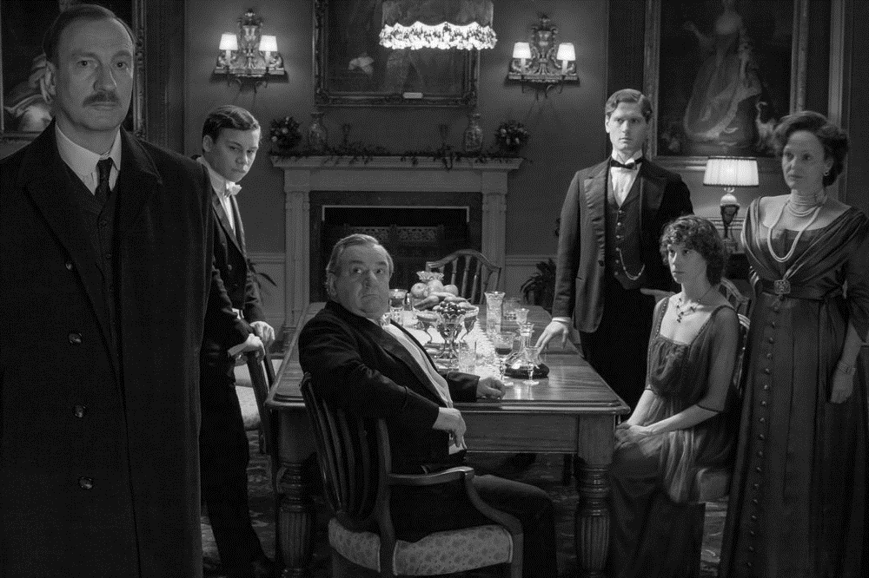

By reminding the audience about the inequalities and limitations of life for ‘millions and millions’ of people in 1912, and by hinting at the devastating conflicts to come, Priestley emphasises the importance of working together for greater social change. In this sense, the central message of the play is both a warning and a call for further action: a warning about the consequences of selfishness and a call to continue campaigning for a fairer and more socially responsible society. Remember that the Labour Party was elected in 1945 and the leader, Clement Attlee, made a pledge to provide welfare to all British citizens who needed it. In this this sense – despite the grizzly events that unfold on stage – the play is actually very optimistic.
Pages 161-2

- What are the Birling family celebrating?

- How do we know they are wealthy?

- Why is Sheila in an excitable mood?

…………………………………………………………………………………………………………………………………………………………………………………………

Pages 162-5

- What does Sheila tease Gerald about?

- What indications do we get that Eric has had too much to drink?

- What does Birling declare he is happy about?

- What are Birling’s hopes for the future regarding his business?

- What does Gerald present to Sheila?

…………………………………………………………………………………………………………………………………………………………………………………………

Pages 165-8

- What does Birling say about the prospect of war?

- What does he say about the Titanic?

- What does Birling suspect about Lady Croft’s feelings towards the marriage?

- What honour does Birling hope to receive?

…………………………………………………………………………………………………………………………………………………………………………………………

Pages 168-74

- What does the Inspector say he has come to investigate?

- What is the connection between Birling and Eva Smith?

- How does Birling attempt to deter the Inspector from asking him further questions?

…………………………………………………………………………………………………………………………………………………………………………………………

Pages 174-9

- What did Birling do that Sheila believes was ‘mean’?

- What is the connection between Sheila and Eva?

…………………………………………………………………………………………………………………………………………………………………………………………

Pages 179-82

- Why was Sheila in Milwards?

- How do Sheila and Birling’s responses to the Inspector’s questions differ?

- What did Eva change her name to?

- How does Gerald inadvertently reveal that he knew her?

- What does Gerald plead Sheila to do?
Review of Act One

- In which year is the play set?

- How should the stage be lit prior to the arrival of the Inspector?

- How is Gerald described in the stage directions?

- What have the Birling family and Gerald had to drink, and what are they about to drink?

- Which character says, ‘Arthur, you’re not supposed to say such things’?

- Why are Lord and Lady Croft absent from the celebration?

- Which character says, ‘You can drink to me’?

- Birling says, ‘We’ve passed the worst of it’ – what is he alluding to?

- In which year did Birling serve as Lord Mayor?

- Is it Lord Croft or Lady Croft who feels that Gerald ‘might have done better’ for himself ‘socially’?

- How should the lighting change when the Inspector enters?

- How should the Inspector be dressed?

- How does the Inspector say that Eva died?

- In which year did Birling fire Eva Smith from his factory?

- Which character says, ‘Look – there’s nothing mysterious – or scandalous – about this business’?

- How much did Eva and the workforce want to earn?

- What is the name of the Chief Constable who Birling plays golf with?

- Which character says, ‘They’d all be broke – if I know them’?

- How old was Eva Smith before she died?

- What is the name of the shop that Eva found work in after she was fired by Birling?

- How long was it before she was taken on?

- Why was she considered to be ‘lucky’?

- Which character claims to have a headache and says, ‘I think I’d better turn in’?

- What did Eva Smith change her name to?

- How does Gerald react when he hears the name announced by the Inspector?

Pages 183-8

- Why does Gerald seem to want Sheila in the room?

- Who insists she should stay?

- What suggestion does Mrs Birling make to Sheila?

- What does Mrs Birling refuse to believe about Eric?

…………………………………………………………………………………………………………………………………………………………………………………………

Pages 188-93

- Where did Gerald meet Daisy?

- Who was Daisy receiving unwanted attention from at the time?

- How does the relationship between Gerald and Daisy develop?

…………………………………………………………………………………………………………………………………………………………………………………………

Pages 193-96

- What does Sheila return to Gerald?

- Which character leaves the room?

- What does Birling demand an apology from the Inspector?

- Which character’s absence is noted by Birling and Mrs Birling?

…………………………………………………………………………………………………………………………………………………………………………………………

Pages 196-201

- Why did Eva come to Mrs Birling?

- How did she introduce herself?

- Who did Mrs Birling say that Eva should seek support from?

- What does Mrs Birling finally realise at the end of the scene?

Review of Act Two

- Which character speaks first at the start of act two?

- Which character says, ‘He means I’m getting hysterical now’?

- How does Priestley describe Mrs Birling’s movement as she enters the scene?

- How is her tone of voice initially described?

- Which character says, ‘You’re looking tired, dear’?

- Which word, used by Mrs Birling, does Sheila believe is ‘silly’?

- Which character is ‘still a magistrate’?

- Which character has Mr Birling been persuading to go to bed?

- Sheila says that she doesn’t ‘want to get poor Eric into trouble’ – what does she reveal?

- In which month did Eva leave Milwards?

- What is the name of the theatre where Gerald meets Daisy Renton?

- How does Gerald describe the appearance of the ‘women of the town’?

- By contrast, how does he describe the appearance of Daisy?

- Which character says, ‘You were the wonderful Fairy Prince?

- What is the name of the alderman who had ‘wedged’ Daisy ‘into a corner’?

- What is the name of Gerald’s friend who gives him the key to ‘a nice little set of rooms’?

- Which character says, ‘Were you in love with her?’

- Sheila says to Gerald, ‘You must have adored it, Gerald’ – what is she referring to?

- In which month did Gerald end the affair?

- Which character says, ‘I don’t understand you, Inspector’?

- What is the name of Mrs Birling’s charity organisation?

- What name did Eva use when she appealed to the charity for help?

- On what grounds was Eva turned down by Mrs Birling?

- Which character says, ‘Mother – stop – stop!’?

- Which character is implicated in the suicide just before the act ends?

Pages 201-6

- What does Mrs Birling say Eric is not the ‘type’ to do?

- Where did Eric meet Eva?

- How much money does Eric admit to stealing?

- Why did he steal the money?

- How does Birling react to the new of the theft?

- Why did Eva refuse to accept the money?

…………………………………………………………………………………………………………………………………………………………………………………………

Pages 206-7

- How many ‘Eva Smiths and John Smiths’ does the Inspector say are still left?

- What warning does he give before leaving the stage?

…………………………………………………………………………………………………………………………………………………………………………………………

Pages 207-13

- What does Birling seem most concerned about?

- What does Sheila start to wonder about the Inspector?

- Which character returns to the room?

- What does Gerald say about the Inspector?

- What evidence does he have?

…………………………………………………………………………………………………………………………………………………………………………………………

Pages 213-20

- Who does Birling phone?

- What is Birling able to confirm after the phone call?

- Why does Eric believe that the confirmation changes nothing?
.
- Who does Gerald phone?

- What is Gerald able to confirm after the phone call?

- What announcement is made at the end of the scene?

Review of Act Three

- Which character speaks first at the start of act three?

- Which character says, ‘Besides, you’re not that type – you don’t get drunk’?

- What does Eric drink before engaging with the Inspector’s questions?

- In which month did Eric meet Eva?

- How much money did Eric give Eva?

- Which character says, ‘Your trouble is – you’ve been spoilt’?

- Which character speaks with ‘calm authority’?

- Which character is ‘nearly at breaking point’?

- How much money does Birling say he would give to Eva if he had the chance?

- How many ‘Eva Smiths and John Smiths’ does the Inspector say there are?

- Which character says, ‘there’ll be a public scandal’?

- Which character is the first to suspect that the Inspector might not be entirely ‘ordinary’?

- Which character says, ‘Probably a Socialist or some sort of crank’?

- Edna has a single line in act three – what is it?

- Which character declares that Inspector Goole ‘wasn’t a police officer’?

- Who does Birling call to verify that the Inspector is a ‘fake’?

- Which character says, ‘I suppose we’re all nice people now’?

- On what page does Sheila say her parents ‘don’t seem to understand’?

- On what page does Sheila say ‘won’t bring Eva Smith back to life’?

- What evidence does Gerald have for suggesting that Eva Smith might actually be ‘four or five different girls’?

- Why doesn’t Eric think it matters if this is the case or not?

- Who does Gerald call to check if ‘there’s a dead girl’?

- Which character says, ‘The whole story’s just a lot of moonshine’?

- Which character recalls the Inspector’s reference to ‘Fire and blood and anguish’?

- Which character says, ‘And a police inspector is on his way here – to ask some – questions’?

