A Christmas Carol
Charles Dickens
Study Booklet

1 | Context Snapshots
2 | Useful Words
3 | First Impressions of Ebenezer Scrooge
 | Writing Focus: Because-But Sentences
4 | Scrooge and Fred
 | Writing Focus: Because-But Sentences
5 | The Poor and Destitute
 | Writing Focus: Because-But Sentences
6 | The Ghost of Jacob Marley
 | Writing Focus: Before-After Sentences
7 | The Ghost of Christmas Past
 | Writing Focus: Not Only… But Also Sentences
8 | Childhood Memories
 | Writing Focus: This Shows Sentences
9 | Fezziwig’s Christmas Ball
 | Writing Focus: In Contrast Sentences + Mixed Practice Sentences
10 | The End of the Engagement
 | Writing Focus: Before-After Sentences
11 | The Ghost of Christmas Present
 | Writing Focus: Mixed Practice Sentences
12 | The Cratchit Family
 | Writing Focus: Before-After Sentences + Although Sentences
13 | Fred and His Wife
 | Writing Focus: Appositive Sentences
14 | Ignorance and Want
 | Writing Focus: Appositive Sentences
15 | The Theft of Scrooge’s Possessions
 | Writing Focus: Appositive Sentences
16 | The Death of Tiny Tim
 | Writing Focus: Above All Sentences
17 | The Death of Scrooge
 | Writing Focus: Mixed Practice Sentences
18 | Christmas Morning
 | Writing Focus: As Revealed Sentences

Context Snapshots

Overcrowding
The novel was published in 1843. At the time, London was rapidly expanding; between 1800 and 1900, the population grew from roughly one million people to over six million. As a result, overcrowding was a serious problem and the majority of Londoners lived in poverty. Look out for this later on in the novel: Bob Cratchit (Scrooge’s clerk) lives in cramped conditions and struggles to provide for his family.

Poverty
Writing in 1798, the economist Thomas Malthus argued that the population would soon grow too large to be sustained by current and future food supplies. He warned that this would lead to increased levels of poverty and, eventually, famine and premature death. His views are reflected in Stave One when Scrooge talks about the necessity of decreasing the ‘surplus population.’ However, we get an alternative and more optimistic perspective of the lives of the working poor in Stave Three through the Cratchit family. Bob is paid a meagre weekly wage of ‘fifteen copies of his Christian name’ but, nevertheless, the family seem happy to live in the moment and help each other make do with the limited resources available.

The Poor Law
In 1834, an amendment to the original Poor Law of 1601 was introduced that reduced the amount of welfare available to those in need and made entry to a workhouse conditional. Food and shelter were not provided to those who did not work in these harsh places. In some cases, families were separated and made to live in different areas of their assigned building; they were essentially powerless. The flawed idea behind the Poor Law Amendment Act of 1834 was to discourage those in poverty from relying on the state for support.

Ghosts
It was said that Dickens had ‘a hankering after ghosts.’ This isn’t to suggest that he believed in them, but it’s fair to say that he was interested by the literary possibilities they offered him. In the novel, ghosts have the capacity to be both frightening and comical. Jacob Marley’s ghost provides a good example of this: it has ‘death-cold eyes’ (frightening) and yet Scrooge also remarks that he is able to see ‘the two buttons on his coat’ through the transparent body (comical).

Transformation
Scrooge emerges from the ghostly visits as a completely changed man. He finally understands that the wealth he has accumulated should be used to help alleviate the struggles of others and bring greater happiness to their lives. In short, Scrooge now embodies the ideals of morality and social responsibility.

Useful Words

Connected to Greed
- Abundance A very large quantity of something
- Misanthropy A dislike of humankind
- Poverty The state of being extremely poor
- Parsimonious Very unwilling to spend money or use resources
- Miser A person who hoards wealth and spends as little money as possible
- Avarice Extreme greed for wealth and material gain
- Covetous Having a great desire to possess something belonging to someone else

Connected to Hardship
- Precarious Insecure or uncertain
- Destitute Extremely poor and lacking the means to provide for oneself
- Solitary Existing alone
- Stoical Enduring pain and hardship without showing one’s feelings or complaining
- Apprehension Anxiety or fear that something bad or unpleasant will happen
- Pity The feeling of sorrow and compassion caused by the suffering and misfortunes of others
- Poignant Evoking a keen sense of sadness or regret
- Grief Intense sorrow

Connected to Transformation
- Nostalgia A sentimental longing or wistful affection for a period in the past
- Remorse Deep regret or guilt
- Empathetic Showing an ability to understand and share the feelings of another
- Redemption The action of saving or being saved from sin, error, or evil
- Altruistic Showing a selfless concern for the well-being of others
- Morality Principles concerning the distinction between right and wrong or good and bad behaviour
- Benevolent Well-meaning and kindly
- Philanthropy The desire to promote the welfare of others, expressed especially by the donation of money

Literary Terms
- Stave Five parallel lines on which musical notes are written
- Gothic A genre of literature characterised by darkness, mystery, conflict, and the supernatural
- Didactic A text that is intended to teach a moral lesson
- Bildungsroman A text that focuses on the psychological and moral growth of a character
- Allegory A story, reference or image that reveals an important message or has a wider meaning
- Allusion An indirect reference
- Foreshadow A warning or indication about a future event
- Pathetic Fallacy The projection of human emotions onto the natural world
- Symbolism The use of images or objects to convey wider meanings
- Foil An intentional contrast between two characters
First Impressions of Ebenezer Scrooge

Quotations
- ‘Hard and sharp as flint, from which no steel had ever struck out generous fire’
- ‘The cold within him froze his old features, nipped his pointed nose, shriveled his check, stiffened his gait’
- ‘A frosty rime was on his head, and on his eyebrows, and his wiry chin’
- ‘No warmth could warm, nor wintery weather chill him’
- ‘No wind that below was bitter than he’
- ‘It was cold, bleak biting weather’
- ‘Scrooge had a very small fire, but the clerk’s fire was so very much smaller’

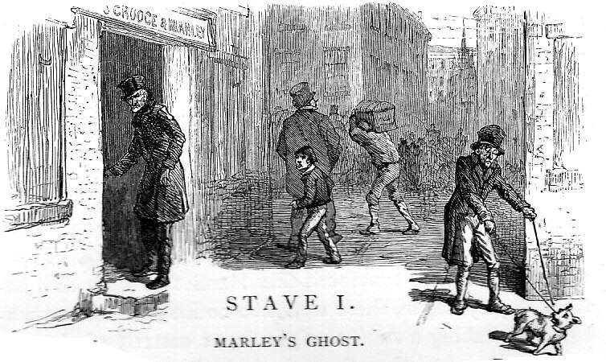

Questions to Consider
- What do we typically associate with cold weather?
- What are the connections between cold weather and someone who is described as ‘cold’?

Because-But Sentences
- The cold weather at the start of the chapter is significant because…
- The ‘cold within’ Scrooge is significant because…
- The ‘bleak biting weather’ doesn’t seem to affect Scrooge because…
- Nobody stops Scrooge in the street with ‘gladsome’ looks, but…
- Bob Cratchit has a fire in his area of the office, but…
- Bob tries to ‘warm himself’ by using his candle, but…

Scrooge and Fred

Questions to Consider
- How is the appearance of Fred different from the appearance of Scrooge?
- What does Fred associate with Christmas?
- What does Scrooge say is ‘more ridiculous than a merry Christmas’?
- Why does Scrooge refuse to say ‘Merry Christmas’ back to Fred?

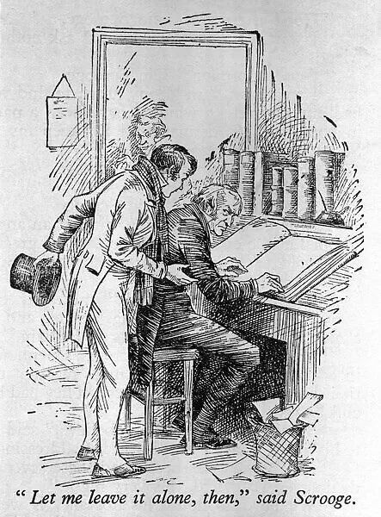

Because-But Sentences
- Scrooge says ‘humbug’ because…
- Scrooge believes that Christmas is not a time for celebration because…
- Scrooge says that those who convey Christmas greetings should be ‘boiled’ and ‘buried’, but…
- Scrooge becomes increasingly angry, but…

The Poor and Destitute

The Workhouse and the Treadmill
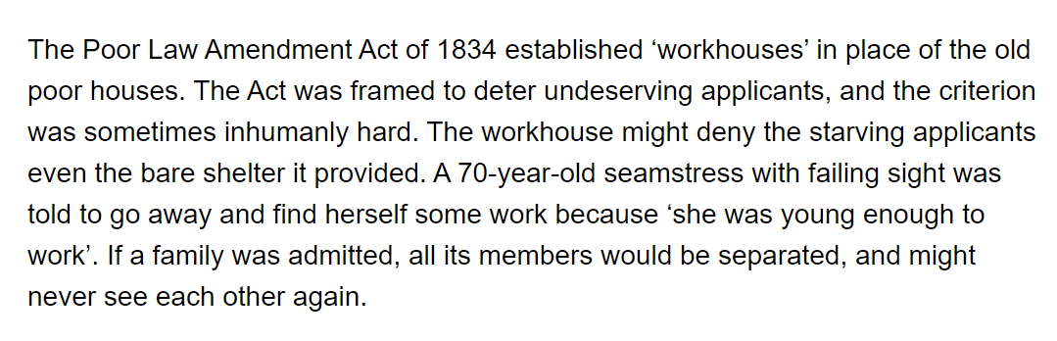

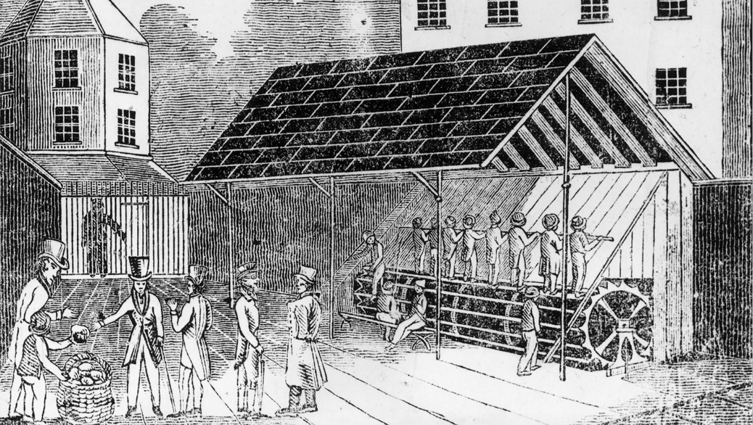

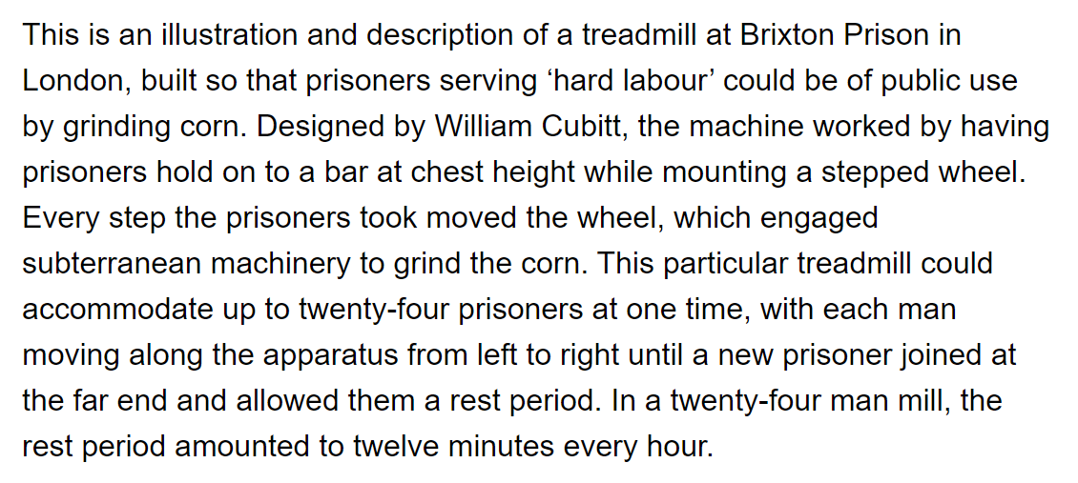

Because-But Sentences
- Fred leaves Scrooge’s office, but…
- Two ‘portly gentlemen’ approach Scrooge because…
- The ‘portly gentlemen’ highlight that ‘many are in want of common necessities’, but…
- Scrooge is in favour of decreasing the ‘surplus population’ because…
- The contrast between the ‘portly gentlemen’ and Scrooge is important because…
- This part of the novel is important because…

The Ghost of Jacob Marley

Questions to Consider
- What is the weather like when the Ghost of Marley first appears?
- How is Marley’s face described?
- How does Scrooge react to seeing it?
- What is the chain that binds him made of?
- How does Scrooge initially react to seeing the Ghost of Marley?
- What does the ghost do to make Scrooge react with ‘horror’?

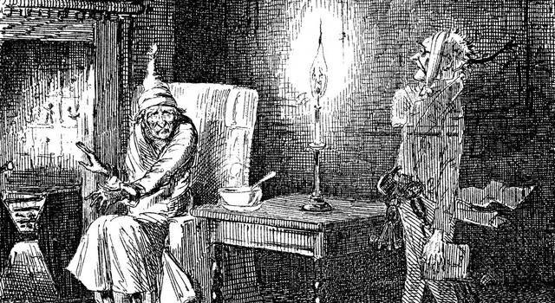

Quotations
- ‘he felt the _______ influence of its _______ cold eyes’
- ‘the specter’s voice _______ the very marrow in his _______’
- ‘Scrooge fell upon his _______ and _______ his hands before his face’
- ‘Scrooge _______ more and _______’
- ‘he _______ in a _______ voice’
- ‘He tried to say _______’ but stopped at the _______’

Before-After Sentences
- Before Scrooge enters his ‘gloomy suite of rooms’…
- After Scrooge sees the ‘ghostly’ face of Jacob Marley in the door knocker…
- Before Scrooge sees the ‘transparent’ Ghost of Jacob Marley…
- After the Ghost of Jacob Marley removes the ‘bandage round its head’…
- After Scrooge approaches the window…

The Ghost of Christmas Past

Questions to Consider
- What elements make the Ghost of Christmas Past such a ‘strange creature’?
- Why is the Ghost of Christmas Past presented in this way?

Vocabulary

Angular | Delicate | Frightening
Threatening | Ephemeral | Towering
Melancholy | Monstrous | Angry
Changeable | Gentle | Strong
Unpredictable | Shapeless | Radiant

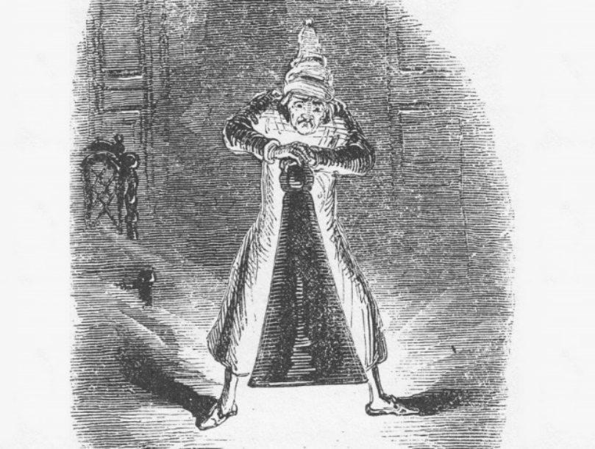

Not Only… But Also Sentences
- The appearance of the Ghost of Christmas Past is not only… [ ? ] but also… [ ? ]
- Scrooge’s reaction to the Ghost of Christmas Past is not only… [ ? ] but also… [ ? ]
- This part of the novel is important not only… [ ? ] but also… [ ? ]

Childhood Memories

Quotations
- ‘his eyes red, his thin lips blue’ (S1)
- ‘No wind that blew was bitterer than he’ (S1)
- ‘growled Scrooge’ (S1)
- ‘in a more facetious temper than was usual’ (S1)
- ‘his melancholy dinner in his usual melancholy tavern (S1)
- ‘Why did his cold eye glisten, and his heart leap up’ (S2)
- ‘Why was he filled with gladness’ (S2)
- ‘wept to see his poor forgotten self’ (S2)
- ‘Scrooge exclaimed in ecstasy’ (S2)
- ‘his heightened and excited face’ (S2)

Questions to Consider
- How are Scrooge’s emotions presented in Stave One?
- How are they presented in Stave Two?
- What more do we learn about Scrooge through his initial interactions with the Ghost of Christmas Present?

This Shows Sentences
- Scrooge is ‘filled with gladness’ when he is shown scenes from his childhood home. This shows…
- Scrooge weeps when he sees his ‘poor forgotten self’ in the school building. This shows…
- Scrooge exclaims ‘in ecstasy’ when he is shown Ali Baba and the parrot. This shows…
- Scrooge is no longer in the same ‘facetious tempter’ from Stave One. This shows…
Fezziwig’s Christmas Ball

Questions to Consider
- ‘with a rapidity of transition very foreign to his usual character’ – What does this show about Scrooge’s ‘usual character’?
- ‘with a mournful shaking of his head, glanced anxiously to the door’ – What does this show about Scrooge’s mood?
- ‘glared on Master Scrooge with a ferocious condescension – What does this show about the school master?
- ‘Scrooge seemed uneasy in his mind’ – What does this show about how Scrooge feels?

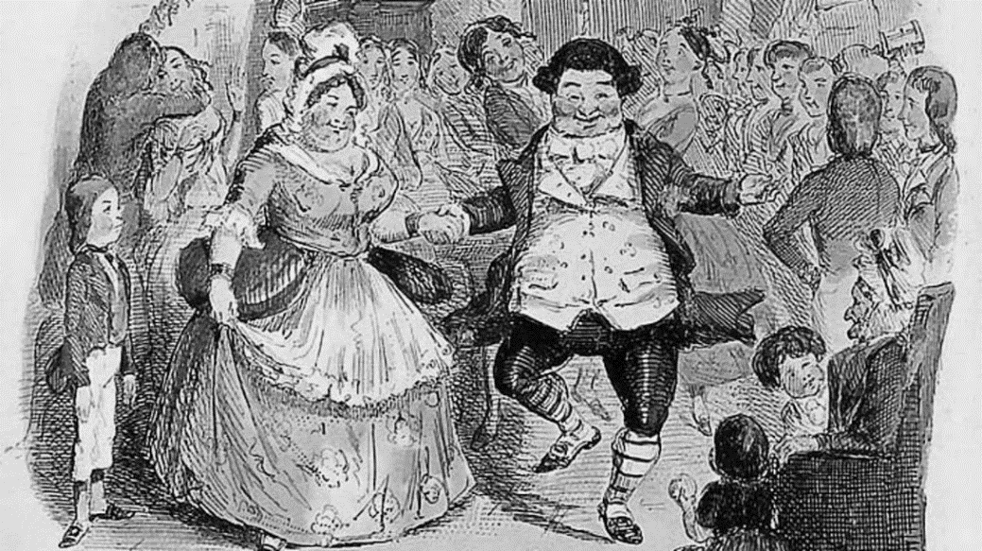

Quotations
- ‘He _______ his hands; adjusted his capacious waistcoat; _______ all over himself’
- ‘‘Hilli-ho!’ cried old Fezziwig, _______ down from the high desk with wonderful _______’
- ‘In came Mrs Fezziwig, one vast substantial _______’
- ‘The _______ in every part of the dance like _______’

Questions to Consider
- How is the character of Fezziwig presented?
- How is Fezziwig different to Scrooge as an employer?

In Contrast Sentences
- In contrast to how he is presented in Stave One, Scrooge…
- In contrast to how Scrooge treats Bob in Stave One, Fezziwig…
- In contrast to the atmosphere in Scrooge’s office, the atmosphere in Fezziwig’s office…

Mixed Practice Sentences
- Fezziwig is described as having an ‘oily, rich, fat, jovial voice’. This shows…
- Fezziwig announces that there will be ‘no more work to-night’ because…
- Dickens describes Scrooge and Dick Wilkins ‘panting like racehorses’ after they’ve cleared the room. This shows…
- Fezziwig’s joyfulness is not only shown through… [ ? ] but also… [ ? ]
- A ‘light’ appears to shine from Fezziwig’s calves as he dances. This shows…
- Scrooge says that ‘nothing particular’ is the matter after the scene ends, but…
- This part of the novel is not only important because… [ ? ] but also… [ ? ]
The End of the Engagement

Questions to Consider
- What views on marriage does Scrooge express in Stave One?
- Why does the relationship end between Belle and Scrooge?
- What do we learn about Belle’s life after she and Scrooge part?
- How do the lives of Belle and Scrooge differ?
- How does Scrooge react to what he sees?

Vocabulary

Angry | Apathetic | Agitated
Unaffected | Relieved | Melancholy
Distressed | Regretful | Anxious

Before-After Sentences
- Before the focus shifts to the conversation between Scrooge and Belle…
- After Belle says that ‘another idol’ has displaced her…
- Before Belle departs…
- After the Ghost of Christmas Past announces that he will show ‘one shadow more’…
- Before Belle’s husband enters the house…
- After Scrooge demands that the Ghost of Christmas Present ‘haunt him no longer’…

The Ghost of Christmas Present

Questions to Consider
- How does Scrooge feel as he waits for the Ghost of Christmas Present?
- How does his room transform?
- How is the Ghost Of Christmas Present described?
- What does the Ghost of Christmas Present show to Scrooge after he touches his robe?

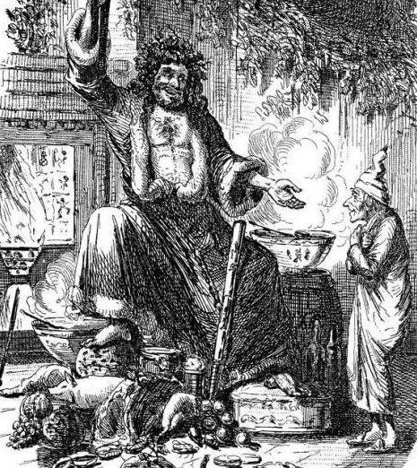

Mixed Practice Sentences
Because | But | Not only | But also | In contrast | Before | After

- _______ Scrooge sees the Ghost of Christmas Present, he sees a ‘ghostly light’ shining in the adjoining room
- The room is unrecognisable _______ it is decorated with ‘crisp leaves of holly’ and piled high with food
- The Ghost of Christmas Present has ‘clear and kind’ eyes, _______ Scrooge is reluctant to look at them
- Scrooge speaks ‘submissively’ to the Ghost of Christmas Present _______ he is now a humbler character
- _______ Scrooge touches the Ghost of Christmas Present’s robe, he is immediately transported outside
- The people are _______ ‘full of glee’, _______ ‘laughing heartily’ as they work
- The scene that Scrooge is shown is important _______ it captures the most important emotions of the day
- _______ to the Ghost of Jacob Marley, the Ghost of Christmas Present is a joyful and benevolent spirit

The Cratchit Family

Christmas Dinner
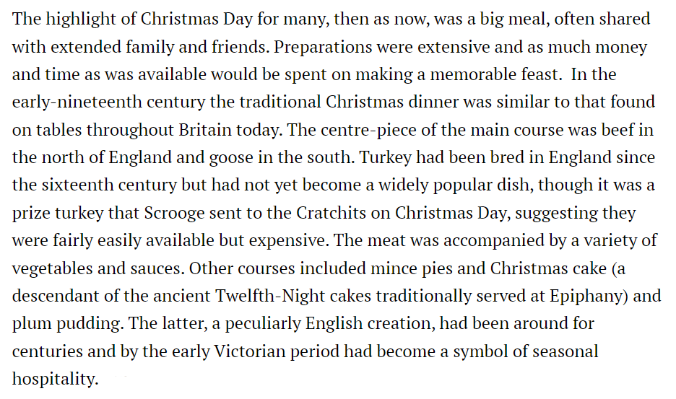

Before-After Sentences
- Before Bob enters the house…
- After Bob arrives…
- Before the goose is presented…
- After the goose is presented…

Although Sentences
- Although the Cratchit family are poor, they are…
- Although Tiny Tim needs his ‘limbs supported by an iron frame’, he
- Although the Bob’s wife believes that Scrooge is an ‘odious’ and ‘stingy’ man, Bob…
- Although the Cratchit family are described as ‘not handsome’ and ‘not well dressed’, they…
- Although Dickens presents an undoubtedly sentimental scene, he also provides a sense of realism by…

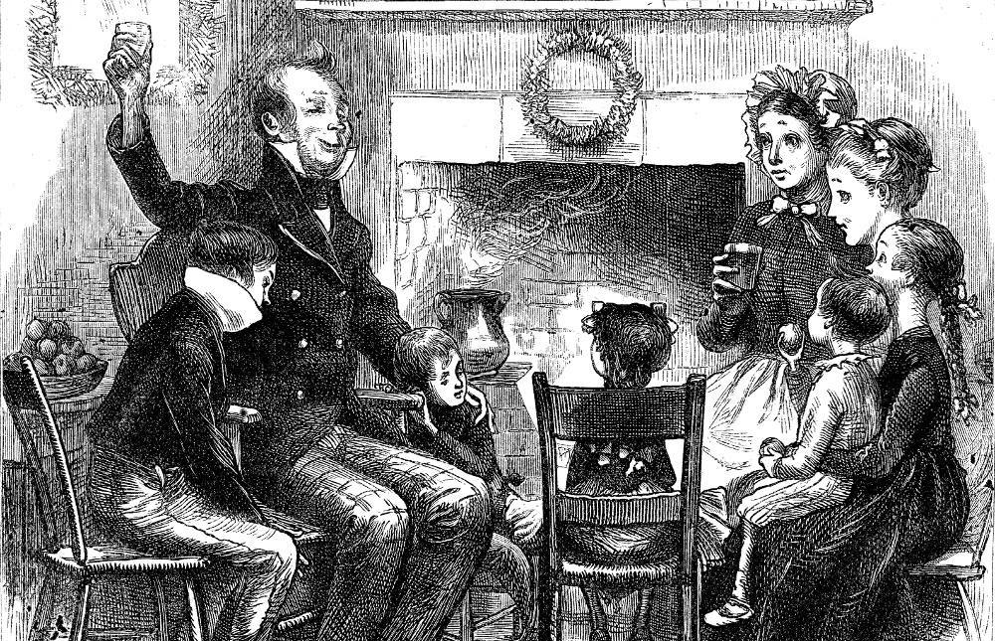

Fred and his Wife

Quotations
- ‘You’re poor enough’ (S1)
- ‘Don’t be angry, uncle. Come! Dine with us’ (S1)
- ‘‘Because you fell in love!’ growled Scrooge’ (S1)
- ‘his wealth is of no use to him’ (S3)
- ‘I think, that he loses some pleasant moments’ (S3)
- ‘I pity him’ (S3)

Vocabulary

Caring | Impolite | Hospitable
Sociable | Supportive | Selfish
Hostile | Surly | Unsympathetic
Joyful | Unfriendly | Contented

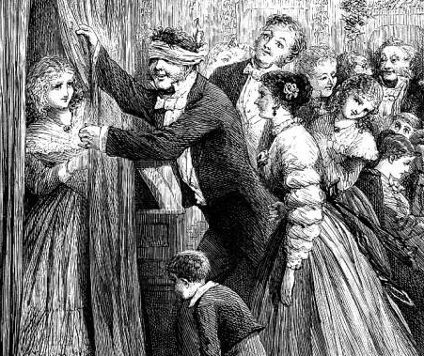

Appositive Sentences
of which Scrooge is the subject | like the one beforehand | his nephew | perhaps surprisingly | so happy together
- The Ghost of Christmas Present takes Scrooge to visit Fred, ____________________, who arrived at his office in Stave One
- The scene that unfolds in Fred’s house, ____________________, is full of joy
- Fred, ____________________, claims that he ‘couldn’t be angry’ with Scrooge
- Fred’s family, ____________________, embody the values of generosity and friendship that Dickens wanted to promote
- The Game of Yes and No, ____________________, is significant because it shows the foolishness of Scrooge’s behaviour
Ignorance and Want

Poverty

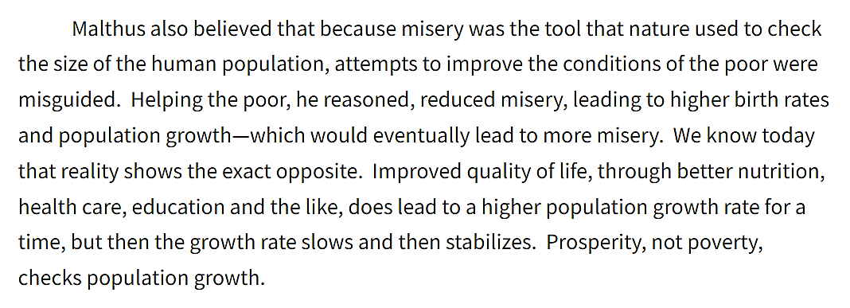

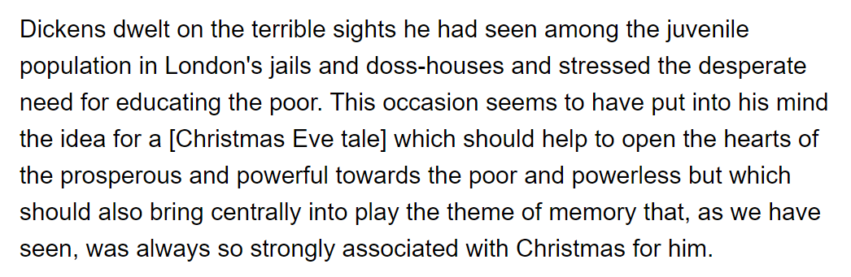

Questions to Consider
- What is Scrooge’s response when he is asked to make a charitable donation in Stave One?
- What ‘provision’ does he suggests the ‘poor and destitute’ should seek?
- What does Scrooge mean when he says, ‘they had better do it, and decrease the surplus population’?

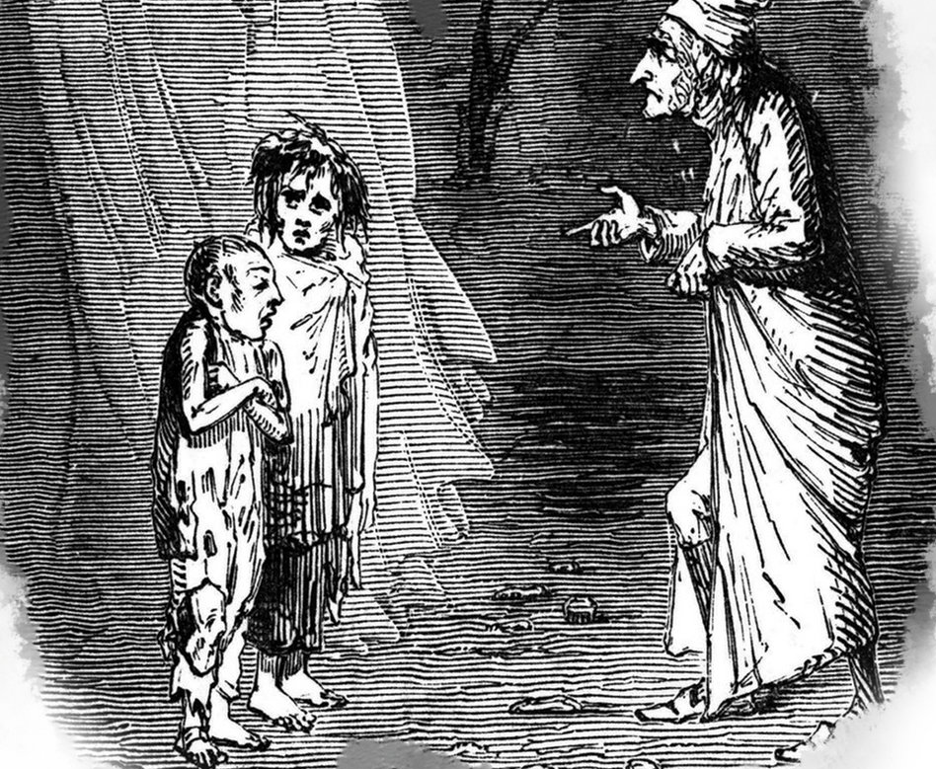

Appositive Sentences
who endured poverty as a child | described as ‘ragged’ and ‘wolfish’ | who believed in the transformative power of education
- The figures of Ignorance and Want, ____________________, highlight the social issues that concerned Dickens
- Dickens, ____________________, believed there was a widespread ‘ignorance’ of the reasons for social inequality
- Dickens, ____________________, wanted all children to receive formal schooling

The Theft of Scrooge’s Possessions

Questions to Consider
- How does Scrooge react to seeing the thieves sort through the items?
- How do the thieves speak about the man they stole them from?
- What does Scrooge learn from the experience?

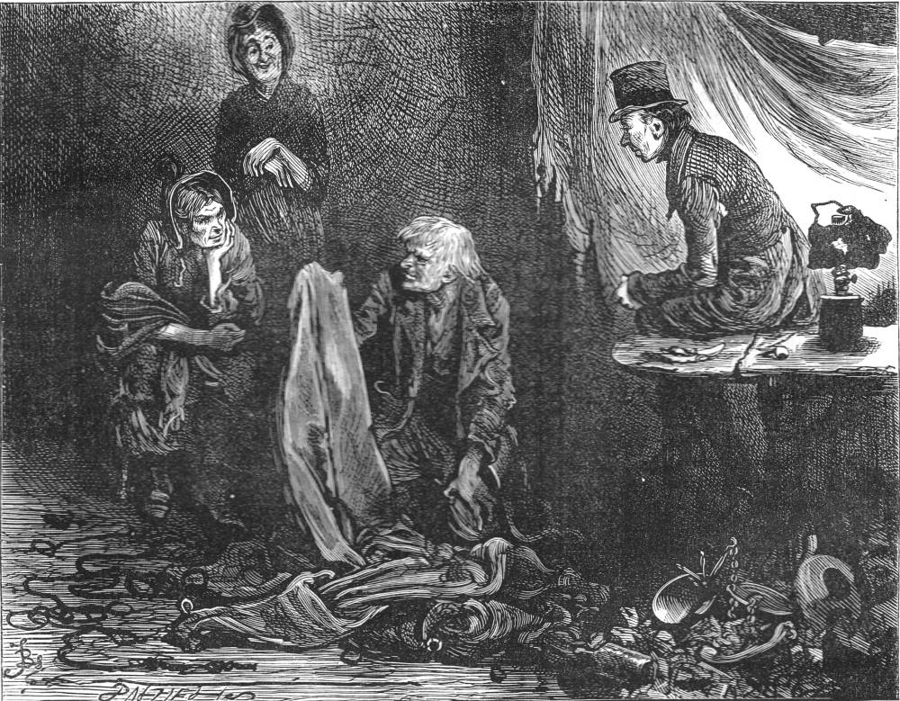

Appositive Sentences
characterised by squalor and misery | described as ‘a covetous old sinner’ in the first stave | who is joyful and friendly | + ? | + ?
- The Ghost of Christmas Yet to Come, ______________________ , visits Scrooge at midnight.
- In contrast to the Ghost of Christmas Present, ____________________ , the Ghost of Christmas Yet to come is very sinister.
- The street that Scrooge is taken to, ____________________, is located in an unfamiliar part of town.
- The thieves, ____________________ , show no empathy as they sort through the stolen items.
- Scrooge, ____________________, realises that the accumulation of so much wealth is futile.

The Death of Tiny Tim

Questions to Consider
- How are the Cratchit family presented in Stave Three?
- How is Tiny Tim presented in Stave Three?
- How have things changed in Stave Four?

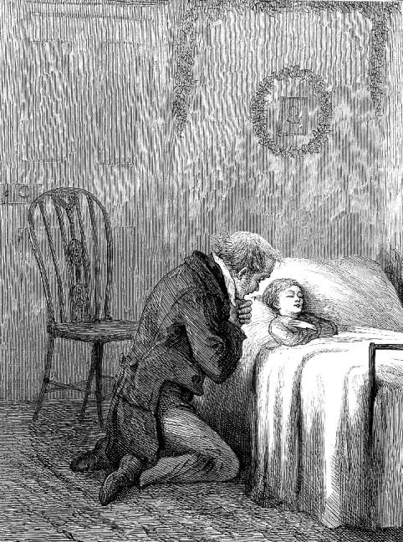

Quotations
- ‘The noisy little Cratchits were as still as statues in one corner’
- ‘They were very quiet again’
- ‘‘My little, little child!’ cried Bob’

Above All Sentences
- Above all, the Cratchit family are presented as…
- Above all, Bob is presented as…
- Above all, the scene is an important part of the narrative because…

The Death of Scrooge

Questions to Consider
- How is the graveyard described?
- Why is it described in that way?
- How does Scrooge react to seeing his own gravestone?
- Why does he react in that way?

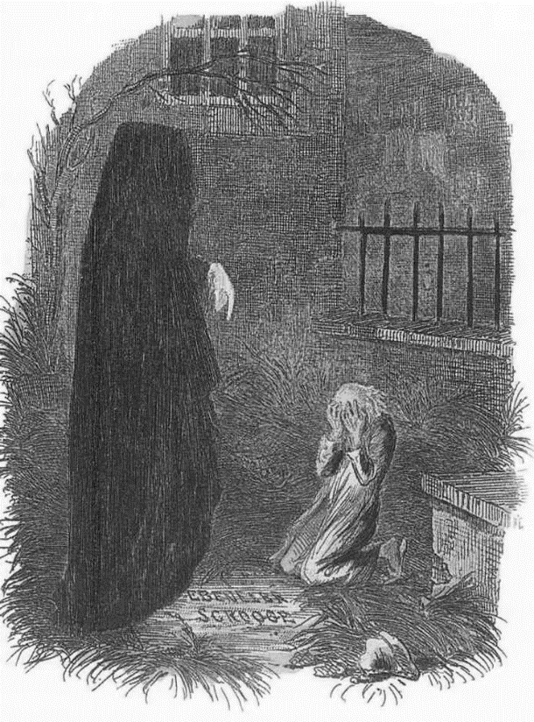

Mixed Practice Sentences
Because | Not only | But also | In contrast | Before | Although | In Contrast

- _______ Scrooge is shown the disturbing sight of his own gravestone, he notices that the churchyard is ‘overrun’ with weeds
- This is an important detail _______ it illustrates that his gravestone has been completely neglected
- Scrooge’s reaction to seeing his own gravestone is _______ shocking, _______ incredibly sad
- _______ to the fond remembrance of Tiny Tim, nobody seems to care about or remember Scrooge
- _______ Scrooge was materially very wealthy, he is totally bereft of friends and family
- The vision _______ emphasises to Scrooge that he must change, _______ serves as a warning to readers of the novel
Christmas Morning

Quotations
- ‘I will live in the Past, the Present, and the Future!’
- ‘A merry Christmas to everybody!’
- ‘No fog, no mist; clear, bright, jovial, stirring, cold’
- ‘He looked so irresistibly pleasant, in a word, that three or four good-humoured fellows said, Good morning, sir!’
- ‘I’ll raise your salary, and endeavor to assist your struggling family’

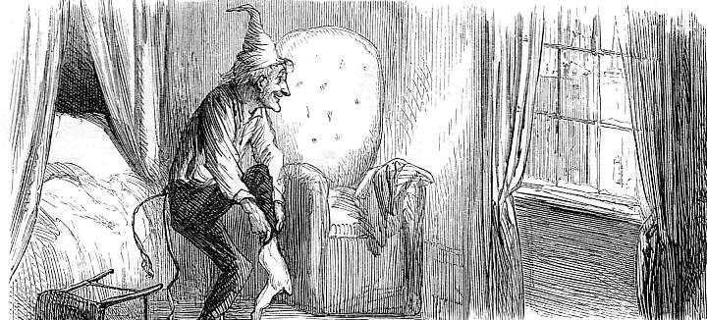

Preface to the Novel
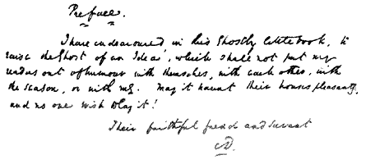

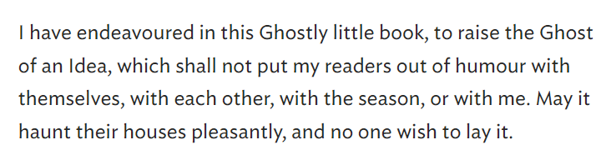

As Revealed Sentences
- As revealed by the first word of Stave Five…
- As revealed by Scrooge’s purchase of the prize turkey…
- As revealed by the narrator’s assertion that Scrooge ‘was better than his word’…
- As revealed by the original preface to the novel…

