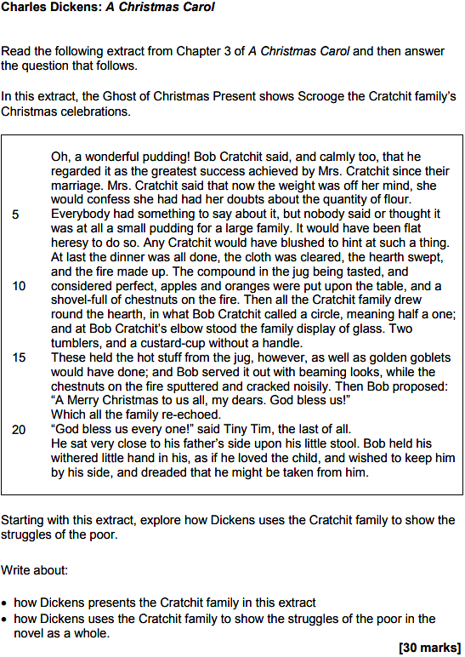

Points on the Extract
- The Cratchit family are grateful for the Christmas pudding, despite its small size

- The word ‘heresy’ is used to emphasise that any expressions of ingratitude would be profoundly unacceptable

- The ‘family display of glass’ is only modest and draws attention to the Cratchit family’s lack of wealth

- Despite their modest circumstances, the family are happy together and Bob ‘beams’ as he pours the drinks

- The family’s interactions are characterised by warmth and joyfulness

- The tone changes when the focus shifts to the character of Tiny Tim who presented as sickly and weak

- However, Tiny Tim is also a character who demonstrates great bravery in the face of adversity

- Bob’s fear that Tiny Tim ‘might be taken from him’ suggests that he is powerless to influence the future

- Bob does not have the resources to help Tiny Tim and this is largely the result of poverty

- Dickens highlights through the extract that social reform is urgently needed to help the most vulnerable

Links
- Stave 1: Scrooge’s refusal to donate money to charity and his obvious lack of empathy for the poor

- Stave 3: The figures of Ignorance and Want and the reasons why they are significant

- Stave 4: The death of Tiny Tim and how his passing affects the Cratchit family (especially Bob)

What Went Well

Even Better If
- Get started a more quickly and aim to write a bit more (aim for at least another half-a-page)

- Review the length of your sentences to make sure they don’t ‘run on’ for too long

- Begin a new paragraph each time you shift the focus to a new part of the extract or novel

- Zoom-in on single words or striking images and explore the significance of them

- Embed short quotations into your sentences

- Slow down a bit and take more care with your presentation

- Proofread after each paragraph and ensure that each sentence makes sense when you read it back

- Continue to think hard about your vocabulary choices and always aim for precision

- Use Templates e.g. not only… but also + this is significant because + this reveals

- Use Extenders e.g. furthermore + additionally + also

- Use Connecters: in contrast to + a similarity is + a difference is + equally + however

- Use Signposts: before + after + initially + as the text progresses + finally

- Use Analysers e.g. this implies + this conveys + this reinforces + this emphasises

- Use Qualifiers: although + despite + whilst + whereas

- Use Speculators: could + might + arguably

