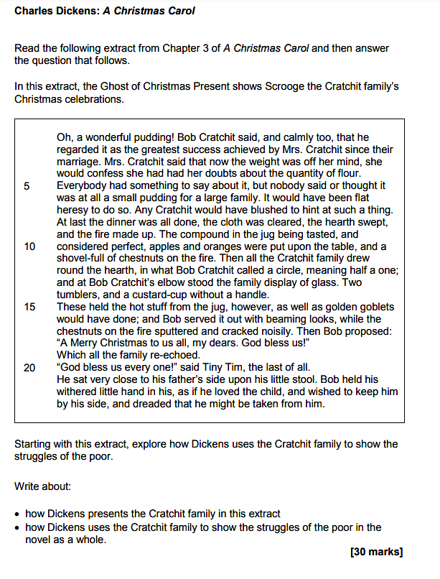

- Introduce the novel and establish the focus of your essay

- The novel was published in 1843, a time of great social inequality and poverty. Through the Cratchit family, Dickens highlights the struggles of the poor whilst emphasising their dignity and resilience…

- The reason why Dickens felt it was important to highlight the struggles of the poor

- Explore how Dickens presents the Cratchits’ gratitude despite their poverty

- In the extract, Dickens presents the Cratchits as a resourceful and loving family…

- Bob’s pride in the Christmas pudding: ‘Oh, a wonderful pudding!’
- The family’s unity and contentment: ‘Nobody said or thought it was at all a small pudding’
- The lack of material wealth contrasted with emotional richness: ‘a custard-cup without a handle’

- Explore how the Cratchits highlight the struggles of the poor in Victorian society

- The struggles of the Cratchits reflect the harsh realities of poverty in Victorian England…

- Tiny Tim’s illness as a symbol of vulnerability: ‘Bob held his withered little hand in his’
- The Cratchit family’s hope despite their hardship: ‘A Merry Christmas to us all, my dears’

- Make a link with Bob’s poor working conditions at Scrooge’s office

- An important moment in the novel that also highlights the struggles of the poor is in Stave One through the focus on Bob’s poor working conditions…

- The conditions that Bob stoically endures: ‘The clerk's fire was so very much smaller’
- How Bob is a representative of the exploited working class
- Why Dickens wanted to highlight the challenges faced by the working class

- Make a link with Scrooge’s transformation at the end of the novel

- Scrooge’s generosity to the Cratchits at the end of the novel conveys Dickens’s hope that those with wealth and power would take greater responsibility for improving the lives of the poor.

- Scrooge’s generosity to the Cratchit family and the importance of it: ‘Tiny Tim, who did not die’
- Scrooge’s transformation as a call to action: ‘Scrooge was better than his word’
- Tiny Tim’s final line as an expression of the universal value of kindness: ‘God bless us every one!’

