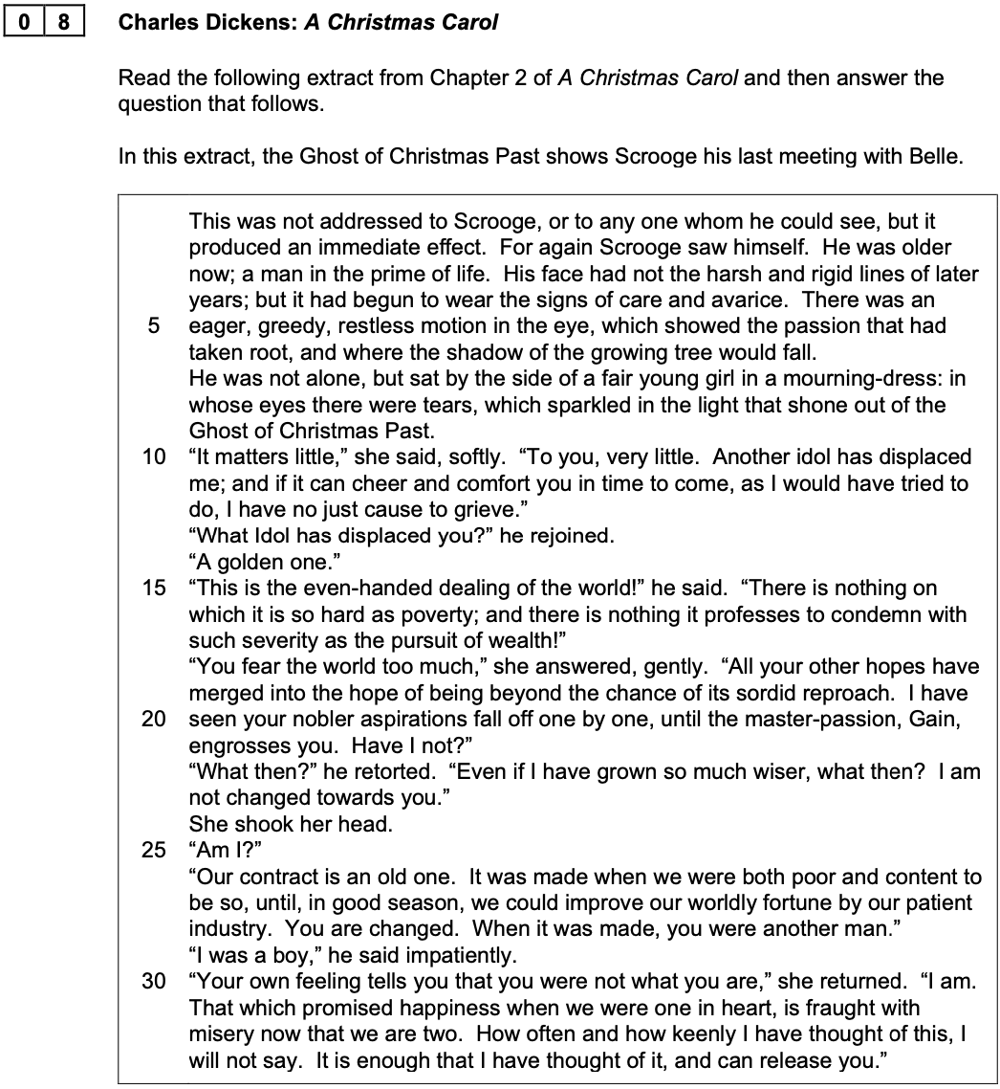

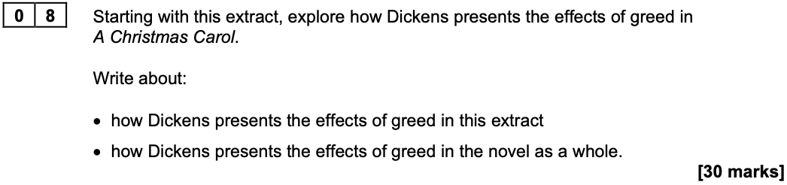

Introduction

- Briefly explain where the extract is placed within the stave
- Explain that the Ghost of Christmas Past shows Scrooge the consequences of his greed

Section 1

- Write about Belle’s reason for ending the engagement
- Include an explanation of why she uses the metaphor of a ‘golden idol’
- Explain the contrast between Belle’s sadness and Scrooge’s defiance

Section 2

- Explain what Belle means when she says that she and Scrooge used to be ‘content’ to be poor
- Write about what Belle means when she says that Scrooge used to be ‘another man’
- Explain that Belle holds values that contrast to the ones held by Scrooge

Section 3

- Make a link with the end of Stave Two and the moment that Scrooge is shown Belle’s family
- Write about the happiness she finds at the centre of family life
- Make it clear that Dickens promotes the value of love and friendship
- Explain how Scrooge reacts and what he learns about the effects of greed

Section 4

- Make a link with Stave Three and the moment Scrooge is shown Fezziwig’s Christmas ball
- Explain that Fezziwig embodies the values of kindness and generosity
- Focus on how he is described and the language used to describe his dancing
- Explain that Dickens purposefully contrasts Fezziwig with Scrooge (i.e. from Stave One)
- Write about how Scrooge reacts and what he learns about effects of greed

Section 5

- Make a link of your choice and explain how the effects of greed are explored
- For example: the figures of Ignorance and Want or Scrooge’s exclusion from the Christmas parties
- Finish your essay by writing that greed is damaging on both a personal level and a social level

Summary

Content Targets

- Analyse Belle’s accusations of greed and selfishness in greater depth
e.g. She describes wealth as Scrooge’s ‘master-passion’ that has had a ‘sordid’ influence on him

- Identify further examples of Scrooge’s greed in the novel and analyse the effect of it
e.g. Scrooge’s greed results in him being perceived as the ‘ogre’ of the Cratchit family

- Provide examples of contrasting generosity
e.g. The two gentlemen seeking charitable donations and the actions of the Ghost of Christmas Present

- Explore the significance of the figures of Ignorance and Want
e.g. They are a metaphor for the problems that Dickens saw in Victorian society, particularly the neglect of the poor

- Make connections between poverty, suffering and responsibility
e.g. Tiny Tim who is vulnerable and suffers because of limited resources

- Contrast the respective values held by Scrooge and Bell
e.g. Scrooge is motivated by the accumulation of material wealth whereas Belle values love and companionship

- Explore the idea that Scrooge is a caricature whose worst characteristics are purposefully exaggerated
e.g. Scrooge is a character who Dickens invites his readers to criticise

- Develop your points further by exploring Dickens use of language in more depth
e.g. ‘growing tree’, ‘golden’ ‘idol’; the adverbs ‘softly’, ‘impatiently’

Academic Writing Targets

- Start each paragraph with a clear topic sentence that directly addresses the essay question
e.g. In this extract, Dickens presents the damaging effects of Scrooge’s greed...

- Use appositives (i.e. extra information placed within commas) to add depth to your analysis
e.g. Belle, with tears in her eyes, ends her engagement to Scrooge…

- Choose language that conveys a formal tone (and avoid using words that are ‘chatty’)
e.g. Scrooge stubbornly defends his pursuit of greater wealth ...

- Embed short quotations into your sentences when you form a point
e.g. Belle describes Scrooge’s greed as his ‘master passion’ before talking about the changes she sees in him...

- Proofread after each paragraph and ensure that each sentence makes sense when you read it back

- Review the length of your sentences to make sure they don’t ‘run on’ for too long

- Get started a more quickly and aim to write a bit more (aim for at least another half-a-page)

