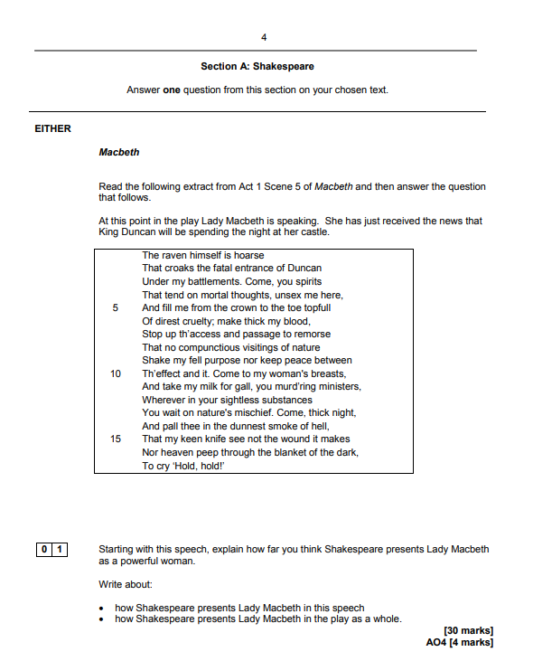

Source: https://filestore.aqa.org.uk/resources/english/AQA-87021-SQP-V1.PDF

Feedback

Quality of written expression
- At the very least, your writing needs to be legible. I want you to benefit from the halo effect in the summer.
- Take care with the technical accuracy of your writing. Four discretionary marks are awarded for AO4.
- Aim for at least two pages. That’s not unrealistic in the time you have available.
- As a class, we need to think really hard about how we can ‘upgrade’ our vocabulary choices.
- On that: remember that you’ve got a combined total of 36 tier 2 and tier 3 words in your work books…

Quality of analysis
- You don’t need to write about every line in the extract. The key is to be selective. Zoom-in on what you know best.
- Be mindful that that Lady Macbeth dominates A1S7 and A2S2. You should’ve focused on both scenes.
- And let’s not forget A3S4.
- Oh, and also the ‘sleepwalking scene’ in A5S1.

Takeaways

Key points on the extract
- This is the first time the audience sees Lady Macbeth
- The raven is symbolic of death and Lady Macbeth’s murderous intentions.
- Lady Macbeth’s direct appeal to the spirit world emphasises her cruel, evil nature.
- This is further emphasised by her references to the ‘thick night’ and ‘smoke of hell’.
- Lady Macbeth’s rejection of her femininity helps to establish her as a ruthless character.
- Techniques to explore: tone, alliteration, sibilance, symbolism, metaphor.

Wider links
- A1S5: Lady Macbeth concedes that her husband lacks ruthlessness; she initially flatters him; she reassures about her plan.
- A1S7: Lady Macbeth calls her husband a coward; she accuses him of breaking his promise; she attempts to reassure him.
- A2S2: More accusations of cowardice; Lady Macbeth’s confidence and strength contrasts to Macbeth’s mental fragility.
- A3S4: Lady Macbeth attempts to reassure the Scottish nobles; she despairs at Macbeth’s erratic behaviour.
- A5S1: Lady Macbeth is plagued by guilt; she sleepwalks whilst darkly remembering Duncan and Macduff’s family.

Vocabulary

Ambitious | Persuasive | Intelligent | Deceitful | Remorseful
Ruthless | Manipulative | Assertive | Merciless | Erratic

