Study Booklet

A View from the Bridge

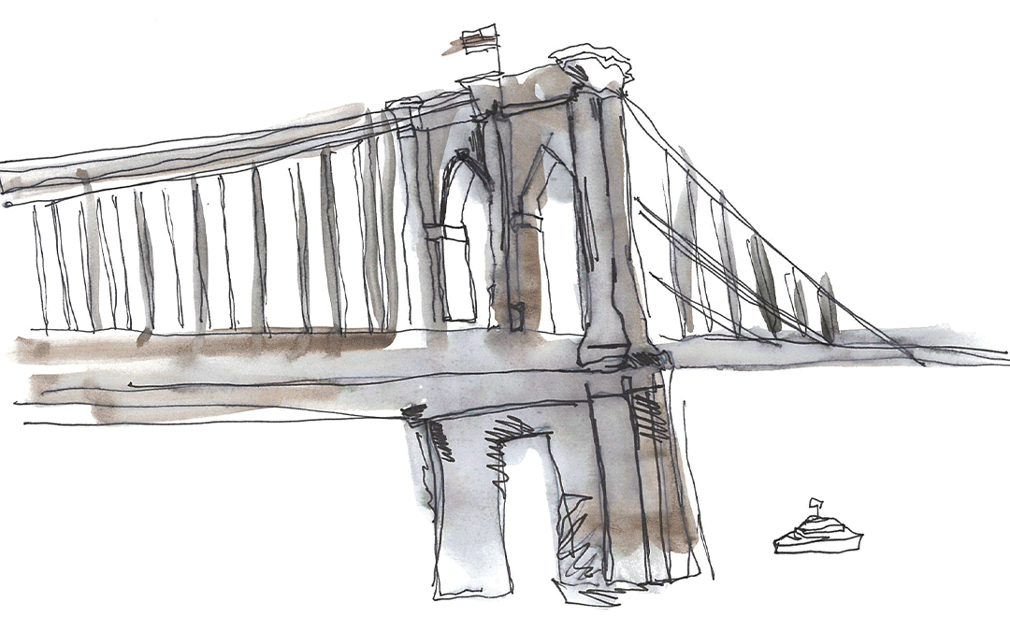

2 | Knowledge organiser
3 | BQ: What themes (big ideas) are introduced in the opening pages of A View from the Bridge?
5 | BQ: What tensions do there appear to be in the relationship between Eddie, Beatrice and Catherine?
6 | BQ: How are the characters of Marco and Rodolpho presented and how do they seem to differ
8 | BQ: What differences does Eddie see between Rodolpho and the other longshoreman and why does he feel uneasy?
10 | Recall test
11 | BQ: What do the other longshoreman say about Rodolpho and what is revealed by the way Eddie reacts?
12 | BQ: Why do Eddie and Beatrice have such different opinions over Catherine’s relationship with Rodolpho?
14 | Recall Test
15 | BQ: Alfieri says of Eddie, ‘I knew where he was heading for’ – what does he mean and why does he say it?
16 | BQ: How does the balance of power shift at the end of the first act?
18 | BQ: ‘Eddie, I’m not going to be a baby anymore!’ – How does the character of Catherine develop as the play progresses?
19 | BQ: ‘Give me the number of the Immigration Bureau’ – Why does Eddie report Marco and Rodolpho?
20 | BQ: ‘Marco knows what’s right from wrong’ – Why does Marco choose to seek revenge on Eddie?
22 | Assessment
24 | Wider reading: A View from the Bridge – Miller reinvented with visceral power (The Guardian)
25 | Useful websites

Key Events
Act 1 | Catherine reveals that she has been offered a job and Eddie expresses his disapproval; Eddie tells the story of Vinny Bolzano; Marco and Rodolpho arrive
 | Rodolpho talks about his life in Italy; Rodolpho sings for Catherine; Eddie becomes increasingly vociferous about his suspicious of Rodolpho
 | Mike and Louis joke to Eddie about Rodolpho’s flamboyance; Eddie continues to restrict Catherine’s freedom; Catherine finally admits that she has feelings for Rodolpho
 | Catherine complains to Beatrice that Eddie will not listen to her; Beatrice urges Catherine to changer her behaviour around Eddie
 | Alfieri advises Eddie not to prevent the relationship between Catherine and Rodolpho; Eddie hits Rodolpho; Marco defeats Eddie in a test of strength
Act 2 | Rodolpho and Catherine find themselves alone in the apartment; Rodolpho angrily rejects the idea of moving to Italy with Catherine
 | Eddie drunkenly returns to the apartment; Eddie sees that Catherine and Rodolpho have been alone; Eddie kisses Rodolpho
 | Alfieri tells Eddie that he is powerless to stop the marriage between Rodolpho and Catherine; Beatrice reveals that Lipari has illegal immigrants living with him
 | Eddie calls the Immigration Bureau; Lipari’s house is raided; Marco challenges Eddie; Marco kills Eddie
Key Characters |  | Key Themes |  | Key Words
Eddie | - An ‘everyman’ character  - Has conflicting feelings for Catherine  - Demands respect | Justice | - Alfieri represents the law  - Contrast between ‘old world’ and ‘new world’  - Revenge is linked to justice | - Miller  - Tragedy  - Fate  - Chorus  - Italy  - Sicily  - America  - Brooklyn  - Red Hook  - Longshoreman  - Dock  - Friendship  - Status  - Loyalty  - Masculinity  - Respect
Beatrice | - Devoted to Eddie  - Feels emotionally and physically distant from him  - Supports Catherine and Rodolpho’s relationship | Honour | - Honour is linked to silence  - Respect is important to Eddie and Marco  - Breaking a code of honour results in isolation
Catherine | - Beatrice niece  - Enters into a relationship with Rodolpho  - Defies Eddie | Love | - Examples of romantic love and familial love  - Eddie’s sexuality is ambiguous  - Eddie and Beatrice share a troubled relationship
Rodolpho | - Blonde-haired and handsome  - Humorous and flamboyant  - Ambitious | Dreams | - Rodolpho believes in the ‘American Dream’  - Rodolpho and Marco have different aspirations  - Eddie was content with his life as a longshoreman
Marco | - Physically strong  - Attempts to avoid conflict  - Kills Eddie | Struggle | - Catherine struggles for her independence  - Eddie and Marco engage in a physical struggle  - Eddie struggles with his conflicting emotions

Big Question

What themes (big ideas) are introduced in the opening pages of A View from the Bridge?

Vocabulary

Immigration | Expectation | Family | Fate
Opportunity | Dreams | Community | Relationship
Hope | Money | Ambition | Love

Retrieval

- Alfieri sets the scene and refers to the importance of justice

- Catherine greets Eddie

- Eddie warns Catherine about her appearance and behaviour

- Eddie informs Beatrice that her cousins have arrived in America

- Catherine reveals that she has been offered a job

Extract

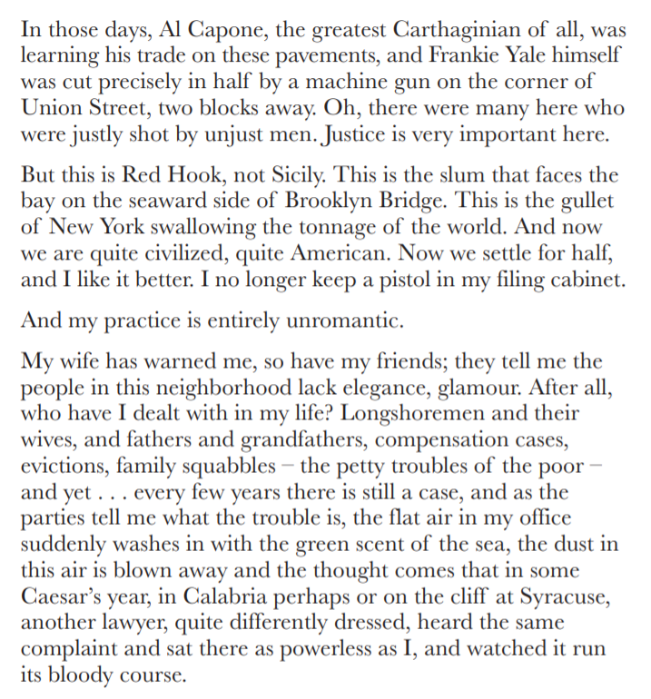

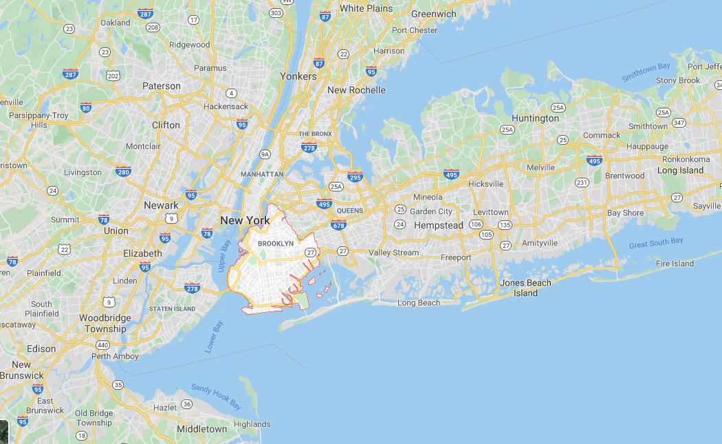

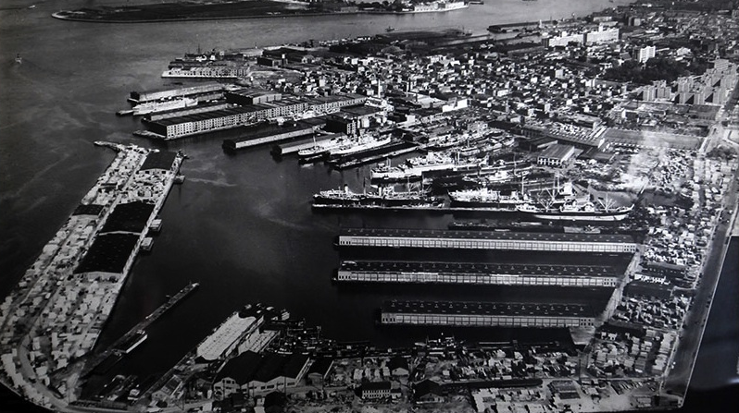

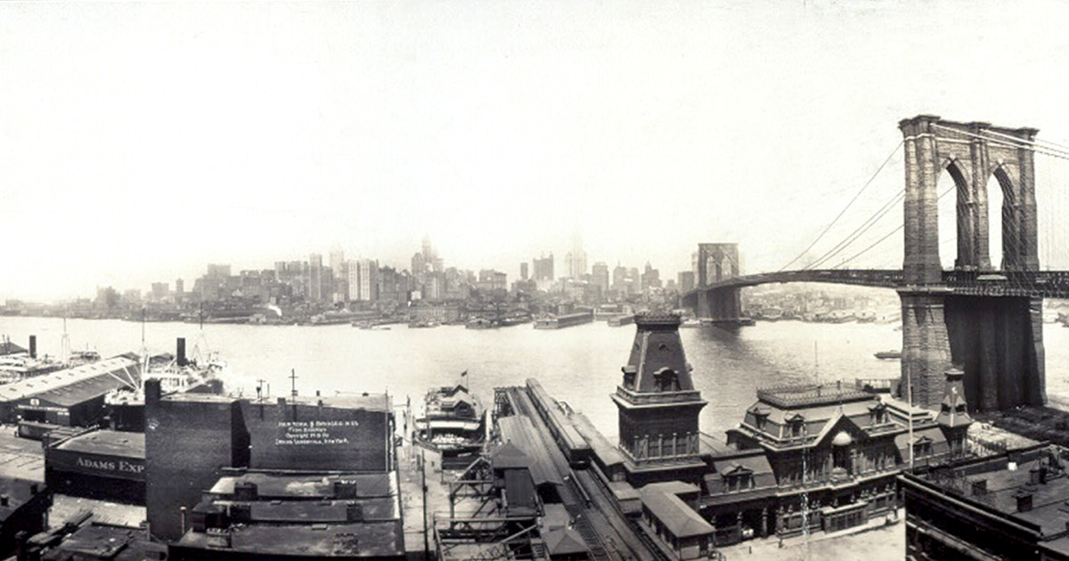
Recap

What do we know so far about Eddie Carbone? List five things

Big Question

What tensions do there appear to be in the relationship between Eddie, Beatrice and Catherine?

Vocabulary

Tension | Maturity | Anger | Freedom
Jealousy | Patriarchy | Insecurity | Independence
Attention | Power | Growth | Conflict

Retrieval

- Eddie emphasises his unhappiness at Catherine’s job offer

- Eddie finally gives his approval to Catherine

- Eddie warns Catherine not to trust anybody

- Beatrice and Eddie tell Catherine about Vinny Bolzano

- Catherine promises not to say a word

Extract

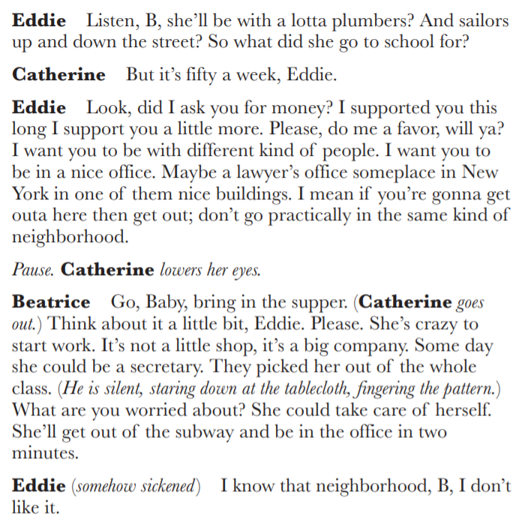

Recap

In which area is the play set?

What is Eddie’s occupation?

‘No, I’m just nervous, that’s all’ – why is Beatrice nervous?

‘The kid snitched?’ – who is the kid and what does the story reveal?

Big Question

How are the characters of Marco and Rodolpho presented and how do they seem to differ?

Vocabulary

America | Brooklyn | Journey | Family
Italy | Longshoreman | Opportunity | Community
Sicily | Boat | Labour | Culture

Retrieval

- Alfieri speaks on stage prior to the arrival of Marco and Rodolpho

- Tony leads the brothers to Eddie’s apartment

- Rodolpho reflects on the limited opportunities in Sicily

- Marco talks about his wife and children

- Rodolpho says he wants to buy a motorbike

Extract

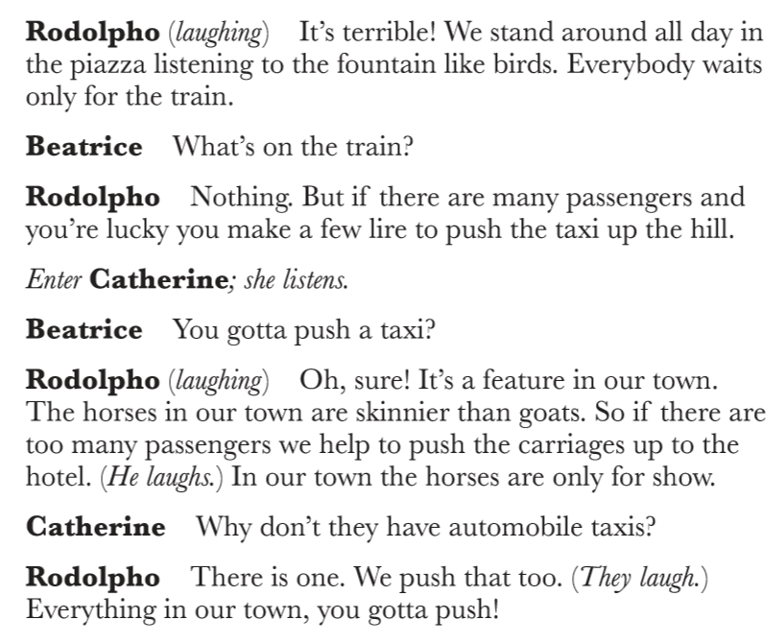

Five Key Points to Remember

- At the start of the play, Alfieri introduces Eddie as an honest and content worker who is clearly part of a close-knit community

- Eddie is the patriarch (i.e. head) of his family and expects his authority to be respected by Beatrice and Catherine

- Eddie is a masculine character who is proud of his status as a worker and provider

- Eddie is particularly protective of Catherine but, at times, his behaviour seems inappropriate and domineering

- Eddie is acutely aware of the cultural codes of Red Hook, particularly the importance of staying silent (think Vinny Bolzano)

Recap

Which two adjectives below most precisely describe the character of Beatrice?

Assertive | Submissive | Anxious | Unhappy | Generous

Big Question

What differences does Eddie perceive between Rodolpho and the other longshoreman and why does this make him feel uneasy?

Vocabulary

Culture | Suspicion | Concerns | Viewpoint
Behaviour | Trust | Jealousy | Contrast
Appearance | Perception | Independence | Masculinity

Retrieval

- Rodolpho remembers singing at a hotel in Italy

- Rodolpho sings for Catherine

- Eddie remarks to Beatrice about Rodolpho’s hair

- Eddie contrasts Rodolpho with Marco

- Eddie says Rodolpho is exploiting Beatrice

Extract

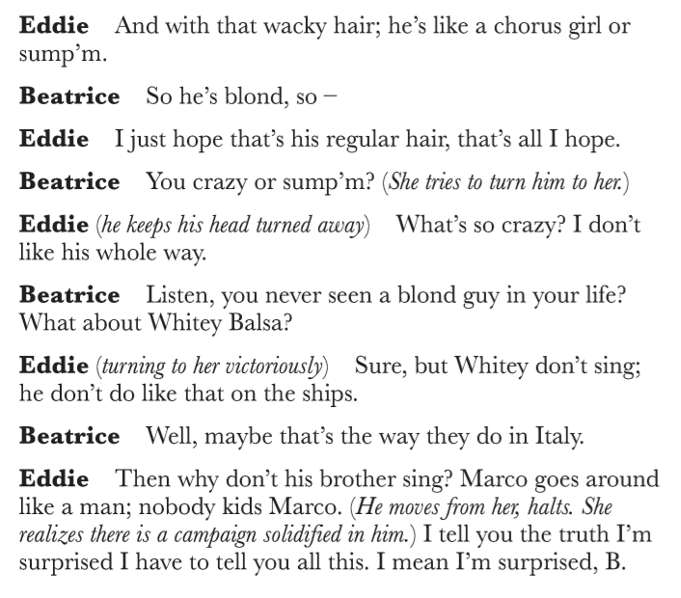

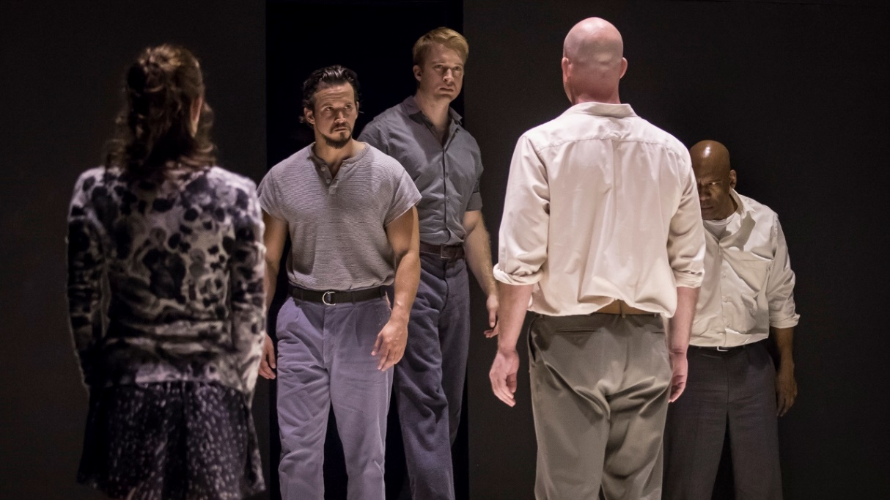

Recall Test

- What is Eddie’s surname?

- What is the name of Eddie’s wife?

- What is the name of the lawyer who also serves as the narrator?

- What is the name of the area of Brooklyn where the play is set?

- In which decade is the play set?

- Which region of Italy do Marco and Rodolpho come from?

- What does the slang term ‘submarine’ mean?

- How old is Catherine?

- What does a longshoreman do?

- Who wrote the play?

- How many children does Marco have?

- How much money does Marco want to immediately send his wife?

- Is Rodolpho married?

- What does Rodolpho want to buy?

- How does Eddie accuse Catherine of walking?

- What cargo does a ‘Brazil ship’ carry?

- What is the name of the informer that Beatrice recalls?

- What did Rodolpho help to push up the hill in Italy?

- ‘Where you goin’ all dressed up?’ – Who said it?

- ‘I didn’t even but a new tablecloth’ – Who said it?

- ‘They probably didn’t see a tablecloth in their whole life’ – Who said it?

- ‘Because as soon as you see a tired relative, I end up on the floor’ – Who said it?

- ‘I’m the best student, he says, and if I want, I should take the job’ – Who said it?

- ‘Look, did I ask you for money?’ – Who said it?

- ‘As long as you owe them money, they’ll get you plenty of work’ – Who said it?

- ‘How much can a man make?’ – Who said it?

- ‘He dreams, he dreams’ – Who said it?

Recap

What do you learn about Beatrice and Eddie from the extract below?

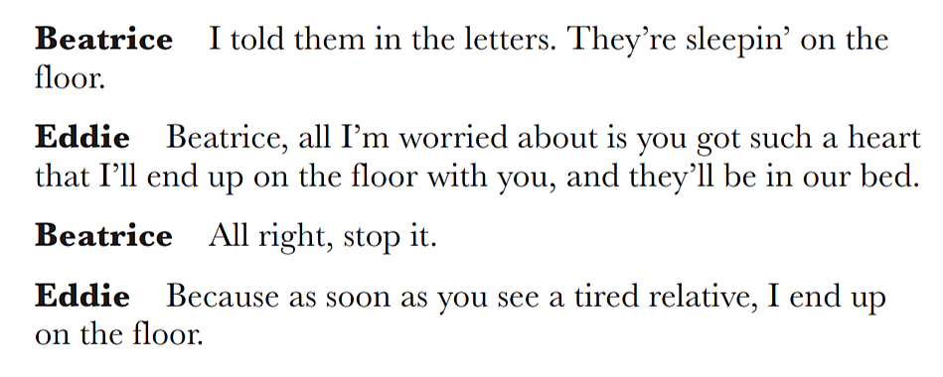

Big Question

What do the other longshoreman say about Rodolpho and what is revealed by the way Eddie reacts?

Vocabulary

Masculinity | Entertainment | Power | Contrast
Labour | Tension | Control | Discomfort
Attitude | Relationship | Jealousy | Embarrassment

Retrieval

- Louis invites Eddie to go bowling

- Mike compliments Marco’s work ethic and strength

- Mike says that Rodolpho makes him laugh

- Eddie says that he does not want Catherine to go to Times Square

- Catherine admits that she has feelings for Rodolpho

Extract

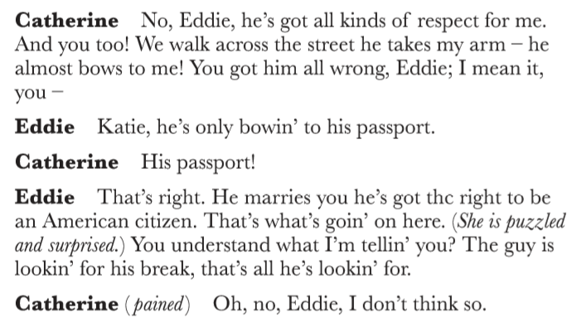
Recap

Retrieve a quotation to link to each of the images below

Big Question

Why do Eddie and Beatrice have such different opinions over Catherine’s relationship with Rodolpho?

Vocabulary

Anger | Anxiety | Loyalty | Empathy
Desperation | Jealousy | Respect | Commitment
Frustration | Love | Belief | Change

Retrieval

- Catherine tries to assure Eddie that Rodolpho respects her

- Eddie claims Rodolpho is only interested in gaining citizenship

- Catherine tells Eddie he is wrong

- Catherine complains to Beatrice about Eddie not listening to her

- Beatrice tells Catherine to changer her behaviour

Extract

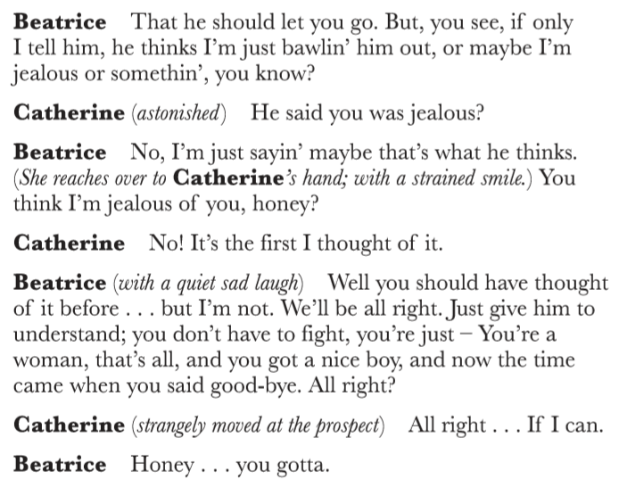

Recall Test

- In which neighbourhood of Brooklyn is the play set?

Question for class discussion: Why is the area significant?

- Which region of Italy have Marco and Rodolpho travelled from?

Question for class discussion: What has motivated Marco to leave his family and move abroad?

- What is the name of the ‘kid’ who ‘snitched’ on his uncle to the immigration authorities?

Question for class discussion: What does his treatment by the community reveal about cultural codes?

- ‘Maybe twenty dollars’ – who said it?

Question for class discussion: What is the money for and what does it reveal about the speaker?

- Alfieri says of Eddie Carbone that he ‘never expected to have a destiny’ – what did Eddie expect instead?

Question for class discussion: What does Alfieri suggest about Eddie’s values and beliefs?

- ‘Like a chorus girl or sump’m’ – who is being described?

Question for class discussion: What does the simile imply?

- Mike says of Marco that ‘he’s a regular bull’ – what does he mean by this?

Question for class discussion: In contrast, Eddie describes Rodolpho as a ‘canary’ – what does he mean?

Recap

List ten adjectives to describe Eddie and then five to describe Catherine

Big Question

Alfieri says of Eddie, ‘I knew where he was heading for’ – what does he mean and why does he say it?

Vocabulary

Culture | Justice | Advice | Jealousy
Rules | Law | Support | Anxiety
Behaviour | Lawyer | Frustration | Anger

Retrieval

- Eddie visits Alfieri

- Eddie expresses his concerns about Rodolpho

- Eddie says the other men laugh at Rodolpho

- Alfieri says that Eddie cannot prevent the relationship

- Eddie leaves Alfieri’s office

Extract

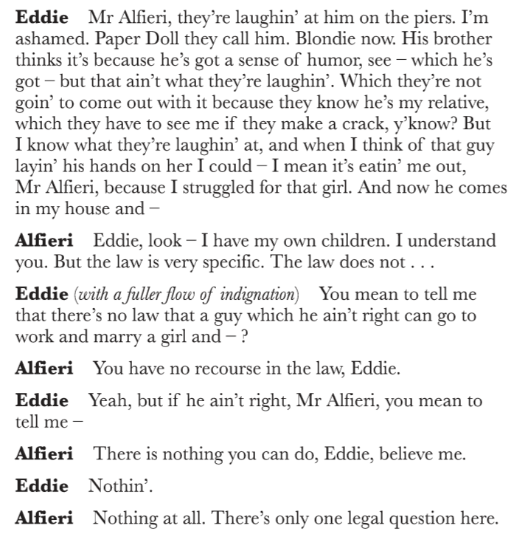
Recap

Correct the spellings below and prepare to explain why they are relevant to the play

Masculinitey | Heirarchy | Dominence | Jealousey | Angre

Big Question

How does the balance of power shift at the end of the first act?

Vocabulary

Relationship | Aggression | Strength | Contrast
Struggle | Battle | Authority | Change
Challenge | Symbolism | Control | Balance

Retrieval

- Eddie offers to teach Rodolpho how to box

- Eddie instructs Rodolpho to raise his hands

- Eddie strikes Rodolpho

- Marco challenges Eddie to lift a chair

- Marco raises the chair above his head

Extract

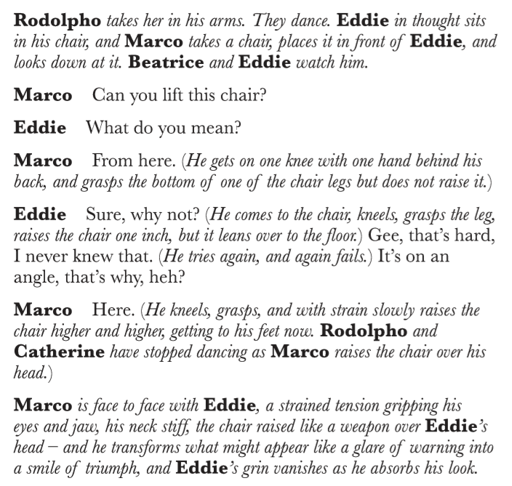

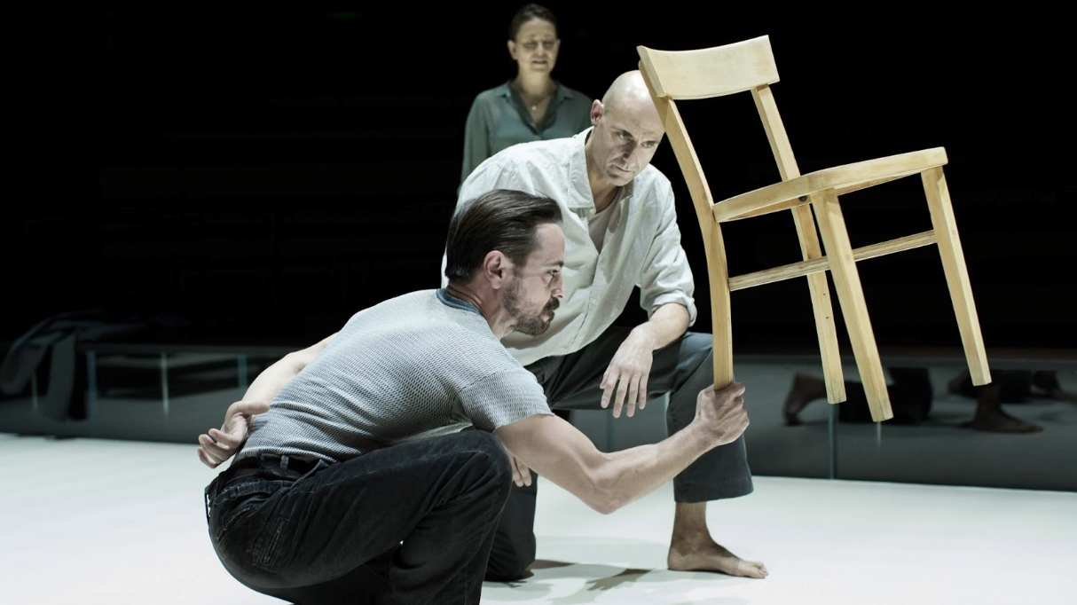

Recap

Arrange the events from Act One into chronological order

- Marco defeats Eddie in a test of strength

- Eddie visits Alfieri and says that Rodolfo ‘ain’t right’

- Marco and Rodolpho arrive in Red Hook

- Catherine reveals to Eddie that she has been offered a job

- Rodolpho reminisces about the time he sung at a hotel

Big Question

‘Eddie, I’m not going to be a baby anymore!’ – How does the character of Catherine develop as the play progresses?

Vocabulary

Foreshadow | Romance | Frustration | Defeat
Hint | Tenderness | Anger | Independence
Contrast | Relationship | Violence | Isolation

Retrieval

- Alfieri reveals that a crate of whisky has gone missing

- Rodolpho is not offered work

- Rodolpho rejects the idea of Catherine moving to Italy

- Rodolpho gets increasingly angry in front of Catherine

- Eddie drunkenly enters and eventually kisses Rodolpho

Extract

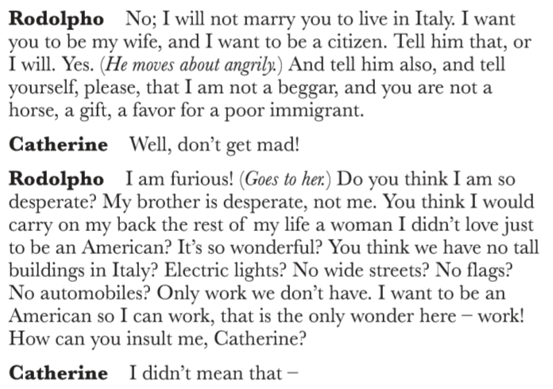
Recap

Write down three adjectives to describe each of the characters below

Eddie | Beatrice | Catherine | Marco | Rodolpho

Big Question

‘Give me the number of the Immigration Bureau’ – What factors influence Eddie’s decision to report Marco and Rodolpho?

Vocabulary

Betrayal | Culture | Law | Anger
Guilt | Immigration | Information | Jealousy
Advice | Rules | Anonymity | Regret

Retrieval

- Alfieri says to Eddie that he cannot prevent the marriage

- Beatrice tells Eddie that Catherine has moved out

- Eddie and Beatrice argue about their relationship

- Catherine announces that the wedding is on Saturday

- Beatrice reveals that illegal immigrants are living with Lipari

Extract

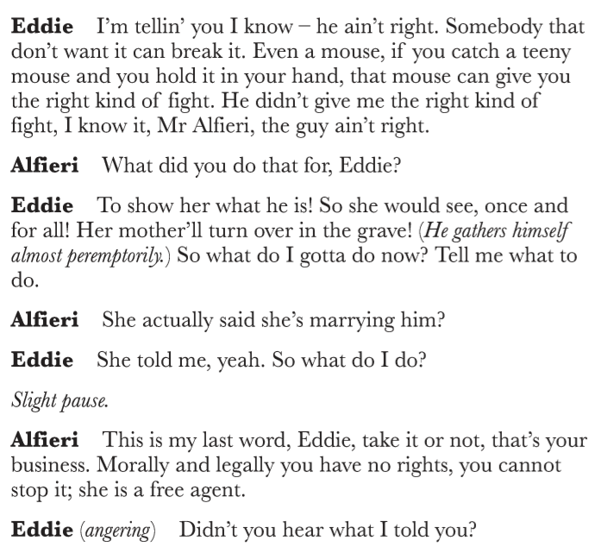

Recap

Form three points based on the extract below

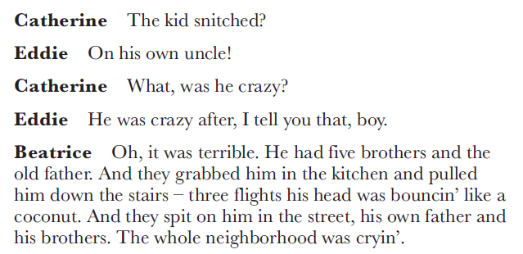

Big Question

‘Marco knows what’s right from wrong’ – Why does Marco choose to seek revenge on Eddie?

Vocabulary

Anger | Justice | Power | Punishment
Respect | Law | Love | Brutality
Betrayal | Conflict | Jealousy | Shock

Retrieval

- Marco spits at Eddie

- Alfieri offers to release Marco on bail

- Rodolpho warns Eddie that Marco will arrive

- Eddie demands an apology from Marco

- Marco kills Eddie

Extract

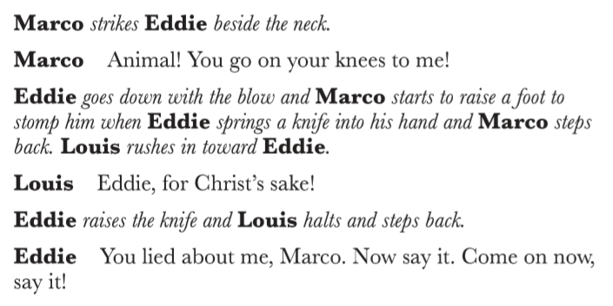

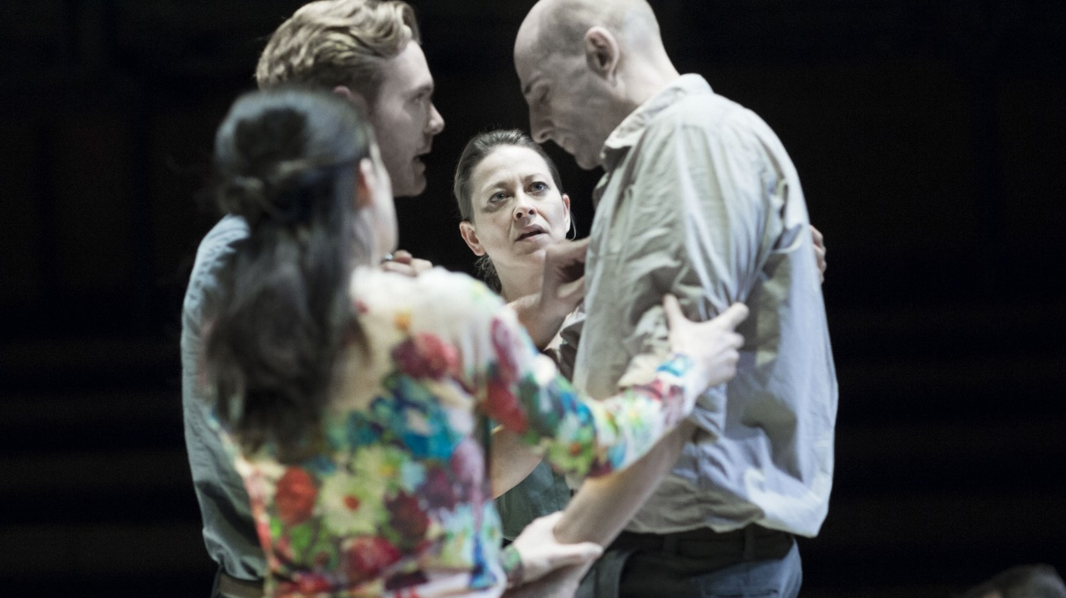

Recap

Answer the questions below

- ‘Submarine’ – what is this slang for?

- ‘Paper Doll’ – which character is given this nickname?

- ‘A regular bull’ – which character is being described?

- ‘I am furious!’ – why is Rodolpho ‘furious’?

Assessment

How the character of Rodolpho is presented in A View from the Bridge? Base your response on the two extracts provided

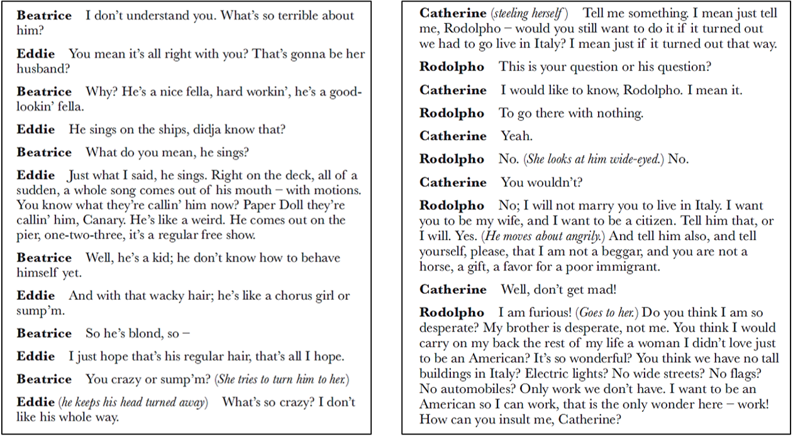

Vocabulary

Additionally | Finally | However | Similarly
Furthermore | Moreover | Contrastingly | Likewise
Consequently | Therefore | Alternatively | Crucially

Writing Frame

Point: Miller presents / explores / conveys
Evidence: An example of this is / This is conveyed by
Explain: Miller deliberately shows / This indicates
Zoom: A key word is / The adjective implies
Link: Miller wanted to reflect / Additionally
Five Key Points to Remember

- Rodolpho is a lively and flamboyant character; he does not behave according to the social norms upheld by Eddie and Marco
- Eddie implies that Rodolpho is gay, but this is arguably only a reflection of his own jealousy and insecurity
- Rodolpho freely admits that he does not want to return to Italy, but this does not mean that he isn’t in love with Catherine
- Catherine is obviously in love with Rodolpho and she develops the courage to openly defy Eddie as the play progresses
- Rodolpho very much represents the future: he is keen to work, wants to have fun and seizes the opportunities given to him

A View from the Bridge – Miller reinvented with visceral power
Source: https://www.theguardian.com/stage/2015/nov/12/view-from-the-bridge-review-arthur-miller-reinvented

Ostensibly, Arthur Miller’s A View from the Bridge is set in Red Hook, Brooklyn, a thriving port in Miller’s day and now home to troubled housing projects and hipster bakeries. But in Ivo van Hove’s thrillingly claustrophobic version, last seen on the West End, the action all takes place in one small square – a bit like a boxing ring, a bit like a prison cell – with the audience surrounding it on three sides.

A View from the Bridge, based loosely on a real-life incident, describes the upheaval in the home of Eddie Carbone (Mark Strong), a career longshoreman who lives with his wife, Beatrice (Nicola Walker), and her niece, Catherine (Phoebe Fox), who has just been offered a secretarial job when the play begins. Conflict arrives in the bodies of Marco (Michael Zegen) and Rodolpho (Russell Tovey), Beatrice’s cousins, newly smuggled ashore from Italy. Marco is a macho sort, so he and Eddie get along fine. But Rodolpho, who sings and dances and sews, discomfits Eddie, especially when Rodolpho fixes his attentions on Catherine.
Van Hove is a genius at revealing and actualising the emotional currents that run underneath dialogue, of giving subtext a visceral and violent expression. So, it wasn’t a given that he would succeed with Miller. More than one character explicitly states Eddie’s predicament, a deeply felt but dangerously unacknowledged desire for his niece, so this text isn’t exactly sub. But Miller can be mealy mouthed about desire itself, which he always seems to treat as something at least a little distasteful. By focusing so keenly on it, Van Hove inflames what had come to seem a settled text. This is an exhilarating production, assured and perilous, abstract and concretely physical.

Van Hove shows us the too-long embraces between Eddie and Catherine, her childish way of wrapping her legs around his waist that doesn’t seem so childish any more. And if Van Hove adjoins a kiss that is not in Miller’s play, it makes the scripted one that follows it all the more disturbing. Maybe that first kiss seems out of character for Eddie, but Miller’s play acknowledges that ‘a passion’ ‘had moved into his body, like a stranger’, and in Mark Strong’s extraordinary and visceral performance we see a man who has become a stranger to himself, a paragon of manhood unmanned and set adrift both by his own desires and by challenges to his masculine assumptions.

Strong is well supported by the other cast members, though accents can waver between south Brooklyn and north London. But pronunciation aside, they’re all very much in the same play and very much entrapped in what Van Hove, following on from Miller, envisions as a supremely tragic cycle. The shower that opens the play, Eddie’s ablutions after a sweaty day on the docks, is echoed in the bloody rain that concludes it, suggesting that the violence that propels the play is inexorable. We are all of us caught, rapt and culpable, in its spray.
Useful Websites

- BBC Bitesize https://www.bbc.co.uk/bitesize/topics/zwhgycw

- Research Guide https://www.aresearchguide.com/a-view-from-the-bridge.html

- Universal Teacher http://www.universalteacher.org.uk/drama/viewfromthebridge.htm

- Shmoop https://www.shmoop.com/study-guides/literature/view-from-the-bridge

- Sparknotes https://www.sparknotes.com/drama/viewbridge/

