A View from the Bridge
By Arthur Miller

Historical Context
Miller was born in New York in 1915 to parents who were both immigrants to the United States. He gained experience as a shipfitter in Brooklyn during the 1940s where the majority of the other workers were Italian. It is likely that he became particularly interested in the work and lives of the communities of dockworkers and longshoreman during this period. In his autobiography, published in 1987, Miller described the waterfront as ‘the Wild West, a desert beyond the law’.

Genre
The play is a modern version of a Greek tragedy in the sense that the flawed central character, Eddie Carbone, seems unable to escape a destiny that ends in his death. By the end of Alfieri’s opening speech, the audience is made aware that the events on stage will eventually reach a ‘bloody’ conclusion.

Central Theme
Each character struggles to find a balance between the conflicting demands of their private and public lives, and they swiftly find themselves at the centre of situations that threaten to overwhelm them. In this sense, the play is an exploration of the way in which individuals are bound by their position in society and the responsibilities they hold.

Pages 3-12

Tenement building A building shared by multiple families with flats or apartments on each floor
Longshoremen People who unload ships at a seaport
Carthaginian Someone from the area in Tunisia that was once the site of the ancient city of Carthage
Sicily A large island in the Mediterranean Sea close to Italy
Al Capone A notorious American gangster who was eventually convicted in 1931
Syracuse A city in Sicily
Walkin’ wavy Walking in a way that attracts attention

…………………………………………………………………………………………………………………………………………………………………………………………

- What is the name of the lawyer? (3)
- What does he say is ‘very important’ in New York? (4)
- What is ‘entirely unromantic’? (4)
- What is Eddie’s job? (4)
- How old is Eddie? (4)
- What question does Catherine ask Eddie? (5)
- What does Catherine say is ‘the style now’? (5)
- ‘Don’t aggravate me, Katie’ (6) – What does the word ‘aggravate’ mean?
- What did Eddie promise Catherine’s mother ‘on her death bed’? (6)
- What is Beatrice ‘worried’ about? (7)
- What is Eddie ‘worried’ about? (8)
- ‘They’ll pay for their board’ (8) – What does the word ‘board’ mean?
- What job has Catherine been offered? (9)
- Why is Eddie not pleased about the job offer? (9)
- What does Catherine say she will buy with her ‘first pay’? (11)

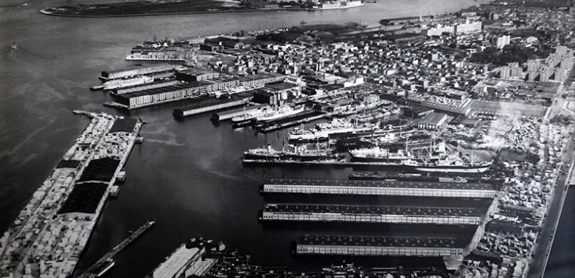
Pages 12-22

Buick An American car manufacturer
Immigration Bureau The department responsible for making decisions about who is allowed to stay in the country
Stool Pigeons Police informants
Snitched Informed on someone
Syndicate A united group of people united by a common interest
Piazza A public square or marketplace
Lire Currency in Italy until 2002
Paper Doll A popular love song released in 1942

…………………………………………………………………………………………………………………………………………………………………………………………

- What is Eddie ‘nervous’ about? (13)
- Who ‘snitched to the Immigration? (13)
- What did his ‘five brothers’ and ‘old father’ do to him? (14)
- ‘Captain’s pieced off’ (14) – What does the phrase ‘pieced off’ mean?
- What does Eddie ‘hope’ for Catherine? (15)
- Who has been avoiding Eddie’s ‘gaze’? (15)
- What are the names of Beatrice’s cousins? (16)
- Who is ‘so dark’ in appearance? (17)
- Who is ‘so light’? (17)
- What does Rodolpho say is the ‘only’ thing that people wait for in his Italian town? (17)
- Which character has three children? (18)
- How much money does Eddie say could be earned ‘a week’? (19)
- How much money does Marco want to send to his wife ‘right away’? (19)
- What does Rodolpho say was ‘falling like a storm in the treasury’? (20)
- What song does Rodolpho sing for Catherine? (21)
- What does Eddie do that makes Catherine ‘embarrassed’ and ‘angered’? (21)

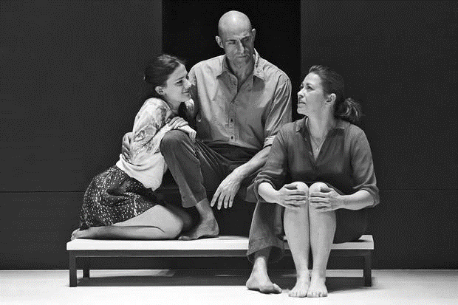
Pages 22-31

Paramount Cinema
Heebie-jeebies A state of anxiety or unease
Broadway A road in New York famous for its theatres

…………………………………………………………………………………………………………………………………………………………………………………………

- Which character ‘never expected to have a destiny’? (22)
- What is Eddie agitated about? (22)
- What nickname have the other longshoreman given Rodolpho? (23)
- What is the difference between Rodolpho and Whitey Balso? (23)
- Who are the ‘submarines’ that Louis refers to? (24)
- Which character is described as a ‘regular bull’? (25)
- Which character is described as having ‘a great sense of humour’? (25)
- What does Rodolpho say Italy has that Brooklyn doesn’t? (26)
- What does Eddie say to Catherine that suggests Rodolpho has an ulterior motive? (28)
- Which character does Eddie say is ‘no good’? (29)
- What does Beatrice say she was ‘happy’ when she thought Catherine was going to ‘go out and get work’? (30)
- What is Beatrice reluctant to tell Eddie? (31)

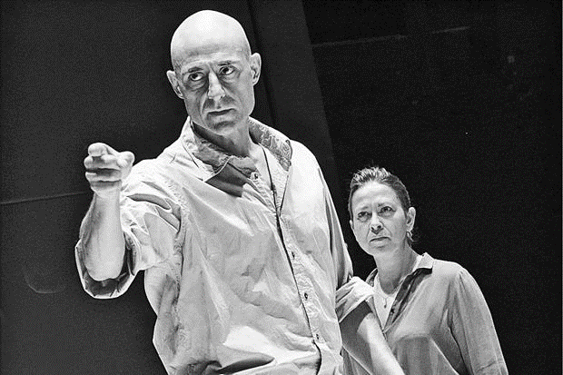
Pages 31-42

Tenor A singer who can reach high notes
Yugoslavia The countries we now know as Serbia and Montenegro
Papers Documents that prove a right to remain in the country

…………………………………………………………………………………………………………………………………………………………………………………………

- How are Eddie’s eyes described? (31)
- What does Alfieri say there ‘is nothing illegal about’? (31)
- What does Eddie say supports his belief that Rodolpho ‘ain’t worried’? (32)
- What is Eddie ‘ashamed’ about? (33)
- What is the ‘one legal question’? (34)
- What advice does Alfieri give to Eddie? (34)
- What ‘promise’ does Eddie say he made? (35)
- Which continent did Rodolpho and Marco once visit? (36)
- What do Eddie and Rodolpho disagree about? (37)
- Which to characters begin to dance? (39)
- Which character is a good cook? (39)
- Which character does Eddie refer to as ‘Danish’? (40)
- What does Beatrice encourage Rodolpho to do? (40)
- What song do Rodolpho and Catherine dance to? (41)
- What does Marco challenge Eddie to do? (42)

Pages 43-55

Shootin’ gallery An area used for shooting practice
Bari A city in southern Italy

…………………………………………………………………………………………………………………………………………………………………………………………

- What date is it at the start of the act? (43)
- What ‘slipped from a net’ onto the pier? (43)
- What does Rodolpho initially think Catherine is ‘fooling’ him about? (44)
- What job odes Catherine suggest Rodolpho could do? (44)
- What is Rodolpho ‘furious’ about? (45)
- What sort of state is Eddie in when he arrives on stage? (46)
- What does Eddie ‘suddenly’ do to Rodolpho? (47)
- What date is it when Alfieri arrives on stage? (48)
- What does Alfieri compare Eddie’s eyes to? (48)
- What does Alfieri say Eddie ‘cannot stop’? (49)
- What number does Eddie ask for? (50)?
- What does Eddie report? (50)?
- What does Eddie say he wants? (50)?
- What advice does Beatrice give to Eddie? (52)?
- What has Catherine made up her mind about? (53)?
- What is the name of the butcher? (54)
- What makes Eddie react with ‘fright’ and ‘anger’? (54)

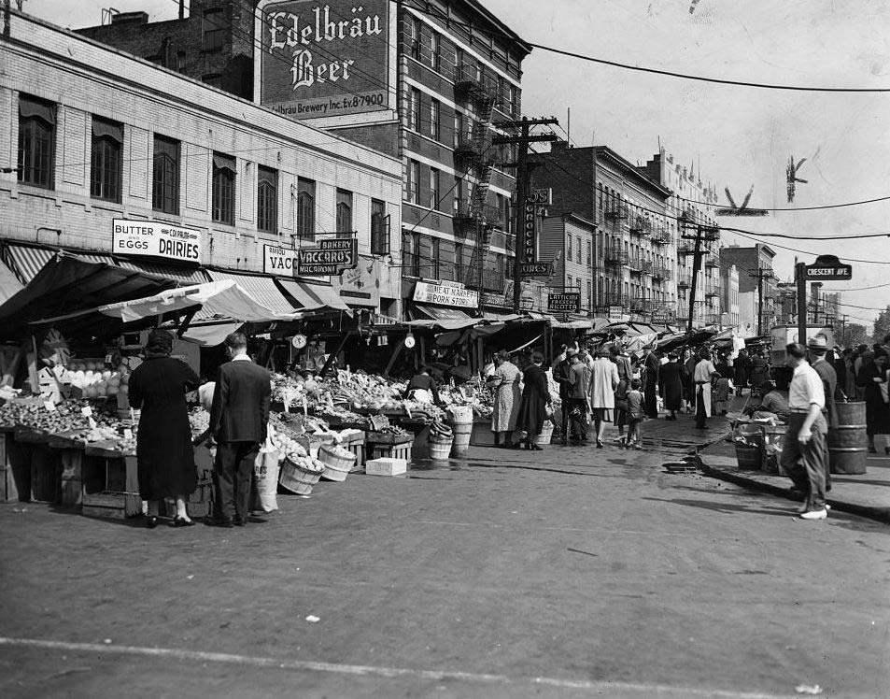

Pages 55-64

Andiamo Italian for ‘come on’

…………………………………………………………………………………………………………………………………………………………………………………………

- Who arrives at the door? (55)
- What does Eddie think Beatrice is accusing him of? (56)
- What does Catherine lie about? (56)
- What does Marco ‘suddenly’ do? (56)
- What does say to Eddie? (57)
- How does Lipari react to Eddie’s attempts criticise Marco? (58)
- How does Louis react to Eddie? (58)
- What does Alfieri want Marco to make a promise about? (59)
- What does Marco have ‘no chance’ of?
- What does Marco say he doesn’t understand? (59)
- What does Catherine attempt to persuade Eddie to do? (60)
- What does Catherine call Eddie? (61)
- What does Eddie say he ‘wants’? (62)
- What does Beatrice say the truth ‘is not as bad as’? (63)
- What does Eddie say that Marco has been ‘wipin’ the neighbourhood’ with? (63)
- What does Eddie ‘spring’ into his hand? (64)
- What does Marco call Eddie? (64)
- What happens to Eddie at the end of the scene? (64)

