A Christmas Carol, by Charles Dickens
Exploring the Context of the Novel

Poverty
- Explain the purpose of a ‘blacking factory’
- Explain what sort of work a young Charles Dickens would have undertaken at one of those factories
- Provide one reason why Dickens might have been particularly interested in social reform
- Explain the difference between the ‘deserving’ and ‘undeserving’ poor
- Explain the primary aim of the (new) Poor Law
- Write down the century and decade in which the (new) Poor Law was introduced
- Provide two reasons why poor people feared being sent to the workhouse
- Read the passage below and write down three adjectives to describe the conditions in workhouses

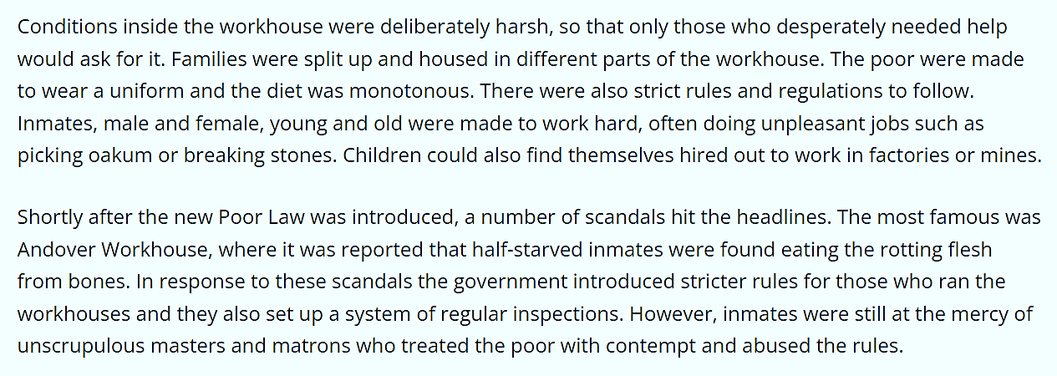

London
- Write down the century and decade in which A Christmas Carol was published
- Read the passage below and provide two reasons why the population of London rapidly expanded in the nineteenth century

Christmas
- Provide a definition of the word ‘charity’
- Explain what the term ‘social conscience’ means

Ghosts
- Name two of the ghosts that appear in A Christmas Carol
- Provide a definition of the word ‘counsel’
- Explain what the phrase ‘embodiment of generosity’ means

