**Plot**

**1**

1. What images are connected to Scrooge in the opening pages?
2. How does Scrooge justify his refusal to donate to charity?
3. What issues do you think Dickens wanted to raise awareness about?
4. How does Scrooge react the presence of the ghost of Jacob Marley?

**Characterisation**

1. Explain how Scrooge is different from Fred
2. Explain Fred’s views on Christmas
3. Explain how Scrooge mistreats Bob
4. Explain how Marley (i.e. when he was alive) was similar to Scrooge
5. Explain which of Scrooge’s characteristics are purposefully emphasised

**Quotations**

1. _______________ and _______________ as flint
2. Solitary as an _______________
3. I can’t _______________ to make idle _______________ merry
4. He felt the chilling influence of its _______________-_______________ eyes
5. There’s more of _______________ than of grave about you
6. I wear the _______________ I forged in life
7. The air was filled with _______________ wandering hither and thither in restless haste
8. He tried to say _______________ !’ but stopped at the first syllable

**Personal Response**

* Write a detailed paragraph on the presentation of the Ghost of Jacob Marley

**Plot**

**2**

1. How does Scrooge react to the arrival of the Ghost of Christmas Past?
2. Which moments in the stave fill Scrooge with joy?
3. Which moments upset him and make him feel regretful?
4. What moment in the stave reveals the point at which Scrooge changed for the worse?
5. What issues do you think Dickens wanted to raise awareness about?

**Characterisation**

1. Explain how Scrooge is different from Fezziwig
2. Explain why Belle ends the relationship with Scrooge
3. Explain what makes Belle happy in her later life
4. Explain how Belle and Fezziwig are similar
5. Explain how Scrooge has changed since the previous stave

**Quotations**

1. From the crown of its head there sprung a bright clear jet of _______________
2. A solitary _______________ , neglected by his friends, is left there still
3. Why, it's old _______________ ! Bless his heart; it’s _______________ alive again!
4. A positive _______________ appeared to issue from _______________ calves
5. Another _______________ has displaced me
6. There is nothing on which it is so hard as _______________
7. His _______________ lies upon the point of death, I hear; and there he sat alone
8. _______________ me no longer!

**Personal Response**

* Write a detailed paragraph on what Scrooge learns from the memory of Fezziwig

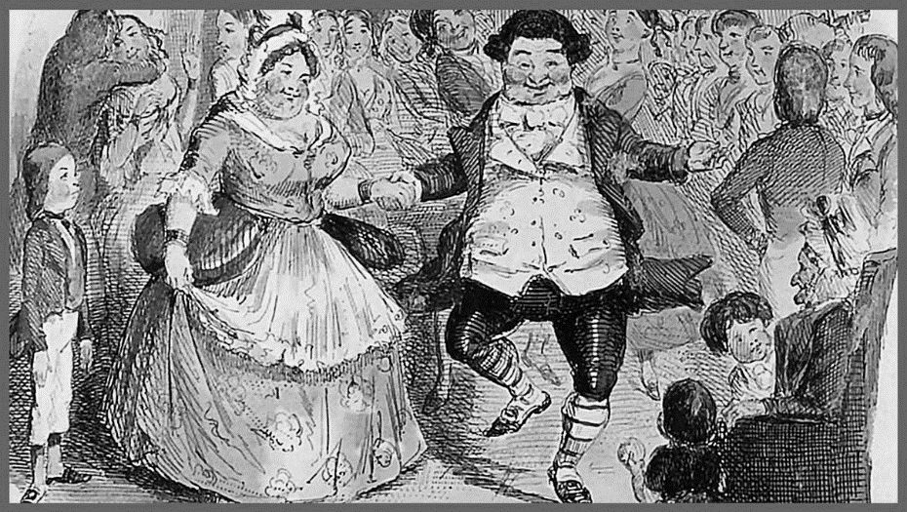

**Plot**

**3**

1. How does Scrooge react to the arrival of the Ghost of Christmas Present?
2. Which moments in the stave fill Scrooge with joy?
3. At which point in the stave does the mood change?
4. Which moment from earlier in the novel does the Ghost of Christmas Present recall?
5. What issues do you think Dickens wanted to raise awareness about?

**Characterisation**

1. Explain what the Ghost of Christmas Present represents about Christmas
2. Explain what we learn about Bob through his toast to Scrooge
3. Explain what we learn about Fred through his refusal to criticise Scrooge
4. Explain how Bob and Fred are similar
5. Explain how the figure of Ignorance is particularly relevant to Scrooge

**Quotations**

1. In easy state upon this couch, there sat a jolly _______________, glorious to see
2. Girded round its middle was an antique scabbard; but no _______________ was in it
3. Alas for Tiny Tim, he bore a little _______________ , and had his limbs supported by an iron frame
4. Scrooge was the _______________ of the family’
5. I think that he loses some pleasant moments, which could do him no _______________
6. They were a _______________ and a _______________
7. Scrooge started back, _______________
8. Beware them both and all of their degree, but most of all beware this _______________

**Personal Response**

* Write a detailed paragraph on what makes the Cratchits such a joyful family

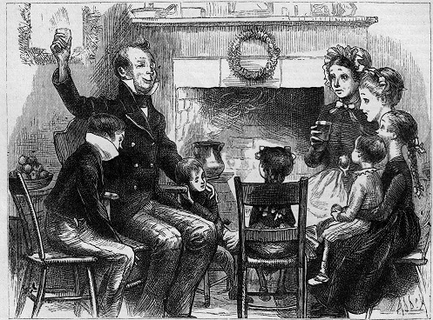

**Plot**

**4**

1. What does the conversation between the businessmen reveal about Scrooge’s reputation?
2. How do the thieves justify the theft of Scrooge’s possessions?
3. Which moment in the stave best captures the damaging effects of Scrooge’s greed?
4. How does Scrooge’s reputation differ from Fred’s reputation?
5. What moment in the stave shows that Scrooge’s transformation is complete?

**Characterisation**

1. Explain how Tiny Tim is remembered by this family
2. Explain the lesson that Scrooge learns from witnessing the thieves
3. Explain how Bob’s presentation is different from the previous stave
4. Explain why Tiny Tim dies
5. Explain why Scrooge finds the sight of his gravestone so distressing

**Quotations**

1. The Phantom slowly, gravely, _______________ approached
2. It’s likely to be a very _______________ funeral
3. He frightened everyone away from him when he was _______________
4. The noisy little _______________ were as still as _______________ in one corner
5. Bob told them of the extraordinary kindness of Mr Scrooge’s _______________
6. Walled in by houses; overrun by grass and _______________
7. Assure me that I yet may _______________ these shadows you have shown me, by an altered life
8. I will live in the _______________ , the _______________ , and the future

**Personal Response**

* Identify three things that Scrooge will be remembered for and explain your choices

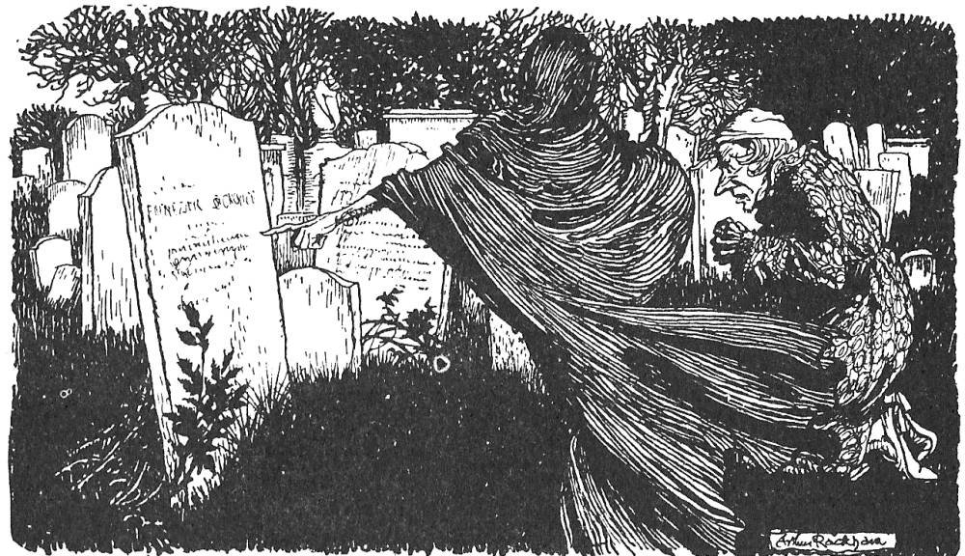

**Plot**

**5**

1. What is Scrooge’s mood like when he wakes-up on Christmas morning?
2. What is the significance of the change in weather?
3. Which moments in the stave show that Scrooge has changed?
4. How do Bob and Fred react to Scrooge’s changed behaviour?
5. What does Scrooge’s newfound happiness reveal about what’s truly valuable?

**Characterisation**

1. Explain how Scrooge has changed since the start of the novel
2. Explain how Scrooge helps Bob
3. Explain what we learn about Fred through his welcoming of Scrooge
4. Explain how Scrooge and Fred are similar
5. Explain why Tiny Tim does not die

**Quotations**

1. I will live in the Past, the _______________ , and the _______________ !
2. No _______________ , no _______________ ; clear, bright, jovial, stirring, cold
3. Do you know whether they’ve sold the _______________ _______________ that was hanging up?
4. He had not gone far, when coming on towards him he beheld the portly _______________
5. _______________ party, _______________ games, wonderful unanimity, won-der-ful happiness!
6. But he was _______________ at the office next morning
7. _______________ was better than his word
8. And so, as _______________ _______________ observed, God bless us, every one!

**Personal Response**

* Identify three important moments in Scrooge’s transformation and explain your choices

