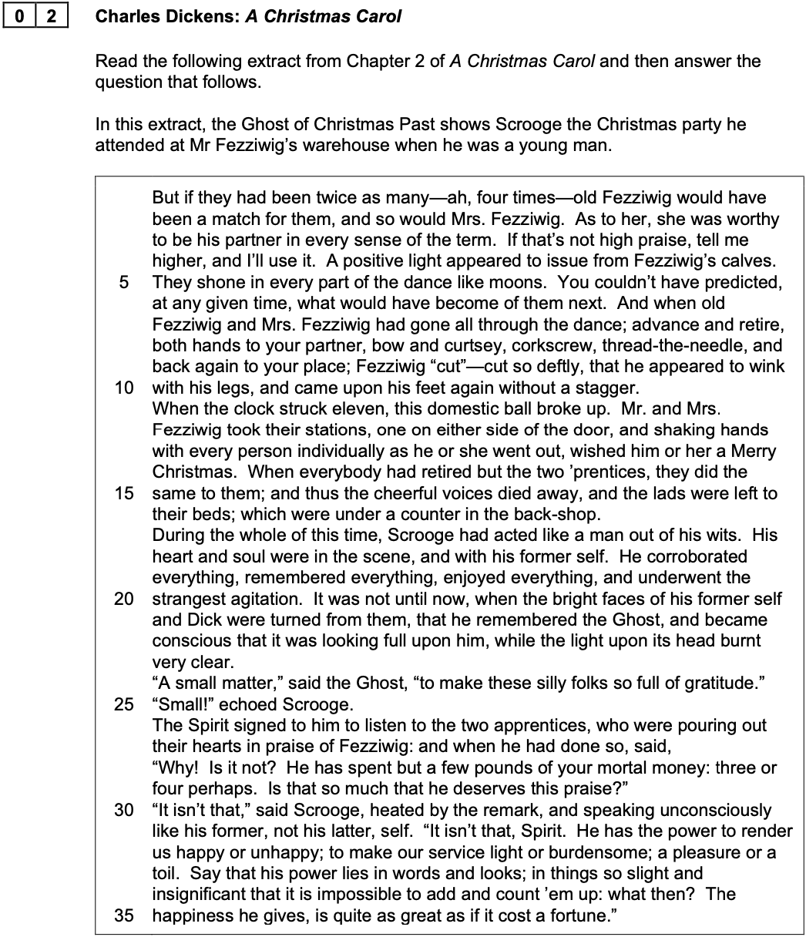

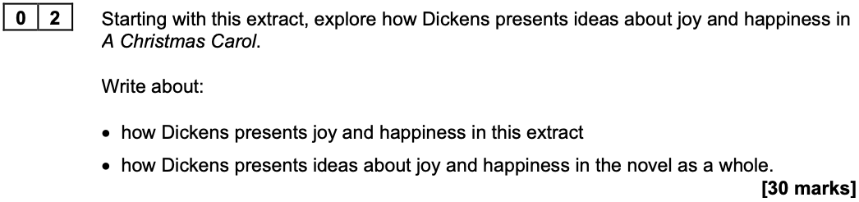

How does Dickens present ideas about
joy and happiness (Fezziwig extract)?

In the extract, Dickens presents joy and happiness through the character of Fezziwig and the party he throws for his workers and family.  Fezziwig is shown to be a fun and cheerful man. He is dancing and makes everyone feel welcome. Dickens describes how everyone is dancing together and having fun. This shows that joy can be created by people when they are enjoying themselves together.  Scrooge watches this memory from his past and begins to feel emotional. At first, he says it’s just a ‘small matter’ that makes people so grateful, but the Ghost wants him to realise that Fezziwig gave people happiness. The Ghost says that Fezziwig only spent a ‘few pounds,’ but made people feel really joyful. This shows that happiness doesn’t come from spending lots of money, but from being generous and kind.  Scrooge feels regret because he hasn’t treated his worker, Bob Cratchit, the same way. This memory helps him see how being kind can make others feel good. Dickens uses this to show the reader that happiness is something you can create for others by being thoughtful.  In the novel as a whole, Dickens continues this idea. The Cratchit family are a good example. Even though they are poor and don’t have much food or money, they are still happy because they love each other. They have a small goose for Christmas, but they make the most of it.  By the end of the novel, Scrooge learns how to be joyful. He visits Fred, gives a turkey to the Cratchits, and laughs. Dickens shows that it’s never too late to change, and that real happiness comes from being with others and helping them.  In conclusion, Dickens shows that people can find joy through kindness, close relationships with their family, and togetherness – not just money. The message is that we should all care for each other, especially at Christmas. |  | Add a bit stating that Dickens uses Fezziwig as a foil to the character of Scrooge  Choose a more formal word to replaced ‘fun’  Make a point about why the imagery of light is significant  Add a point about how Fezziwig is viewed by those who work for him  Make a link between Fezziwig and Fred by highlighting that they share similar values  Provide an example of Scrooge mistreating Bob and then make a further point about Scrooge being the ‘ogre’ of the Cratchit family  Provide an example of the Cratchit family being happy  Add more detail about the Cratchit family being grateful  Retrieve and explore supporting quotations about Scrooge’s purchase of the turkey and his visit to see Fred and his family  Add a bit that make it clear that Scrooge’s transformation reflects the wider changes that Dickens wanted to see in society

