Past Papers

A Christmas Carol

- Summer 2018

- Summer 2019

- Summer 2020

- Autumn 2021

- Summer 2022

- Summer 2023

Summer 2018

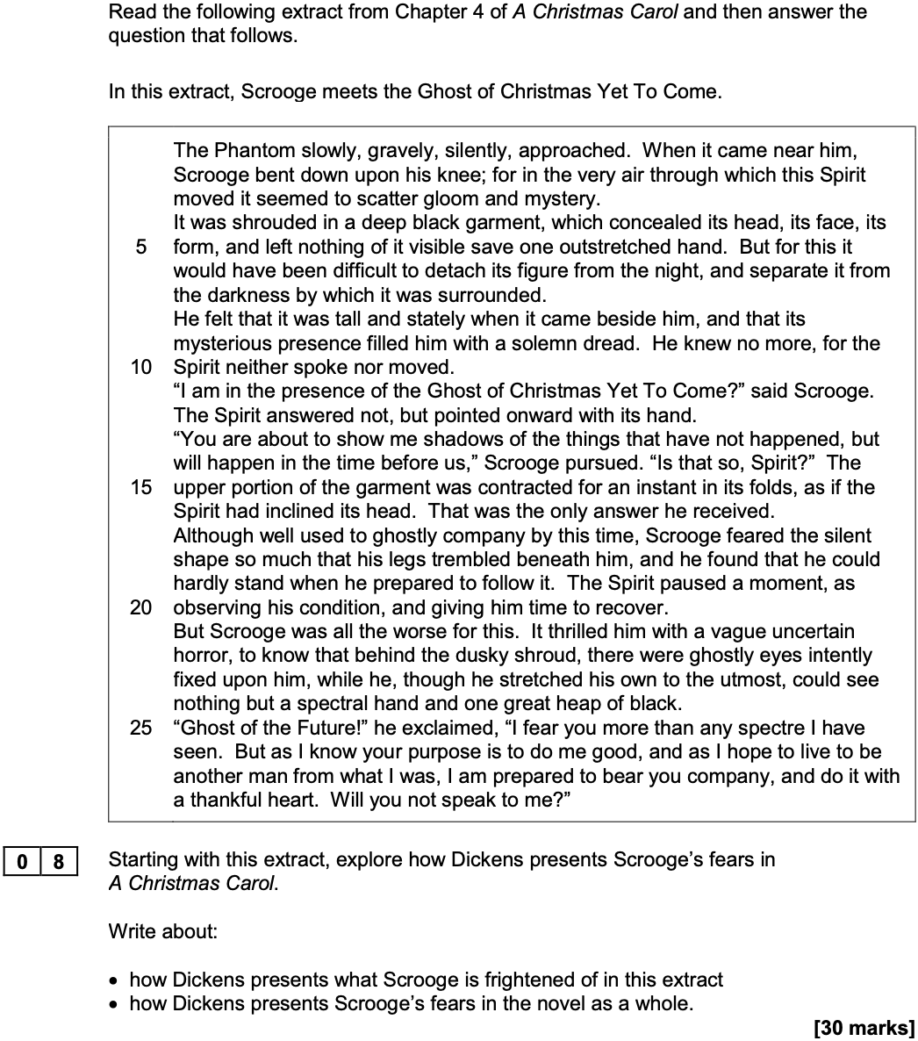

Summer 2019

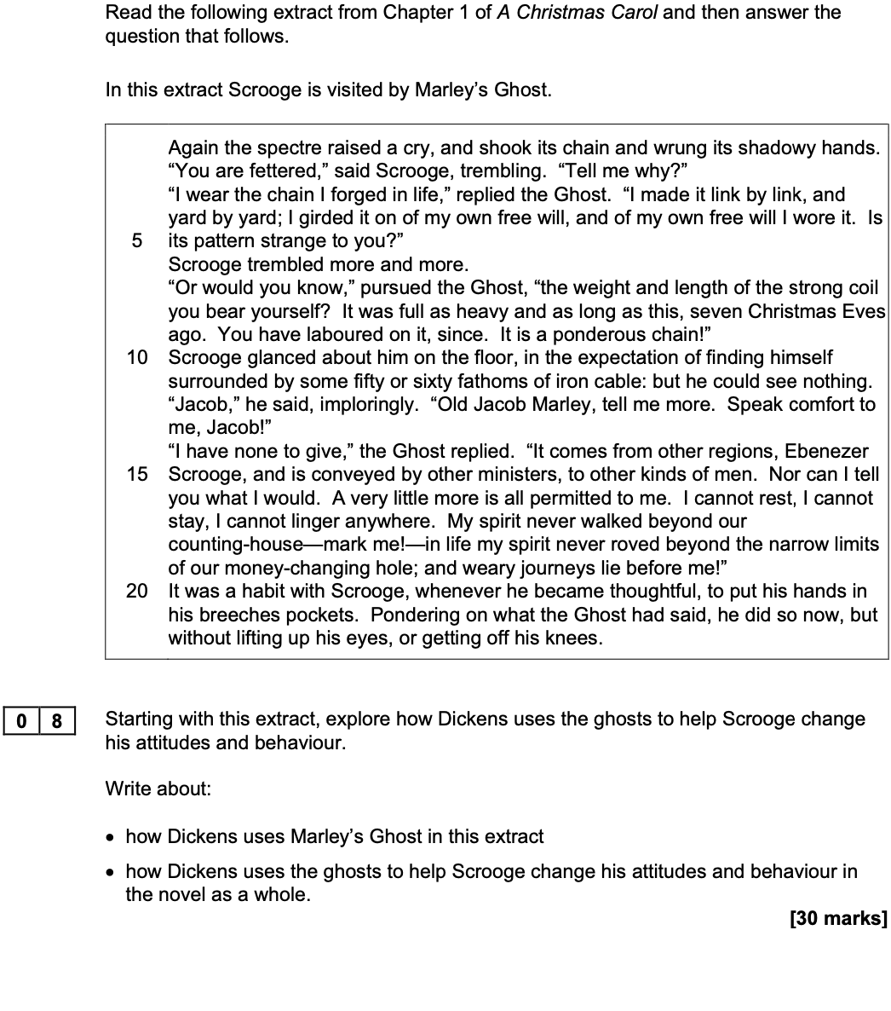

Summer 2020

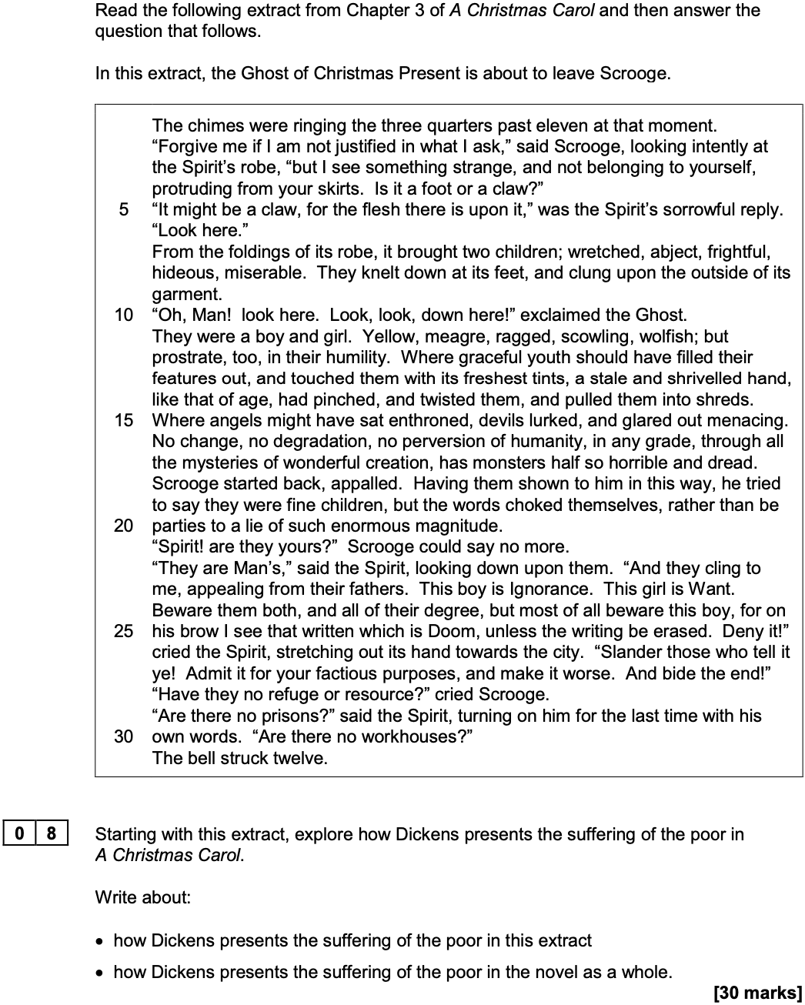

Autumn 2021

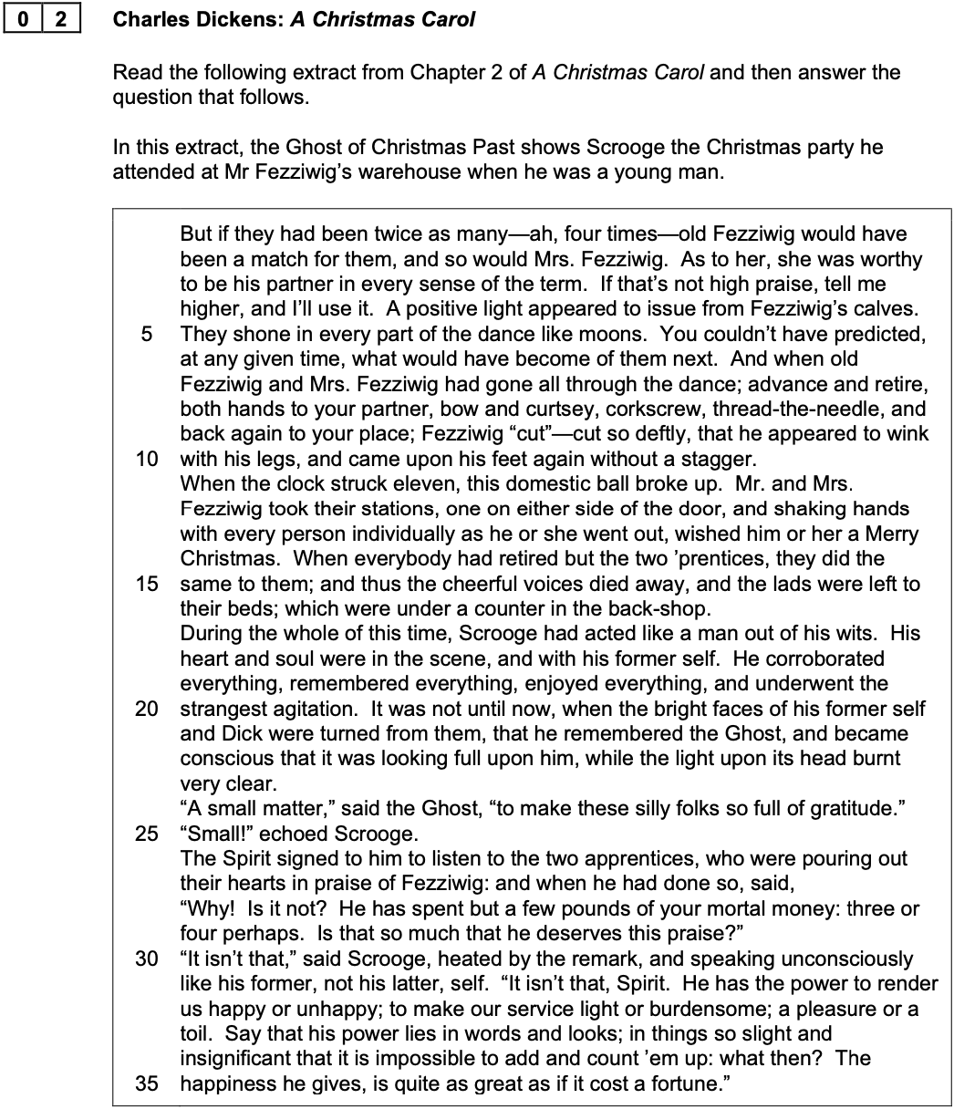

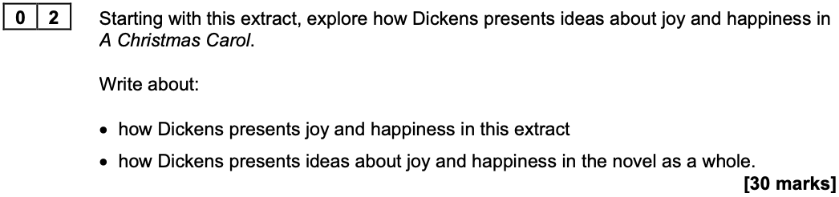

Summer 2022

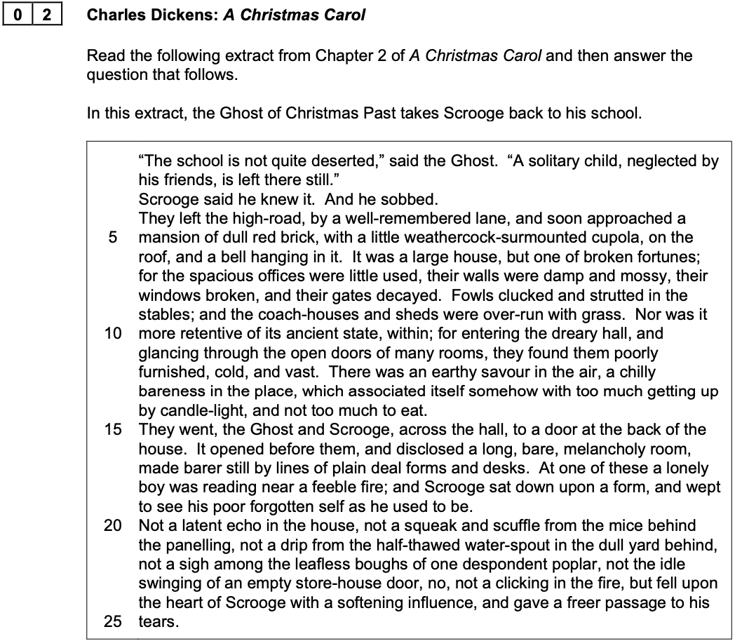

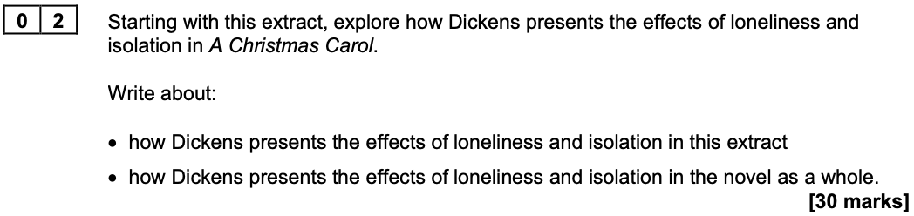

Summer 2023

