500 Word Short Story

Over the next two lessons, I’d like you to plan and write a short story that contains some of the ‘ingredients’ that we’ve encountered in Lamb to the Slaughter and The Landlady. Your job is to transform a scene that appears to be quite ‘ordinary’ into something exciting, scary or mysterious. The challenge with this task is to think hard and craft your writing so that it fills roughly 500 words. Think: quality over quantity.

- Describe an ‘ordinary’ scene (e.g. a supermarket, the front room of a house, a park)
- Subtly indicate that things aren’t quite as they seem (e.g. the scene might be eerily quiet)
- Create a problem for your character or a challenge they need to overcome (e.g. they might get lost)
- Decide whether or not you want them to be successful
- End the story (e.g. with a nice and tidy resolution or a cliff-hanger)

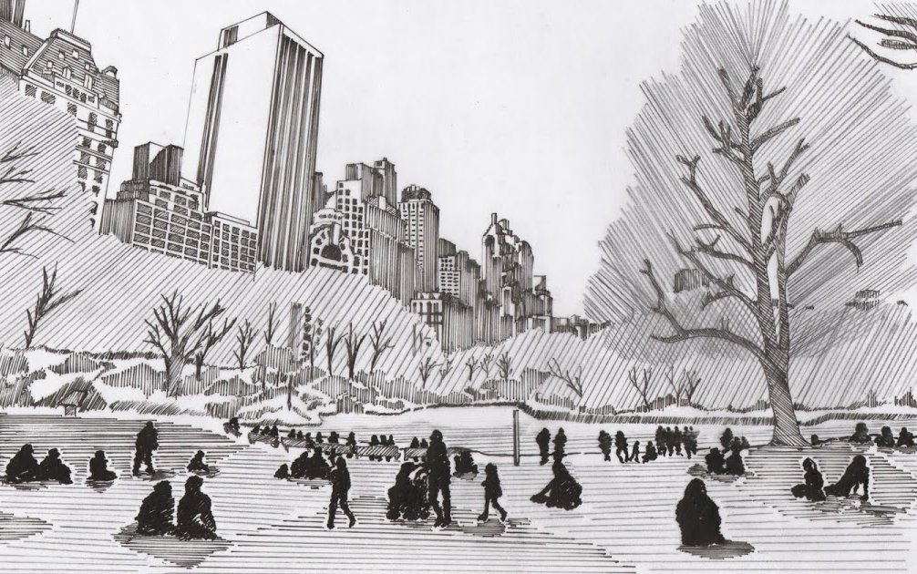

If you’re stuck for ideas, continue (or adapt) the passage below…

The day started with all the grim predictability of the one before. And the one before that. Life in lockdown was dull and Sabina was fed-up of it. She thought back to when the announcement was first made and remembered the contrast between the scruffy blond hair and the dark, hooded eyes of the Prime Minister; he had talked about the importance of staying safe and saving lives. And, of course, she hadn’t disagreed. But any early excitement she had felt – no school! – had soon disappeared and she longed for normality. So, what to do? Perhaps a short walk in the park. Yes, why not? So, off she went. However, at the precise moment that Sabina closed the front behind her, she noticed…

