War Poetry | The Sisters Buried at Lemnos, by Vera Brittain

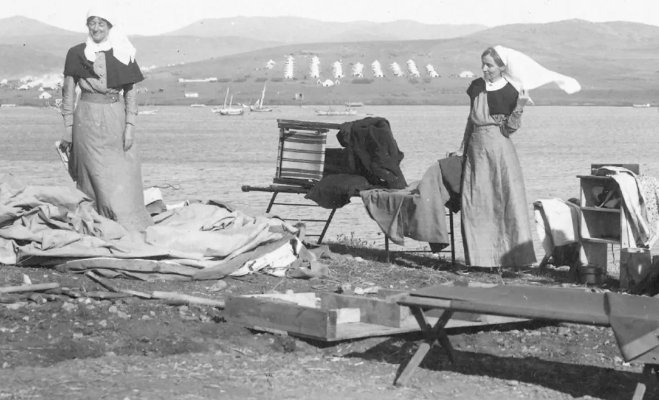

The poem is about two Canadian nurses who were buried on the Greek island of Lemnos. The nurses died after contracting an illness during the Gallipoli Campaign of World War I. Vera Brittain visited their graves in 1916 when her ship, the HMHS Britannic, docked in Lemnos en route to Malta.

Line 1 What is the significance of the adjective ‘golden’?
Lines 1 - 4 How is the island of Lemnos presented?
Line 3 Why does the speaker ‘kneel’ in ‘reverent devotion’?
Lines 5 - 8 What is suggested about the contributions of women during the war?
Lines 9 -12 What challenges did the women on Lemnos face?
Line 13 What is ‘mortal frailty’ a reference to?
Line 15 What is suggested by the contrast between ‘body weak’ and ‘spirit ever stronger’?
Line 20 How is the ‘victorious dying’ of the Sisters recognised and remembered?
Lines 25 - 28 What is the effect of the connection between the island of Lemnos and the Sisters’ graves?

The Sisters Buried at Lemnos

O golden Isle set in the deep blue Ocean,
With purple shadows flitting o’er thy crest,
I kneel to thee in reverent devotion
Of some who on thy bosom lie at rest!

5 Seldom they enter into song or story;
Poets praise the soldier’s might and deeds of War,
But few exalt the Sisters, and the glory
Of women dead beneath a distant star.

No armies threatened in that lonely station,
10 They fought not fire or steel or ruthless foe,
But heat and hunger, sickness and privation,
And Winter’s deathly chill and blinding snow.

Till mortal frailty could endure no longer
Disease’s ravages and climate’s power,
15 In body weak, but spirit ever stronger,
Courageously they stayed to meet their hour.

No blazing tribute through the wide world flying,
No rich reward of sacrifice they craved,
The only meed of their victorious dying
20 Lives in the hearts of humble men they saved.

Who when in light the Final Dawn is breaking,
Still faithful, though the world’s regard may cease,
Will honour, splendid in triumphant waking,
The souls of women, lonely here at peace.

25 O golden Isle with purple shadows falling
Across thy rocky shore and sapphire sea,
I shall not picture these without recalling
The Sisters sleeping on the heart of thee!

