War Poetry | The Shadow, by Rose Macaulay

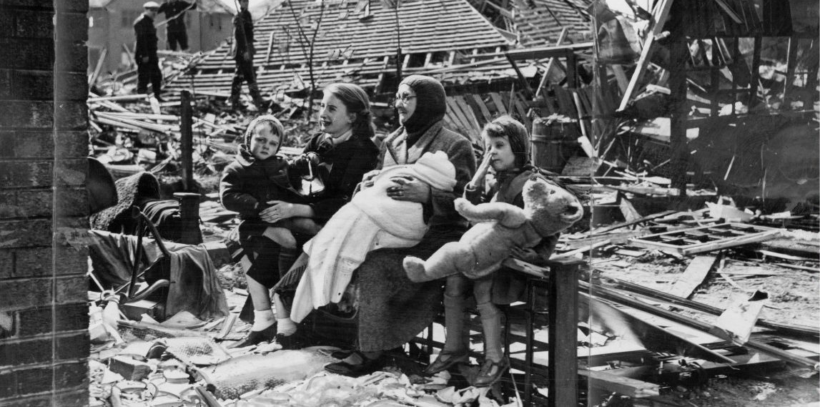

I went out with the ambulance from 10 till 4am… bombing was v. bad all around that night; I attended an incident in Camden Town – two fallen houses, a great pile of ruins, with all the inhabitants buried deep. I drove to hospital another mother, who had left two small children under the ruins. I told her they would be out very soon – but they never were,
they were killed.

Source: Letter from Rose Macaulay to her sister Jean (in Rose Macaulay, by Constance Babbington Smith)

Lines 1 - 4 What sort of scene is being described?
Lines 1 - 4 What contrasts can you identify and what effect do you think they have?
Line 5 Why do you think ‘Fear’ is personified?
Line 8 Why do you think Macaulay chose to write ‘The world’s young men’ and not ‘England’s young men’?
Lines 9 - 12 What do the verbs reveal about the experience of war for those who remained at home?
Line 10 What is suggested about Macaulay’s view of God?
Line 14 What does the question (also repeated in stanzas two and six) require the reader to think about?
Lines 17 - 21 What details emphasise Macaulay’s intense sorrow for the collective loss of life?
Line 20 What does the reference to ‘Tonight’s show’ mean?
Lines 22 - 35 How does the final stanza develop the two concepts from stanzas two and four (i.e. ‘Fear’ and ‘Pain’)?

The Shadow

There was a shadow on the moon; I saw it poise and tilt and go
Its lonely way, and so I know that the blue velvet night will soon
Blaze loud and bright, as if the stars were crashing right into the town,
And tumbling street and houses down, and smashing people like wine-jars…

5 Fear wakes:
What then?
Strayed shows of the Fear that breaks
The world’s young men.

Bright fingers point all-round the sky; they point and grope and cannot find.
10 (God’s hand, you’d think, and he gone blind…) … the queer white faces twist and cry.
Last time they came they messed our square, and left it a hot rubbish-heap,
With people sunk in it so deep, you could not even hear them swear.

Fire blinds.
What then?
15 Pale shadows of the Pain that grinds
The world’s young men.

The weak blood running down the street, oh, does it run like fire, like wine?
And are the spilt brains so keen, so fine, crushed limbs so swift, dead dreams so sweet!
There is a Plain where limbs and dreams and brains to see the world a-fire
20 Lie tossed in sodden heaps of mire… Crash! Tonight’s show
Begins, it seems.

Death… Well,
What then?
Rim of the shadows of Hell
25 Of the world’s young men.

