War Poetry | Munition Wages, by Ida Bedford

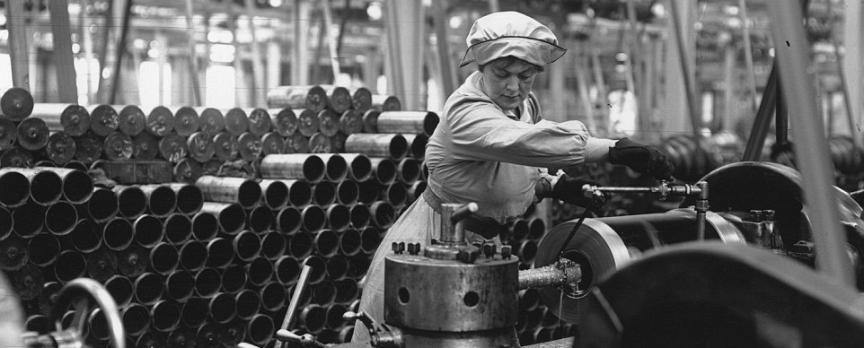

It is relatively rare to find the voice of the working people in anthologised poetry, imagined as this voice undoubtedly is. It is also rare to find a celebration of opportunity for improvement of personal circumstances, a chance to ‘better oneself’. That many women who found themselves in munitions factories saw this as a quick taste of a more financially rewarding life is quite clear, even though not all women were so approving of their experiences. There is nothing here of the long-term effects of such work, heavy and chemical-ridden, and the worker in this poem does not seem to have faced
circumstances which other accounts show offered workers less freedom and lower wages. It is the celebration of a new life. Death is a possibility to consider around the corner, yet no more of a certainty than a short life expectancy was the likely outcome of her days of ‘tatters’.

Source: The English Association of the University of Leicester

- Read Professor Susan Grayzel’s essay on the extent to which World War I challenged gender roles –
https://www.bl.uk/world-war-one/articles/changing-lives-gender-expectations

- List five adjectives to describe the speaker of the poem and find a supporting quotation for each one

- Explain why you think Bedford chose to makes the second and fourth lines of each stanza rhyme

- Explain why you think Bedford chose to use a range of colloquial language (e.g. ‘ain’t’, ‘touch-and-go-bizz’)

- List four similarities between Many Sisters to Many Brothers and Munition Wages

Munition Wages

Earning high wages?
Yus, Five quid a week.
A woman, too, mind you,
I calls it dim sweet.

Ye’are asking some questions –
But bless yer, here goes:
I spends the whole racket
On good times and clothes.

Me saving? Elijah!
Yer do think I’m mad.
I’m acting the lady,
But – I ain’t living bad.

I’m having life’s good times.
See ‘ere, it’s like this:
The ‘oof come o’ danger,
A touch-and-go bizz.

We’re all here today, mate,
Tomorrow – perhaps dead,
If Fate tumbles on us
And blows up our shed.

Afraid! Are yer kidding?
With money to spend!
Years back I wore tatters,
Now – silk stockings, mi friend!

I’ve bracelets and jewellery,
Rings envied by friends;
A sergeant to swank with,
And something to lend.

I drive out in taxis,
Do theatres in style.
And this is mi verdict –
It is jolly worthwhile.

Worthwhile, for tomorrow
If I’m blown to the sky,
I’ll have repaid mi wages
In death – and pass by.

