100 Years of Dystopian Fiction: 1920 - 2020

City of Endless Night, by Milo Hastings 1920
We, by Eugene Zamiatin 1924
Brave New World, by Aldous Huxley 1932
1984, by George Orwell 1949
Fahrenheit 451, by Ray Bradbury 1953
The Handmaid’s Tale, by Margaret Atwood 1985
Brown Girl in the Ring, by Nalo Hopkinson 1998
Never Let Me Go, by Kazuo Ishiguro 2005
The Hunger Games, by Suzanne Collins 2008
Smoketown, by Tenea Johnson 2011
The Power, by Naomi Alderman 2016
The Light at the Bottom of the World, by London Shah 2019
Riot Baby, by Tochi Onyebuchi 2020

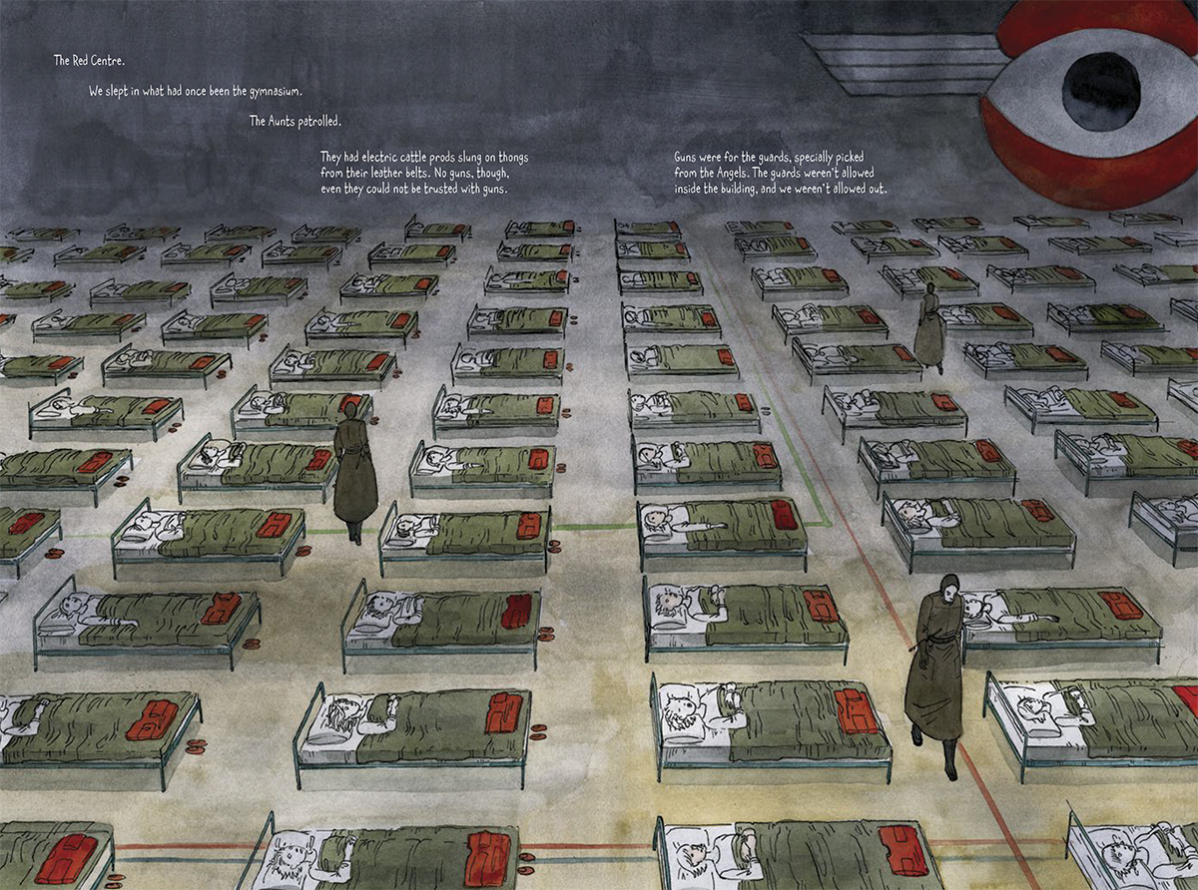
City of Endless Night, by Milo Hastings

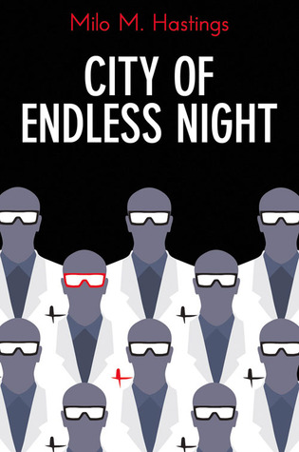
My uncle had predicted correctly, for by the time I again came home on my vacation, the newly elected Pacifist Council had reduced the aerial activities to mere watchful patroling over the land of the enemy. Then came the report of an attempt to launch an airplane from the roof of Berlin. The people, in dire panic lest Ray generators were being carried out by German aircraft, had clamoured for the recall of the Pacifist Council, and the bombardment of Berlin was resumed.

During the lull of the bombing activities my uncle, who stood high with the Pacifist Administration, had obtained permission to fly over Europe, and I, most fortunate of boys, accompanied him. The plane in which we travelled bore the emblem of the World Patrol. On a cloudless day we sailed over the pock-marked desert that had once been Germany and came within field-glass range of Berlin itself. On the wasted, bomb-torn land lay the great grey disc--the city of mystery. Three hundred metres high they said it stood, but so vast was its extent that it seemed as flat and thin as a pancake on a griddle.

‘More people live in that mass of concrete,’ said my uncle, ‘than in the whole of America west of the Rocky Mountains.’ His statement, I have since learned, fell short of half the truth, but then it seemed appalling. I fancied the city a giant anthill, and searched with my glass as if I expected to see the ants swarming out. But no sign of life was visible upon the monotonous surface of the sand-blanketed roof, and high above the range of naked vision hung the hawk-like watchers of the World Patrol.

The lure of unravelled secrets, the ambition for discovery and exploration stirred my boyish veins. Yes, I would know more of the strange race, the unknown life that surged beneath that grey blanket of mystery. But how? For over a century millions of men had felt that same longing to know. Aviators, landing by accident or intent within the lines, had either returned with nothing to report, or they had not returned. Daring journalists, with baskets of carrier pigeons, had on foggy nights dropped by parachute to the roof of the city; but neither they nor the birds had brought back a single word of what lay beneath the armed and armoured roof.

We, by Eugene Zamiatin

I have had opportunity to read and hear many improbable things about those times when human beings still lived in the state of freedom, that is, an unorganized primitive state. One thing has always seemed to me the most improbable: how could a government, even a primitive government, permit people to live without anything like our Tables – without compulsory walks, without precise regulation of the time to eat, for instance? They would get up and go to bed whenever they liked. Some historians even say that in those days the streets were lighted all night; and all night people went about the streets.

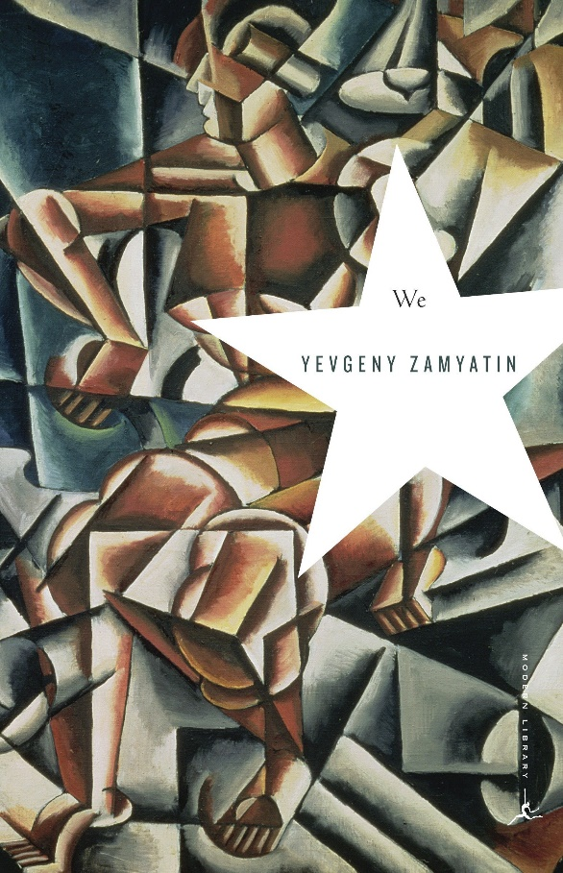
That I cannot understand; true, their minds were rather limited in those days. Yet they should have understood, should they not, that such a life was actually wholesale murder, although slow murder, day after day? The State (humanitarianism) forbade in those days the murder of one person, but it did not forbid the killing of millions slowly and by half. To kill one, that is, to reduce the general sum of human life by fifty years, was considered criminal, but to reduce the general sum of human life by fifty million years was not considered criminal! Is it not droll? Today this simple mathematical moral problem could easily be solved in half a minute’s time by any ten-year-old Number, yet they couldn’t do it! All their Immanuel Kants together couldn’t do it! It didn’t enter the heads of all their Kants to build a system of scientific ethics, that is, ethics based on adding, subtracting, multiplying and dividing.

Further, is it not absurd that their State (they called it State!) left sexual life absolutely without control? However, whenever and as much as they wanted... Absolutely unscientific like beasts; and like beasts they blindly gave birth to children! Is it not strange to understand gardening, chicken-farming, fishery (we have definite knowledge that they were familiar with all these things), and not to be able to reach the last step in this logical scale, namely, production of children – not to be able to discover such things as Maternal and Paternal Norms?

It is so droll, so improbable, that while I write this I am afraid lest you, my unknown future readers, should think I am merely a bad jester. I feel almost as though you may think I simply want to mock you and with a most serious appearance try to relate to you absolute nonsense. But first, I am incapable of jesting, for in every joke a lie has its hidden function. And second, the science of the United State contends that the life of the ancients was exactly what I am describing, and the science of the United State cannot make a mistake! Yet how could they have State logic, since they lived in a condition of freedom like beasts, like apes, like herds? What could one expect of them, since even in our day one hears from time to time, coming from the bottom, the primitive depths, the echo of the apes?

Brave New World, by Aldous Huxley

A squat grey building of only thirty-four storeys. Over the main entrance the words, Central London Hatchery and Conditioning Centre, and, in a shield, the World State’s motto: Community, Identity, Stability.

The enormous room on the ground floor faced towards the north. Cold for all the summer beyond the panes, for all the tropical heat of the room itself, a harsh thin light glared through the windows, hungrily seeking some draped lay figure, some pallid shape of academic gooseflesh, but finding only the glass and nickel and bleakly shining porcelain of a laboratory. Wintriness responded to wintriness. The overalls of the workers were white, their hands gloved with a pale corpse-coloured rubber. The light was frozen, dead, a ghost. Only from the yellow barrels of the microscopes did it borrow a certain rich and living substance, lying along the polished tubes like butter, streak after luscious streak in long recession down the worktables.

’And this,’ said the Director opening the door, ‘is the Fertilizing Room.’

Bent over their instruments, three hundred Fertilizers were plunged, as the Director of Hatcheries and Conditioning entered the room, in the scarcely breathing silence, the absentminded, soliloquizing hum or whistle, of absorbed concentration. A troop of newly arrived students, very young, pink and callow, followed nervously, rather abjectly, at the Director’s heels. Each of them carried a notebook, in which, whenever the great man spoke, he desperately scribbled. Straight from the horse’s mouth. It was a rare privilege. The DHC for Central London always made a point of personally conducting his new students round the various departments.

‘Just to give you a general idea,’ he would explain to them. For of course some sort of general idea they must have, if they were to do their work intelligently — though as little of one, if they were to be good and happy members of society, as possible. For particulars, as everyone knows, make for virtue and happiness; generalities are intellectually necessary evils. Not philosophers, but fret-sawyers and stamp collectors compose the backbone of society.

‘Tomorrow,’ he would add, smiling at them with a slightly menacing geniality, ‘you’ll be settling down to serious work. You won’t have time for generalities. Meanwhile...’

Meanwhile, it was a privilege. Straight from the horse’s mouth into the notebook. The boys scribbled like mad.

1984, by George Orwell

It was a bright cold day in April, and the clocks were striking thirteen. Winston Smith, his chin nuzzled into his breast in an effort to escape the vile wind, slipped quickly through the glass doors of Victory Mansions, though not quickly enough to prevent a swirl of gritty dust from entering along with him.

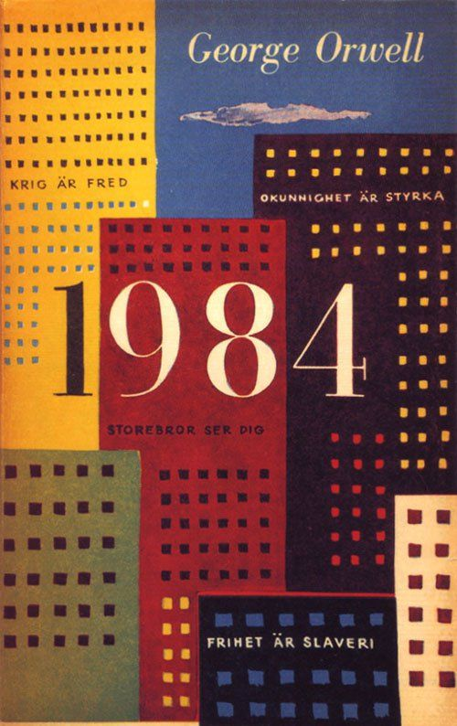
The hallway smelt of boiled cabbage and old rag mats. At one end of it a coloured poster, too large for indoor display, had been tacked to the wall. It depicted simply an enormous face, more than a metre wide: the face of a man of about forty-five, with a heavy black moustache and ruggedly handsome features. Winston made for the stairs. It was no use trying the lift. Even at the best of times it was seldom working, and at present the electric current was cut off during daylight hours. It was part of the economy drive in preparation for HateWeek. The flat was seven flights up, and Winston, who was thirty-nine and had a varicose ulcer above his right ankle, went slowly, resting several times on the way. On each landing, opposite the lift shaft, the poster with the enormous face gazed from the wall. It was one of those pictures which are so contrived that the eyes follow you about when you move. BIG BROTHER IS WATCHING YOU, the caption beneath it ran.

Inside the flat a fruity voice was reading out a list of figures which had something to do with the production of pig-iron. The voice came from an oblong metal plaque like a dulled mirror which formed part of the surface of the right-hand wall. Winston turned a switch and the voice sank somewhat, though the words were still distinguishable. The instrument (the telescreen, it was called) could be dimmed, but there was no way of shutting it off completely. He moved over to the window: a smallish, frail figure, the meagreness of his body merely emphasized by the blue overalls which were the uniform of the Party. His hair was very fair, his face naturally sanguine, his skin roughened by coarse soap and blunt razor blades and the cold of the winter that had just ended.

Outside, even through the shut windowpane, the world looked cold. Down in the street little eddies of wind were whirling dust and torn paper into spirals, and though the sun was shining and the sky a harsh blue, there seemed to be no colour in anything, except the posters that were plastered everywhere. The black-moustachioed face gazed down from every commanding corner. There was one on the house-front immediately opposite. BIG BROTHER IS WATCHING YOU, the caption said, while the dark eyes looked deep into Winston’s own.

Down at street level another poster, torn at one corner, flapped fitfully in the wind, alternately covering and uncovering the single word INGSOC. In the far distance a helicopter skimmed down between the roofs, hovered for an instant like a bluebottle, and darted away again with a curving flight. It was the police patrol, snooping into people’s windows. The patrols did not matter, however. Only the Thought Police mattered.
Fahrenheit 451, by Ray Bradbury

It was a pleasure to burn.

It was a special pleasure to see things eaten, to see things blackened and changed. With the brass nozzle in his fists, with this great python spitting its venomous kerosene upon the world, the blood pounded in his head, and his hands were the hands of some amazing conductor playing all the symphonies of blazing and burning to bring down the tatters and charcoal ruins of history. With his symbolic helmet numbered 451 on his stolid head, and his eyes all orange flame with the thought of what came next, he flicked the igniter and the house jumped up in a gorging fire that burned the evening sky red and yellow and black. He strode in a swarm of fireflies. He wanted above all, like the old joke, to shove a marshmallow on a stick in the furnace, while the flapping pigeon-winged books died on the porch and lawn of the house. While the books went up in sparkling whirls and blew away on a wind turned dark with burning.

Montag grinned the fierce grin of all men singed and driven back by flame.

He knew that when he returned to the firehouse, he might wink at himself, a minstrel man, burnt-corked, in the mirror. Later, going to sleep, he would feel the fiery smile still gripped by his face muscles, in the dark. It never went away, that smile, it never ever went away, as long as he remembered.

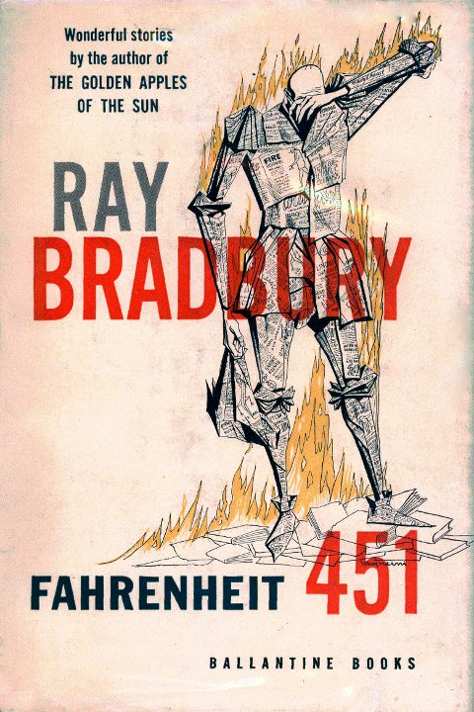
He hung up his black beetle-colored helmet and shined it; he hung his flameproof jacket neatly; he showered luxuriously, and then, whistling, hands in pockets, walked across the upper floor of the fire station and fell down the hole. At the last moment, when disaster seemed positive, he pulled his hands from his pockets and broke his fall by grasping the golden pole. He slid to a squeaking halt, the heels one inch from the concrete floor downstairs.

He walked out of the fire station and along the midnight street toward the subway where the silent air-propelled train slid soundlessly down its lubricated flue in the earth and let him out with a great puff of warm air onto the cream-tiled escalator rising to the suburb.

Whistling, he let the escalator waft him into the still night air. He walked toward the corner, thinking little at all about nothing in particular. Before he reached the corner, however, he slowed as if a wind had sprung up from nowhere, as if someone had called his name.

The Handmaid’s Tale, by Margaret Atwood

A group of people is coming towards us. They’re tourists, from Japan it looks like, a trade delegation perhaps, on a tour of the historic landmarks or out for local color. They’re diminutive and neatly turned out; each has his or her camera, his or her smile. They look around, brighteyed, cocking their heads to one side like robins, their very cheerfulness aggressive, and I can’t help staring. It’s been a long time since I’ve seen skirts that short on women. The skirts reach just below the knee and the legs come out from beneath them, nearly naked in their thin stockings,
blatant, the high-heeled shoes with their straps attached to the feet like delicate instruments of torture. The women teeter on their spiked feet as if on stilts, but off balance; their backs arch at the waist, thrusting the buttocks out. Their heads are uncovered and their hair too is exposed, in all its darkness and sexuality. They wear lipstick, red, outlining the damp cavities of their mouths, like scrawls on a washroom wall, of the time before.

I stop walking. Ofglen stops beside me and I know that she too cannot take her eyes off these women. We are fascinated, but also repelled.

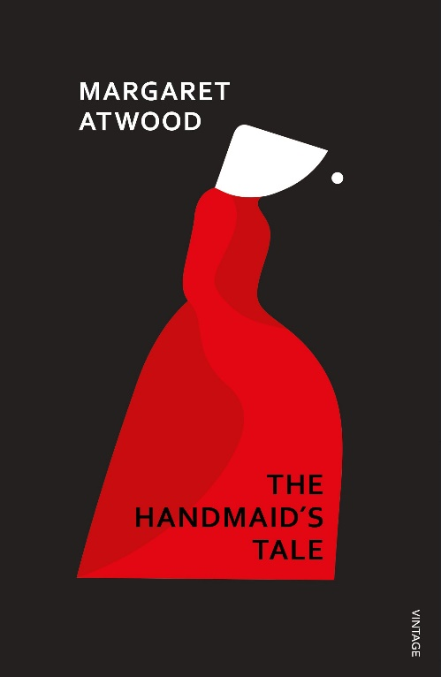
They seem undressed. It has taken so little time to change our minds, about things like this. Then I think: I used to dress like that. That was freedom. Westernized, they used to call it.

The Japanese tourists come towards us, twittering, and we turn our heads away too late: our faces have been seen.
There’s an interpreter, in the standard blue suit and red-patterned tie, with the winged-eye tie pin. He’s the one who steps forward, out of the group, in front of us, blocking our way. The tourists bunch behind him; one of them raises a camera.

‘Excuse me,’ he says to both of us, politely enough. ‘They’re asking if they can take your picture.’

I look down at the sidewalk, shake my head for no. What they must see is the white wings only, a scrap of face, my chin and part of my mouth. Not the eyes. I know better than to look the interpreter in the face. Most of the interpreters are Eyes, or so it’s said.

Brown Girl in the Ring, by Nalo Hopkinson

Paula and Pavel had set up their awning at the corner of Carlton and Sherbourne, next to the shack from which Bruk-Foot Sam sold reconditioned bicycles. Braces of skinned, gutted squirrels were strung up under Paula and Pavel’s awning. Ti-Jeanne could smell the rankness of the fresh raw meat as she walked by. It must have been the morning’s kill. The couple had claimed the adjacent Allan Gardens park and its greenhouse, which they farmed. In the winter, Paula and Pavel were the Burn’s source of fresh vegetables for those who lacked the resources to import them from outcity. And the overgrown park hid a surprising amount of wild game; pigeons, squirrels; wild dogs and cats for the not too particular. Paula and Pavel defended their territory fiercely. Both brawny people, they each had a large, blood-smeared butcher knife tucked into one boot: warning and advertisement. Nobody gave them much trouble any more, though. It wasn’t worth the personal damages to try to steal from the well-muscled pair. Rumour had it that those who crossed Paula and Pavel ended up in the cookpot. Besides, vegetables and fresh meat were scarce, so people tried to stay on Paula and Pavel’s good side. Those who lived in the Burn were still city people; most preferred to barter or buy from the couple, rather than learn how to trap for themselves.

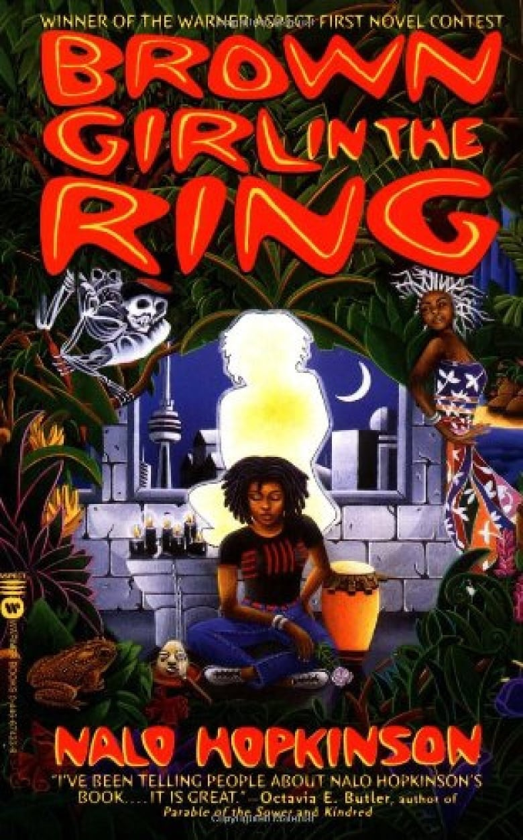
Hugely pregnant, Paula was arguing the price of two scrawny squirrels with two gaunt young women who had their arms wrapped possessively around each other. They’d probably take the meat across the street to Lenny’s cookstand, where for a price he’d throw it onto the barbecue next to the unidentifiable flesh he skewered, cooked, and sold for money or barter.

‘Good evening, Ti-Jeanne,’ Pavel called out as she went by. He and his wife, Paula, had been lecturers at the University of Toronto before the Riots changed everything. ‘We got something for your grandmother; leaves from that tree – sour-sop, I think she calls it?’

‘Yes,’ Ti-Jeanne replied. Mami would like that. Soursop leaf tea made a gentle sedative, and the old greenhouse was the only source of the tropical plant.

‘Good,’ Pavel said. ‘Tell your grandma we’ll be by with them later, eh? We’ll trade her for some cough syrup for our little Sasha.’

Ti-Jeanne nodded, smiled, looked away. In the eleven years since the Riots, she’d had to get used to people talking out loud about her grandmother’s homemade medicines. Among Caribbean people, bush medicine used to be something private, but living in the Burn changed all the rules.

Never Let Me Go, by Kazuo Ishiguro

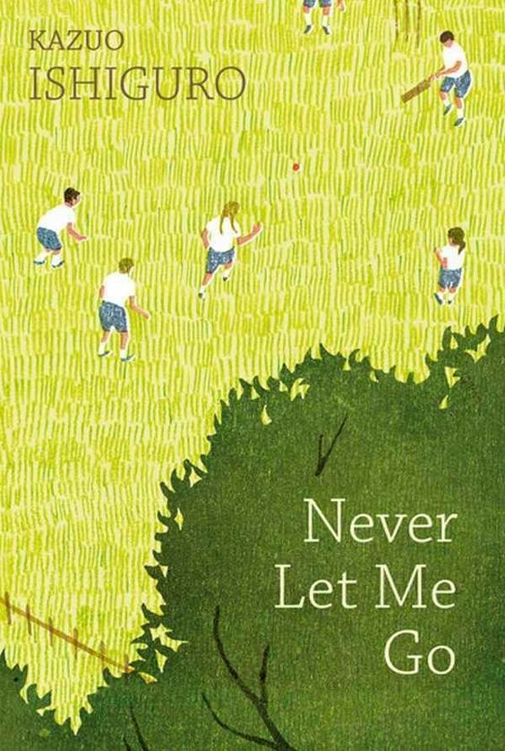
My name is Kathy H. I’m thirty-one years old, and I’ve been a carer now for over eleven years. That sounds long enough, I know, but actually they want me to go on for another eight months, until the end of this year. That’ll make it almost exactly twelve years. Now I know my being a carer so long isn’t necessarily because they think I’m fantastic at what I do. There are some really good carers who’ve been told to stop after just two or three years. And I can think of one carer at least who went on for all of fourteen years despite being a complete waste of space. So I’m not trying to boast. But then I do know for a fact they’ve been pleased with my work, and by and large, I have too. My donors have always tended to do much better than expected. Their recovery times have been impressive, and hardly any of them have been classified as “agitated,” even before fourth donation. Okay, maybe I am boasting now. But it means a lot to me, being able to do my work well, especially that bit about my donors staying “calm.” I’ve developed a kind of instinct around donors. I know when to hang around and comfort them, when to leave them to themselves; when to listen to everything they have to say, and when just to shrug and tell them to snap out of it.

Anyway, I’m not making any big claims for myself. I know carers, working now, who are just as good and don’t get half the credit. If you’re one of them, I can understand how you might get resentful – about my bedsit, my car, above all, the way I get to pick and choose who I look after. And I’m a Hailsham student – which is enough by itself sometimes to get people’s backs up. Kathy H., they say, she gets to pick and choose, and she always chooses her own kind: people from Hailsham, or one of the other privileged estates. No wonder she has a great record. I’ve heard it said enough, so I’m sure you’ve heard it plenty more, and maybe there’s something in it. But I’m not the first to be allowed to pick and choose, and I doubt if I’ll be the last. And anyway, I’ve done my share of looking after donors brought up in every kind of place. By the time I finish, remember, I’ll have done twelve years of this, and it’s only for the last six they’ve let me choose.

And why shouldn’t they? Carers aren’t machines. You try and do your best for every donor, but in the end, it wears you down. You don’t have unlimited patience and energy. So when you get a chance to choose, of course, you choose your own kind. That’s natural. There’s no way I could have gone on for as long as I have if I’d stopped feeling for my donors every step of the way. And anyway, if I’d never started choosing, how would I ever have got close again to Ruth and Tommy after all those years?

But these days, of course, there are fewer and fewer donors left who I remember, and so in practice, I haven’t been choosing that much. As I say, the work gets a lot harder when you don’t have that deeper link with the donor, and though I’ll miss being a carer, it feels just about right to be finishing at last come the end of the year.

The Hunger Games, by Suzanne Collins

Our part of District 12, nicknamed the Seam, is usually crawling with coal miners heading out to the morning shift at this hour. Men and women with hunched shoulders, swollen knuckles, many who have long since stopped trying to scrub the coal dust out of their broken nails, the lines of their sunken faces. But today the black cinder streets are empty. Shutters on the squat gray houses are closed. The reaping isn’t until two. May as well sleep in. If you can.

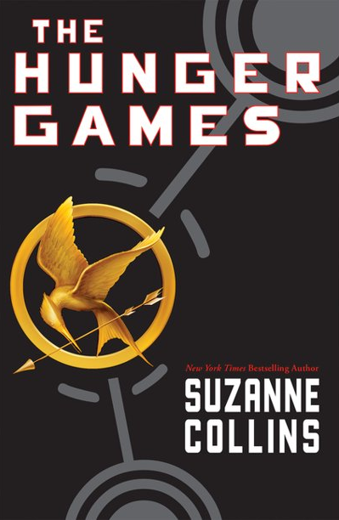
Our house is almost at the edge of the Seam. I only have to pass a few gates to reach the scruffy field called the Meadow. Separating the Meadow from the woods, in fact enclosing all of District 12, is a high chain-link fence topped with barbed-wire loops. In theory, it’s supposed to be electrified twenty-four hours a day as a deterrent to the predators that live in the woods – packs of wild dogs, lone cougars, bears – that used to threaten our streets. But since we’re lucky to get two or three hours of electricity in the evenings, it’s usually safe to touch. Even so, I always take a moment to listen carefully for the hum that means the fence is live. Right now, it’s silent as a stone. Concealed by a clump of bushes, I flatten out on my belly and slide under a two-foot stretch that’s been loose for years. There are several other weak spots in the fence, but this one is so close to home I almost always enter the woods here.

As soon as I’m in the trees, I retrieve a bow and sheath of arrows from a hollow log. Electrified or not, the fence has been successful at keeping the flesh-eaters out of District 12. Inside the woods they roam freely, and there are added concerns like venomous snakes, rabid animals, and no real paths to follow. But there’s also food if you know how to find it. My father knew and he taught me some before he was blown to bits in a mine explosion. There was nothing even to bury. I was eleven then. Five years later, I still wake up screaming for him to run.

Even though trespassing in the woods is illegal and poaching carries the severest of penalties, more people would risk it if they had weapons. But most are not bold enough to venture out with just a knife. My bow is a rarity, crafted by my father along with a few others that I keep well hidden in the woods, carefully wrapped in waterproof covers. My father could have made good money selling them, but if the officials found out he would have been publicly executed for inciting a rebellion Most of the Peacekeepers turn a blind eye to the few of us who hunt because they’re as hungry for fresh meat as anybody is. In fact, they’re among our best customers. But the idea that someone might be arming the Seam would never have been allowed.

Smoketown, by Tenea Johnson

It was cold inside the train. The air conditioning chilled the sweat on her brow and she suppressed a shiver. Across from her hung a transit map. It showed the circles of Leiodare’s rail system as well as the distant outlines of the other city-states that lay beyond the surrounding jungle. She chuckled quietly looking at it. The scale of the maps in Leiodare was always off--as if it were the largest city-state in the southeastern US when it clearly wasn’t, perhaps the third largest at best. But inside the city that didn’t matter. As the train zipped further down the line, Anna looked above the map to the time glowing blue. Seventeen minutes till close; she should just make it.

At the post office, battalion members stood sentry at a new security gate just outside the entrance. Anna joined the short line, shaking her head imperceptibly. The gate made no sense. Though Leiodaran paranoia dictated that people should be searched as they left the post office, even the city’s unstable framework of beliefs couldn’t make sense of examining people as they entered the post office. No one smuggled contraband to the outside world; Leiodare was the city surrounded by an invisible fence after all. But in the short time she’d been in Leiodare, Anna had noticed that around the outbreak’s anniversary, all manner of new and exotic municipal neuroses took hold. Last year, there had been talk of elevating the all-encompassing barrier further into the city’s airspace. Only the cost had quieted that particular fervor. So this year she supposed they’d decided to erect the ominous red gates outside all the post offices and ports of entry.

Anna clenched her jaw as she looked around, waiting for the woman in front of her to enter the security gate. After that woman had passed inspection, the battalion member on the right waved Anna through. As she stepped across the red threshold, a shrill alarm sounded.

Anna froze, her hands already up to protect herself. The battalion guards pushed past her, running to the bank of post office boxes near the exit, weapons drawn. Their boots sent flowers flying as they crossed the grassy median and joined a circle of other soldiers whose attentions were trained on the ground. Anna could see a man stretched out there, with hands behind his head. She rushed through the gate and into the post office.

Standing at the counter she wondered what the man had done. Had it been a false alarm or had he been so stupid as to try and smuggle birds through the post? Everyone knew that Leiodare had outlawed birds twenty-five years ago. The city was infamous for it. No birds could be found in the city’s beautiful gardens, on its houses, or in its trees. Smugglers, and often even suspected smugglers, served no less than five years of hard labor maintaining the electric avian barrier that surrounded the city, stretching into the sky, and across Leiodare, just below the path of planes. She couldn’t imagine what price could tempt someone to risk that sentence. But Anna knew, perhaps better than most, that people did crazy things for paltry rewards.
The Power, by Naomi Alderman

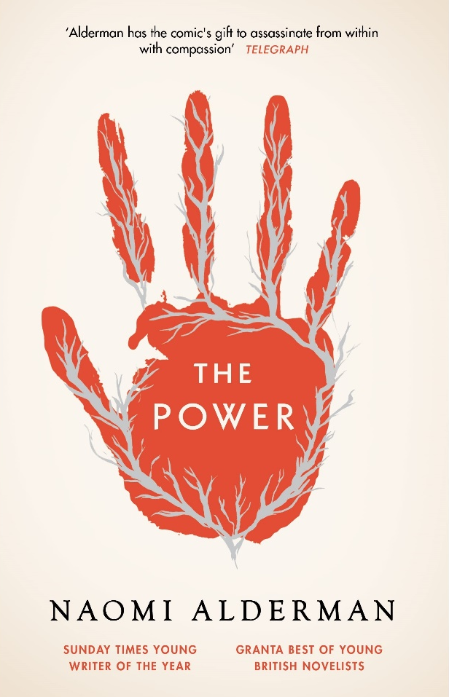
From the place on her forearm where Jos is touching her, it starts as a dull bone-ache. The flu, travelling through the muscles and joints. It deepens. Something is cracking her bone, twisting it, bending it, and she wants to tell Jos to stop but she can’t open her mouth. It burrows through the bone like it’s splintering apart from the inside; she can’t stop herself seeing a tumour, a solid, sticky lump bursting out through the marrow of her arm, splitting the ulna and the radius to sharp fragments. She feels sick. She wants to cry out. The pain radiates across her arm and, nauseatingly, through her body. There’s not a part of her it hasn’t touched now; she feels it echo in her head and down her spine, across her back, around her throat and out, spreading across her collarbone.

The collarbone. It has only been a few seconds, but the moments have elongated. Only pain can bring such attention to the body; this is how Margot notices the answering echo in her chest. Among the forests and mountains of pain, a chiming note along her collarbone. Like answering to like.

It reminds her of something. A game she played when she was a girl. How funny: she hasn’t thought of that game in years. She never told anyone about it; she knew she mustn’t, although she couldn’t say how she knew. In the game, she was a witch, and she could make a ball of light in the palm of her hand. Her brothers played that they were spacemen with plastic ray-guns they’d bought with cereal-packet tokens, but the little game she’d played entirely by herself among the beech trees along the rim of their property was different. In her game, she didn’t need a gun, or space-helmet, or lightsaber. In the game Margot played when she was a child, she was enough all by herself.

There is a tingling feeling in her chest and arms and hands. Like a dead arm, waking up. The pain is not gone now, but it is irrelevant. Something else is happening. Instinctively, she digs her hands into Jocelyn’s patchwork comforter. She smells the scent of the beech trees, as if she were back beneath their woody protection, their musk of old timber and wet loam.

She sendeth her lightning even unto the ends of the earth.

When she opens her eyes, there is a pattern around each of her hands. Concentric circles, light and dark, light and dark, burned into the comforter where her hands clutched it. And she knows, she felt that twist, and she remembers that maybe she has always known it and it has always belonged to her. Hers to cup in her hand. Hers to command to strike.

‘Oh God,’ she says. ‘Oh God.’

The Light at the Bottom of the World, by London Shah

The Old World Heritage Society demands a respectable distance be kept from all revered ancient London sites. This respect can take a deep dive into one of those endless chasms in the wild because honestly, I just don’t understand what’s so sacred about ruins.

I turn down the blaring punk rock music ricocheting off the submersible’s interior and peer into the murky green-gray depths once more for any hint of a watchful Eyeball; the tiny spherical cameras could be anywhere. The current looks clear. I steer past the fluorescent face of Big Ben and edge closer to the center of the former Houses of Parliament, toward the soft illumination of the Memorial Candle. A small number of patterned rabbitfish remain transfixed by the commemorative shaft of light. A traditional reminder of the looming anniversary, the lilac ray beams up through the city’s waters as far as the eye can see.

God, how I love staring at it every year.

Sometimes the Memorial Candle is all of humankind echoing up through layer after layer of current and wave and pressure, breaking through the liquid skin of the surface and reminding the universe: Hey, we’re still alive, still going down here! Other times the glow is a greeting across forever, a trillion Old World hugs and laughter and memories and dreams reaching down through the ages, lighting our way.

Sixty-five years tomorrow. Only sixty-five years ago all of this was air, not water. Like, there was nothing all around. Nothing in between structures, below people, or above their heads. Humanity carried on outside as if they were safely inside. Imagine being out in the open without the security of the water, exposed to the whole universe like that? Surreal!

My Bracelet flashes. I check the caller ID on the plain flexi-band around my wrist. ‘Accept.’

Theo’s holographic face materializes above my Bracelet, his smile reaching his pale blue eyes. ‘You on your way, Leyla? There’s a money pot with your name on it. We have a clear window – pair of Eyeballs passed by not ten minutes ago, so we’re good for another hour. You’d think they’d take Christmas Day off, but nope.’

Riot Baby, by Tochi Onyebuchi

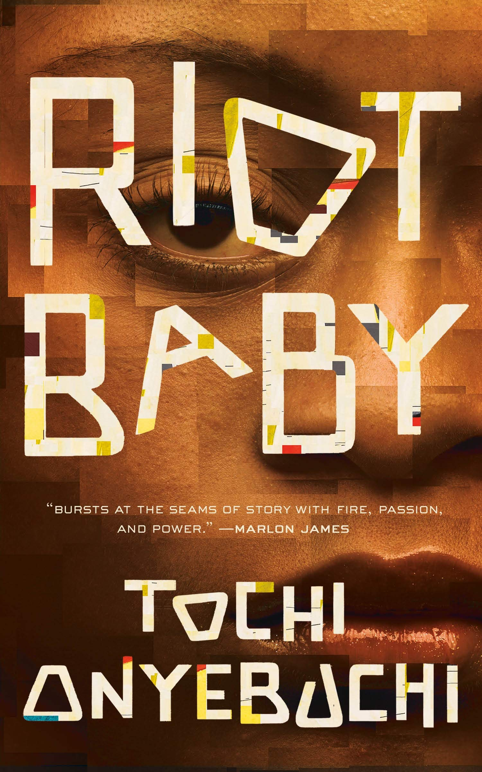
Before her Thing begins. Before even Kev is born. Before the move to Harlem. Ella on a school bus ambling through a Piru block in Compton and the kids across the aisle from her in blue giggling and throwing up Crip gang signs out the window at the Bloods in the low-rider pulling up alongside the bus. Somebody, a kid-poet, scribbling in a Staples composition notebook, head down, dutiful, praying almost. Two girls in front of Ella clapping their hands together in a faster, more intricate patty-cake, bobbing their heads side to side, smiling crescent moons at each other.

Bus slowing, then stopped. Metallic tapping on the plastic doors, which whoosh open, and warm air whooshes in with the Pirus that stomp up the steps in their red-and-black lumberjack tops with white shirts underneath and their red bandannas in their pockets and their .357 Magnums in their hands, and one of them goes up to the ringleader kid who had been throwing up the signs most fervently and presses the barrel of the gun to his temple and cocks back the hammer and tells the kid to stay in school and if he catches him chucking up another Crip sign, he’s gonna knock his fuckin’ top off, feel me? And Ella can see in the gangbanger’s eyes that he’s got no compunctions about it, that this is only half an act, it’s only half meant to scare the kid away from the corner, that if it came to it, the guy would meet disrespect with murder.

Ella hates South Central. She doesn’t know it yet, but can sense vaguely in a whisper that Harlem and a sweltering apartment and a snowball are somewhere in the distance, not close enough to touch, but close enough to see.

